DAILY ASSIGNMENT (20-03-26)

//upcasting
float mark1=97.8f;
double mark2=mark1;
System.out.println("Orginial value="+mark1);
System.out.println("Converted double value="+mark2);
//downcasting
int mark3=(int)mark1;
System.out.println("Converted int value="+mark3);
//ASCII
char ascii=(char)mark3;
System.out.println("ASCII value of 97 is " +ascii);

}

}
OUTPUT
Orginial value=97.8
Converted double value=97.80000305175781
Converted int value=97
ASCII value of 97 is a

SCREENSHOT
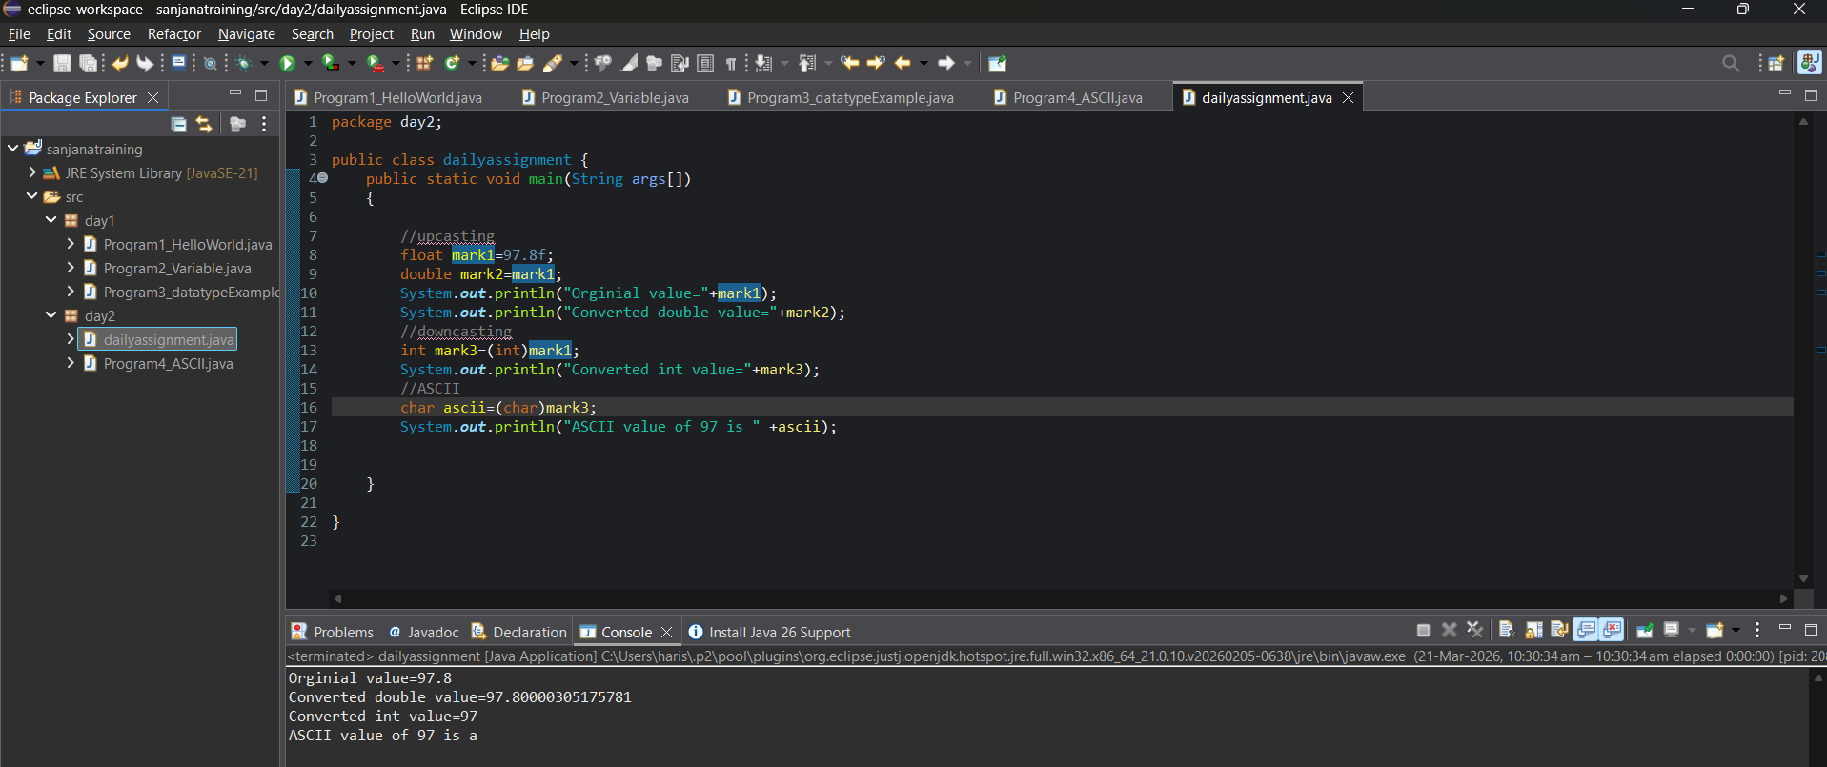
DAILY ASSIGNMENT (19-03-26)
PROGRAM

PROGRAM
package day2;
public class dailyassignment {
public static void main(String args[])
{
int age=21;
short mark=450;
byte battery=85;
int population=2500000;
char grade='A';
short Bank=5000;
boolean status=true;
short distance=1200;
long number=90000000L;
System.out.println("FINAL STUDENT MANAGEMENT SYSTEM RESULT");
System.out.println("Age=" +age);
System.out.println("Mark=" +mark);
System.out.println("Battery=" +battery+ "%");
System.out.println("City Population=" +population);
System.out.println("Bank Balance=" +Bank);
System.out.println("Login Status=" +status);
System.out.println("Distance=" +distance+ "meters");
System.out.println("Large Number=" +number);
}
}

OUTPUT
FINAL STUDENT MANAGEMENT SYSTEM RESULT
Age=21
Mark=450
Battery=85%
City Population=2500000
Bank Balance=5000
Login Status=true
Distance=1200meters
Large Number=90000000

SCREENSHOT
