Synonyms and built in functions.

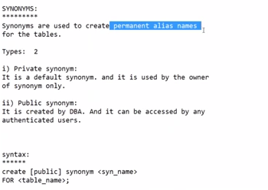

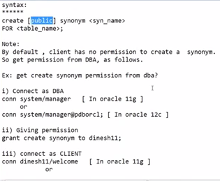

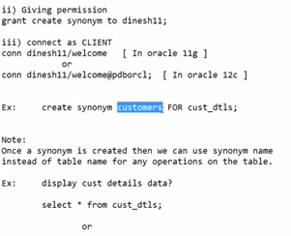

SQL> select * from emp;

EMPNO ENAME JOB MGR HIREDATE SAL COMM

---------- ---------- --------- ---------- --------- ---------- ----------

DEPTNO

----------

7839 KING PRESIDENT 17-NOV-81 5000

10

7698 BLAKE MANAGER 7839 01-MAY-81 2850

30

7782 CLARK MANAGER 7839 09-JUN-81 2450

10

EMPNO ENAME JOB MGR HIREDATE SAL COMM

---------- ---------- --------- ---------- --------- ---------- ----------

DEPTNO

----------

7566 JONES MANAGER 7839 02-APR-81 2975

20

7788 SCOTT ANALYST 7566 19-APR-87 3000

20

7902 FORD ANALYST 7566 03-DEC-81 3000

20

EMPNO ENAME JOB MGR HIREDATE SAL COMM

---------- ---------- --------- ---------- --------- ---------- ----------

DEPTNO

----------

7369 SMITH CLERK 7902 17-DEC-80 800

20

7499 ALLEN SALESMAN 7698 20-FEB-81 1600 300

30

7521 WARD SALESMAN 7698 22-FEB-81 1250 500

30

EMPNO ENAME JOB MGR HIREDATE SAL COMM

---------- ---------- --------- ---------- --------- ---------- ----------

DEPTNO

----------

7654 MARTIN SALESMAN 7698 28-SEP-81 1250 1400

30

7844 TURNER SALESMAN 7698 08-SEP-81 1500 0

30

7876 ADAMS CLERK 7788 23-MAY-87 1100

20

EMPNO ENAME JOB MGR HIREDATE SAL COMM

---------- ---------- --------- ---------- --------- ---------- ----------

DEPTNO

----------

7900 JAMES CLERK 7698 03-DEC-81 950

30

7934 MILLER CLERK 7782 23-JAN-82 1300

10

14 rows selected.

SQL> -- create synonym on emp table

SQL> create synonym empp for emp;

Synonym created.

SQL> select * from empp;

EMPNO ENAME JOB MGR HIREDATE SAL COMM

---------- ---------- --------- ---------- --------- ---------- ----------

DEPTNO

----------

7839 KING PRESIDENT 17-NOV-81 5000

10

7698 BLAKE MANAGER 7839 01-MAY-81 2850

30

7782 CLARK MANAGER 7839 09-JUN-81 2450

10

EMPNO ENAME JOB MGR HIREDATE SAL COMM

---------- ---------- --------- ---------- --------- ---------- ----------

DEPTNO

----------

7566 JONES MANAGER 7839 02-APR-81 2975

20

7788 SCOTT ANALYST 7566 19-APR-87 3000

20

7902 FORD ANALYST 7566 03-DEC-81 3000

20

EMPNO ENAME JOB MGR HIREDATE SAL COMM

---------- ---------- --------- ---------- --------- ---------- ----------

DEPTNO

----------

7369 SMITH CLERK 7902 17-DEC-80 800

20

7499 ALLEN SALESMAN 7698 20-FEB-81 1600 300

30

7521 WARD SALESMAN 7698 22-FEB-81 1250 500

30

EMPNO ENAME JOB MGR HIREDATE SAL COMM

---------- ---------- --------- ---------- --------- ---------- ----------

DEPTNO

----------

7654 MARTIN SALESMAN 7698 28-SEP-81 1250 1400

30

7844 TURNER SALESMAN 7698 08-SEP-81 1500 0

30

7876 ADAMS CLERK 7788 23-MAY-87 1100

20

EMPNO ENAME JOB MGR HIREDATE SAL COMM

---------- ---------- --------- ---------- --------- ---------- ----------

DEPTNO

----------

7900 JAMES CLERK 7698 03-DEC-81 950

30

7934 MILLER CLERK 7782 23-JAN-82 1300

10

14 rows selected.

SQL> select * from empp where deptno=30;

EMPNO ENAME JOB MGR HIREDATE SAL COMM

---------- ---------- --------- ---------- --------- ---------- ----------

DEPTNO

----------

7698 BLAKE MANAGER 7839 01-MAY-81 2850

30

7499 ALLEN SALESMAN 7698 20-FEB-81 1600 300

30

7521 WARD SALESMAN 7698 22-FEB-81 1250 500

30

EMPNO ENAME JOB MGR HIREDATE SAL COMM

---------- ---------- --------- ---------- --------- ---------- ----------

DEPTNO

----------

7654 MARTIN SALESMAN 7698 28-SEP-81 1250 1400

30

7844 TURNER SALESMAN 7698 08-SEP-81 1500 0

30

7900 JAMES CLERK 7698 03-DEC-81 950

30

6 rows selected.

SQL> select * from empp where deptno=30 and sal>1000;

EMPNO ENAME JOB MGR HIREDATE SAL COMM

---------- ---------- --------- ---------- --------- ---------- ----------

DEPTNO

----------

7698 BLAKE MANAGER 7839 01-MAY-81 2850

30

7499 ALLEN SALESMAN 7698 20-FEB-81 1600 300

30

7521 WARD SALESMAN 7698 22-FEB-81 1250 500

30

EMPNO ENAME JOB MGR HIREDATE SAL COMM

---------- ---------- --------- ---------- --------- ---------- ----------

DEPTNO

----------

7654 MARTIN SALESMAN 7698 28-SEP-81 1250 1400

30

7844 TURNER SALESMAN 7698 08-SEP-81 1500 0

30

SQL> select synonym_name from user_synonyms;

SYNONYM_NAME

------------------------------

CATALOG

COL

EMPP

PRODUCT_USER_PROFILE

PUBLICSYN

SYSCATALOG

SYSFILES

TAB

TABQUOTAS

9 rows selected.

SQL> drop synonym empp;

Synonym dropped.

SQL> select * from empp where deptno=30 and sal>1000;

select * from empp where deptno=30 and sal>1000

*

ERROR at line 1:

ORA-00942: table or view does not exist

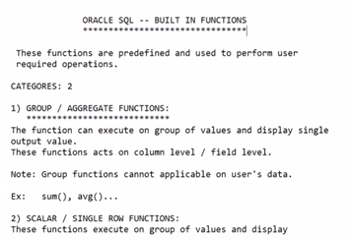

SQL> select (453125234-4626-3456535+24525) from dual;

(453125234-4626-3456535+24525)

------------------------------

449688598

SQL> select sum(sal) from emp;

SUM(SAL)

----------

29025

SQL> select avg(sal) from emp;

AVG(SAL)

----------

2073.21429

SQL> select max(sal) from emp;

MAX(SAL)

----------

5000

SQL> select min(sal) from emp;

MIN(SAL)

----------

800

SQL> select * from emp where sal=max(sal);

select * from emp where sal=max(sal)

*

ERROR at line 1:

ORA-00934: group function is not allowed here

SQL> select * from emp where sal= max(sal);

select * from emp where sal= max(sal)

*

ERROR at line 1:

ORA-00934: group function is not allowed here

SQL> select max(sal) from emp;

MAX(SAL)

----------

5000

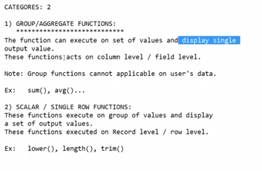

These fun applicable on column data of a table .

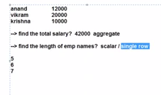

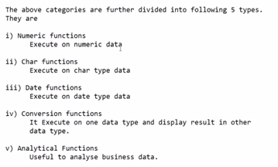

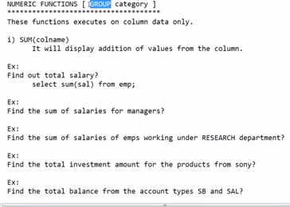

SQL> select count(sal) from emp;

COUNT(SAL)

----------

14

SQL> select count(comm) from emp;

COUNT(COMM)

-----------

4

SQL> select count(*) from emp;

COUNT(*)

----------

14

SQL> select count(*) from emp where deptno=30;

COUNT(*)

----------

6

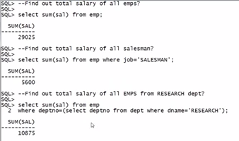

SQL> select * from emp where job='CLERK' and sal<(select avg(sal) from emp where job='CLERK');

EMPNO ENAME JOB MGR HIREDATE SAL COMM

---------- ---------- --------- ---------- --------- ---------- ----------

DEPTNO

----------

7369 SMITH CLERK 7902 17-DEC-80 800

20

7900 JAMES CLERK 7698 03-DEC-81 950

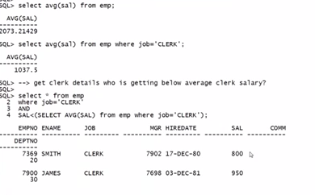

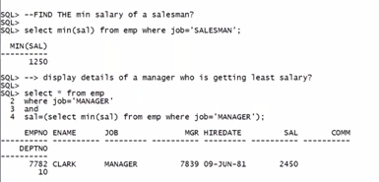

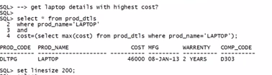

SQL> SELECT * FROM EMP WHERE COMM=NULL;

no rows selected

SQL> SELECT COUNT(COMM) FROM EMP;

COUNT(COMM)

-----------

4

SQL> SELECT * FROM EMP WHERE COMM IS NULL;

EMPNO ENAME JOB MGR HIREDATE SAL COMM

---------- ---------- --------- ---------- --------- ---------- ----------

DEPTNO

----------

7839 KING PRESIDENT 17-NOV-81 5000

10

7698 BLAKE MANAGER 7839 01-MAY-81 2850

30

7782 CLARK MANAGER 7839 09-JUN-81 2450

10

EMPNO ENAME JOB MGR HIREDATE SAL COMM

---------- ---------- --------- ---------- --------- ---------- ----------

DEPTNO

----------

7566 JONES MANAGER 7839 02-APR-81 2975

20

7788 SCOTT ANALYST 7566 19-APR-87 3000

20

7902 FORD ANALYST 7566 03-DEC-81 3000

20

EMPNO ENAME JOB MGR HIREDATE SAL COMM

---------- ---------- --------- ---------- --------- ---------- ----------

DEPTNO

----------

7369 SMITH CLERK 7902 17-DEC-80 800

20

7876 ADAMS CLERK 7788 23-MAY-87 1100

20

7900 JAMES CLERK 7698 03-DEC-81 950

30

EMPNO ENAME JOB MGR HIREDATE SAL COMM

---------- ---------- --------- ---------- --------- ---------- ----------

DEPTNO

----------

7934 MILLER CLERK 7782 23-JAN-82 1300

10

10 rows selected.

SQL> SELECT * FROM EMP WHERE COMM IS NOT NULL;

EMPNO ENAME JOB MGR HIREDATE SAL COMM

---------- ---------- --------- ---------- --------- ---------- ----------

DEPTNO

----------

7499 ALLEN SALESMAN 7698 20-FEB-81 1600 300

30

7521 WARD SALESMAN 7698 22-FEB-81 1250 500

30

7654 MARTIN SALESMAN 7698 28-SEP-81 1250 1400

30

EMPNO ENAME JOB MGR HIREDATE SAL COMM

---------- ---------- --------- ---------- --------- ---------- ----------

DEPTNO

----------

7844 TURNER SALESMAN 7698 08-SEP-81 1500 0

30

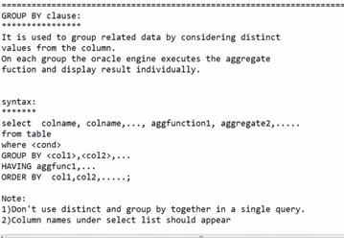

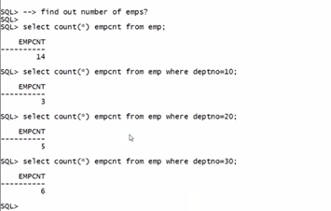

IF WE WANT TO DISPLAY AS IN BELOW PIC

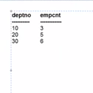

SQL> SELECT DISTINCT DEPTNO, COUNT(DEPTNO) EMPCNT FROM EMP;

SELECT DISTINCT DEPTNO, COUNT(DEPTNO) EMPCNT FROM EMP

*

ERROR at line 1:

ORA-00937: not a single-group group function

SQL> SELECT DEPTNO, COUNT(DEPTNO) EMPCNT FROM EMP;

SELECT DEPTNO, COUNT(DEPTNO) EMPCNT FROM EMP

*

ERROR at line 1:

ORA-00937: not a single-group group function

SQL> SELECT DEPTNO, COUNT(DEPTNO) FROM EMP;

SELECT DEPTNO, COUNT(DEPTNO) FROM EMP

*

ERROR at line 1:

ORA-00937: not a single-group group function

SQL> SELECT DEPTNO FROM EMP;

DEPTNO

----------

10

30

10

20

20

20

20

30

30

30

30

DEPTNO

----------

20

30

10

14 rows selected.

SQL> SELECT DISTINCT(DEPTNO) FROM EMP;

DEPTNO

----------

30

20

10

SQL> SELECT DISTINCT(DEPTNO), COUNT(DISTINCT(DEPTNO)) FROM EMP;

SELECT DISTINCT(DEPTNO), COUNT(DISTINCT(DEPTNO)) FROM EMP

*

ERROR at line 1:

ORA-00937: not a single-group group function

SQL> SELECT DISTINCT(DEPTNO), COUNT(DEPTNO)) FROM EMP;

SELECT DISTINCT(DEPTNO), COUNT(DEPTNO)) FROM EMP

*

ERROR at line 1:

ORA-00923: FROM keyword not found where expected

SQL> SELECT DEPTNO FROM EMP;

DEPTNO

----------

10

30

10

20

20

20

20

30

30

30

30

DEPTNO

----------

20

30

10

14 rows selected.

SQL> SELECT DISTINCT(DEPTNO) FROM EMP;

DEPTNO

----------

30

20

10

SQL> SELECT DISTINCT(DEPTNO), COUNT(SELECT DISTINCT(DEPTNO) FROM EMP) FROM EMP;

SELECT DISTINCT(DEPTNO), COUNT(SELECT DISTINCT(DEPTNO) FROM EMP) FROM EMP

*

ERROR at line 1:

ORA-00936: missing expression

SQL> SELECT DISTINCT(DEPTNO), COUNT(SELECT DISTINCT(DEPTNO) FROM EMP) FROM EMP;

ITS NOT POSSIBLE IN THE ABOVE EXAMPLE.

IT CAN BE DON BY USING GROUP BY

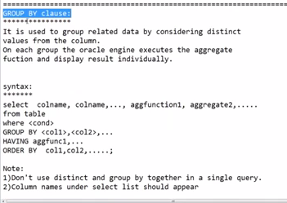

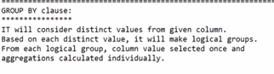

SQL> --FIND OUT NUMBER OF EMPS FROM EACH DEPT;

SQL> SELECT DEPTNO, COUNT((DEPTNO)) FROM EMP GROUP BY DEPTNO;

DEPTNO COUNT((DEPTNO))

---------- ---------------

30 6

20 5

10 3

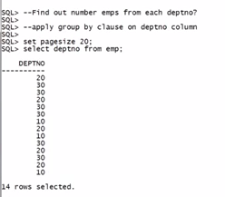

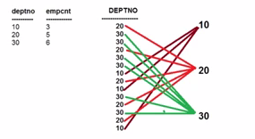

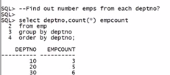

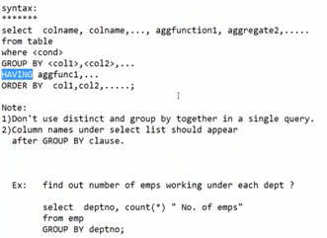

SQL> SELECT COUNT(*), SUM(SAL) FROM EMP GROUP BY(JOB);

COUNT(*) SUM(SAL)

---------- ----------

4 4150

4 5600

1 5000

3 8275

2 6000

SQL> SELECT COUNT(*), SUM(SAL), JOB FROM EMP GROUP BY(JOB);

COUNT(*) SUM(SAL) JOB

---------- ---------- ---------

4 4150 CLERK

4 5600 SALESMAN

1 5000 PRESIDENT

3 8275 MANAGER

2 6000 ANALYST

