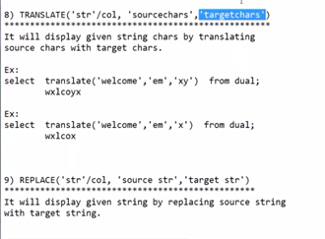

QL> TRANSLATE('SURESH', 'UE', 'II');

SP2-0734: unknown command beginning "TRANSLATE(..." - rest of line ignored.

SQL> SELECT TRANSLATE('SURESH', 'UE', 'II') FROM DUAL;

TRANSL

------

SIRISH

SQL> SELECT TRANSLATE('SUREESH', 'UE', 'III') FROM DUAL;

TRANSLA

-------

SIRIISH

SQL> SELECT TRANSLATE('SUREESH', 'UE', 'II') FROM DUAL;

TRANSLA

-------

SIRIISH

SQL> SELECT TRANSLATE('SUREESH', 'UE', 'I') FROM DUAL;

TRANS

-----

SIRSH

SQL> SELECT TRANSLATE('ABCDEF', '12', 'I') FROM DUAL;

TRANSL

------

ABCDEF

SQL> SELECT TRANSLATE('ABCDEF', 'AB', '12') FROM DUAL;

TRANSL

------

12CDEF

SQL> SELECT TRANSLATE('ABCDEF', 'ABC\', '12') FROM DUAL;

TRANS

-----

12DEF

SQL> SELECT TRANSLATE('ABCDEF', 'ABC', '12') FROM DUAL;

TRANS

-----

12DEF

SQL> SELECT TRANSLATE('SIREESH', 'IE', 'UI') FROM DUAL;

TRANSLA

-------

SURIISH

SQL> SELECT TRANSLATE('SIREESH', 'IE', 'UID') FROM DUAL;

TRANSLA

-------

SURIISH

SQL> SELECT TRANSLATE('SIREESH', 'IE', 'U') FROM DUAL;

TRANS

-----

SURSH

SQL> SELECT TRANSLATE('DSFGVSGAERBXDFBSGBSXBSAGVE', 'D', 'U') FROM DUAL;

TRANSLATE('DSFGVSGAERBXDFB

--------------------------

USFGVSGAERBXUFBSGBSXBSAGVE

SQL> -- REPLASES IN ALL POSITIONS

SQL> SELECT TRANSLATE('DSFGVSGAERBXDFBSGBSXBSAGVE', 'D') FROM DUAL;

SELECT TRANSLATE('DSFGVSGAERBXDFBSGBSXBSAGVE', 'D') FROM DUAL

\*

ERROR at line 1:

ORA-00909: invalid number of arguments

SQL> SELECT TRANSLATE('DSFGVSGAERBXDFBSGBSXBSAGVE', 'DF', 'T') FROM DUAL;

TRANSLATE('DSFGVSGAERBXD

------------------------

TSGVSGAERBXTBSGBSXBSAGVE

SQL> SELECT TRANSLATE('DSFFFFFFFFFFFFFFGVSGAERBXDFBSGBSXBSAGVE', 'DF', 'T') FROM DUAL;

TRANSLATE('DSFFFFFFFFFFF

------------------------

TSGVSGAERBXTBSGBSXBSAGVE

SQL> --IF REPLACING CHAR NOT MENTIONED, THEN IT WILL REMOVE THAT CHARECTER FROM GIVEN WORD/SENTENCE.

SQL>

SQL> SELECT TRANSLATE('DSFFFFFFFFFFFFFFGD', 'DF', 'T') FROM DUAL;

TRAN

----

TSGT

SQL>

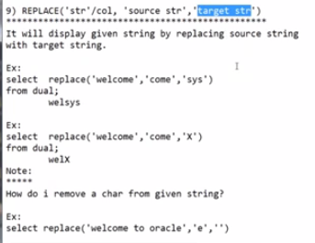

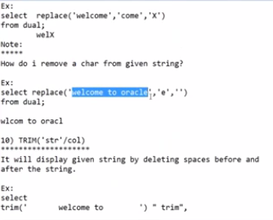

SQL> SELECT TRANSLATE('DSFFFFFFFFFFFFFFGD', 'DF', 'T') FROM DUAL;

TRAN

----

TSGT

SQL> SELECT REPLACE('DSFFFFFFFFFFFFFFGD', 'DF', 'T') FROM DUAL;

REPLACE('DSFFFFFFF

------------------

DSFFFFFFFFFFFFFFGD

SQL> SELECT REPLACE('DSFFFFFFFFFFFFFFGD', 'DSF', 'T') FROM DUAL;

REPLACE('DSFFFFF

----------------

TFFFFFFFFFFFFFGD

SQL> SELECT REPLACE('DSFFFFFFFFFFFFFFGD', 'DSFFFFFFFFFF', 'T') FROM DUAL;

REPLACE

-------

TFFFFGD

SQL> SELECT REPLACE('DSFFFFFFFFFFFFFFGD', 'DSFFFFFFFFFF', '') FROM DUAL;

REPLAC

------

FFFFGD

SQL> SELECT REPLACE('DSFFFFFFFFFFFFFFGD', 'DSFFFFFFFFFF', 'BSBSBFSBFSGBVSGBS') FROM DUAL;

REPLACE('DSFFFFFFFFFFFF

-----------------------

BSBSBFSBFSGBVSGBSFFFFGD

SQL> SELECT REPLACE('DSFFFFFFFFFFFFFFGD', 'DSFFFFFFFFFFFFFF', '') FROM DUAL;

RE

--

GD

SQL> SELECT REPLACE('I AM SURESH', 'I AM ', '') FROM DUAL;

REPLAC

------

SURESH

SQL> SELECT REPLACE('I AM SURESH', 'UE', 'II') FROM DUAL;

REPLACE('IA

-----------

I AM SURESH

SQL> SELECT TRANSLATE('I AM SURESH', 'UE', 'II') FROM DUAL;

TRANSLATE('

-----------

I AM SIRISH

SQL> SELECT TRANSLATE('I AM SURESH', 'URE', 'IRI') FROM DUAL;

TRANSLATE('

-----------

I AM SIRISH

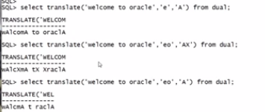

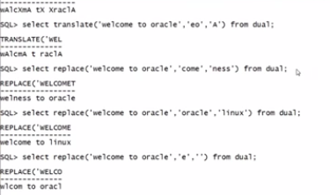

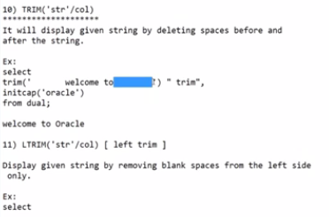

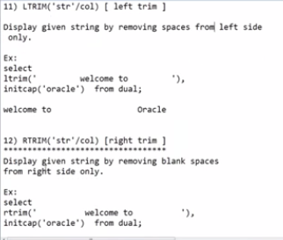

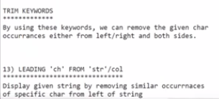

SQL> -- TRIM, REMOVES IF THERE IS ANY SPACE

SQL> SELECT TRIM(' SURESH ') FROM DUAL;

TRIM('

------

SURESH

SQL> SELECT TRIM(' I AM SURESH ') FROM DUAL;

TRIM('IAMSU

-----------

I AM SURESH

SQL> SELECT TRIM('I AM SURESH ') FROM DUAL;

TRIM('IAMSURESH')

-----------------

I AM SURESH

SQL> SELECT LTRIM(' I AM SURESH ') FROM DUAL;

LTRIM('IAMSURESH')

------------------

I AM SURESH

SQL> SELECT TRIM(' I AM SURESH ') FROM DUAL;

TRIM('IAMSU

-----------

I AM SURESH

SQL> SELECT RTRIM(' I AM SURESH ') FROM DUAL;

RTRIM('IAMSURESH

----------------

I AM SURESH

SQL> SELECT RTRIM(' I AM SURESH ') FROM DUAL;

RTRIM('IAMSURESH')

---------------------------

I AM SURESH

SQL> SELECT RTRIM(' I AM SURESH KUMAR') FROM DUAL;

RTRIM('IAMSURESHKUMAR')

---------------------------------------

I AM SURESH KUMAR

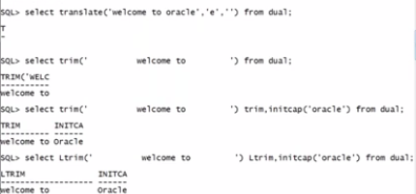

SQL> SELECT RTRIM(' I AM SURESH '), LTRIM('KUMAR') FROM DUAL;

RTRIM('IAMSURESH') LTRIM

--------------------------- -----

I AM SURESH KUMAR

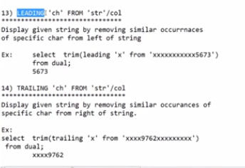

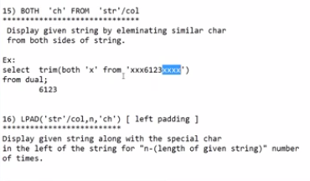

SQL> SELECT TRIM(LEADING 'X' FROM 'XXXXXXXXXXXX24562XXXXXXXXXX') FROM DUAL

2 ;

TRIM(LEADING'X'

---------------

24562XXXXXXXXXX

SQL> SELECT TRIM(TRIALING 'X' FROM 'XXXXXXXXXXXX24562XXXXXXXXXX') FROM DUAL;

SELECT TRIM(TRIALING 'X' FROM 'XXXXXXXXXXXX24562XXXXXXXXXX') FROM DUAL

\*

ERROR at line 1:

ORA-00907: missing right parenthesis

SQL> SELECT TRIM(TRAILING 'X' FROM 'XXXXXXXXXXXX24562XXXXXXXXXX') FROM DUAL;

TRIM(TRAILING'X'F

-----------------

XXXXXXXXXXXX24562

SQL> SELECT TRIM(BOTH 'X' FROM 'XXXXXXXXXXXX24562XXXXXXXXXX') FROM DUAL;

TRIM(

-----

24562

SQL> SELECT TRIM(BOTH 'XX' FROM 'XXXXXXXXXXXX24562XXXXXXXXXX') FROM DUAL;

SELECT TRIM(BOTH 'XX' FROM 'XXXXXXXXXXXX24562XXXXXXXXXX') FROM DUAL

\*

ERROR at line 1:

ORA-30001: trim set should have only one character

SQL> SELECT TRIM(BOTH 'D' FROM 'XXXXXXXXXXXX24562XXXXXXXXXX') FROM DUAL;

TRIM(BOTH'D'FROM'XXXXXXXXXX

---------------------------

XXXXXXXXXXXX24562XXXXXXXXXX

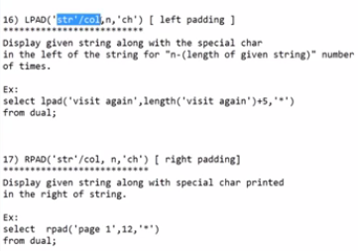

SQL> SELECT LPAD('WEL COME', 10, '\*') FROM DUAL;

LPAD('WELC

----------

\*\*WEL COME

SQL> SELECT LPAD('WEL COME', 100, '\*') FROM DUAL;

LPAD('WELCOME',100,'\*')

--------------------------------------------------------------------------------

\*\*\*\*\*\*\*\*\*\*\*\*\*\*\*\*\*\*\*\*\*\*\*\*\*\*\*\*\*\*\*\*\*\*\*\*\*\*\*\*\*\*\*\*\*\*\*\*\*\*\*\*\*\*\*\*\*\*\*\*\*\*\*\*\*\*\*\*\*\*\*\*\*\*\*\*\*\*\*\*

\*\*\*\*\*\*\*\*\*\*\*\*WEL COME

SQL> SELECT LPAD('WEL COME', 15, '\*') FROM DUAL;

LPAD('WELCOME',

---------------

\*\*\*\*\*\*\*WEL COME

SQL> SELECT LPAD('WEL COME', 16, '\*') FROM DUAL;

LPAD('WELCOME',1

----------------

\*\*\*\*\*\*\*\*WEL COME

SQL> SELECT LPAD('WEL COME', 17, '\*') FROM DUAL;

LPAD('WELCOME',17

-----------------

\*\*\*\*\*\*\*\*\*WEL COME

SQL> SELECT LPAD('WEL COME', 18, '\*') FROM DUAL;

LPAD('WELCOME',18,

------------------

\*\*\*\*\*\*\*\*\*\*WEL COME

SQL> SELECT LPAD('WEL COME', 20, '\*') FROM DUAL;

LPAD('WELCOME',20,'\*

--------------------

\*\*\*\*\*\*\*\*\*\*\*\*WEL COME

SQL> SELECT RPAD('WEL COME', 20, '\*') FROM DUAL;

RPAD('WELCOME',20,'\*

--------------------

WEL COME\*\*\*\*\*\*\*\*\*\*\*\*

SQL> SELECT RPAD('WEL COME', 10, '\*') FROM DUAL;

RPAD('WELC

----------

WEL COME\*\*

SQL> SELECT RPAD('WEL COME', 8, '\*') FROM DUAL;

RPAD('WE

--------

WEL COME

SQL> --BECAUSE LENGTH OF STRING ALSO 8, 8-8=0;

SQL> SELECT PAD('WEL COME', 8, '\*') FROM DUAL;

SELECT PAD('WEL COME', 8, '\*') FROM DUAL

\*