SQL> -- we should not create tables as our own

SQL> -- we should create acc. to client req.

SQL> -- to create table , we should meet client req.

SQL> -- acc. to info. related to his business.

SQL> --what is data model ?

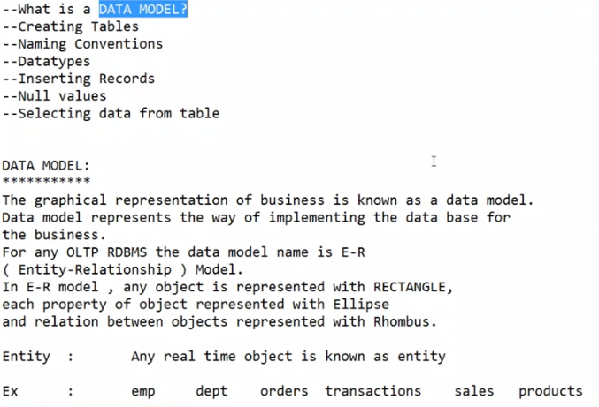

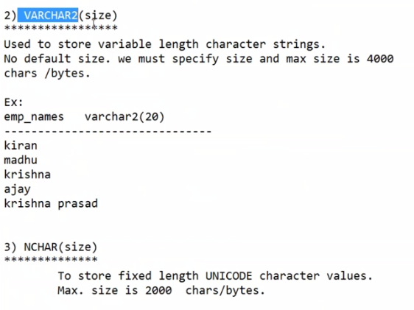

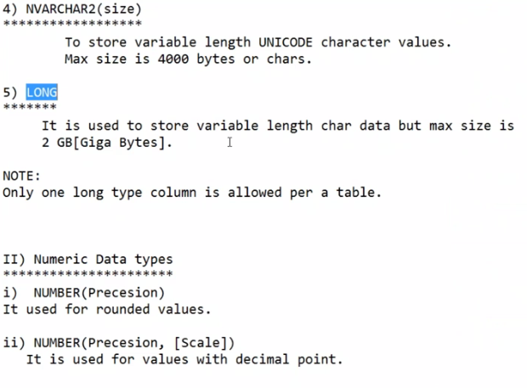

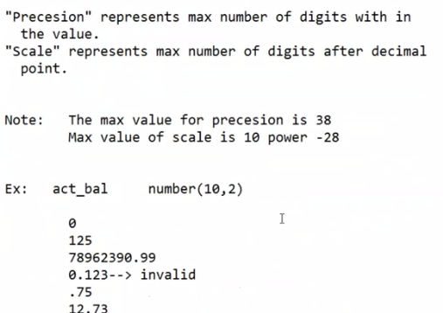

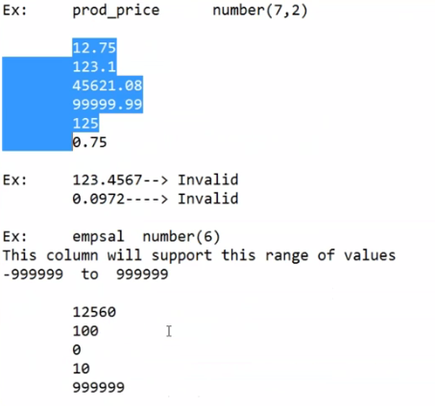

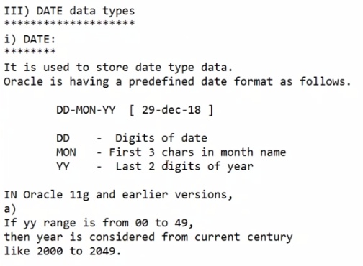

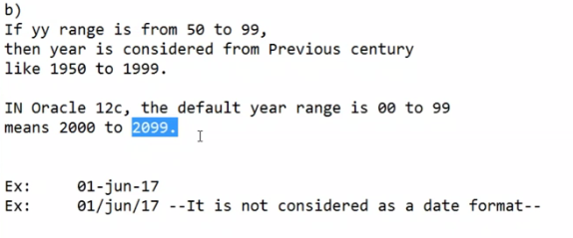

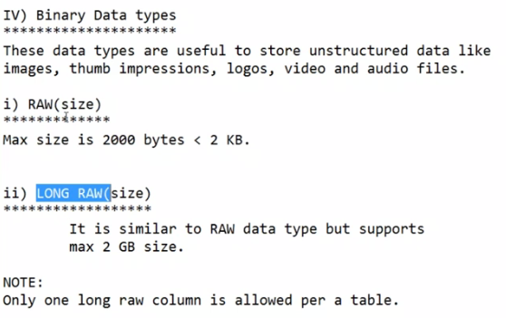

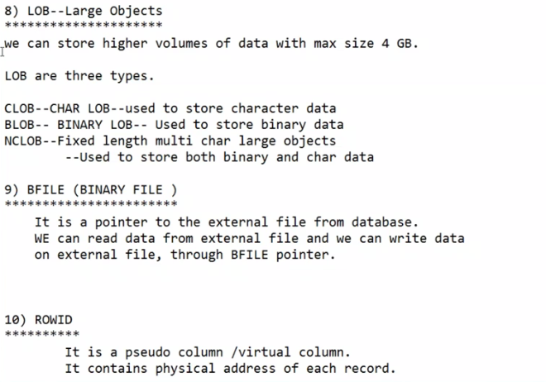

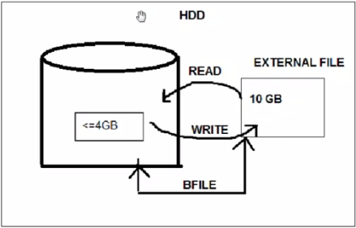

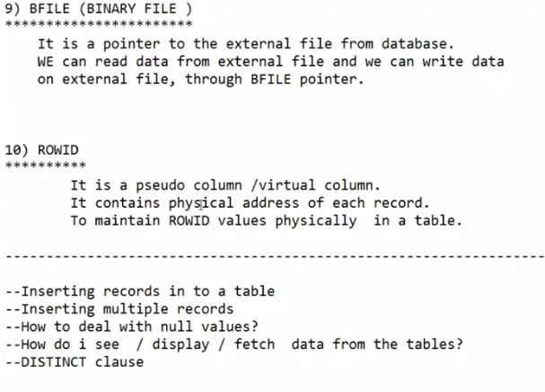

SQL> -- the input for business developement is called data model.

SQL> -- based on data model, we need to start developement.

SQL> --data model rep[resents the business in a graphical diag.

SQL> --fig.

SQL> --Data Model : input for business developement in a graphical representation.

SQL> -- objects represents in the form of rectangle.

SQL> --properties represents in the form of ellipse/ovels.

SQL> -- relation b/w 2 objects represents with rombhus.

SQL> --generally data model designed by data base designers who has more exp. >10years.

SQL> -- then developers can start development like creating tables and inserting data.

SQL> -- if we know primary key and foriegn key then we can easily able to draw ER diag. for any number of objects.

SQL> --This is real time project data model.

SQL> --object names are tables.

SQL> --property names are column names.

SQL> --DDL Commands

SQL> --CREATE : used to create any database objects liike tables, views, indexes, sequences, synonyms, users.

SQL> --logged into db

SQL> -- and againen logged into local user.

SQL> create user suresh identified by Target@80

2 quota 100 M on users;

create user suresh identified by Target@80

*

ERROR at line 1:

ORA-00922: missing or invalid option

SQL> create user suresh identified by Target

2 quota 100 M on users;

User created.

SQL> grant resource, connect to suresh;

Grant succeeded.

SQL> connect suresh/Target@orclpdb;

ERROR:

ORA-12154: TNS:could not resolve the connect identifier specified

Warning: You are no longer connected to ORACLE.

SQL> connect SYS/SYS;

ERROR:

ORA-28009: connection as SYS should be as SYSDBA or SYSOPER

SQL> connect SYSTEM/SYS;

Connected.

SQL> connect suresh/Target@orclpdb;

ERROR:

ORA-12154: TNS:could not resolve the connect identifier specified

Warning: You are no longer connected to ORACLE.

SQL> -- i am not understanding all these user connections.

SQL> connect suresh/Target

Connected.

SQL> show user;

USER is "SURESH"

SQL> show con_name;

concat "." (hex 2e)

SP2-0158: unknown SHOW option "_name"

SQL> -- actually here we should get container name but i am unable to connect orclpdb.

SQL> select * from tab;

no rows selected

SQL> --creating 1st table.

SQL> CREATE TABLE EMPS

2 (

3 EMPID NUMBER(3),

4 ENAME VRACHAR2(14),

5 SALARY NUMBER(5),

6 DESG VARCHAR2(15),

7 JOINDATE DATE

8 );

ENAME VRACHAR2(14),

*

ERROR at line 4:

ORA-00907: missing right parenthesis

SQL> CREATE TABLE EMPS

2 (

3 EMPID NUMBER(3),

4 ENAME VARCHAR2(14),

5 SALARY NUMBER(5),

6 DESG VARCHAR2(15),

7 JOINDATE DATE

8 );

Table created.

SQL> -- BEFORE SPECIFYING TABLE NAMES AND COLUMN NAMES WE SHOULD FOLLOW SOME RULES.

SQL> --FIG.

SQL> --MIN LEAGTH SHOULD BE 1 CHAR, AND MAX LENGTH SHOULD BE 30 CHAR.

SQL> --WE CAN USE A-Z, a-z, 0-9, @,$,# AND _.

SQL> --BUT BETTER TO AVOID @,$,#

SQL> -- DATA TYPE : THE TYPE OF DATA WHICH WILL BE ALLOWED INTO COLUMN.

SQL> --IN GENERAL, IN WORLD WE HAVE 4 DATA TYPES AS SHOWN IN FIG.

SQL> --FIG.

SQL> --FIXED LENGTH CHAR VALUE, EX: PANCARD NUMBER. LENGTH IS SAME FOR ALL PEOPLE.

SQL> --ACCOUNT NUMBERS FOR SAME BANK IS OF SAME LENGTH, ID CARD NUMBERS.

SQL> -- FOR VARCHAR2 DATATYPE, ONLY EXISTING DATA MEMORY WILL BE ALLOCATED , THERE IS NO MEMORY WASTAGE HERE LIKE CHAR DATATYPE.

SQL> -- IF WE WANT TO USE ANY OTHER LANGUAGE OTHER THAN ENGLISH WE CAN USE NCHAR.

SQL> --NVARCHAR2 IS SAME AS VARCHAR2 BUT SUPPORTS ALL LANGUAGES.

SQL> --PRECISSION: MAX LENGTH OF COMPLETE VALUE

SQL> --SCALE : MAX LENGTH OF DECIMAL VALUE.

SQL> --DATE DATATYPE.

SQL> -- IF WE WANT DATE AS PER OUR REQUIREMENT , WE CAN GIVE DATATYPE AS CHAR DATATYPE.

SQL> --MOVIE CAN BE STORED USING BFILE EVEN IT IS >4GB.

SQL> --WILL BE SAVED IN EXTERNAL FILE, LIKE HARD DISK.

SQL> --BFILE IS LIKE A POINTER, WE CAN READ AND WRITE THROUGHT BFILE WHICH GIVES LOCATION OF EXTERNAL FILE.

SQL> SPOOL OFF