History Of Wars

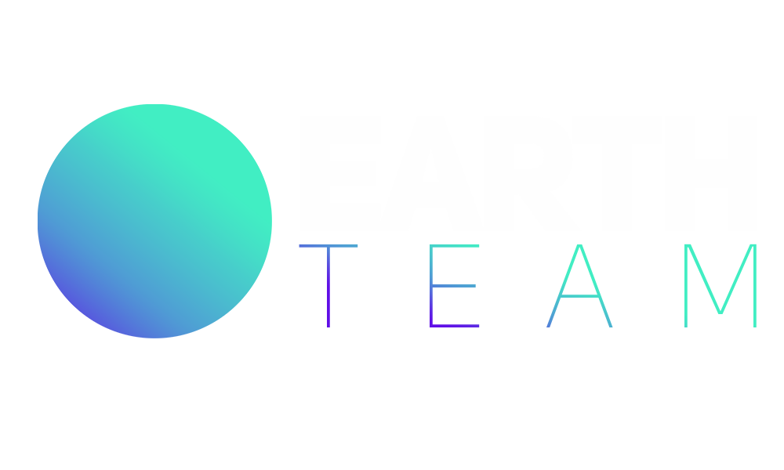

**MADE BY** Earth Team

**Table of Contents**

Idea of the project3

Team members3

Team work 3

Technologies 4

Access the project 4

JavaScript 5

|  |  |
| --- | --- |
| № | Roles in the team |
|  | Simeon Boev – Scrum trainer and Back-end developer |
|  | Stepan Urivko – Front-end developer |
|  | Beatris Topuzyan – Designer |

Team work

Our main communicating platforms were Microsoft Teams and Discord. During the project we met almost every day, so that everyone can catch up with the work.

Idea of the project

Our goal is to use rigorously research and simple straight-forward analysis to improve education areas and practices in ways that help reduce conflict and build lasting peace.

Team members



What technologies are used?

The technologies used are **Visual Studio & Visual Studio Code**  as our code editors, the website was created using simple **HTML & SCSS** , we used **GitHub** for collaborative work, **Discord and Microsoft Team** - connection and communication, **PowerPoint** - preparing a Presentation, **Word** - preparing Documentation, **Excel** – for the QA tests and **Photoshop** – photo and graphic processing.



How can you access the project ?

Our collaborative work took place in **GitHub** and in order for the files to be accessible to everyone they were uploaded in the GitHub Repository of our project.

**Link** - [ssurivko20/history-of-wars (github.com)](https://github.com/ssurivko20/history-of-wars)





Block Diagram