Results: budget-constrained multi-task network for EU crops
ENGG2112 group project. This document collects every result table and figure behind the final report's findings section, with a short reading of each. The model is one neural network for all four crops that predicts yield and harvested N removal and computes N surplus from the soil-surface budget. All values are generated by the project code from results/ and figures/, so a rerun refreshes them. Figures are also exported at 16:9 in figures/slides for the presentation, and the headline values are listed in reports/key_numbers.csv.

1. Key results at a glance
- Accuracy on later years (2017-2018): yield MAE 0.85 t/ha (R² 0.81), removal MAE 15.7 kg N/ha, surplus MAE 10.2 kg N/ha.
- Accuracy on countries held out of training: yield MAE 1.22 t/ha and surplus MAE 15.7 kg N/ha. Yield error is 44% higher than on later years, because no data from the region itself was seen in training.
- Budget closure: the largest gap between inputs, removal and surplus in any prediction was 0.00003 kg N/ha, which is rounding. Every output obeys the budget.
- Largest error source: the 2018 drought. Yield bias was +0.10 t/ha in 2017 and +0.61 t/ha in 2018. The model has no weather input.
- Hotspots: the 10% of crop-region-years with the highest predicted surplus per tonne of yield cover 6% of crop area but 19% of predicted surplus. The ranking agrees with the budget values (Spearman 0.88 to 0.95).

2. Data and coverage
Table 1. Per-crop budget dataset: 13,185 crop-region-years from 216 NUTS2 regions in 26 countries, 2000-2018 (crops with at least 1,000 ha in a region).
Crop | Rows | Regions | Mean yield, t/ha | Mineral N, kg N/ha | Removal, kg N/ha | Surplus, kg N/ha
Soft wheat | 3747 | 203 | 5.67 | 119 | 114 | 106
Barley | 3802 | 209 | 4.73 | 97 | 90 | 107
Grain maize | 2892 | 163 | 7.96 | 136 | 111 | 127
Rapeseed | 2744 | 160 | 2.85 | 107 | 90 | 104

Reading. CAPRI's regional budget closes: the largest gap between inputs, retention and surplus was 0.006 kg N/ha, which is rounding. The per-crop budget is our construction, because CAPRI reports surplus only for all farmland in a region.
Table 2. Grain N content. Calibrated by non-negative least squares of CAPRI regional N retention on area times yield of all 35 CAPRI crops (R² = 0.990).
Crop | Calibrated, kg N/t | Literature range | Used, kg N/t
Soft wheat | 20.1 | 17-23 | 20.1
Barley | 18.9 | 14-20 | 18.9
Grain maize | 24.1 | 12-16 | 14.0
Rapeseed | 62.9 | 28-35 | 31.5

Reading. Wheat and barley calibrate inside their literature ranges, which supports reading CAPRI's retention term as harvested removal for cereals. Maize and rapeseed did not, most likely because they share regions with crops the regression cannot separate, so literature midpoints were used.
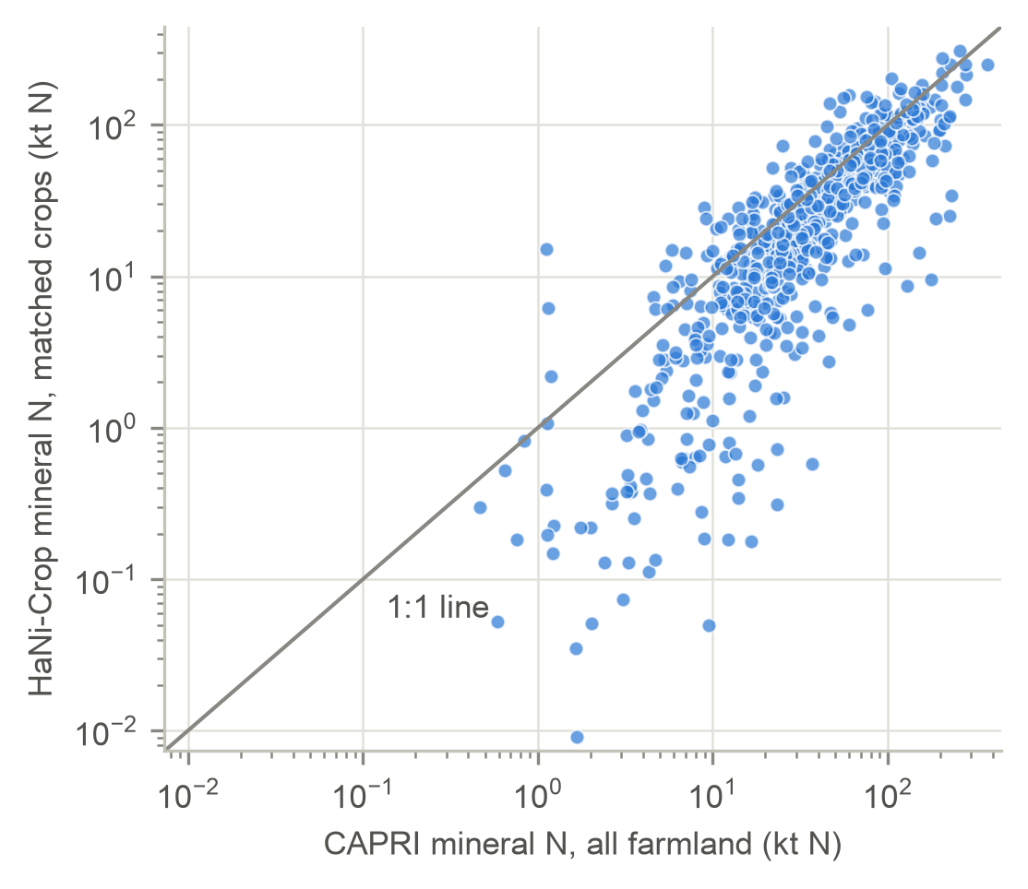
Figure 1. HaNi-Crop mineral N on matched crops against CAPRI mineral N on all farmland, per region-year (log scales; 2000, 2009, 2018).
Figure 1. The two sources agree on the pattern (correlation 0.81), and HaNi's matched crops account for 75% of CAPRI's mineral N. The ratio is lowest where grassland or olives and vines dominate (IE 0.10, CY 0.31, NL 0.40, EL 0.41), which HaNi does not cover. Raw HaNi rates changed by more than 50% from the previous year in 27% of 2017 rows, against 7% in a typical year. Using the HaNi level from the training years with CAPRI's annual series brought this to 0.1%.

3. Model performance
Table 3. Test results, mean of 5 training seeds. Later years: trained on 2000-2014, tested on 2017-2018. Held-out countries: 5 folds of whole countries, 2000-2016, with regions bordering a test region removed from training. Bias is predicted minus observed.
Output | Test | MAE (± sd over seeds) | RMSE | Bias | R²
Yield (t/ha) | Later years (2017-2018) | 0.85 ± 0.03 | 1.15 | +0.35 | 0.81
Yield (t/ha) | Held-out countries | 1.22 ± 0.02 | 1.69 | +0.18 | 0.59
Removal (kg N/ha) | Later years (2017-2018) | 15.7 ± 0.6 | 20.3 | +7.0 | 0.68
Removal (kg N/ha) | Held-out countries | 22.5 ± 0.5 | 29.4 | +3.9 | 0.41
Surplus (kg N/ha) | Later years (2017-2018) | 10.2 ± 0.5 | 13.2 | -5.5 | 0.98
Surplus (kg N/ha) | Held-out countries | 15.7 ± 0.3 | 20.7 | -3.4 | 0.94

Reading. On later years the model explains 81% of the variation in yield, and the spread across seeds is small (yield MAE ± 0.032 t/ha), so the result does not depend on a lucky start. On countries it never saw, the yield error is 44% higher, because no data from the region itself was available in training and the model has to rely on location and inputs alone.
Reference. As a reference point, reusing each region's own past average yield (which the model is not given) has an error of 0.76 t/ha on later years, slightly better than the model's 0.85. Where no history exists, as in held-out countries, that approach can only use a crop-wide average and its error is 1.76 t/ha, against 1.22 for the model. The model's value is that it works in regions without records and returns removal and surplus that balance, not that it beats a region's own past average where one exists.
Caution. Surplus R² is above 0.9 in both tests. This mostly reflects the algebra of the budget: once inputs are known, surplus follows from removal. Yield and removal errors are the informative measures.
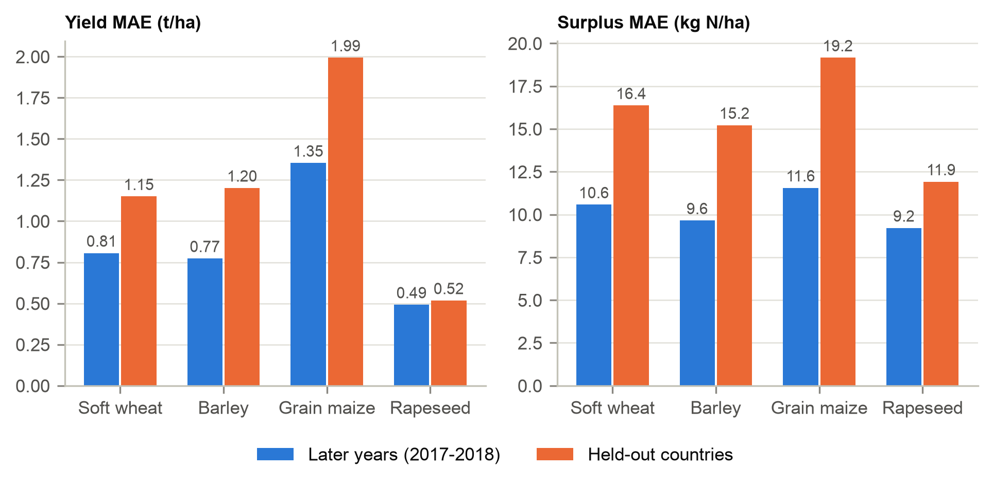
Figure 2. Yield and surplus MAE by crop for the two tests.
Figure 2. Wheat and barley were predicted best on later years (R² 0.75 and 0.69). Maize had the largest absolute error and rapeseed the weakest R², probably because rapeseed yields vary little between regions compared with their year-to-year swings. On held-out countries the R² within each crop ranges from 0.08 for maize to 0.54 for wheat, so the model captures differences between regions well for wheat but poorly for maize.
Table 4. Yield accuracy by crop.
Crop | Later years MAE, t/ha | Later years R² | Held-out MAE, t/ha | Held-out R²
Soft wheat | 0.81 | 0.75 | 1.15 | 0.54
Barley | 0.77 | 0.69 | 1.20 | 0.25
Grain maize | 1.35 | 0.44 | 1.99 | 0.08
Rapeseed | 0.49 | 0.16 | 0.52 | 0.38

4. Budget closure
Reading. The model predicts yield and removal and computes surplus from the budget, so its three outputs cannot disagree. Across all 65,925 test predictions the largest residual was 0.00003 kg N/ha, the size of floating-point rounding. Because the surplus error is measured after this step, training on it also corrects the removal head, so the constraint shapes learning as well as the output.

5. Error analysis
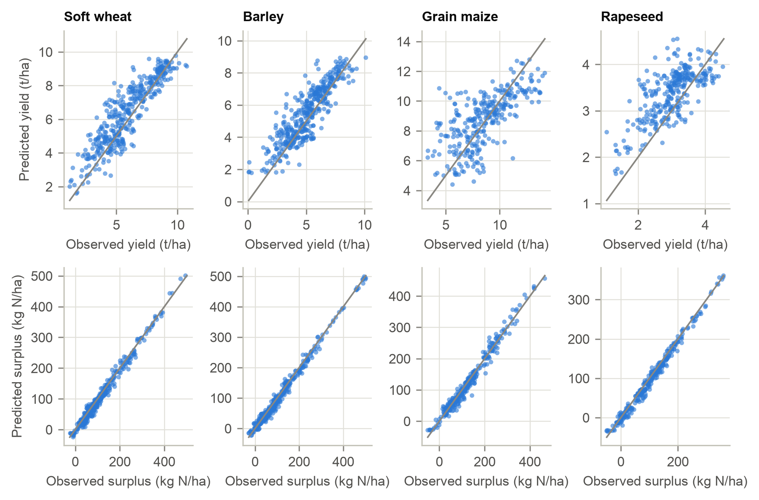
Figure 3. Predicted against observed yield (top) and surplus (bottom) on 2017-2018, by crop. The line is 1:1.
Figure 3. Points scatter evenly around the line for wheat and barley. Maize shows the widest spread, and surplus sits tightly on the line because of the budget algebra.
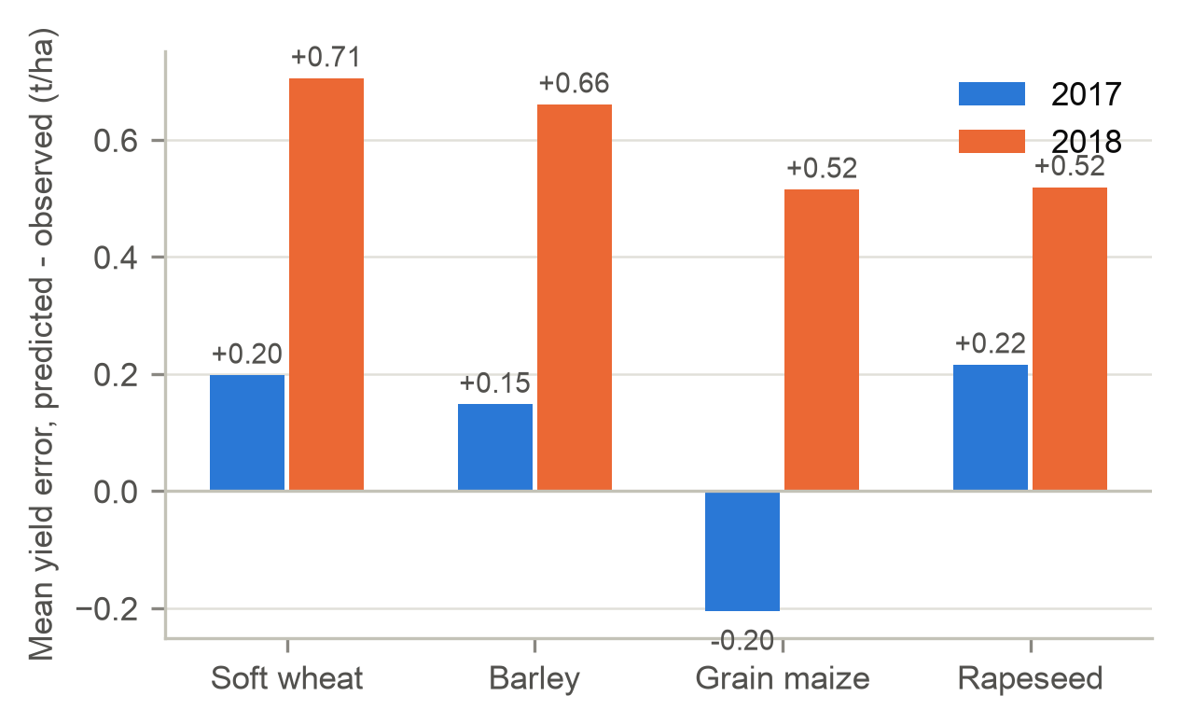
Figure 4. Mean yield error by crop and test year.
Figure 4. The model was close to unbiased in 2017 and over-predicted every crop in 2018. Among countries with at least 20 test rows, the 2018 over-prediction was largest in Sweden, Germany, Poland and Czechia, the area hit by that summer's drought, while Romania, Bulgaria and Hungary were under-predicted after good harvests. Without weather inputs the model cannot see a drought year.
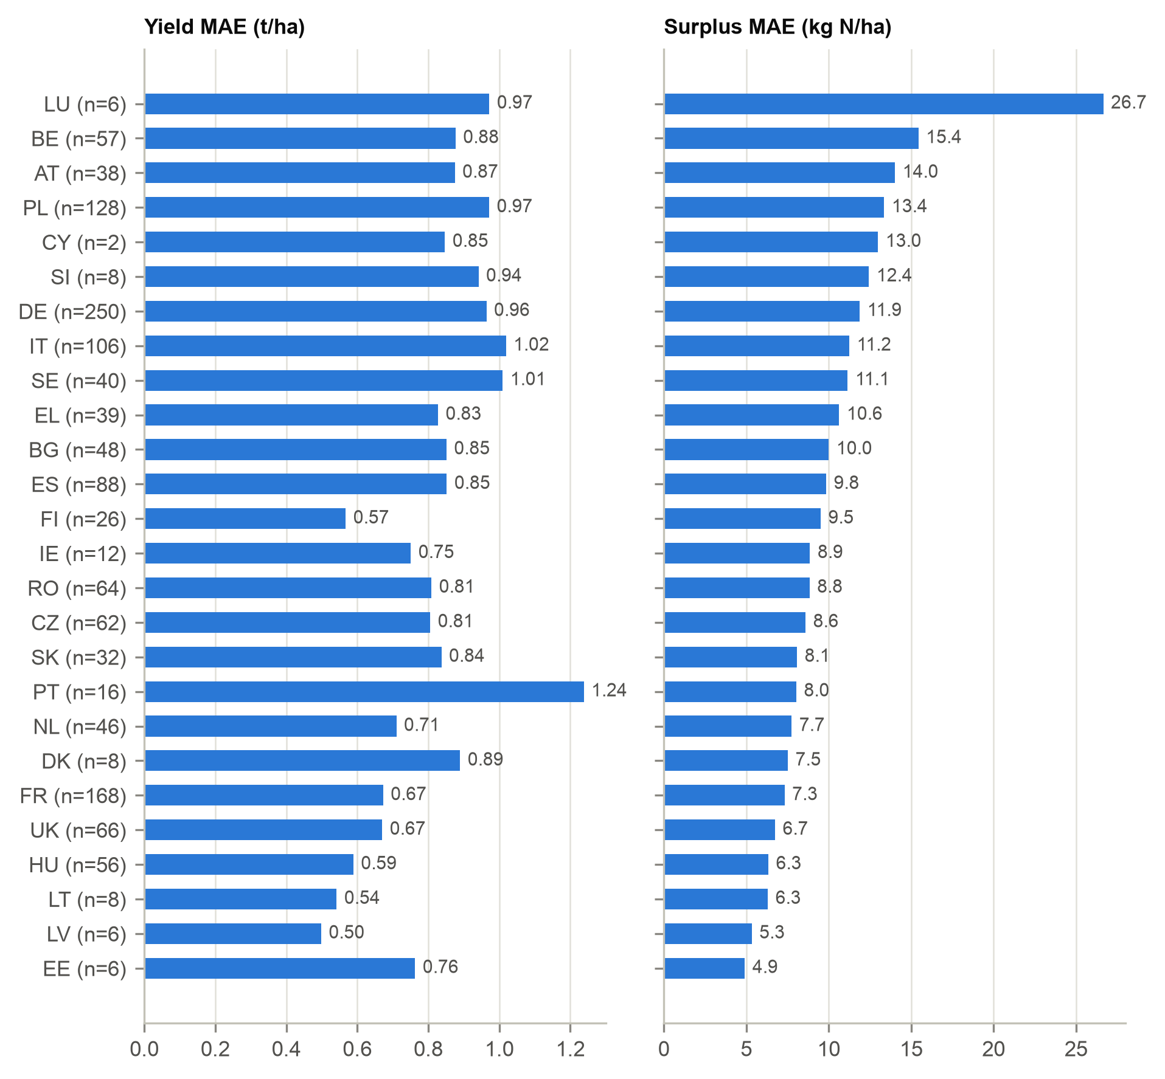
Figure 5. Yield and surplus MAE by country, 2017-2018 (n = test rows). Countries are sorted by surplus error.
Figure 5. The largest surplus error is in Luxembourg, which has only six test rows. Belgium, Austria and Poland follow, and in Belgium HaNi also covers little of CAPRI's mineral N. Cyprus has just two test rows, so its error says little.

6. Hotspot ranking
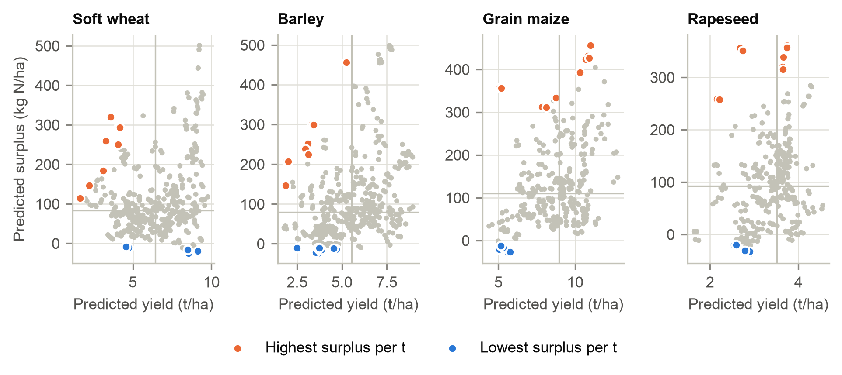
Figure 6. Predicted yield against predicted surplus for each crop-region-year in 2017-2018. Lines mark the crop medians; the 10 highest and 10 lowest surplus-per-tonne cases are highlighted.
Figure 6. The highest surplus per tonne comes from very high inputs relative to yield. The lowest values are negative surpluses (6% of cases), where removal exceeds inputs and soil N is being drawn down. These are not efficient in a sustainable sense.
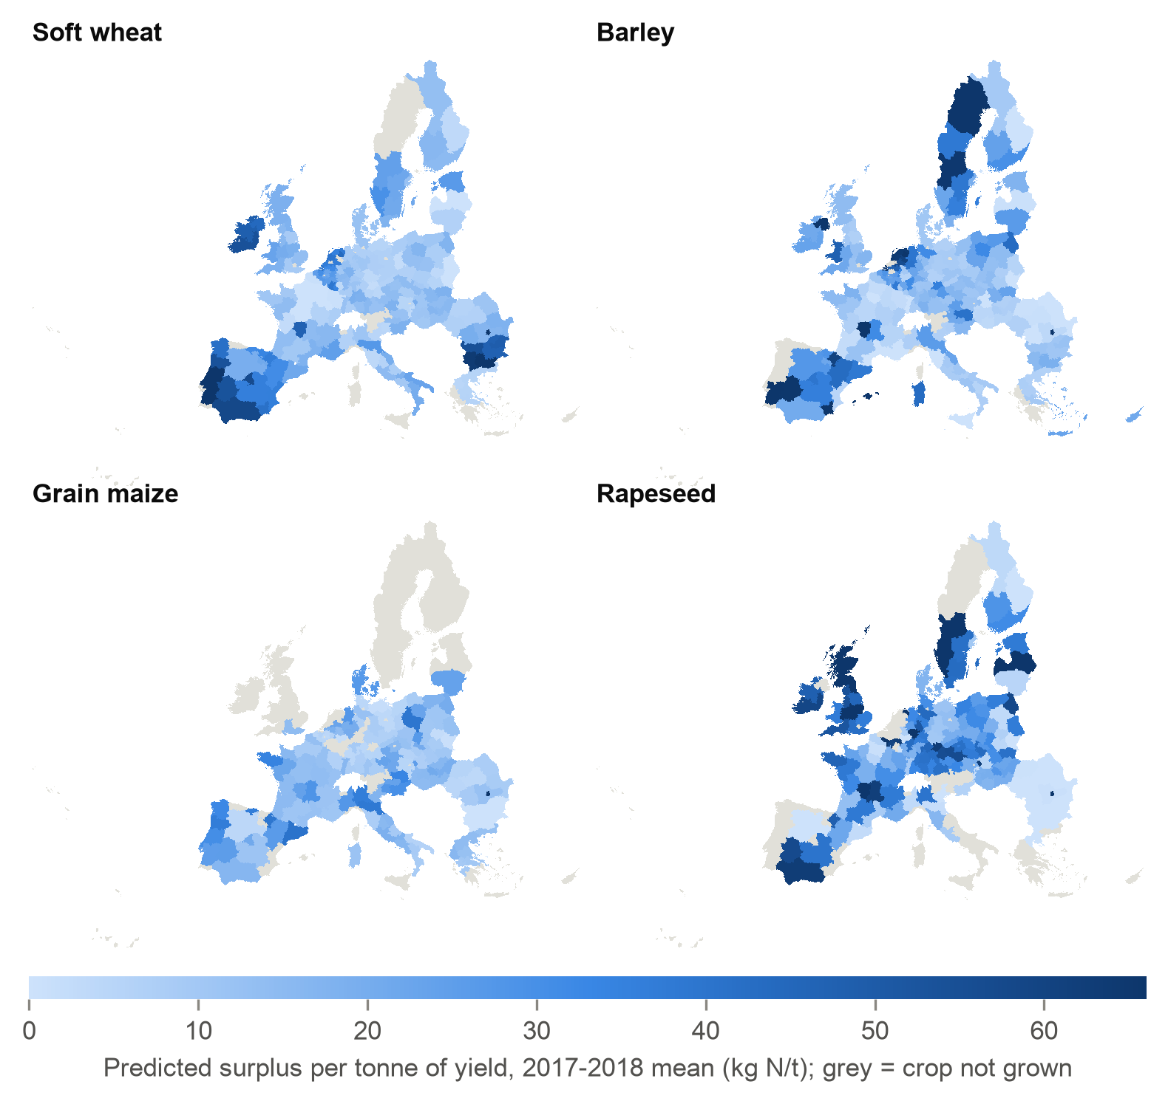
Figure 7. Predicted surplus per tonne of yield by NUTS2 region and crop, mean of 2017 and 2018. Grey regions do not grow the crop at 1,000 ha or more.
Figure 7. Rapeseed in Latvia, Sweden and the United Kingdom, and barley in Spain, stand out. The Latvian rapeseed values are extreme enough to suggest an input artefact and should be checked before any use.
Table 5. The 10 region-crops with the highest predicted surplus per tonne (CAPRI region codes).
Region | Country | Crop | Year | Yield, t/ha | Surplus, kg N/ha | kg N per t
LV00 | Latvia | Rapeseed | 2017 | 2.68 | 356 | 133
SE06 | Sweden | Rapeseed | 2017 | 2.15 | 259 | 120
ES62 | Spain | Barley | 2017 | 1.92 | 208 | 108
UKM0 | United Kingdom | Rapeseed | 2017 | 3.74 | 361 | 96
UKF0 | United Kingdom | Rapeseed | 2017 | 3.65 | 340 | 93
RO08 | Romania | Barley | 2017 | 3.32 | 301 | 90
BG05 | Bulgaria | Soft wheat | 2017 | 3.61 | 320 | 89
UKC0 | United Kingdom | Rapeseed | 2017 | 3.64 | 320 | 88
FR63 | France | Barley | 2017 | 5.24 | 456 | 87
SE08 | Sweden | Barley | 2018 | 3.11 | 252 | 81

Table 6. Region-crops in the high-yield, high-surplus quadrant in both 2017 and 2018, by country.
Country | Region-crops in both years
Germany | 57
United Kingdom | 27
Netherlands | 22
Belgium | 21
France | 19
Italy | 8
Austria | 7
Spain | 7

Reading. The ranking is stable: 88% to 94% of region-crops sit in the same quadrant in both years. The high-yield, high-surplus group is concentrated in Germany, the United Kingdom, the Netherlands, Belgium and France, regions with intensive arable systems and high manure loads. That is where trimming inputs is most likely to cut surplus without large yield losses, a hypothesis that needs field trials.

7. Limitations visible in the results
- The per-crop surplus is constructed from CAPRI and HaNi-Crop, not measured, and CAPRI itself is partly modelled. Accuracy against it shows agreement with these sources, not with field truth.
- Removal equals yield times a fixed grain N content, so yield and removal carry the same information, and surplus R² is inflated by the budget algebra.
- No weather inputs: the 2018 drought is the single largest error source.
- In countries not seen in training, the model separates regions within a crop only moderately (R² from 0.08 for maize to 0.54 for wheat), and on later years it is slightly less accurate than reusing a region's own past average yield (0.85 against 0.76 t/ha).
- Deposition is a 2006-2010 average repeated for every year, so it cannot explain change over time.
- Countries with few test rows (Luxembourg, Cyprus) have unstable error estimates.
- HaNi-Crop lacks grassland and several crop groups, and it is still under peer review (used with the authors' permission).

