IBMHR Attrition Analysis Project Report

1. Introduction
Employee attrition is a critical challenge for organizations as it leads to increased hiring costs, loss of talent, and reduced productivity.
This project analyzes employee data to identify key factors contributing to attrition and provide actionable insights.

2. Objectives
Calculate overall attrition rate
Identify key drivers of attrition
Analyze attrition across department, salary, job satisfaction,
Provide data-driven recommendations

3. Tools & Technologies Used
Python (Pandas, NumPy, Matplotlib, Seaborn)
SQL (MySQL / SQL Server)
Power BI (Dashboard & Visualization)

4. Dataset Collection
Dataset Source : Kaggle.com

5. Data Analysis in Python
Step 1: importing libraries and load dataset
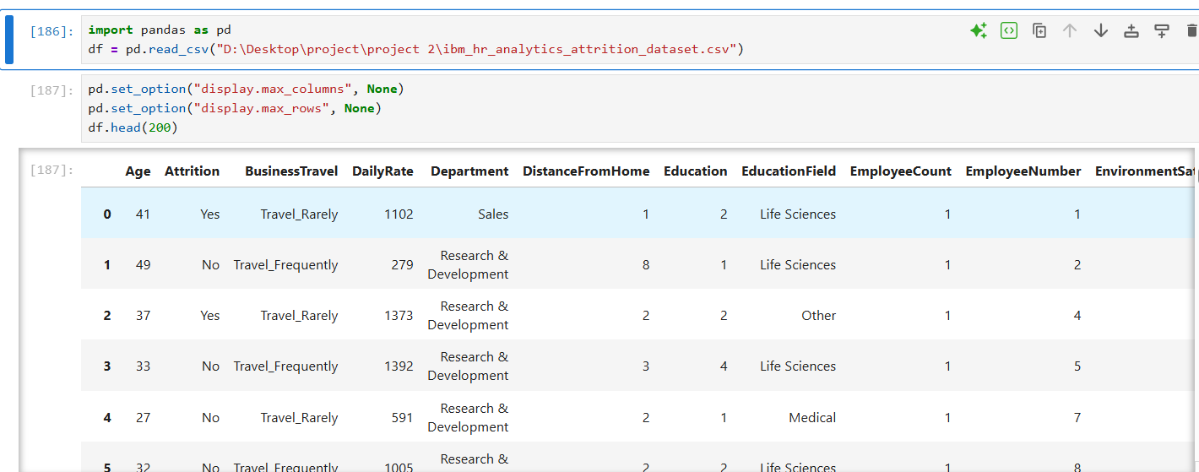
Step 2 : Understanding Data
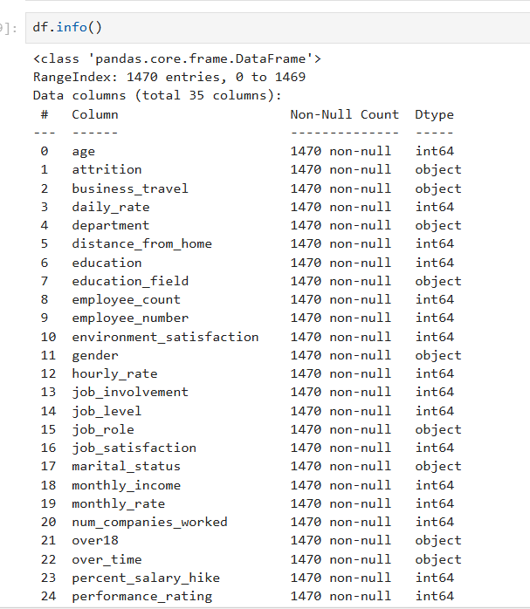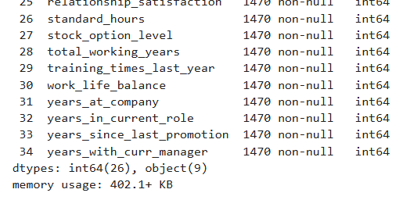
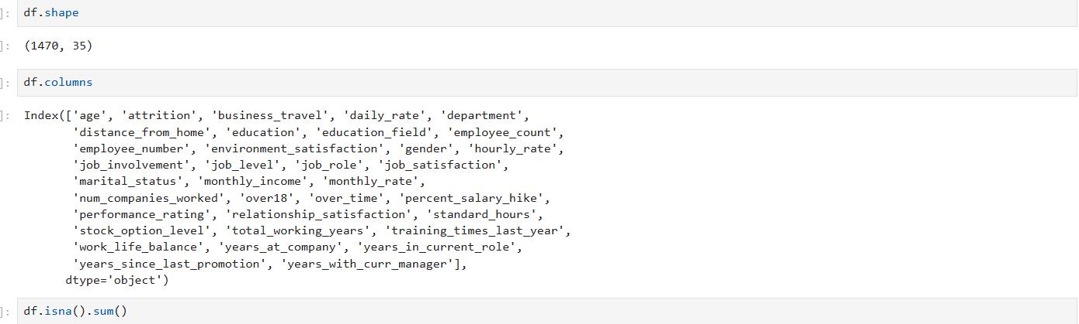

Step 3: Standardizing text columns
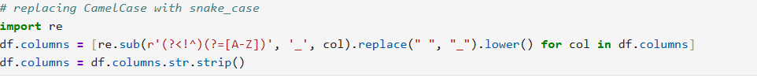
Step 4: Data cleaning
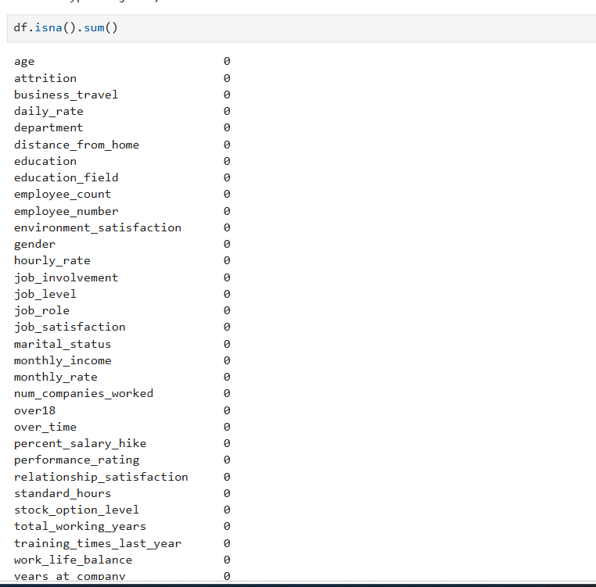
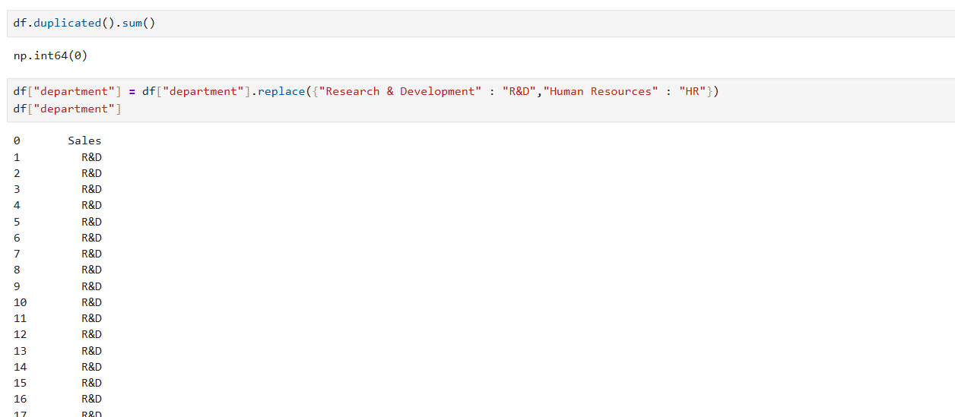

6. Exploratory Data Analysis (Python)
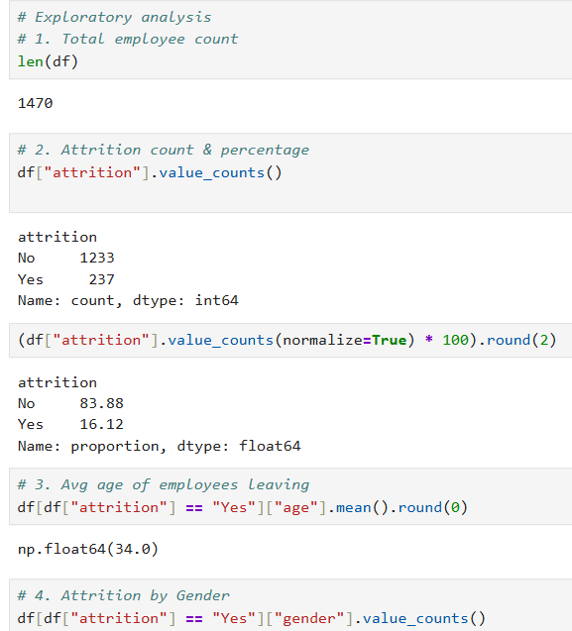
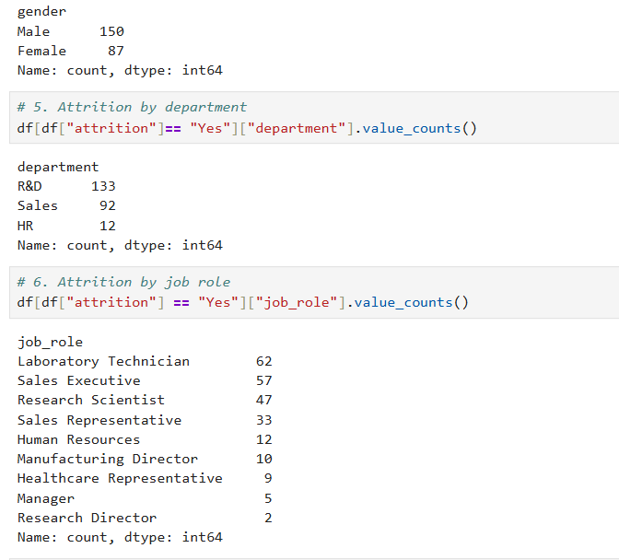
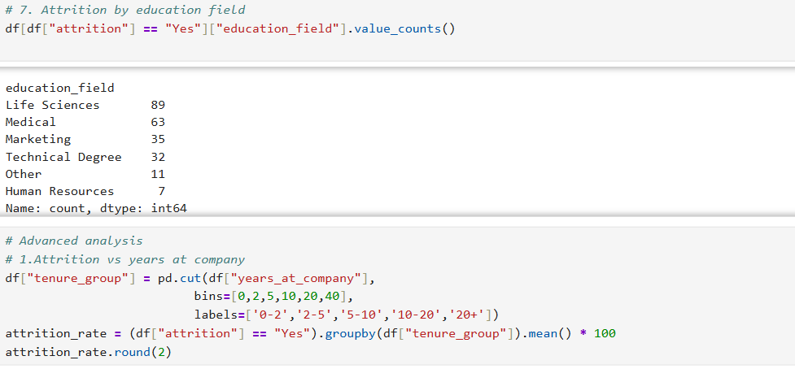

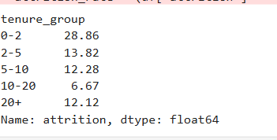
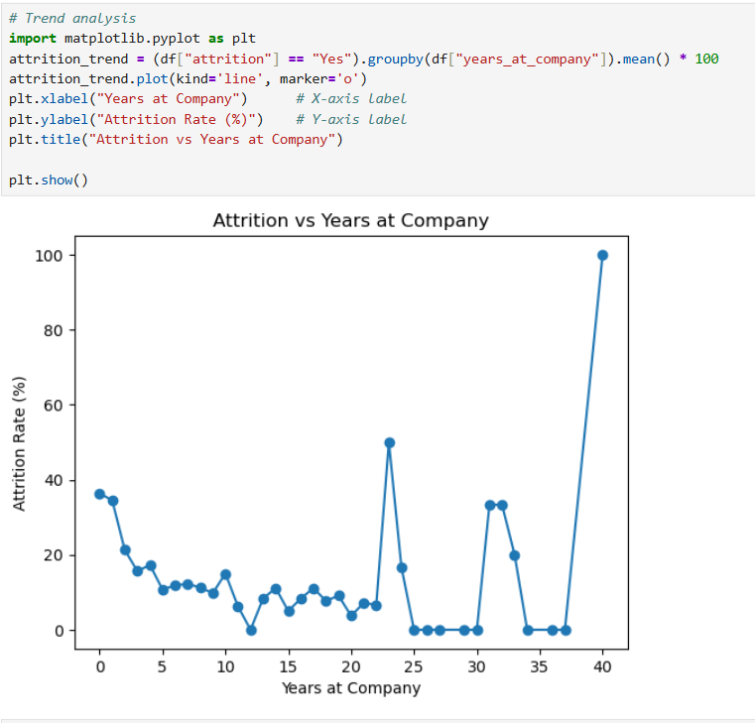
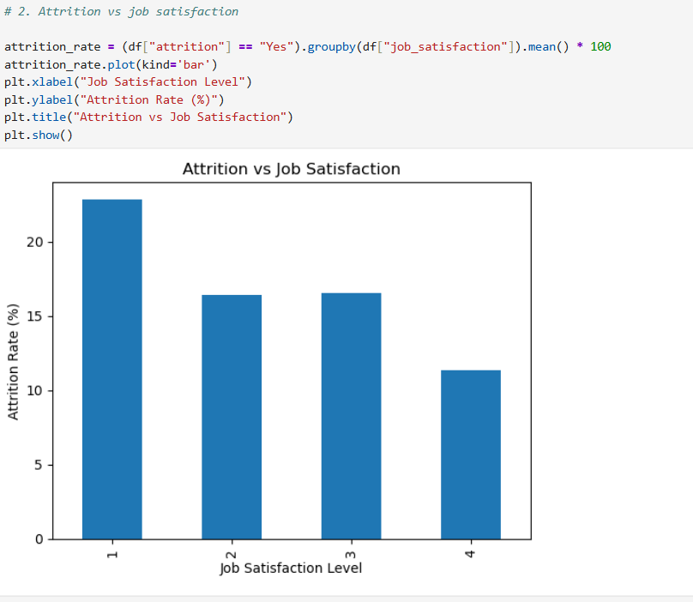
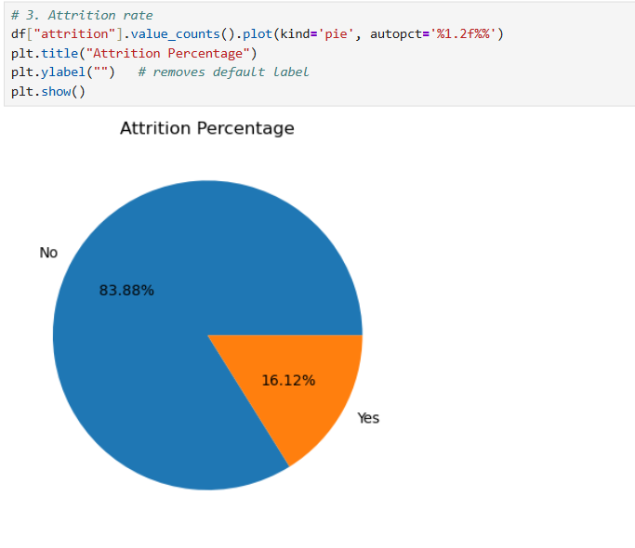
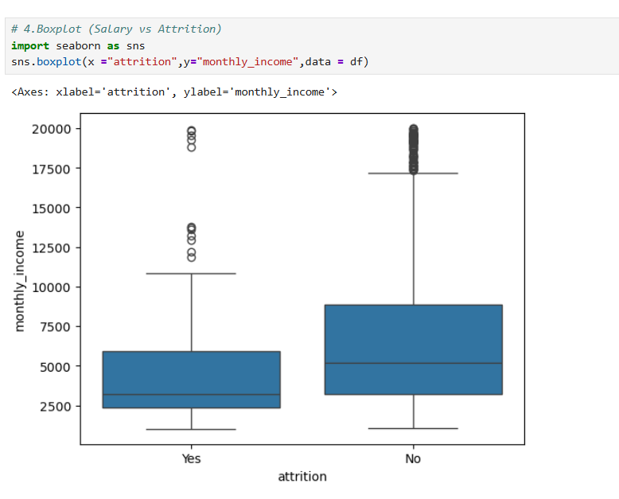
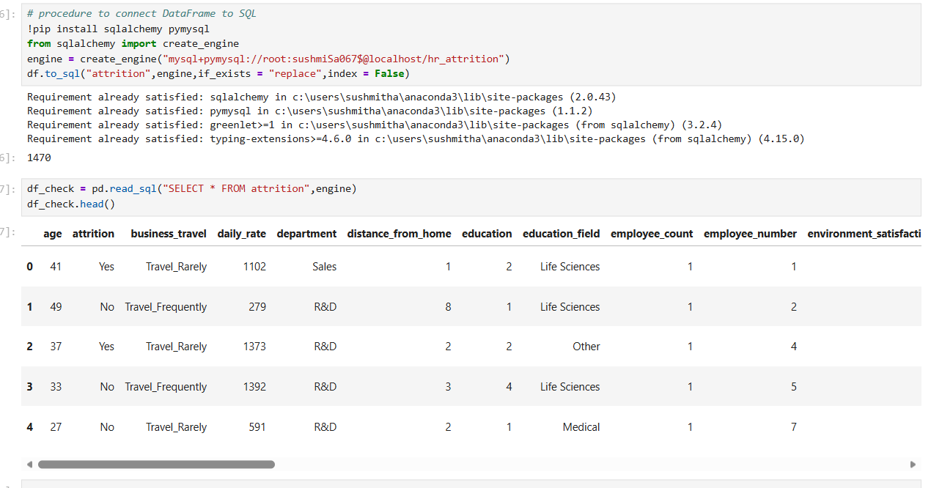

7. SQL Analysis
Step 1: Connected data from jupyter notebook
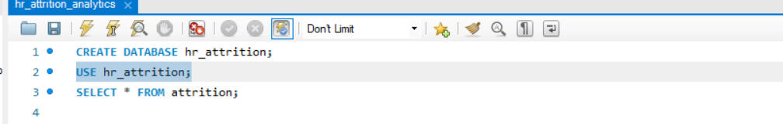
Step 2: Basic queries
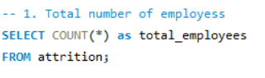
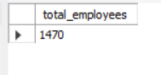
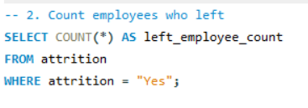
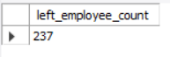
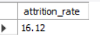
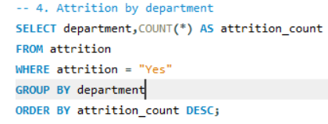

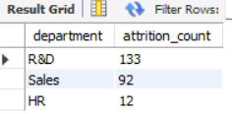
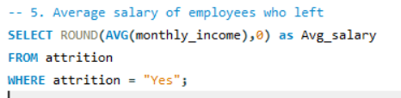
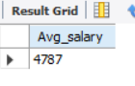
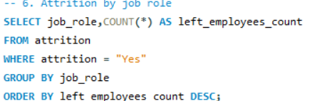
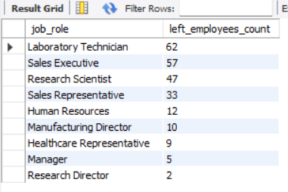

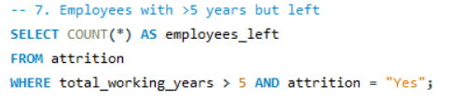
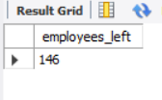
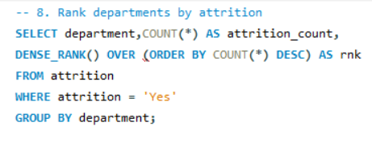
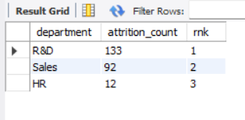
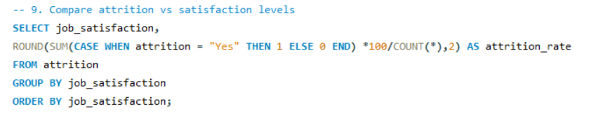
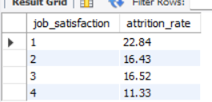

8. Power BI Dashboard
Step 1: Get data from SQL database and load it
Step 2: Created salary bucket column
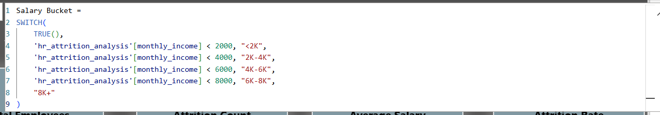
Step 3: Created measures for KPI’s
Step 3: Create dashboard with KPI’s and charts
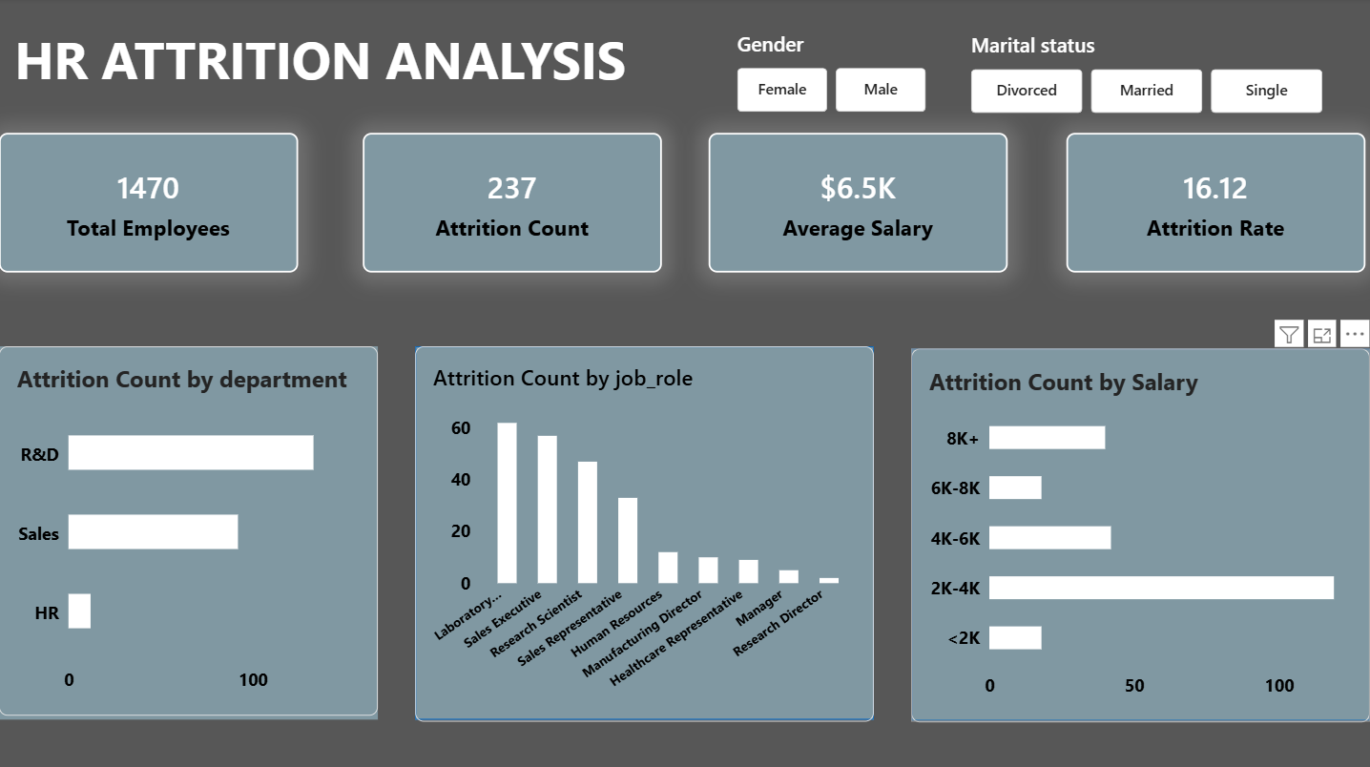

9. Key Insights
Low salary & low satisfaction → high attrition
Early tenure employees more likely to leave
Certain roles have higher attrition

10. Recommendations
Improve compensation
Enhance job satisfaction programs
Focus on early employee retention
Provide career growth

11. Conclusion
The project identifies key attrition drivers using Python, SQL, and Power BI.
Provides actionable business insights.

12. Future Scope
Build predictive model
Automate dashboards
Use real-time HR data

