Customer Shopping Behavior Analysis Project Report

1. Introduction

Customer shopping behavior analysis helps businesses understand how customers purchase products, what influences their buying decisions, and how to improve sales strategies.

In this project, we analyze customer transaction data to identify patterns, trends, and key factors affecting purchasing behavior using Python, SQL, and Power BI.

2. Objectives
• Analyse customer purchasing patterns
• Identify high-value customers
• Understand product preferences
• Improve sales and marketing strategies

• Build an interactive dashboard

3. Tools & Technologies Used
Python (Pandas, NumPy)
SQL (MySQL)
Power BI

4. Dataset collected
Dataset collected through Kaggle.com

5. Data Preprocessing (Python)
Step 1: import libraries and load the dataset
Step 2: Understand the dataset
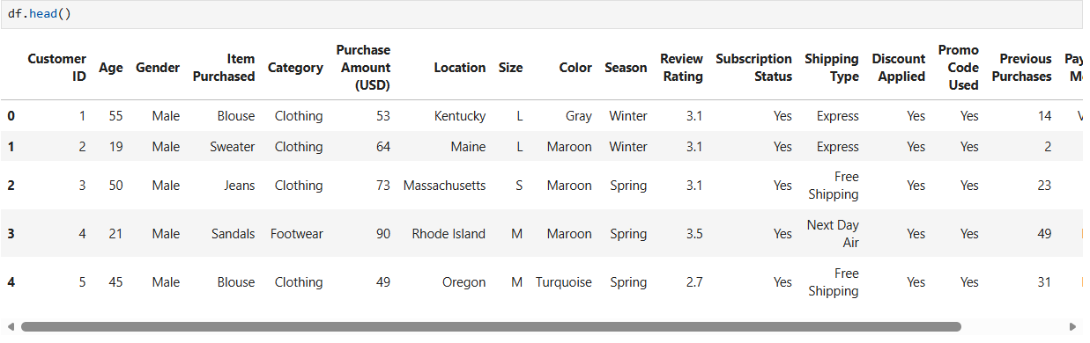
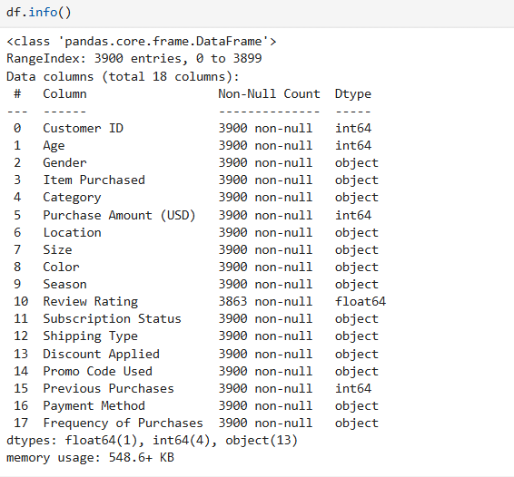
Step 3: Data cleaning
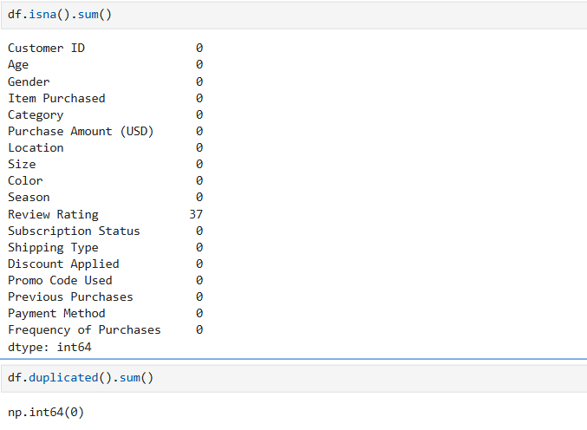
1: Replacing null values of Review Rating with median values
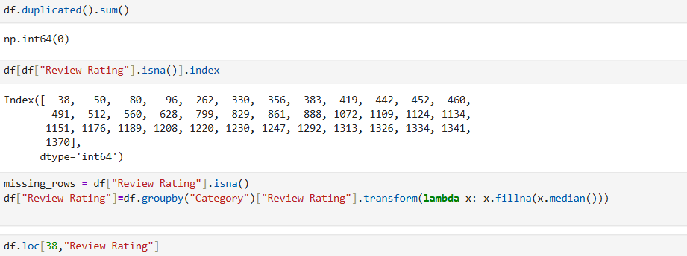
2: Standardize the column headers
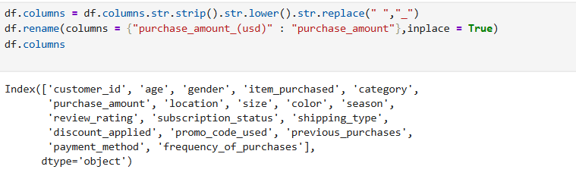
3. Feature Engineering
Create new columns like:
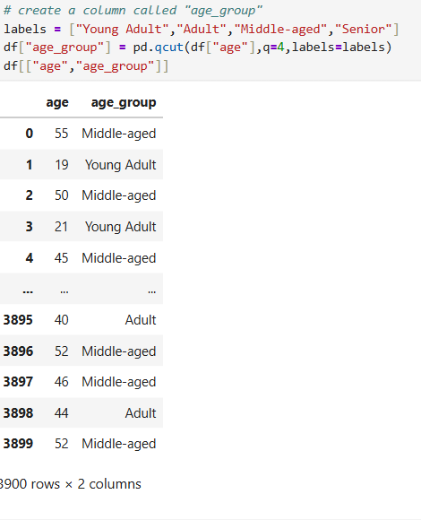
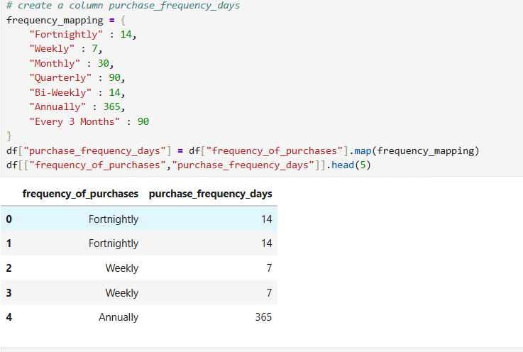
4. Dropping column that are same
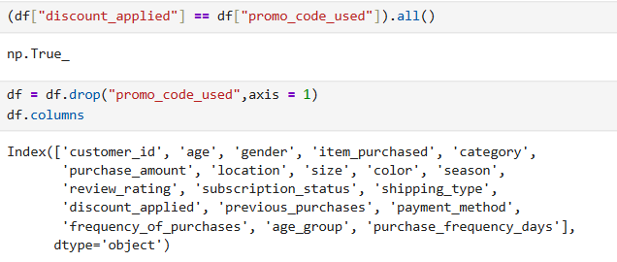

6. Exploratory Data Analysis (Python)
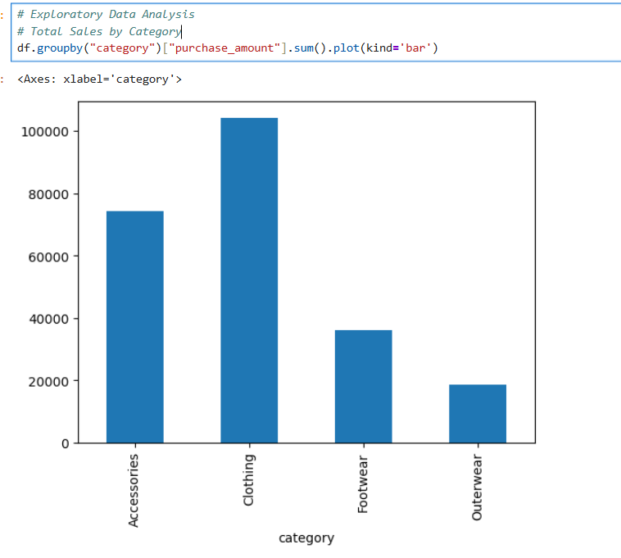
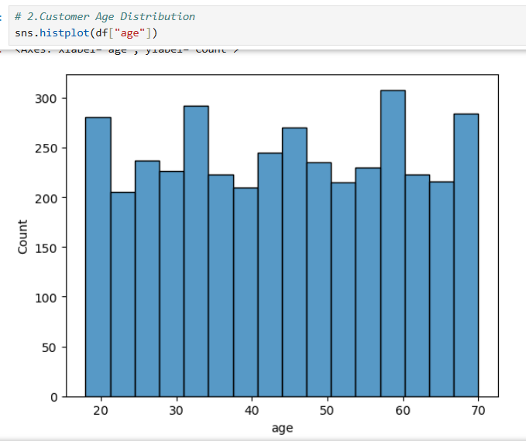
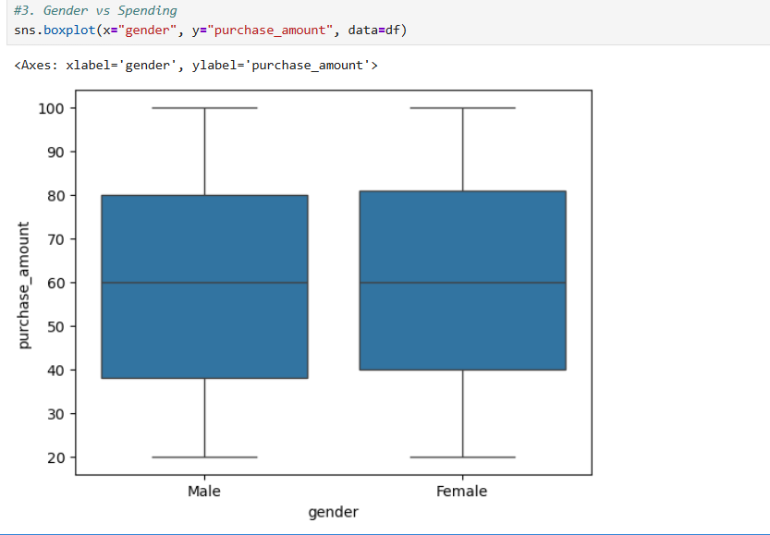

7. SQL Analysis
Step 1: connect jupyter to SQL
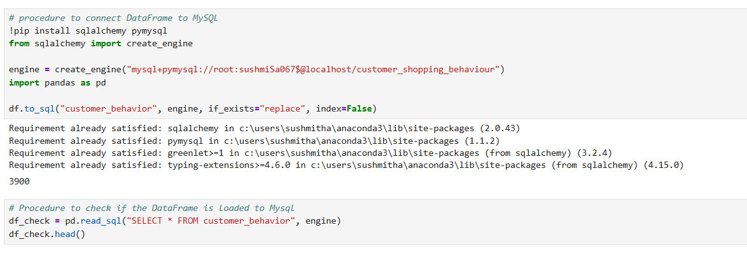
Step 2: Basic queries
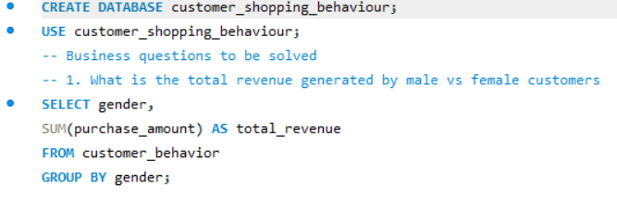
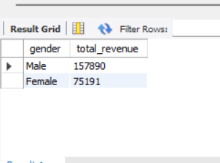

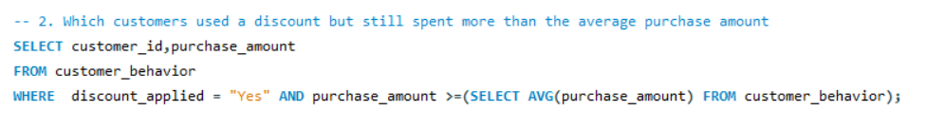
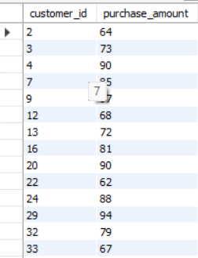

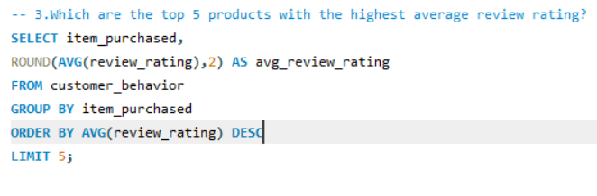
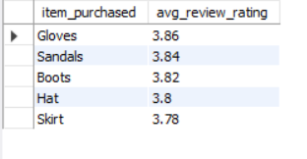
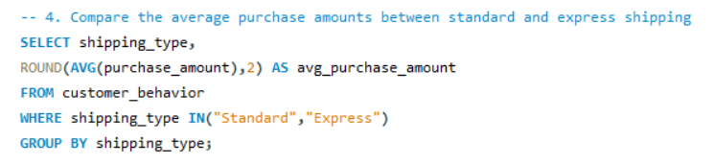
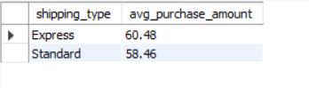
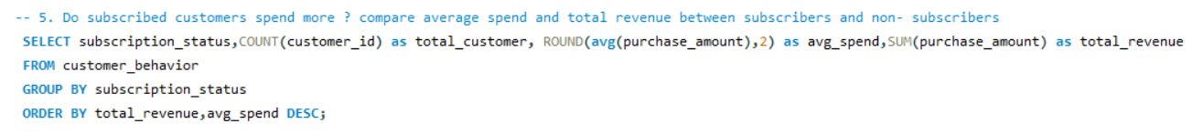
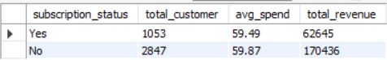
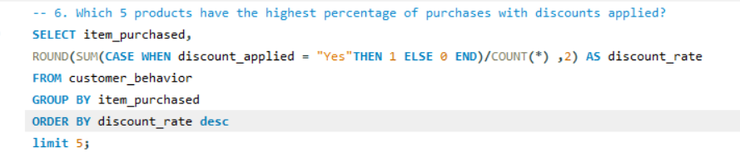
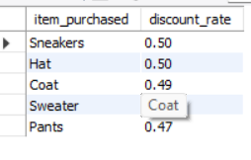
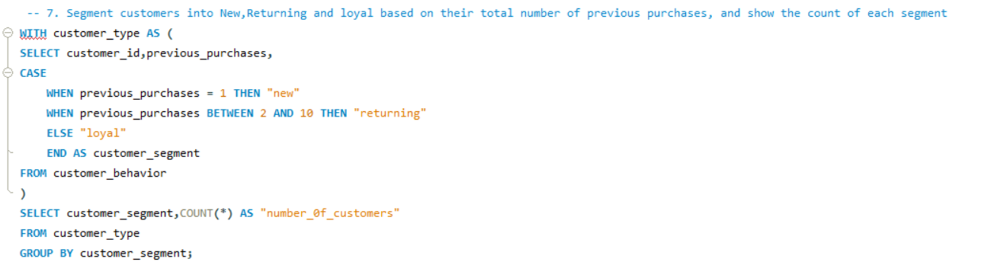
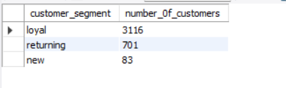
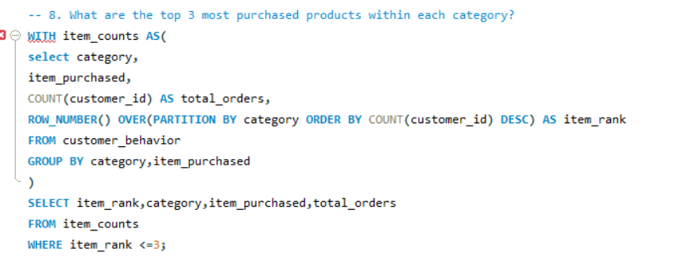
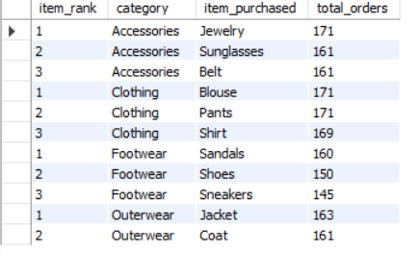
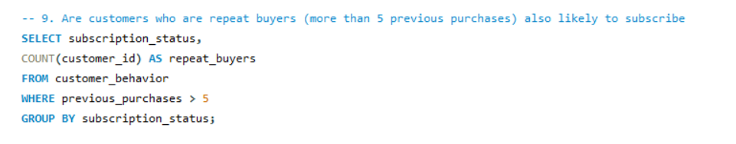

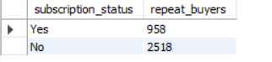
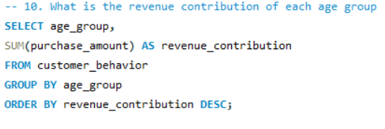
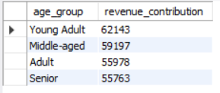

8. Power BI Dashboard
Step 1: Load data from SQL database
Step 2: Create Measures (DAX)
- average_purchase_amount = AVERAGE(customer_shopping_behavior[purchase_amount])
- average_review_rating = AVERAGE(customer_shopping_behavior[review_rating])
- number_of_customers = COUNT(customer_shopping_behavior[customer_id])
Step 3: Create Visuals
- KPI Cards → No. of customers, Average purchase amount, average review rating
- Bar Chart → Category-wise - revenue, category-wise-sales
- Pie Chart → % of customers by subscription status
- Slicers → Category, Gender, shipping type, subscription status

9. Key Insights
• Clothing category generates the highest revenue
• Also clothing category contributes most of the sales
• Seasonal trends affect purchasing behavior
•Male customers bring in more revenue
• Age influence spending patterns
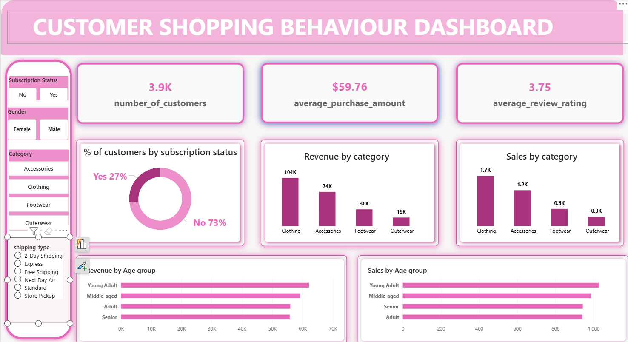

10. Recommendations
Target high-value customers
Promote top products
Introduce loyalty programs

11. Conclusion
This project demonstrates how businesses can use data analytics to understand customer behavior, optimize product offerings, and improve decision-making.

12. Future Scope
Build ML models for recommendations
Use real-time data integration

