**Git Hub Location :** https://github.com/ssvb200911/Lloyds-java-test-srinivas.git

**Testing from my local environment**

1. Valid file format

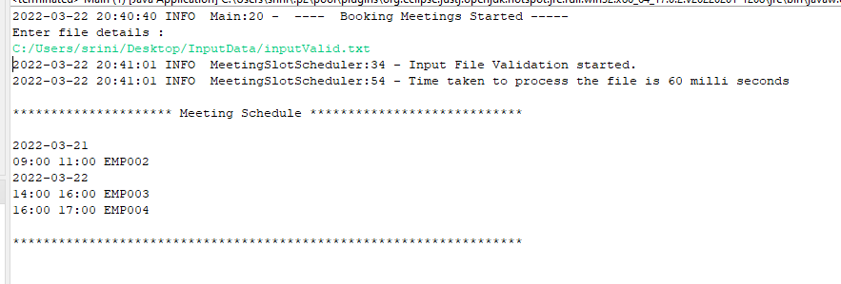

1. **User enter invalid file format**

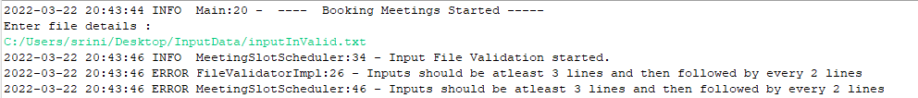

1. User enter invalid file format

1. **User enter invalid file format**

