**Git Hub Location :** [**https://github.com/ssvb200911/fileProcessor/tree/main/filemanagement**](https://github.com/ssvb200911/fileProcessor/tree/main/filemanagement)

**Below are list of technologies/tools used to develop the project**

* Java 8
* java.nio (For file operations, watch event for file monitoring on folder)
* java 8 WatchService (watching for changes events on folders & files)
* java.util. logging
* Apache Pdfbox (To read pdf files)

**Crated maven project with below project folder structure.**

**Testing from my local environment**

As per the current implementation .txt , .pdf file formats are valid

Other file formats will be considered as invalid

Below are 3 are the input parameters to the main file (i.e. FileWatcher.java)

* **Source folder path**: user has to upload files to process
* **Destination folder path**: Files to be copied the destination after successful processing
* **Error folder path**: Invalid file formats uploaded by user, will be copied to the error folder

**FileWatcher.java is the main file which accepts below input parameters from java scanner api**

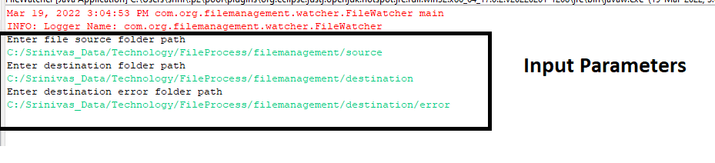

**Copied below input files to the source folder (i.e. Input parameter 1)**

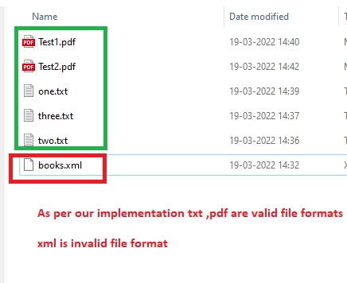

**After processing files above files, copied to destination folder (i.e. Input Paramter2)**

**Below is the content of Test1.pdf with special characters**

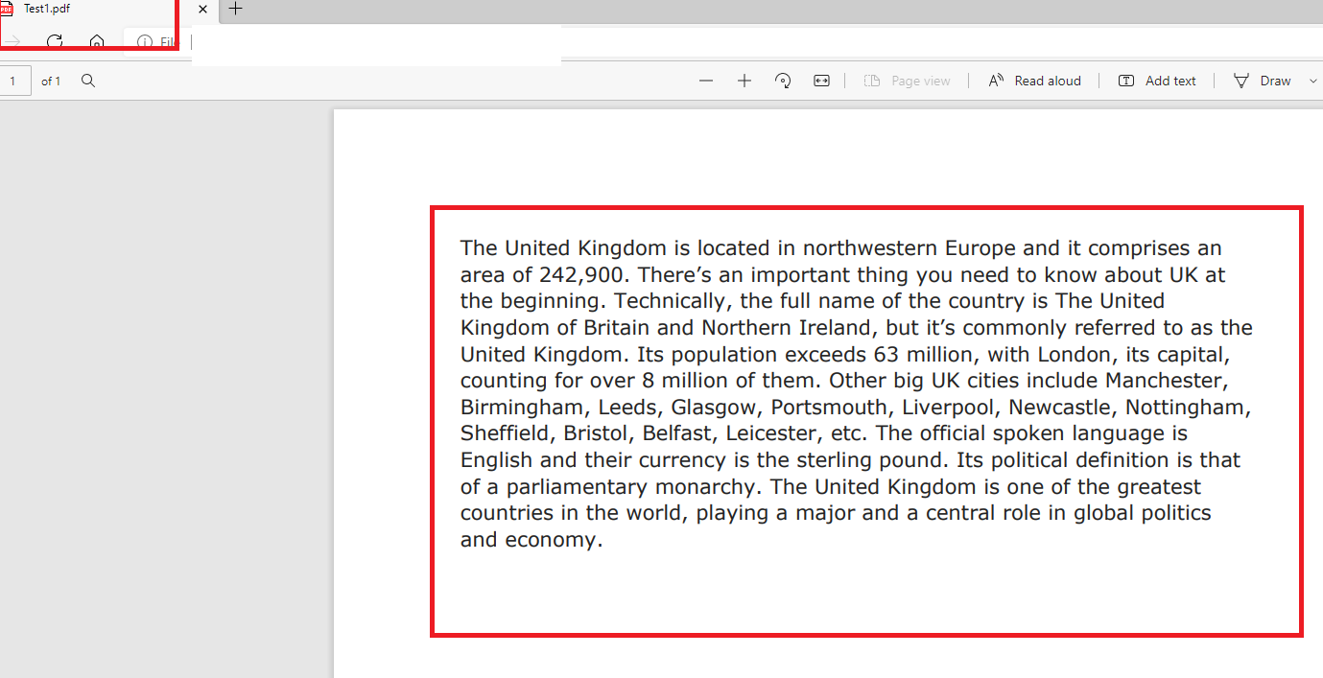

**Below is the content of two.txt with special characters**

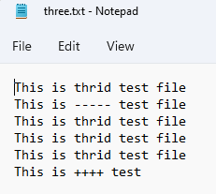

**Invalid file are copied to error folder ( i.e. Input parameter3 )**

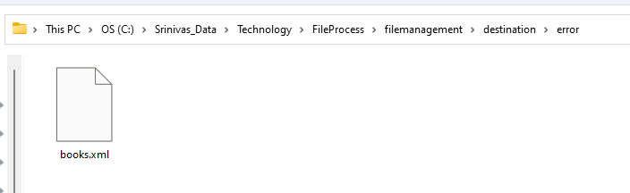

**Below is the summary of the files processed along with no of words, special character details are printed in the eclipse console**

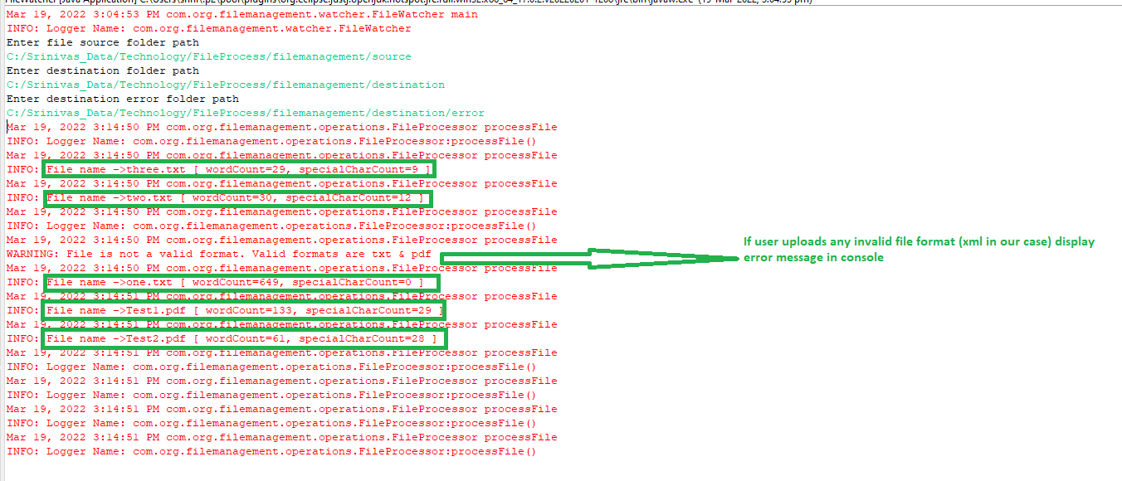

Again, user copy another two files (i.e. four.txt, five.txt ) to the source folder, immediately files will be processed and copied the respective folders.

