List of technologies, tools being used to develop the project

* React 16.9
* Bootstrap 4.3.1
* Reach Router
* cogo-toast ( notifications)
* Visual Studio

**Below is project folder structure.**

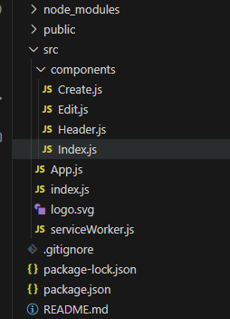

Products home page

**Adding new product** by clikcing on Add Product button

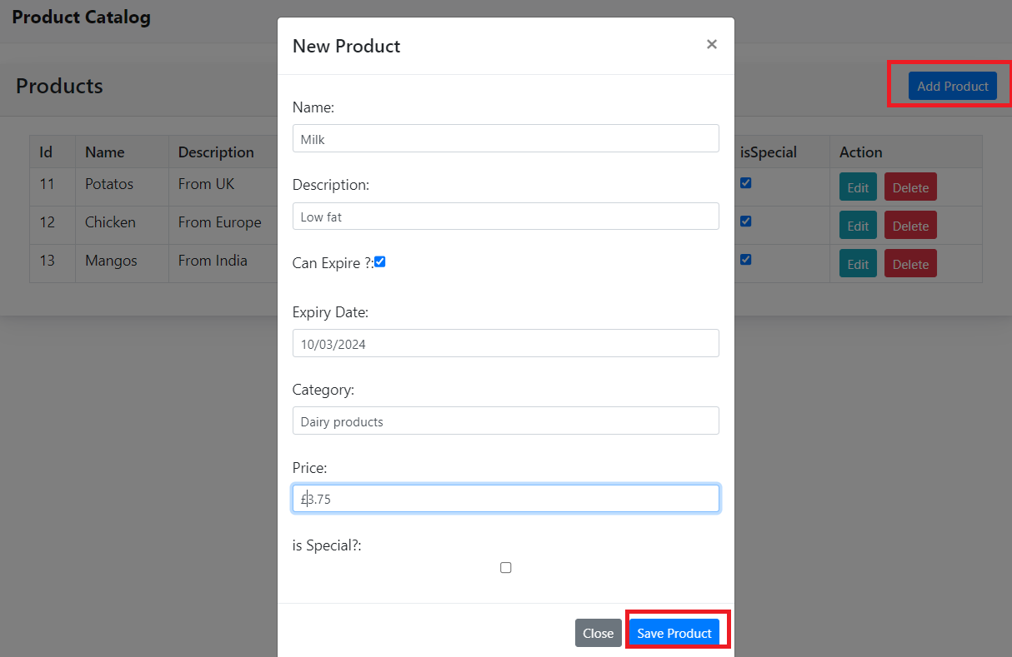

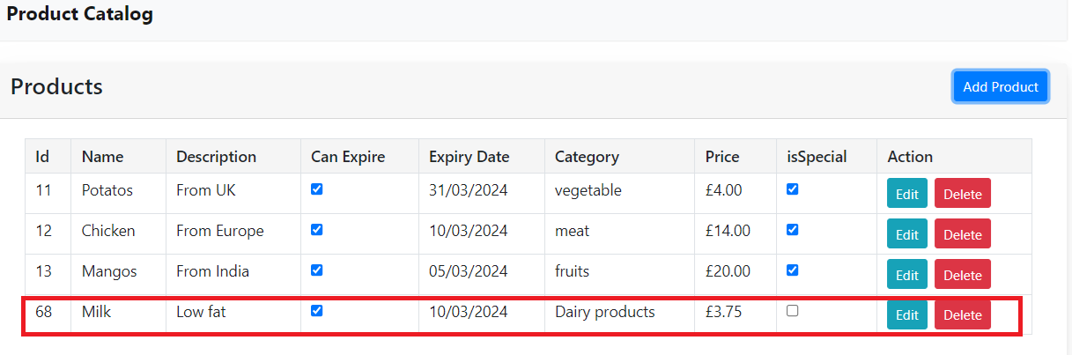

**Edit Product**

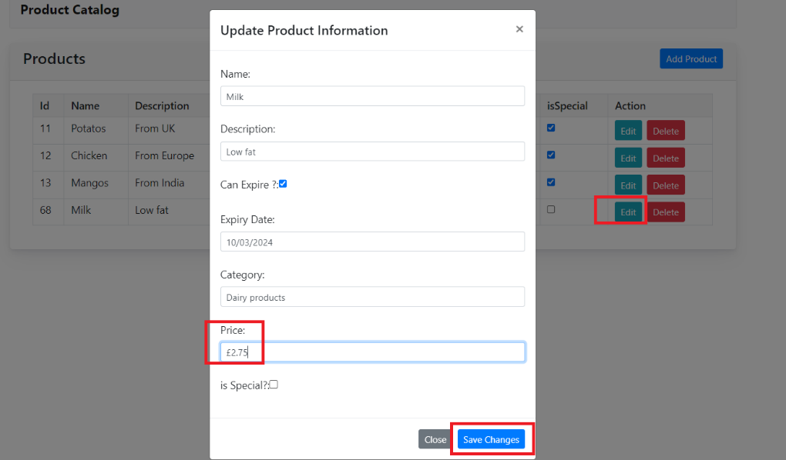

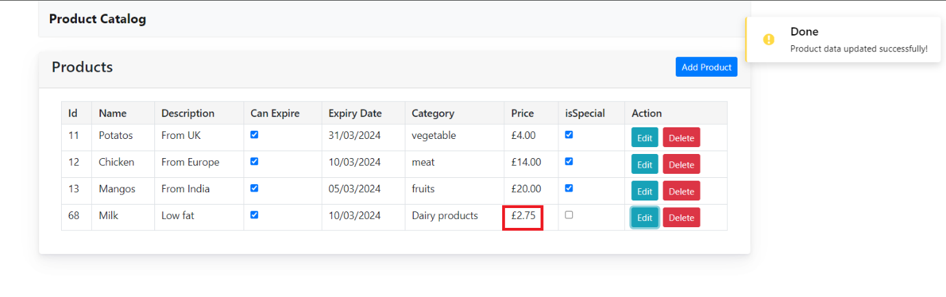

**Delete Product**



