List of technologies, tools being used to develop the project

* Jdk1.8
* Spring BOOT 2.5.3
* SpringDataJPA
* MySql 8.0.29
* H2database 2.1.214 [ JUnit’s]
* Apache Maven 3.0.4
* Apache Tomcat 9.0.50
* Spring Tool Suite 4.13[STS]

**Below is project folder structure. It follows 3 tier architecture.**

Below is the location of JUNIT classes

POSTMAN request

|  |  |  |  |
| --- | --- | --- | --- |
| **Request** | **Type** | **Request URL** | **Request body** |
| Creating New retrospective | POST | http://localhost:8080/retrospective/create | {  "name" : "Retrospective 1",  "summary": "Post release retrospective",  "participants": "Viktor,Gareth,Mike"  } |

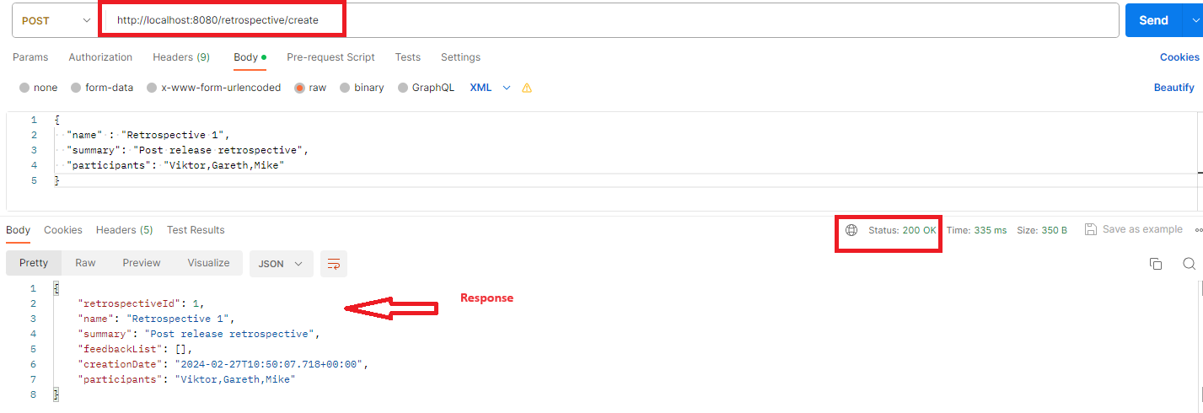

|  |  |  |  |
| --- | --- | --- | --- |
| **Request** | **Type** | **Request URL** | **Request body** |
| **Add Feedback Items to Retrospective** | POST | [http://localhost:8080/feedback/add/{retrospectiveId}](http://localhost:8080/feedback/add/%7bretrospectiveId%7d)  Input : retrospectiveId | {  "name" : "Retrospective 1",  "summary": "Post release retrospective",  "participants": "Viktor,Gareth,Mike"  } |

Adding one feed back at time for above newly created spring by each participant

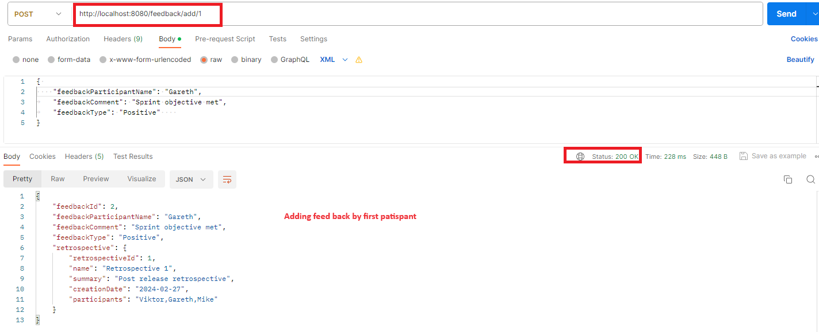

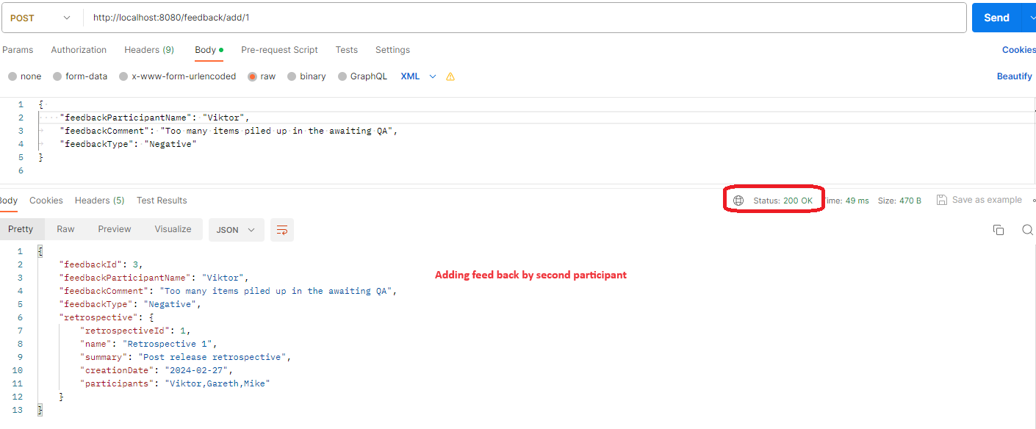

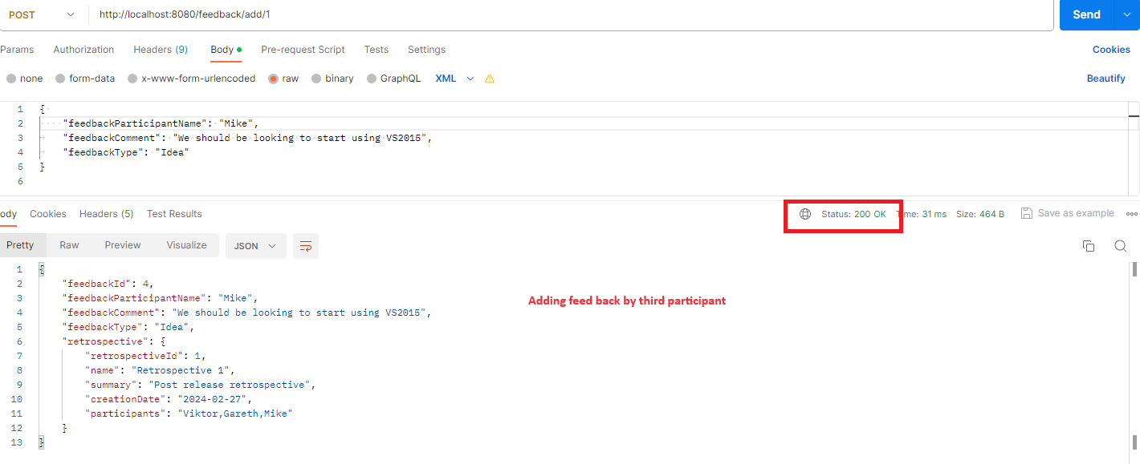

|  |  |  |  |
| --- | --- | --- | --- |
| Request | Type | Request URL | Request body |
| **Update Feedback Items** | PUT | http://localhost:8080/feedback/update/{feedbackId}  Input param : feedbackId | {      "feedbackParticipantName": "Gareth",      "feedbackComment": "Sprint objective met  on JIRA8234,JIRA 9342",      "feedbackType": "Positive"  } |

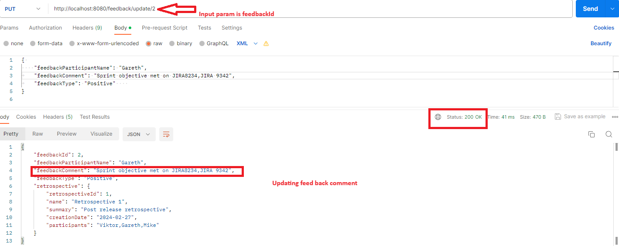

|  |  |  |  |
| --- | --- | --- | --- |
| **Request** | **Type** | **Request URL** |  |
| **Search based on page size** | GET | [http://localhost:8080/retrospective/pageandsize?page={currentPage}&size=](http://localhost:8080/retrospective/pageandsize?page=%7bcurrentPage%7d&size=){pageSize}  Input : current page  pageSize |  |

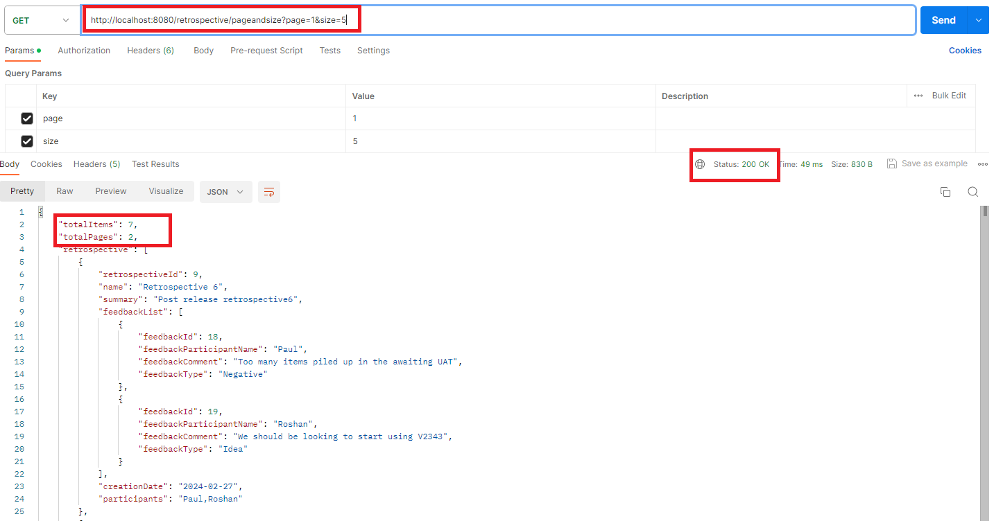

|  |  |  |
| --- | --- | --- |
| **Request** | **Type** | **Request URL** |
| **Search based on date** | GET | http://localhost:8080/retrospective/byDate?creationDate={ retrospectiveDate }  Input : retrospectiveDate |

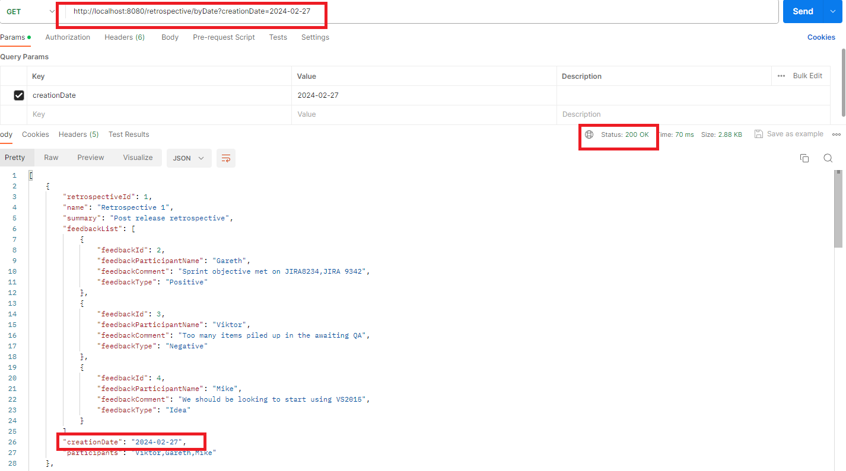

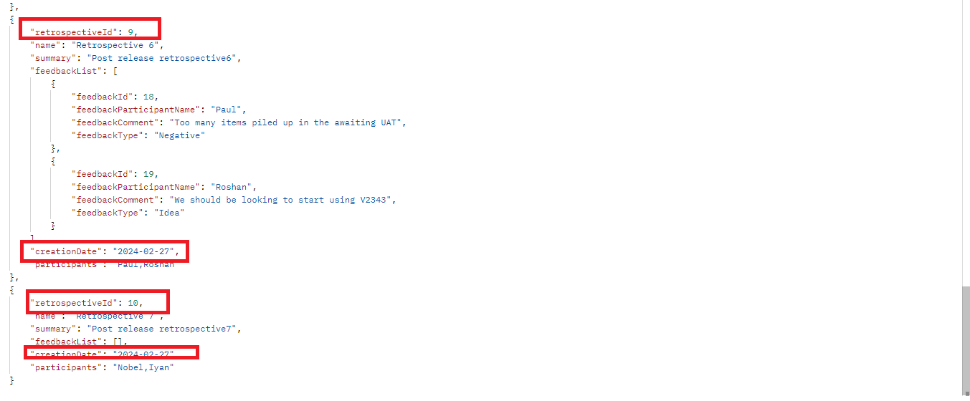

JUnits

