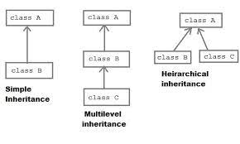

Single Inheritance:

* Bases on aren’t class and child class.Child class is derived from parent class

Syntax: public class B extends A{}

MultiLevel Inheritance:

Based on Parent class,Child class,GrandParent Class. Parent class is derived from GrandParent Class. Child class is derived from parent class.

Syntax: public class B extends A{}

public class C extends B{}

Multiple Inheritance:

Class C has the property of both Class A and B

Syntax: public class C extends B,A{}