**Set Up Multi site Manager and Live Copies**

**Use Case:**

Create a content and cater the same to multiple pages.

Prerequisite setup should be done, up and running.

On the successful login of AEM screen ([AEM Sites](http://localhost:4502/sites.html/content) ), we should go to Navigation>Sites. In this V retail screen, there you will find a create button here choose this site key.

Here there are several websites for USA, Canada, Switzerland and Italy and all countries have different languages pages.

**Steps followed:**

Language Master is a blueprint using this we can create other websites.

language Master have many languages sites like English, Dutch and Italian .

Let's create a new website for India and we can assign two languages English and Hindi.

**Creating a new site for Weretail**

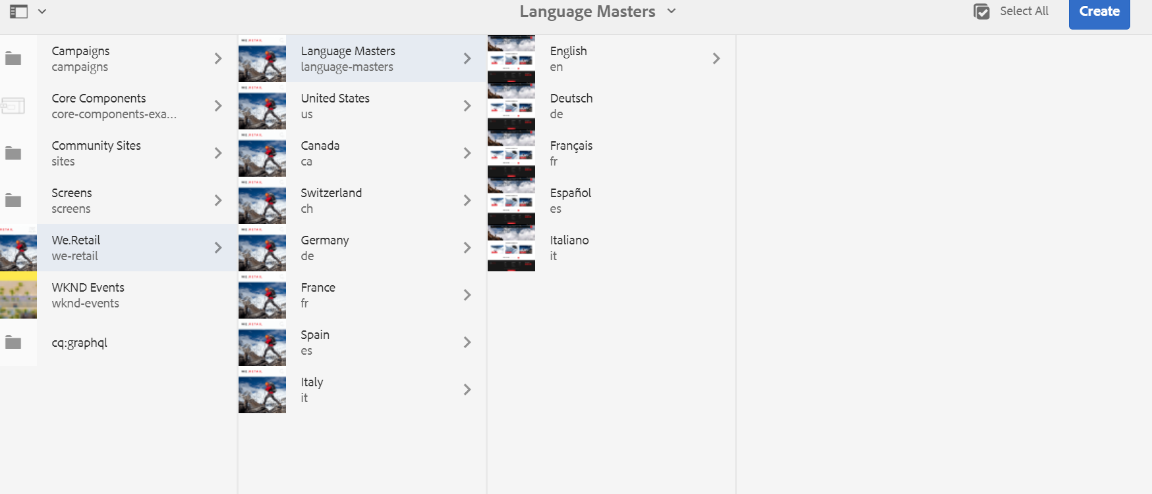

If the above page India was not there in the list as highlighted in Amber box

Which is now available in following screenshot.

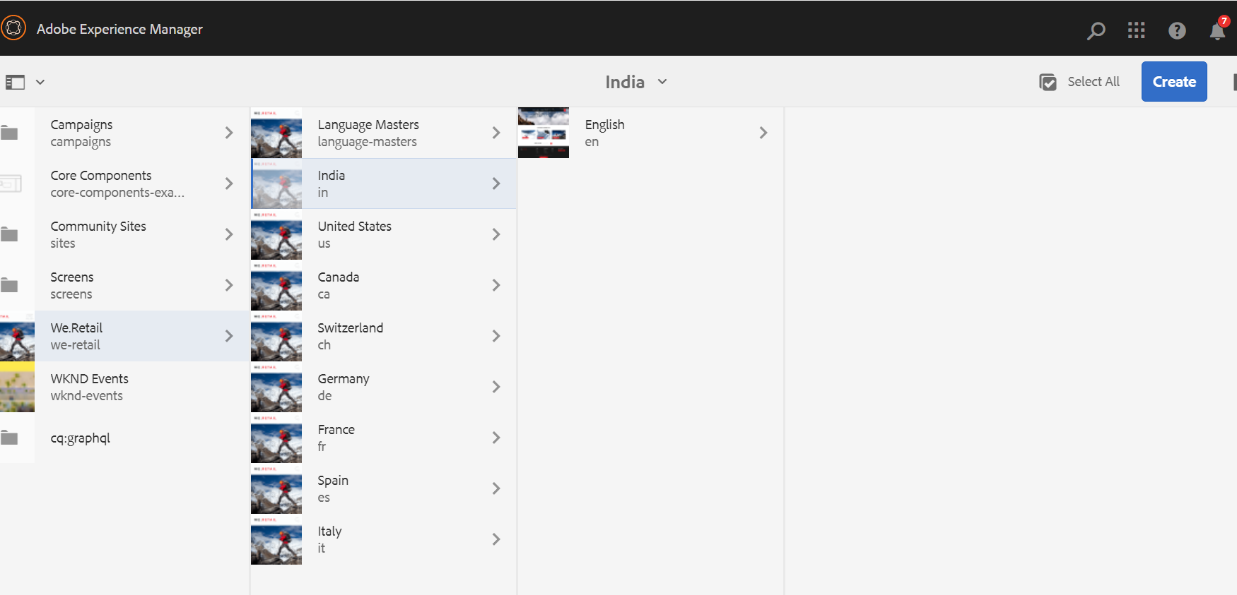

**Create language Copy for Hindi**

We can create one more language copy Hindi under language-master blueprint.

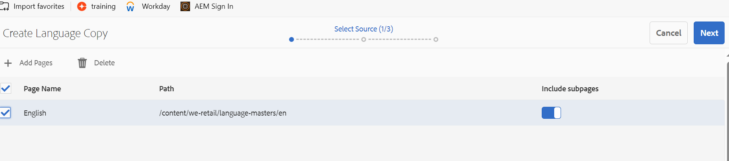

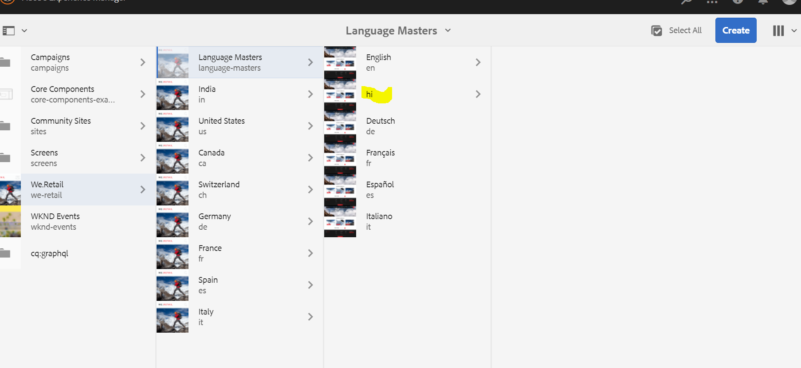

**Create Live copy**

we can assign this Hindi language in India site as a live copy.

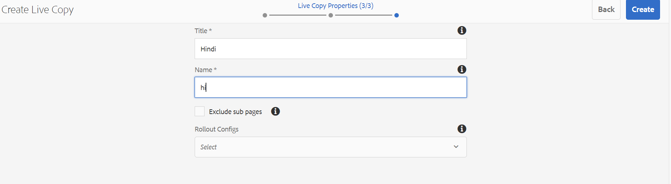

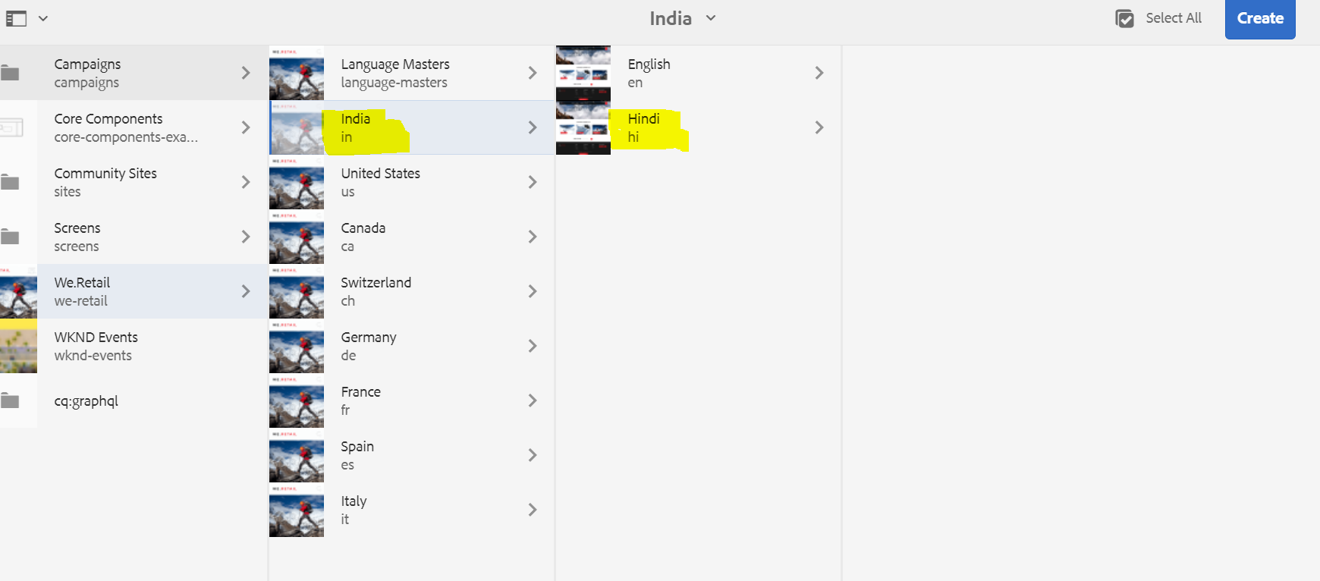

**Rollout Configuration:**

Create a page inside the language master and we can move that page to other countries sites.

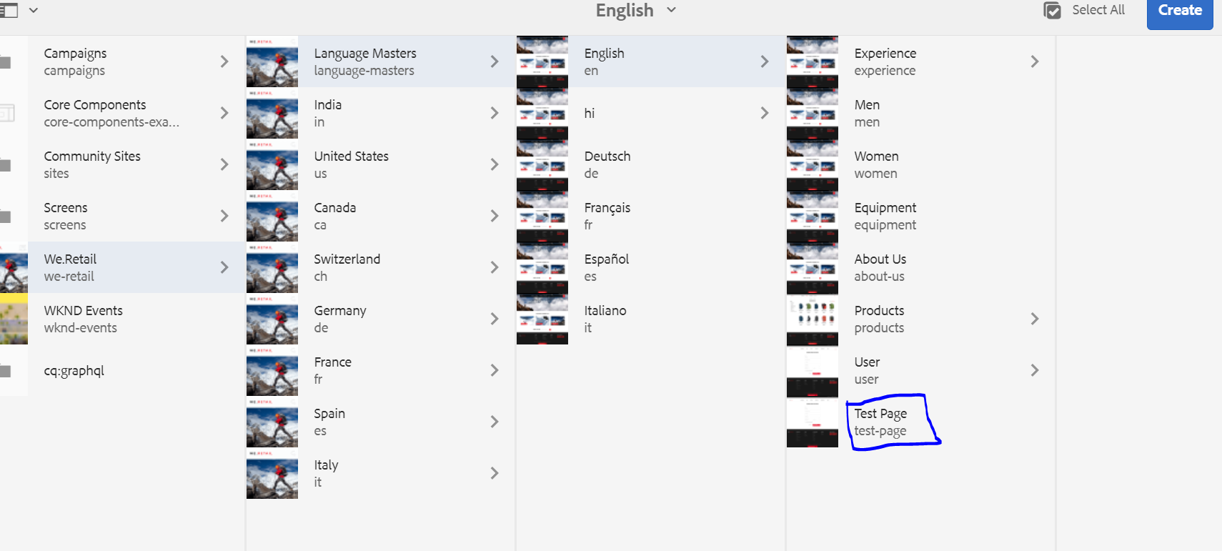

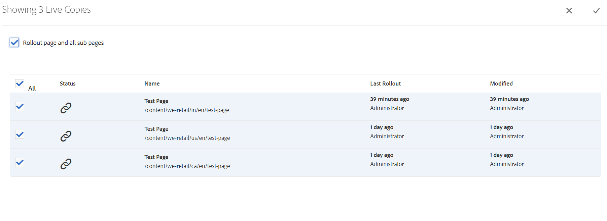

Test Page created in English language master copy has successfully rolled out to India,US,Canada.

