A **work-breakdown structure (WBS)** in project management and systems engineering, is a deliverable-oriented breakdown of a project into smaller components. A work breakdown structureis a key project deliverable that organizes the team'swork into manageable sections.

This is a checklist to use when reviewing the quality of a Work Breakdown Structure.

* Does it define 100% of the work that will be produced by the project?
* Does each element represent a deliverable?
* Does it use a coding structure so that each element has a unique ID that shows its place in the hierarchy e.g. 1.1, 1.2, 1.1.1, 1.1.2?
* Will project stakeholders be able to understand the project scope from the WBS?
* Does it capture all external and internal deliverables including project management deliverables?
* Does each level represent 100% of the work required to deliver the parent level?
* Is the decomposition sufficient that the tasks required to deliver each work package can easily be identified?
* Is it in the format that gives a clear graphical, textual or tabular breakdown of the project scope?
* Is a hierarchical structure used?
* Does it have a least two levels with at least one level of decomposition?
* Can you identify one person who is accountable for each work package?
* Can you clearly define the acceptance criteria for each work package?
* Does it allow you to estimate costs accurately?
* Does the WBS align with the size and complexity of the project? Is it sufficiently detailed to support planning and control, but not so detailed as to become cumbersome?

You can use MS Project or MindView 7

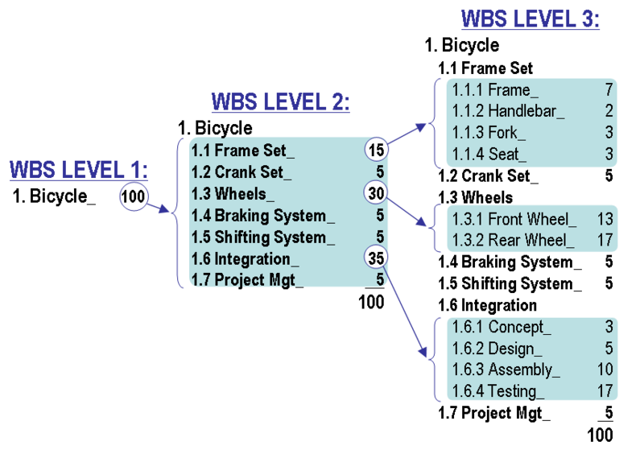

|  |  |
| --- | --- |
| **ID** | 58 |
| **Name** | Design of the room update function for client software |
| **WBS #** | 11.1.4.2.9 |
| **Estimated duration** | 1 day |
| **Predecessors** | 34 |
| **Successors** | 67 |
| **Start Date** | Sat 4/20/02 |
| **End Date** | Sat 4/20/02 |
| **Personnel responsible** | Seda Barış |
| **Description** | Establishing a design for the room update function of client software. Only the root can use this function if she/he chooses the chat group function after the user authentication to change information (except the room name) of an existing room of the ION-CHAT SYSTEM. |

|  |  |
| --- | --- |
| **ID** | 53 |
| **Name** | Bus firm administrator functions |
| **WBS #** | 1.2.5 |
| **Estimated duration** | 26 days |
| **Predecessors** | 51 |
| **Successors** | 56 |
| **Start Date** | 12/4/2002 |
| **End Date** | 10/5/2002 |
| **Personnel responsible** | Candas BOZKURT |
| **Description** | Bus firm administrators’ module implementation |

|  |
| --- |
| **Work Activity** |
| Stating the problem statement |
| Training for IEEE Std. 1058-1998 |
| Preparation of the Initial Plan |
| Training for IEEE Std. 830-1998 |
| Preparation of the SRS |
| Review meeting for the changes of software requirements with the customer |
| Training for IEEE Std. 1058-1998 |
| Preparation of the SPMP |
| Update of the Initial Plan |
| Preparation of managerial process plans |
| Work plan |
| Control Plan |
| Risk management plan |
| Project closeout plan |
| Control of the project schedule |
| Control of the budget requirements |
| Review of the project risk factors |
| Review meeting for the content of the SPMP with the customer |
| Preparation of technical process plans |
| Preparation of supporting process plans |
| Control of the quality of the SPMP |
| Writing of the SPMP documentation |
| Review meeting for SPMP documentation |
| Update of the SPMP documentation |
| Training for IEEE Std. 1016-1998 |
| Review meeting for the changes of software requirements with the customer |
| Preparation of the SDD |
| Design of the ION-CHAT SYSTEM |
| Design of the communication protocol between client & server softwares |
| Design of the user and room information files |
| Design of the server software |
| Design of the common functions of all users |
| Design of the user authentication function for server software |
| Design of the functions for root |
| Design of the user addition function for server software |
| Design of the user deletion function for server software |
| Design of the user update function for server software |
| Design of the chat group addition function for server software |
| Design of the chat group deletion function for server software |
| Design of the chat group update function for server software |
| Design of the room addition function for server software |
| Design of the room deletion function for server software |
| Design of the room update function for server software |
| "Design of the functions for instructor, students & customers" |
| Design of the chat function for server software |
| Design of the client software |
| Design of the common functions of all users |
| Design of the user authentication function for client software |
| Design of the functions for root |
| Design of the user addition function for client software |
| Design of the user deletion function for client software |
| Design of the user update function for client software |
| Design of the chat group addition function for client software |
| Design of the chat group deletion function for client software |
| Design of the chat group update function for client software |
| Design of the room addition function for client software |
| Design of the room deletion function for client software |
| Design of the room update function for client software |
| "Design of the functions for instructor, students & customers" |
| Design of the chat function for client software |
| Control of the project schedule |
| Control of the budget requirements |
| Review of the project risk factors |
| Review meeting for the content of the SDD with the customer |
| Control of the quality of the SDD |
| Writing of the SDD documentation |
| Review meeting for SDD documentation |
| Update of the SDD documentation |
| Training for Java programming language |
| Coding of the ION-CHAT SYSTEM |
| Coding of the server software |
| Coding of the common functions of all users |
| Coding of the user authentication function for server software |
| Coding of the functions for root |
| Coding of the user addition function for server software |
| Coding of the user deletion function for server software |
| Coding of the user update function for server software |
| Coding of the chat group addition function for server software |
| Coding of the chat group deletion function for server software |
| Coding of the chat group update function for server software |
| Coding of the room addition function for server software |
| Coding of the room deletion function for server software |
| Coding of the room update function for server software |
| "Coding of the functions for instructor, students & customers" |
| Coding of the chat function for server software |
| Coding of the client software |
| Coding of the common functions of all users |
| Coding of the user authentication function for client software |
| Coding of the functions for root |
| Coding of the user addition function for client software |
| Coding of the user deletion function for client software |
| Coding of the user update function for client software |
| Coding of the chat group addition function for client software |
| Coding of the chat group deletion function for client software |
| Coding of the chat group update function for client software |
| Coding of the room addition function for client software |
| Coding of the room deletion function for client software |
| Coding of the room update function for client software |
| "Coding of the functions for instructor, students & customers" |
| Coding of the chat function for client software |
| Control of the project schedule |
| Control of the budget requirements |
| Review of the project risk factors |
| Control of the quality of the code generated |
| Training for testing processes |
| Testing of the ION-CHAT SYSTEM |
| Testing of the common functions of all users |
| Testing of the user authentication function |
| Testing of the functions for root |
| Testing of the user addition function |
| Testing of the user deletion function |
| Testing of the user update function |
| Testing of the chat group addition function |
| Testing of the chat group deletion function |
| Testing of the chat group update function |
| Testing of the room addition function |
| Testing of the room deletion function |
| Testing of the room update function |
| "Testing of the functions for instructor, students & customers" |
| Testing of the chat function |
| Control of the project schedule |
| Control of the budget requirements |
| Review of the project risk factors |
| Delivery of initial product |
| Review meeting for the initial product with the customer |
| Control of the project schedule |
| Control of the budget requirements |
| Review of the project risk factors |
| Control of the quality of the initial product |
| Training for IEEE Std. 1063-1987 |
| Preparation of the User Manual |
| Product Demonstration |
| Delivery of the final product |