**SYSTEM ANALYSIS AND DESIGN**

**GROUP NAME:** Syswriters

**GROUP MEMBERS:** Anıl Kuşçu , Gülfem Işık , Ebru Sarı

**REPORT 1:PROBLEM STATEMENT**

* Problem:Nowadays managing company employees , projects , operations etc. are getting harder and harder.To solve this problem we offer a web based company management system.
* Who - Who does the problem affect? Specific groups, organizations, customers, etc.

-Problem is affecting managers of companies or who is trying to manage some human resources.

* What - What is the problem that needs to be solved? What are the boundaries of the problem, e.g. organizational, work flow, geographic, customer, segments, etc. - What is the issue? - What is the impact of the issue? - What impact is the issue causing? - What will happen when it is fixed? - What would happen if we didn’t solve the problem? - What impact does it have on the business or customer? - What impact does it have on all stakeholders, e.g. employees, suppliers, customers, shareholders, etc.  
    
  -We need to solve the managing people problem.It seems like there is no boundries about problem because this problem is about managing all the people.If we can solve this problem there won’t be more conflict in companies and the most important thing is saving time.You can give tasks to specific person,display and manage your all projects on one hand.Employees can reach their tasks quickly and starting to project will taking less time.
* When - When does the issue occur? - When does it need to be fixed?

-The managing people was always a issue but in this times companies are getting bigger so

it is harder to get in touch with people so this issue should solve as soon as possible.

* Where - Where is the issue occurring? Only in certain locations, processes, products, etc.

-This issue can occure everywhere but we are trying to solve some specific locations like

companies who have a lot of projects and employees.

* Why - Why is it important that we fix the problem?

-Because every manager needs a simple managing system that getting jobs easy and it will be getting easier other things in the company.

* How - How is the problem observed? (symptoms)

-We can observe the problem if we go any company or work in any company.There are many conflicts and complicated jobs somewhere like this bussines companies.

* How often - How often is the problem observed? (error rate, magnitude, trend)

-This problem often observed if the company has a lot of projects and employees.

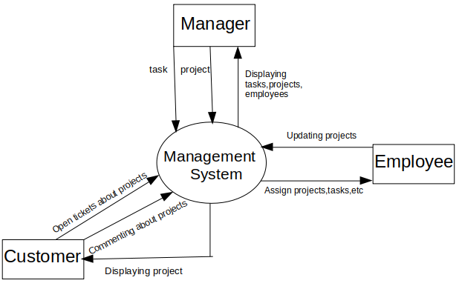**CONTEXT DIAGRAM**