**SOFTWARE REQUIREMENTS SPECIFICATION**

***for***

**Company Management System**

***Prepared By***

***Syswriters***

Anıl Kuşçu

Gülfem Işık

Ebru Sarı

Due Date:30.10.2018

CHANGE HISTORY

|  |  |  |  |  |
| --- | --- | --- | --- | --- |
| **Date** | **Version** | **File Name** | **Format** | **Status** |
| 30.10.2018 | V1.0 | CMS-SRS-v1.0 | docx | Created |

Table 1‑1

PREFACE

*The document contains the Software Requirements Specification of COMPANY MANAGEMENT SYSTEM. The mission of the project is to develop a web-based management system for companies,schools etc. The goal of the SRS is to describe the requirements of the COMPANY MANAGEMENT SYSTEM.*

**TABLE OF CONTENTS**

CHANGE HISTORY i

PREFACE ii

TABLE OF CONTENTS iii

LIST OF FIGURES iv

LIST OF TABLES v

1 INTRODUCTION (Section 1 of the SRS) 1

1.1 Purpose of the SRS 1

1.2 Scope of the Product 1

1.3 Definitions, acronyms and abbreviations 1

1.4 References 2

1.5 Overview 2

2 OVERALL DESCRIPTION (Section 2 of the SRS) 2

2.1 Product perspective 2

2.1.1 System interfaces 2

2.1.2 User interfaces 2

2.1.3 Hardware interfaces 3

2.1.4 Software interfaces 3

2.1.5 Communication interfaces 4

2.1.6 Memory Constraints 4

2.1.7 Operations 4

2.1.8 Site adaptation requirements 5

2.2 Product Functions: 5

2.3 User Characteristics: 5

2.4 Constraints: 6

2.5 Assumptions and Dependencies: 6

2.6 Apportioning of Requirements: 6

3 SPECIFIC REQUIREMENTS (Section 3 of the SRS) 7

3.1 External Interfaces: 7

3.2 Functions: 10

3.3 Performance Requirements: 20

3.4 Logical Database Requirements 20

3.5 Design Constraints 20

3.5.1 Standards Compliance 20

3.6 Software System Attributes 20

3.6.1 Reliability 20

3.6.2 Availability 20

3.6.3 Security 20

3.6.4 Maintainability 21

3.6.5 Portability 21

LIST OF FIGURES

Figure 1 22

Figure 2 23

Figure 3 24

Figure 4 25

Figure 5 26

LIST OF TABLES

Table 1 i

Table 2 10

Table 3 11

Table 4 12

Table 5 13

Table 6 14

Table 7 15

Table 8 16

Table 9 17

Table 10 18

# INTRODUCTION (Section 1 of the SRS)

## Purpose of the SRS

The purpose of the Software Requirements Specification (SRS) is to identify what the COMPANY MANAGEMENT SYSTEM is supposed to do, • to provide better communication among the Syswriters and the acquirers, who are the intended audience of the SRS, • to provide a basis for controlling the evolution of the COMPANY MANAGEMENT SYSTEM and system verification in a correct, complete, unambiguous and verifiable manner.

## Scope of the Product

CMS is a web access management system that managing your employees. Also customer of the companies can see their projects. For this reason, the overall system will consist of web interfaces. And these interfaces are used to support the following functions:

* Make real-time operations on projects.
* Assure data consistency.
* Access the information of the projects ands employees from anywhere and at anytime.
* Customers can see the project,people that assigned to the project.
* Customers can comment about the project.
* Manage employees from anytime and at anyplace by using only a web browser.
* Managers informs up to date information to the customers about projects or jobs via using CMS web page.

## Definitions, acronyms and abbreviations

Project: Jobs that company should done.

DNS: Domain Name System

EX: Exception

ER: Entity Relationship

HTML: Hypertext Markup Language

HTTP: Hyper Text Transform Protocol

Instructor: Teacher of the Course

C#: Programmin language

.NET:Framework

MVC:Model View Controller

CMS: Company Management System

OS: Operating System

RDBMS: Relational Database Management System

SQL: Structured Query Language

SRS: Software Requirements Specification

TCP / IP: Transmission Control Protocol / Internet Protocol

UC Use Case

WAP: Web Application Project

XML: Extensible Markup Language

## References

[1] <http://httpd.apache.org/docs>

[2] <https://www.google.com/intl/tr_tr/docs/>

[3] IEEE Std 1058-1998, IEEE Standard for Software Project Management Plans

[4] IEEE Std 830-1998, IEEE Recommended Practice for Software Requirements

Specifications

[5] IEEE Std 1016-1998, Recommended Practice for Software Design Descriptions

[6] IEEE Std 1063-1998, IEEE Standard for Software User Documentation

## Overview

The SRS is organized in three sections.

* Introduction Section (Section 1 of the SRS) in which purpose, scope, definitions,

references and an overview of the SRS are given.

* Overall Description Section (Section 2 of the SRS) describes the general factors

that affect the product and its requirements. This section does not state specific

requirements. Instead, it provides a background for those requirements, which are

defined in detail in specific requirements part (Section 3 of the SRS), and makes

them easier to understand.

* Specific Requirements Section (Section 3 of the SRS) contains all of the software

requirements to a level of detail sufficent to enable Syswriters to design the COMPANY MANAGEMENT SYSTEM to satisfy those requirements, and testers to test that the system satifsies those requirements.

# OVERALL DESCRIPTION (Section 2 of the SRS)

This section of this SRS describes the general factors that affect the CMS Software and its requirements. It does not state specific requirements, but provides a background for them.

## Product perspective

### System interfaces

The Company Management System will be a stand-alone system and it is independent from platform just needs web browser.

### User interfaces

* All of the user interfaces shall be web-based.
* The format of the screens may differ depending on the operating system, the window manager and the HTTP client used by the user.
* There shall be 8 different types of user interfaces. These are :

1. authentication
2. root/admin/manager interface
3. customer interface
4. employee interfaces
5. displaying projects interface(3 different user interfaces)
6. user management(add,update,delete) interface (only for manager )

* The COMPANY MANAGEMENT SYSTEM shall be designed such that a university graduate shall be able to learn using it after 30 minutes of continuous training.

### Hardware interfaces

There is no defined hardware interface for the COMPANY MANAGEMENT SYSTEM.

### Software interfaces

The required software products shall be:

**Name** : Apache HTTP Server

**Version number**:2.4.37

**Source**:https://httpd.apache.org/download.cgi

**Purpose of the interfacing software with the proposed software** : In order to execute the client site of COMPANY MANAGEMENT SYSTEM, the web server specified above is required as the provider of the client software at the server site.

**-----------------------------------------------------------------------**

**Name** : MySQL Database Server

**Version number**:8.0

**Source**:https://dev.mysql.com/downloads/file/?id=480649

**Purpose of the interfacing software with the proposed software** : It is a database program so there should be a database server.

**-----------------------------------------------------------------------**

**Name** : Google Chrome Web Browser

**Version number**:**69.0.3497.58**

**Source**:https://chrome.tr.softonic.com/

**Purpose of the interfacing software with the proposed software** : Google Chrome is the software, which shall provide the necessary run-time environment in order the client software to be executed at the client site.

### Communication interfaces

Since the CMS is a web-based application, both the client side machine and the CMS’s deployed web server must connect to the Internet. And TCP/IP protocol must be installed to communicate through HTTP messages between client and CMS deployed web server with default port 80. To enable clients for carrying out hostname resolution, a DNS A Record will be added to the appropriate DNS Server.

### Memory Constraints

Satisfying the memory requirements of CMS software interfaces’ [4] at least 256 MB RAM with 512MB hard disk space for virtual memory will be required to work properly at the server side. At the client side, the memory requirement is at least 64 MB RAM to run Google Chrome.

### Operations

The required operations classified according to the user are as follows:

**Manager:**

* • Add New User Registration.
* • Update User Registration Information.
* • Add,Update,Close Project
* Display All The Interfaces

**Customer**:

* • Display Their Projects
* • Comment About Their Projects

**Employee**:

* • Display Attended Projects
* • Changing Project Status

### Site adaptation requirements

Since the server software shall only be installed to a unique location, namely the

server site, and since no installation is required for the client software, there are no site

adaptation requirements for the COMPANY MANAGEMENT SYSTEM.

## Product Functions:

The general functions that the CMS will perform, can be categorized as follows:

1. User Authentication Function: This function shall authenticate user to enter to the system. In case of any kind of failure, an appropriate error message shall be displayed. Otherwise, the message indicating successful completion of the operation shall be displayed.

2. User Addition Function: This function shall allow the manager to add a user. In case of any kind of failure, an appropriate error message shall be displayed. Otherwise, the message indicating successful completion of the operation shall be displayed.

3. User Deletion Function: This function shall allow the manager to delete a user for whom the user_id is specified. In case of any kind of failure, an appropriate error message shall be displayed. Otherwise, the message indicating successful completion of the operation shall be displayed.

4. User Update Function: This function shall allow the manager to update the information of a user for whom the user_id is specified. In case of any kind of failure, an appropriate CMS Software Requirements Specification Version 1.2 10 error message shall be displayed. Otherwise, the message indicating successful completion of the operation shall be displayed.

5. Comment Project Function: This function shall allow all of the related users to comment about projects.

6. Project Status Function: This function shall allow the manager and related employees to update the status of project.

## User Characteristics:

The user types that would use the CMS are as follows:

* **Manager**: The manager of the system and has some privileges(like manage user informations) about all the user.
* **Employees**: Take tasks from manager about projects.
* **Customers**: Can follow their projects.

## Constraints:

1. The COMPANY MANAGEMENT SYSTEM shall be a standalone system since authorization to access to CMS is given.

2. The COMPANY MANAGEMENT shall be a web-based, platform independent system.

3. The CMS shall log all of the database information.

4. The COMPANY MANAGEMENT SYSTEM shall be used by authorized people only, due to security considerations.

## Assumptions and Dependencies:

1. Apache HTTP Server shall be installed at the server site.

2. Google Chrome Web Browser shall be installed at the client site.

3. Syswriters shall not be responsible for acquisition, installation, configuration or

maintenance of Google Chrome for the client site.

4. The MySQL database server should be installed on the system

## Apportioning of Requirements:

The COMPANY MANAGEMENT SYSTEM has no requirements that may be delayed until future versions of the COMPANY MANAGEMENT SYSTEM.

# SPECIFIC REQUIREMENTS (Section 3 of the SRS)

## External Interfaces:

Interfaces external to the OBRS are understood as “User Interfaces”. The following sections provide details of the user interfaces:

**3.1.1 Authentication Page**

**Name**: Company Management System Main Page

**Purpose**: It is used to make the login process; users can login from this page, and go to the related page according to the login user and password.If there is a wrong about login name and password in this page, user should not advance in the system. Also, this page is used to set the environment that visitors can call the related functions.

**Inputs/Types**:

• Login Name = string

• Password = string

**Outputs/Types**: The related page according to the identity of the user is displayed. If

the password or login name wrong then Login is failed. Try again…” message will be displayed. Possible reasons of the failure can be: User name or password is wrong.

**Screen Formats**: Visitors can put in their login name and password in the

corresponding fields, and by clicking to the “Login” button; they can go to the related

pages for their identity. “Login” is a textbox and enter here the name of the any user. “Password” is a textbox too, but entering numbers or characters are shown only “ ***** ” format in this field.

**Relationship to other interfaces**: From this interface, login process can be done and

the corresponding page can be reached according to the given user name and password.

**3.1.2 Manager – Main Page**

**Name**: Main Page For Manager

**Purpose**: It is used to display to all the system features.

**Inputs/Types**:

• Change Project Status = Pulldown Menu

• Comment = string

**Outputs/Types**: “Project added” when project added succesfully.

**Screen Formats**: In this page,manager can manage projects and users by click user management button and add project button.

**Relationship to other interfaces**: User management page .

**3.1.3 Manager – User Management Page**

**Name**: CMS User Management(add,update,delete) Page For Manager

**Purpose**: It is used to manage to all the system users.

**Inputs/Types**:

• Name = string

• Surname = string

E-mail = e-mail string

Phone = number

Password = password string

Company Name = string

System Role = Pulldown Menu

**Outputs/Types**: “Registered successfully” message will be displayed when there is no problem in the registration process. “Registration is failed. Try again with correcting the “XXX” field” message will be displayed when it is failed.

**Screen Formats**: In this page, administrator registration can be finished by clicking to the “Register” button and the process can be cancelled and turned back to the main page by clicking to the “Back” button. Bus firm administrator completes fields with using keyboard

**Relationship to other interfaces**: You can see the changings in the manager main page.

**3.1.4 Manager – Add Project Page**

**Name**: Add Project Page For Manager

**Purpose**: It is used to adding project .

**Inputs/Types**:

• Project Name = string

• Start Date = date

Due Date = date

Status = Pulldown Menu

Attended People = checkbox

**Outputs/Types**: “Project added successfully” message will be displayed when there is no problem in the adding process. “Failed. Try again with correcting the “XXX” field” message will be displayed when it is failed.

**Screen Formats**: In this page, project adding can be finished by clicking to the “Add” button and the process can be cancelled and turned back to the main page by clicking to the “Back” button.

**Relationship to other interfaces**: You can see the changings in the manager main page.

**3.1.5 Employee – Main Page**

**Name**: Main Page For Employee

**Purpose**: It is used to display to related projects and its features.

**Inputs/Types**:

• Change Project Status = Pulldown Menu

• Comment = string

**Outputs/Types**: -

**Screen Formats**: In this page,employe can change projects status by click pulldown menu of the project.

**Relationship to other interfaces**: - .

**3.1.6 Customer – Main Page**

**Name**: Main Page For Customer

**Purpose**: It is used to display to related projects and its features.

**Inputs/Types**:

• Change Project Status = Pulldown Menu

• Comment = string

**Outputs/Types**: -

**Screen Formats**: In this page,customer can see the related projects and change projects status by click pulldown menu of the project.

## Functions:

Table 3‑2UC1. Add Customer

|  |  |  |  |  |
| --- | --- | --- | --- | --- |
| **Use Case ID**: | UC1 | | | |
| **Use Case Name:** | Add Customer | | | |
| **Created By:** | Syswriters | | **Last Updated By:** |  |
| **Date Created:** | 30.10.2018 | | **Date Last Updated:** |  |
| **Actor(s):** | | Manager | | |
| **Description:** | | This use case is used by the manager to adding customer to database. | | |
| **Preconditions:** | | 1. Manager should login the CMS. | | |
| **Post conditions:** | | - | | |
| **Normal Course of Events:** | | 1. Manager logins to system.  2. Clicks to user management.  3. Clicks to add user.  4. Fills the customer informations and select customer as user.  5. Clicks add user | | |
| **Alternative Courses: -** | | Manager can add employee rather than customer  Manager can cancel the process | | |
| **Exceptions:** | | Only manager can do this process | | |
| **Assumptions:** | | - | | |
| **Notes and Issues:** | | - | | |

Table 3‑3 UC2. Add Employee

|  |  |  |  |  |
| --- | --- | --- | --- | --- |
| **Use Case ID**: | UC2 | | | |
| **Use Case Name:** | Add Employee | | | |
| **Created By:** | Syswriters | | **Last Updated By:** |  |
| **Date Created:** | 30.10.2018 | | **Date Last Updated:** |  |
| **Actor(s):** | | Manager | | |
| **Description:** | | This use case is used by the manager to adding employee to database. | | |
| **Preconditions:** | | 1. Manager should login the CMS. | | |
| **Post conditions:** | | - | | |
| **Normal Course of Events:** | | 1. Manager logins to system.  2. Clicks to user management.  3. Clicks to add user.  4. Fills the employee informations and select employee as user.  5. Clicks add user | | |
| **Alternative Courses: -** | | Manager can add customer rather than employee  Manager can cancel the process | | |
| **Exceptions:** | | Only manager can do this process | | |
| **Assumptions:** | | - | | |
| **Notes and Issues:** | | - | | |

Table 3‑4 UC3. Add Project

|  |  |  |  |  |
| --- | --- | --- | --- | --- |
| **Use Case ID**: | UC3 | | | |
| **Use Case Name:** | Add Project | | | |
| **Created By:** | Syswriters | | **Last Updated By:** |  |
| **Date Created:** | 30.10.2018 | | **Date Last Updated:** |  |
| **Actor(s):** | | Manager | | |
| **Description:** | | This use case is used by the manager to adding project to database. | | |
| **Preconditions:** | | 1. Manager should login the CMS. | | |
| **Post conditions:** | | Customers and employees that attended to the project should be verify by the database. | | |
| **Normal Course of Events:** | | 1. Manager logins to system.  2. Clicks to add project.  3. Fills the project informations and select attended users to projects.  4. Clicks add project | | |
| **Alternative Courses:** | | Manager can cancel the process | | |
| **Exceptions:** | | Only manager can do this process | | |
| **Assumptions:** | | - | | |
| **Notes and Issues:** | | - | | |

Table 3‑5 UC4. Display Project

|  |  |  |  |  |
| --- | --- | --- | --- | --- |
| **Use Case ID**: | UC4 | | | |
| **Use Case Name:** | Display Project | | | |
| **Created By:** | Syswriters | | **Last Updated By:** |  |
| **Date Created:** | 30.10.2018 | | **Date Last Updated:** |  |
| **Actor(s):** | | Manager,Employee,Customer | | |
| **Description:** | | This use case is used to displaying related projects. | | |
| **Preconditions:** | | 1. User should login the CMS. | | |
| **Post conditions:** | | - | | |
| **Normal Course of Events:** | | 1. User logins to system.  2. On the main page user should display projects directly | | |
| **Alternative Courses:** | | - | | |
| **Exceptions:** | | - | | |
| **Assumptions:** | | - | | |
| **Notes and Issues:** | | - | | |

Table 3‑6 UC5. Adding Comment

|  |  |  |  |
| --- | --- | --- | --- |
| **Use Case ID**: | UC5 | | |
| **Use Case Name:** | Adding Comment | | |
| **Created By:** | Syswriters | **Last Updated By:** |  |
| **Date Created:** | 30.10.2018 | **Date Last Updated:** |  |

|  |  |
| --- | --- |
| **Actor(s):** | Manager,Employee,Customer |
| **Description:** | This use case is used to adding comment to projects by users |
| **Preconditions:** | 1. User should login the CMS. |
| **Post conditions:** | - |
| **Normal Course of Events:** | 1. User logins to system.  2. On the main page users should display commit directly  3. On the main page users should add commit under the project |
| **Alternative Courses:** | - |
| **Exceptions:** | - |
| **Assumptions:** | - |
| **Notes and Issues:** | - |

Table 3‑7 UC6. Delete User

|  |  |  |  |  |
| --- | --- | --- | --- | --- |
| **Use Case ID**: | UC6 | | | |
| **Use Case Name:** | Delete User | | | |
| **Created By:** | Syswriters | | **Last Updated By:** |  |
| **Date Created:** | 30.10.2018 | | **Date Last Updated:** |  |
| **Actor(s):** | | Manager | | |
| **Description:** | | This use case is used to delete user from database | | |
| **Preconditions:** | | 1. Manager should login the CMS. | | |
| **Post conditions:** | | - | | |
| **Normal Course of Events:** | | 1. Manager logins to system.  2. Clicks to user management.  3. Clicks to cross next to the user.  4. Answer the are you sure question. | | |
| **Alternative Courses:** | | - | | |
| **Exceptions:** | | Manager can cancel the process | | |
| **Assumptions:** | | Only manager can do this process | | |
| **Notes and Issues:** | | - | | |

Table 3‑8 UC7. Update User

|  |  |  |  |  |
| --- | --- | --- | --- | --- |
| **Use Case ID**: | UC7 | | | |
| **Use Case Name:** | Update User | | | |
| **Created By:** | Syswriters | | **Last Updated By:** |  |
| **Date Created:** | 30.10.2018 | | **Date Last Updated:** |  |
| **Actor(s):** | | Manager | | |
| **Description:** | | This use case is used to update user information | | |
| **Preconditions:** | | 1. Manager should login the CMS. | | |
| **Post conditions:** | | - | | |
| **Normal Course of Events:** | | 1. Manager logins to system.  2. Clicks to user management.  3. Clicks to update icon next to the user.  4. Change the informations due to desire.  5. Click Update Button | | |
| **Alternative Courses:** | | - | | |
| **Exceptions:** | | Manager can cancel the process | | |
| **Assumptions:** | | Only manager can do this process | | |
| **Notes and Issues:** | | - | | |

Table 3‑9 UC8. Update Project

|  |  |  |  |  |
| --- | --- | --- | --- | --- |
| **Use Case ID**: | UC8 | | | |
| **Use Case Name:** | Update Project | | | |
| **Created By:** | Syswriters | | **Last Updated By:** |  |
| **Date Created:** | 30.10.2018 | | **Date Last Updated:** |  |
| **Actor(s):** | | Manager | | |
| **Description:** | | This use case is used to update user information | | |
| **Preconditions:** | | 1. Manager should login the CMS. | | |
| **Post conditions:** | | - | | |
| **Normal Course of Events:** | | 1. Manager logins to system.  2. Clicks to user management.  3. Clicks to update icon next to the user.  4. Change the informations due to desire.  5. Click Update Button | | |
| **Alternative Courses:** | | - | | |
| **Exceptions:** | | Manager can cancel the process | | |
| **Assumptions:** | | Only manager can do this process | | |
| **Notes and Issues:** | | - | | |

Table 3‑10 UC9. Delete Project

|  |  |  |  |  |
| --- | --- | --- | --- | --- |
| **Use Case ID**: | UC9 | | | |
| **Use Case Name:** | Delete Project | | | |
| **Created By:** | Syswriters | | **Last Updated By:** |  |
| **Date Created:** | 30.10.2018 | | **Date Last Updated:** |  |
| **Actor(s):** | | Manager | | |
| **Description:** | | This use case is used to delete project from database | | |
| **Preconditions:** | | 1. Manager should login the CMS. | | |
| **Post conditions:** | | - | | |
| **Normal Course of Events:** | | 1. Manager logins to system.  2. Clicks to croos next to the project.  3. Answers are you sure question. | | |
| **Alternative Courses:** | | - | | |
| **Exceptions:** | | Manager can cancel the process | | |
| **Assumptions:** | | Only manager can do this process | | |
| **Notes and Issues:** | | - | | |

Table 3‑11 UC10. Change Project Status

|  |  |  |  |  |
| --- | --- | --- | --- | --- |
| **Use Case ID**: | UC10 | | | |
| **Use Case Name:** | Change Project Status | | | |
| **Created By:** | Syswriters | | **Last Updated By:** |  |
| **Date Created:** | 30.10.2018 | | **Date Last Updated:** |  |
| **Actor(s):** | | Manager,Employee,Customer | | |
| **Description:** | | This use case is used to change project status like opened,closed,pending etc. | | |
| **Preconditions:** | | 1. Manager should login the CMS. | | |
| **Post conditions:** | | - | | |
| **Normal Course of Events:** | | 1. User logins to the system.  2. Clicks to pulldown menu near the project.  3. Selects the desired status. | | |
| **Alternative Courses:** | | - | | |
| **Exceptions:** | | - | | |
| **Assumptions:** | | Everybody can do this process | | |
| **Notes and Issues:** | | - | | |

## 

## Performance Requirements:

* The system shall support 100 simultaneous client connections.
* The system response time shall be maximum 5 seconds in the 100 mbit LAN environment.

**3.4 Design Constraints**

**3.4.1** Standards Compliance The COMPANY MANAGEMENT SYSTEM standard compliance requirements are as follows:

1. Any kind of documentation prepared for COMPANY MANAGEMENT SYSTEM shall be in content compliance with IEEE standards [3,4,5,6].

**3.5** Software System Attributes

**3.5.1 Reliability**:

1. The COMPANY MANAGEMENT SYSTEM shall be 100% operational for 90% of the calendar time during its first year of operation

**3.5.2 Security:**

1. In order to protect itself from accidental or malicious access, use or modification, the COMPANY MANAGEMENT SYSTEM shall enforce supply of a valid username and password pair, when any user attempts to login to the system.

**2**. The issues concerning the security of the operating system at the server site, which may lead security problems for the COMPANY MANAGEMENT SYSTEM, shall not be the responsibility of the DeepBlue.

**3.5.3 Portability:**

**1**. The COMPANY MANAGEMENT SYSTEM shall be a platform independent system, provided that, all of the software interfaces specified in subsection

**2.1.4** are provided for both the server site and the client site. 2. In order to establish the platform independence, Java2 Standard Edition version 1.3.1 of Sun Microsystems shall be used for coding both the server software and the client software. 3.6 Other Requirements Although, the COMPANY MANAGEMENT SYSTEM shall not use any logical database, it shall use two different files which are “User Information File” and “Room Information File”. The requirements for these files are:

**1**. The User Information File shall be used in User Authentication Function, User Addition Function, User Deletion Function, User Update Function, Chat Group Addition Function, Chat Group Deletion Function and Chat Group Update Function. **2.** The Room Information File shall be used in Room Addition Function, Room Deletion Function and Room Update Function.

### Appendix – A: Use Case Diagram

Login

manager

Employe

### Appendix – B: User Interfaces

*Figure 1: Login Page*

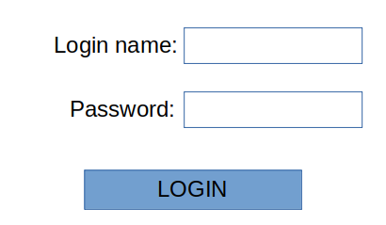

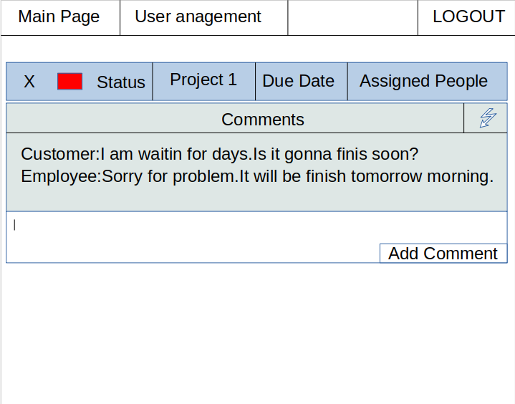*Figure 2: Manager Main Page*

*Figure 3: Manager User Management Page*

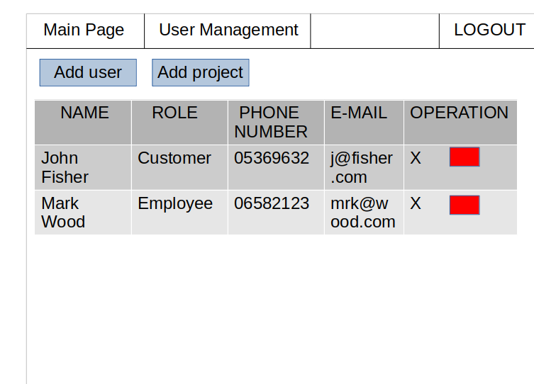

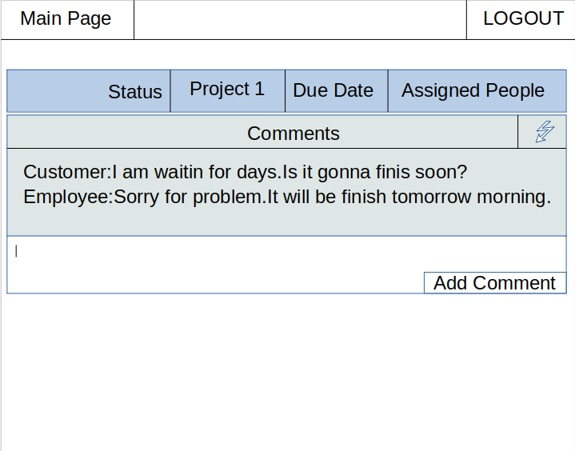*Figure 4: Customer Main Page*

*Figure 5: Employee Main Page*

### *4.3 Appendix – C: Er Dıagram*

Comment

Change_Project

Customer

Comment_Project

Management

Surname

Company_Name

Password

Phone

Name

E-mail

Add Project Page

Pri_Date

Start_Date

Project_Name

Status

Change_Project

Comment

Employer