AERO1005 MATLAB Coursework 2

Author: Boyang Hu
Student ID: 20721145
Date of report: 25 April 2026

Supporting Figures and Brief Notes
This document contains the photographs, plots, flowcharts and concise descriptive notes required to accompany the MATLAB submission files for AERO1005 Coursework 2. The hardware implementation was built and tested using an Arduino Uno, a breadboard, an MCP9700 temperature sensor and red/yellow/green LEDs.

Preliminary Task - Arduino Communication
The preliminary task established communication between MATLAB and the Arduino Uno. A simple LED circuit was used to verify that digital output commands could switch the LED on and off at the required 0.5 s interval before progressing to the temperature monitoring tasks.
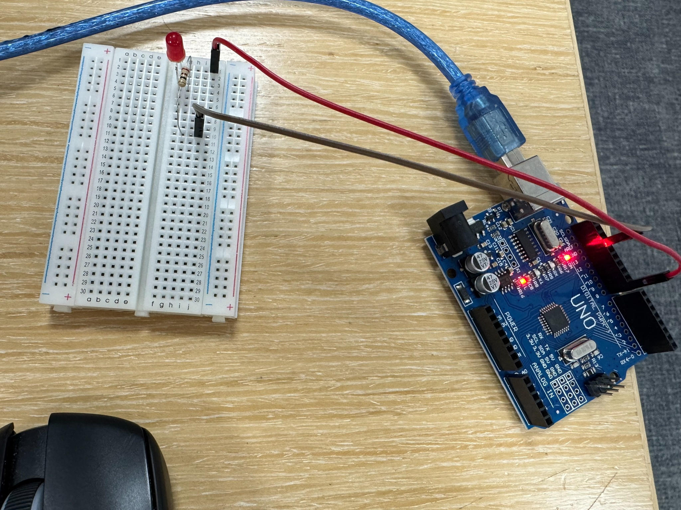
Figure 1. Preliminary Arduino communication and LED blink test circuit.

Task 1 - Read Temperature Data, Plot, and Write to a Log File
The temperature sensor was connected to the breadboard and linked to the Arduino analogue input. The main script recorded temperature data for 600 s at approximately 1 s intervals, converted the measured voltage into temperature using the MCP9700 constants, and wrote the formatted results to a text log file.
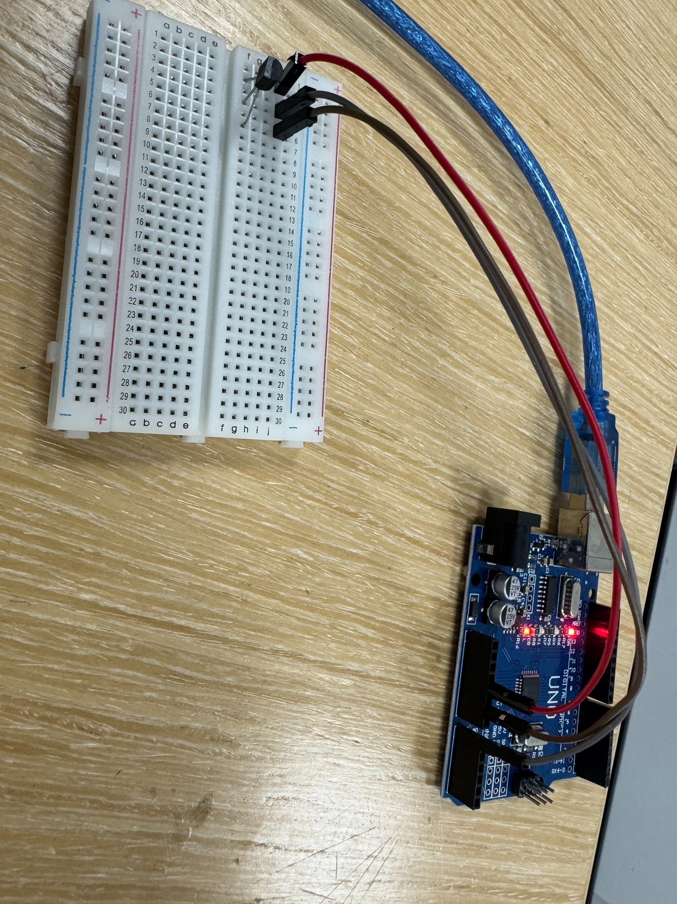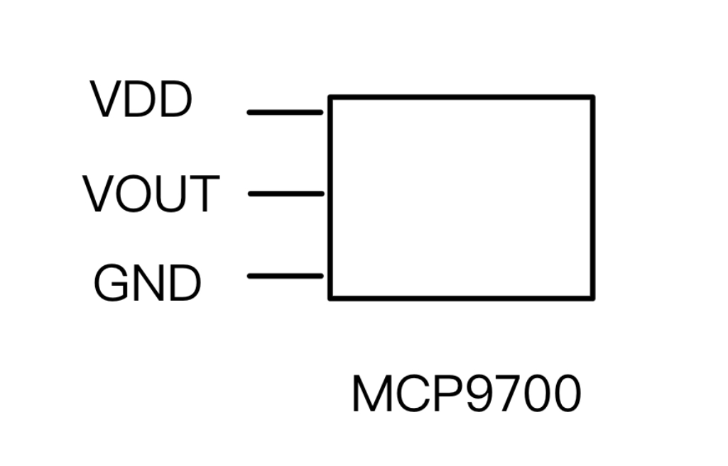

Figure 2. Temperature sensor circuit used for Task 1 data acquisition.
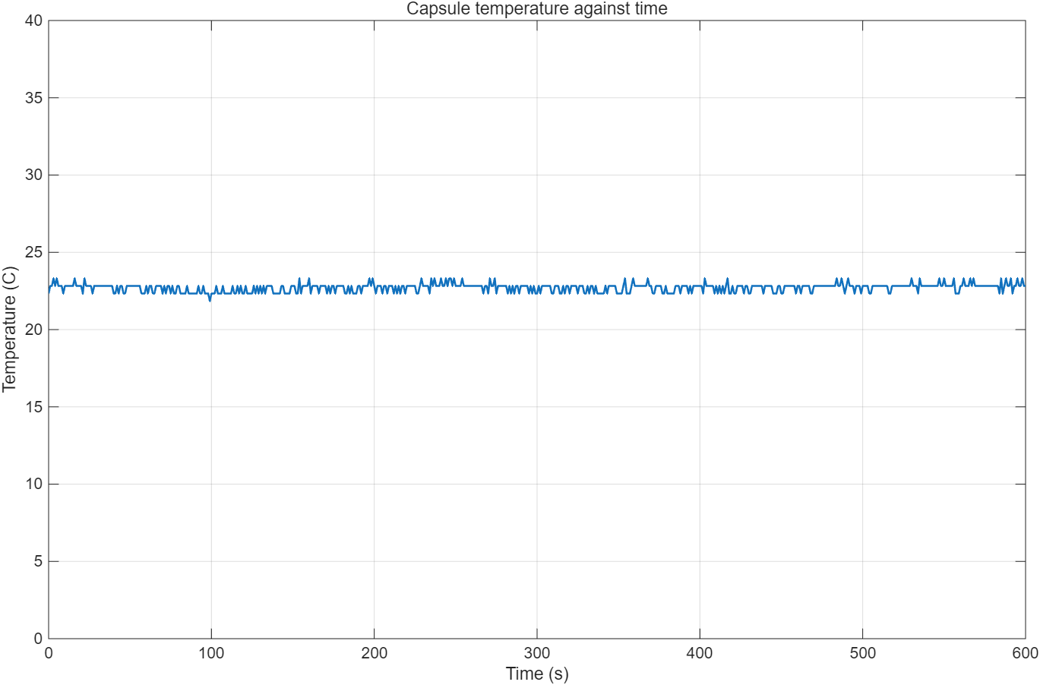
Figure 3. Temperature against time plot obtained from the 600 s Task 1 recording.
A summary of the recorded Task 1 values is given in Table 1. These values were taken from the generated capsule_temperature.txt log file.
Quantity | Value
Maximum temperature | 23.31 °C
Minimum temperature | 21.85 °C
Average temperature | 22.71 °C
Table 1. Summary statistics from the Task 1 temperature log.

Task 2 - LED Temperature Monitoring Device
Task 2 extended the hardware configuration to include the temperature sensor and three LEDs. The function temp_monitor.m continuously reads the measured temperature, updates a live graph and switches the LEDs according to the comfort band: green within 18-24 °C, yellow flashing below the range and red flashing above the range.
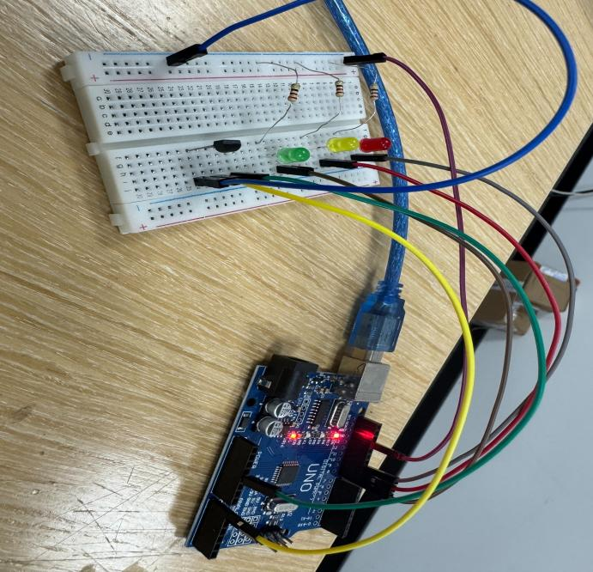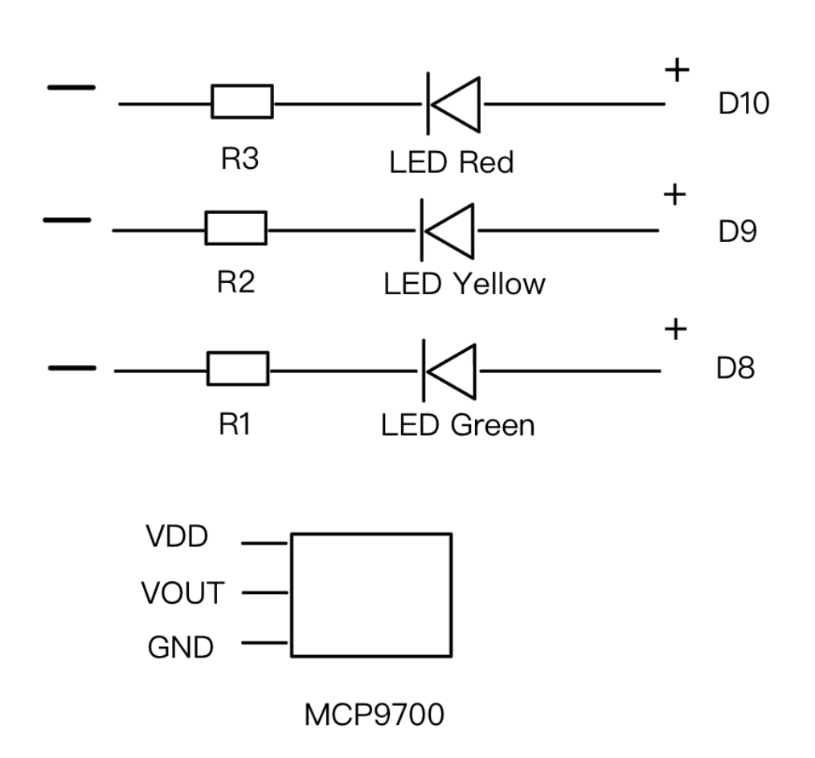
Figure 4. Combined temperature sensor and three-LED breadboard implementation for Task 2.
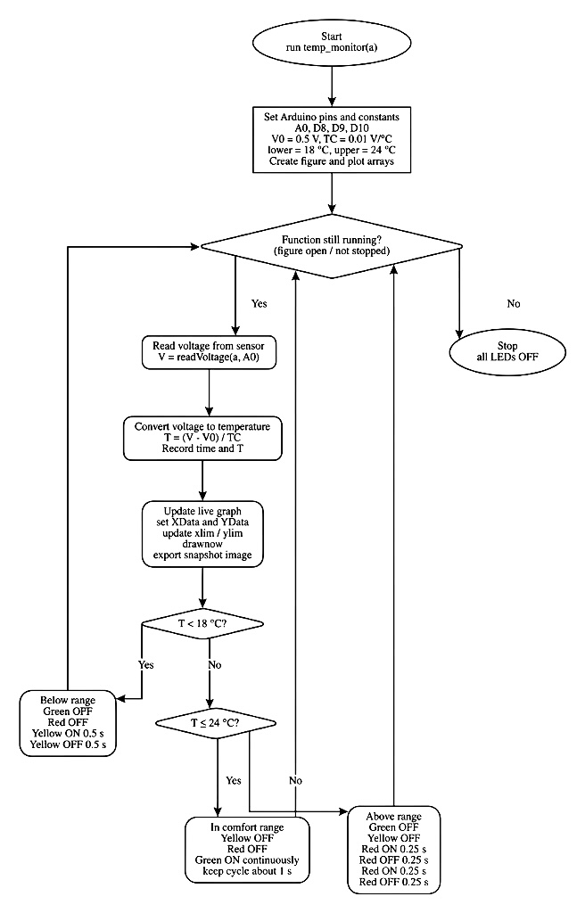
Figure 5. Task 2 flowchart showing the implementation plan before coding.
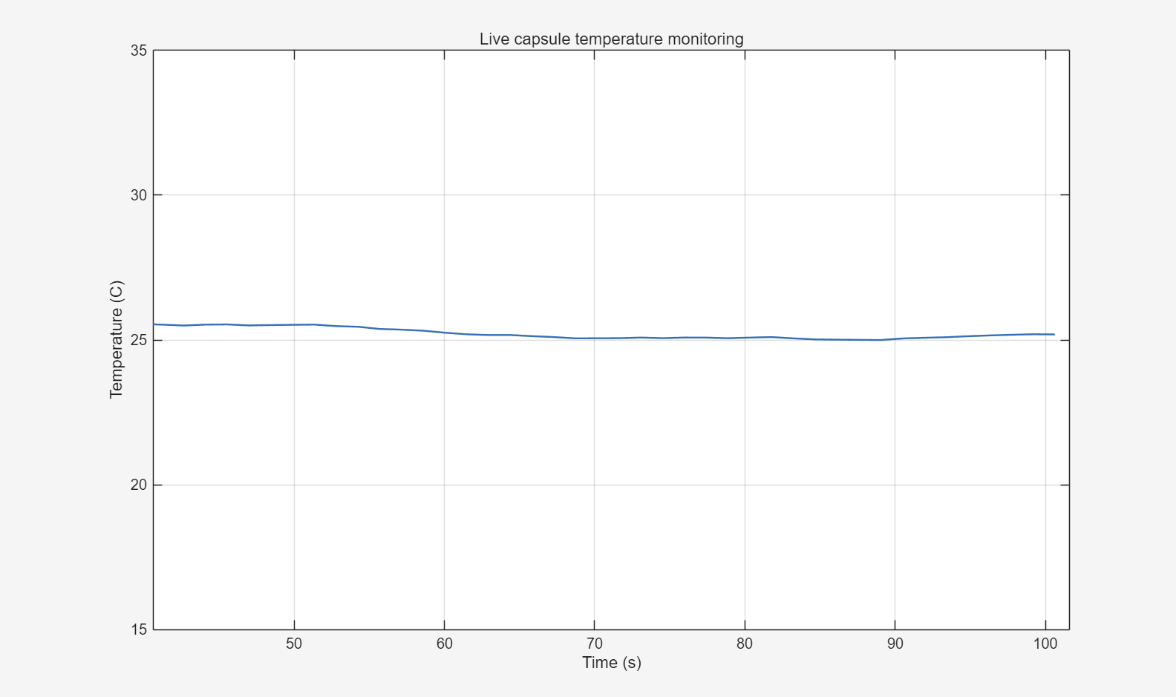
Figure 6. Screenshot of the live Task 2 temperature monitoring graph during operation.

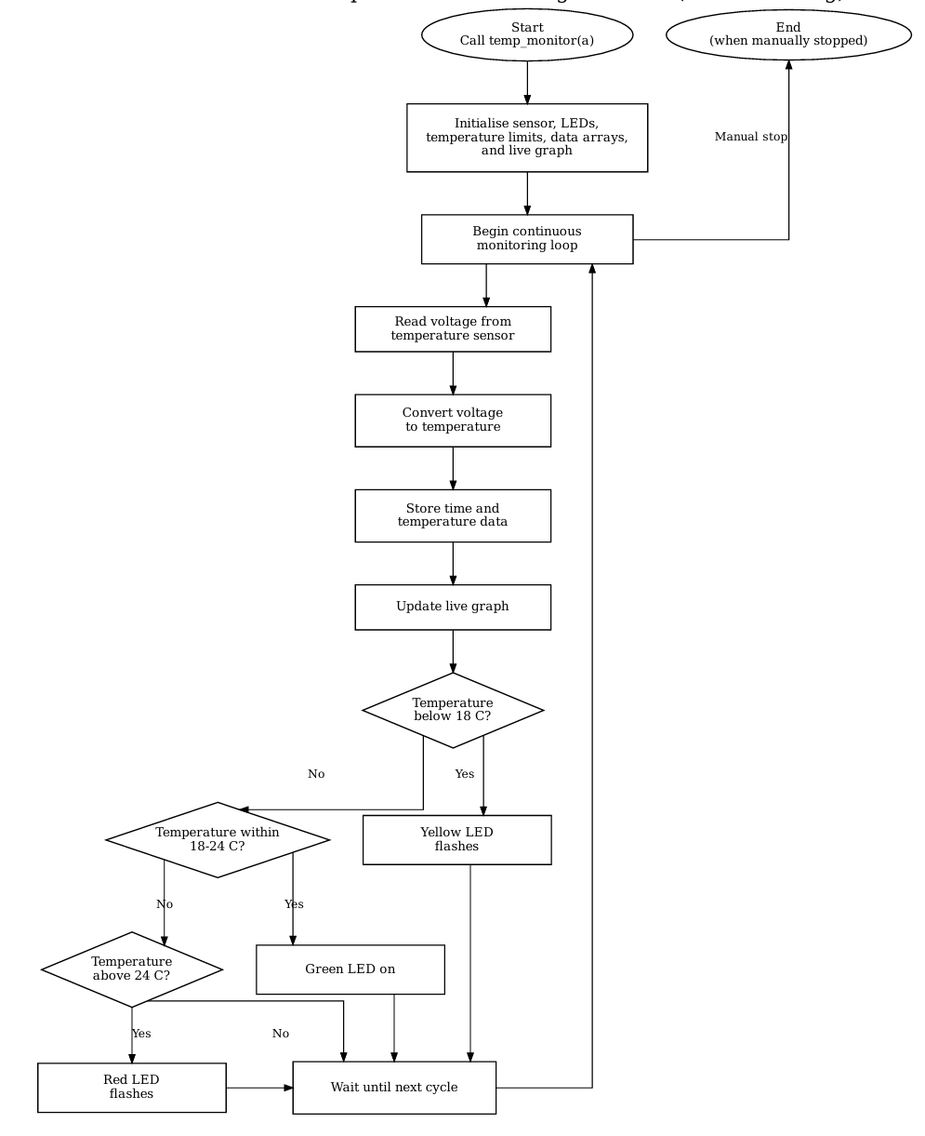

Figure 7. Updated Task 2 flowchart reflecting the final implementation logic.

Task 3 - Algorithms: Temperature Prediction
Task 3 uses the function temp_prediction.m to calculate the medium-term rate of temperature change in °C/s, predict the temperature 5 minutes ahead and control the LEDs using rate-based logic. A red LED indicates a rapid increase (> +4 °C/min), a yellow LED indicates a rapid decrease (< -4 °C/min), and a green LED is used when the temperature is stable within the comfort range.

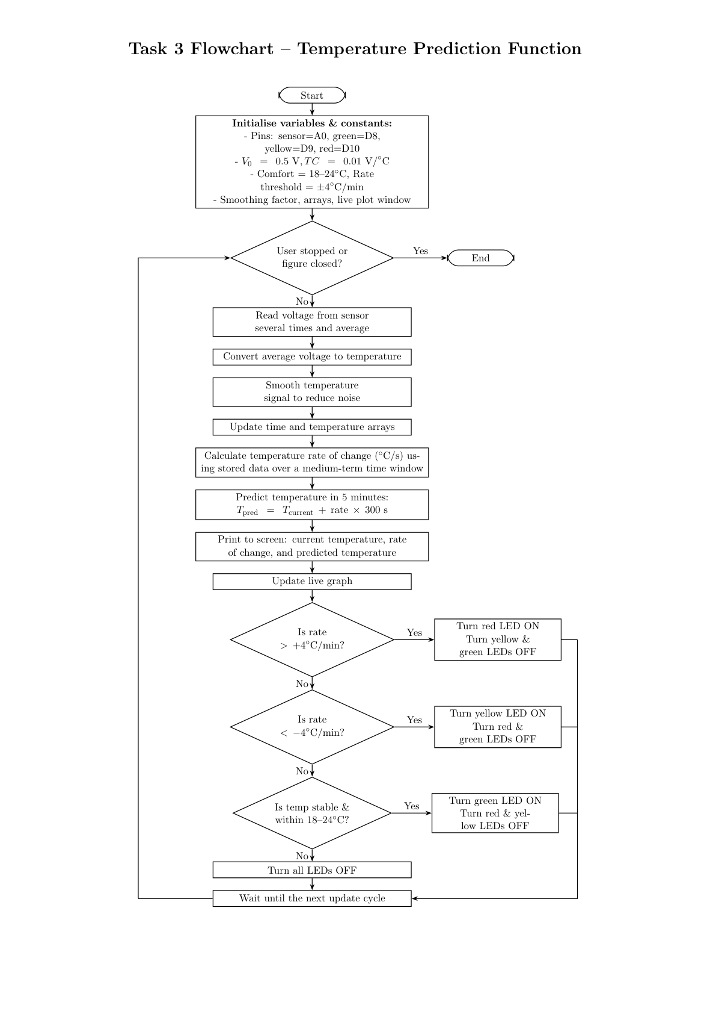
Figure 8. Task 3 flowchart for the temperature prediction function.

Task 4 - Reflective Statement
This project provided practical experience of linking MATLAB to Arduino hardware and using code to solve an engineering monitoring problem. One key strength of the work is that the final system integrates data acquisition, plotting, file output and LED-based feedback in a single workflow. The use of separate functions for temp_monitor and temp_prediction also made the program easier to read, test and extend. A further strength is that the breadboard implementation was tested in stages, beginning with the basic LED communication task and then progressing to the sensor circuit and the final three-LED arrangement.
The main challenges were associated with real-time behaviour and debugging. The monitoring and prediction functions both needed to run continuously, but the main script also needed to remain usable. This required changes so that Task 2 could be stopped cleanly before Task 3 was started. Another challenge was sensor noise. Even when the temperature was nearly steady, small voltage fluctuations produced visible variations in the measured temperature and in the predicted rate of change. Smoothing and a medium-term rate window improved the stability of the output.
The main limitation of the present system is that it is only a prototype. The prediction assumes that the recent rate of temperature change remains constant for the next five minutes, which is a useful approximation but not always physically realistic. The hardware layout is also temporary because it relies on a breadboard and jumper wires. In future work, the system could be improved by adding better filtering, a more advanced prediction method, automatic data saving for Task 2 and Task 3, and a more robust final circuit layout.

AI Use Declaration
AI tools were used only in a limited supporting role during the preparation of this coursework, such as how to create a Git-hub account and how to push the files into the repository. Their use was restricted to minor assistance with wording, formatting and general clarification of workflow. All MATLAB code, hardware implementation, testing, debugging decisions and final submission content were checked and completed manually without AI.

