Models of Communication

The Process of Communication raises some issue that need to be studied.
Communication research has its roots in the desire to increase efficiency and effectiveness in various spheres of life, including education, telecommunication, advertising and public relations. Various communication models have been developed with the aim of capturing the essence of the process of communication.

A model is a pictorial depiction of how communication looks if we diagram it. (Pearson & Nelson, 1993, p.10). One of the early, basic models was the sender-message-channel-receiver (SMCR) model, which is essentially a linear model and can be diagrammatically represented as follows.
Linear model (SMCR)
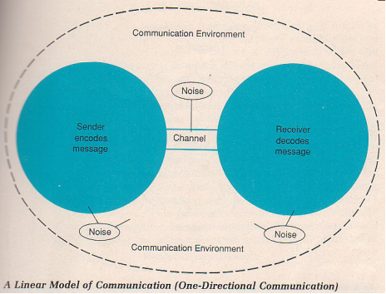

Here, communication is seen as a linear process in which a speaker encodes a message and sends it to a receiver through various channels e.g. audio, visual, etc. The receiver then decodes the message.

The linear model was modified from the 1950’s onwards, resulting in several different models which took into consideration additional aspects of communication e.g. the differences between interpersonal and mass communication, the purposiveness of communication, feedback in communication etc. Thus, based on the view that communication involves a sender, a message, a channel and a receiver, various models have evolved which reflect communication in different contexts.

The interactional model tries to capture the interactional and dynamic nature of communication and, like the linear model, the sender encodes a message and sends it to a receiver through various channels. The receiver decodes the message received. He/she then encodes feedback which is sent to the source (sender). The sender encodes a new message which is adapted based on the feedback received.

Example
Sender : Meet me at the library (message)
Receiver : Which one? (feedback)
Sender : CUEA library (adapted message)

People engage in interaction and this helps ensure that the message has been communicated as intended.
Example:
Sender : The chicken is ready to eat
Receiver : What shall I feed it?
Sender : No! I mean, the one we roasted is now cooked.

As you can see from the dialogue, the receiver also plays the role of a sender and provides feedback to the first sender. In this instance, the sender realises that miscommunication has occurred due to ‘noise’. Noise refers to any barrier that impedes effective communication. In this example, ambiguity led to a brief misunderstanding. With feedback, the sender was able to clarify his/her message, thus preventing further misunderstanding.

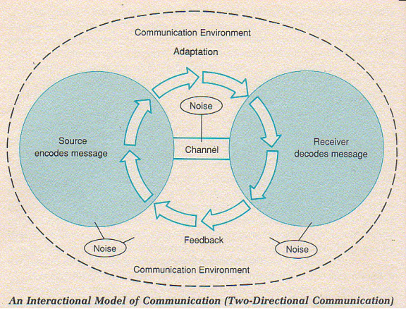

Transactional Model
Other thinkers have viewed communication as transaction. The process of encoding and decoding messages does not necessarily occur serially. The transactional model suggests that communication involves encoding and decoding messages and these processes may occur simultaneously. People simultaneously play the role of both sender and receiver. As a sender, person A asks: “Would you like a cup of tea?” As a sender, person A anticipates affirmative reply as Person B smiles and nods. People encode and decode both verbal and non-verbal messages in the process of communication.

