示例7-1

def crypt(source,key):   
    from itertools import cycle  
    result=''  
    temp=cycle(key)  
    for ch in source:   
        result=result+chr(ord(ch)^ord(next(temp)))  
    return result   
source='Shandong Institute of Business and Technology'  
key='Dong Fuguo'  
print('Before Encrypted:'+source)  
encrypted=crypt(source,key)  
print('After Encrypted:'+encrypted)  
decrypted=crypt(encrypted,key)  
print('After Decrypted:'+decrypted)

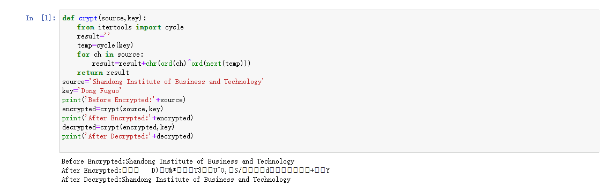

示例7-2

from random import choice,randint  
import string  
import codecs  
StringBase='\u7684\u4e00\u4e86\u662f\u6211\u4e0d\u5728\u4eba'  
def getEmail():   
    suffix=['.com','.org','.net','.cn']  
    characters=string.ascii_letters+string.digits+'_'  
    username=''.join((choice(characters) for i in range(randint(6,12))))  
    domain=''.join((choice(characters) for i in range(randint(3,6))))  
    return username+'@'+domain+choice(suffix)  
def getTelNo():  
    return''.join((str(randint(0,9)) for i in range(11)))  
def getNameOrAddress(flag):  
    '''flag=1表示返回随机姓名,flag=0表示返回随机地址'''  
    if flag==1:  
        rangestart,rangeend=2,5  
    elif flag==0:  
        rangestart,rangeend=10,30  
    result=''.join((choice(StringBase) for i in range(randint(rangestart,rangeend))))  
    return result  
def getSex():  
    return choice(('男','女'))  
def getAge():  
    return str(randint(18,100))  
def main(filename):  
    with codecs.open(filename,'w','utf-8') as fp:  
        fp.write('Name,Sex,Age,TelNO,Address,Email\n')  
        for i in range(200):  
            name=getNameOrAddress(1)  
            sex=getSex()  
            age=getAge()  
            tel=getTelNo()  
            address=getNameOrAddress(0)  
            email=getEmail()  
            line= ','.join([name,sex,age,tel,address,email])+'\n'  
            fp.write(line)  
def output(filename):  
    with codecs.open(filename,'r','utf-8') as fp:  
        for line in fp:  
            line=line.split(',')  
            for i in line:  
                print(i,end=',')  
            print()  
if __name__=='__main__':  
    filename='information.txt'  
    main(filename)  
    output(filename)

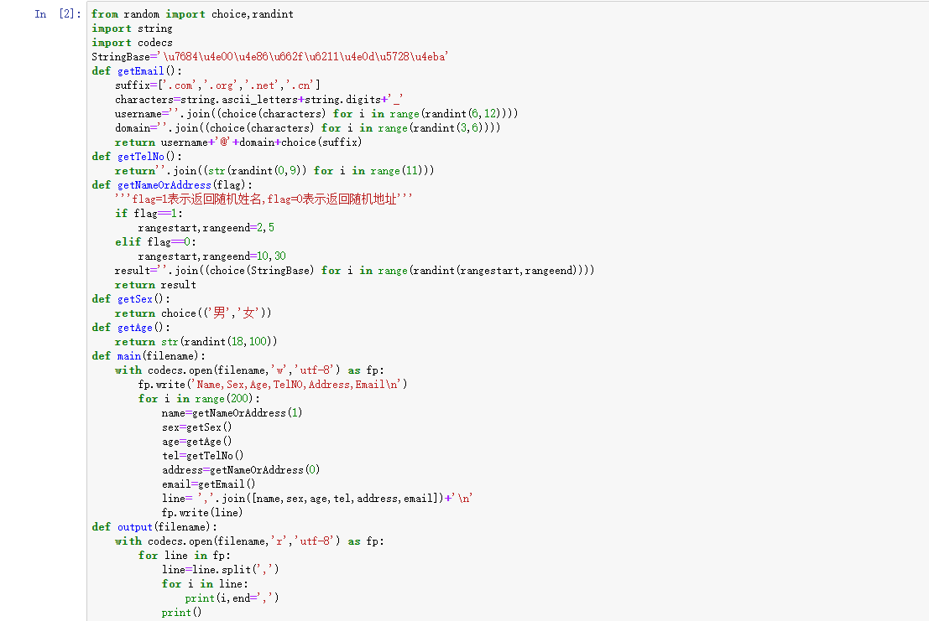

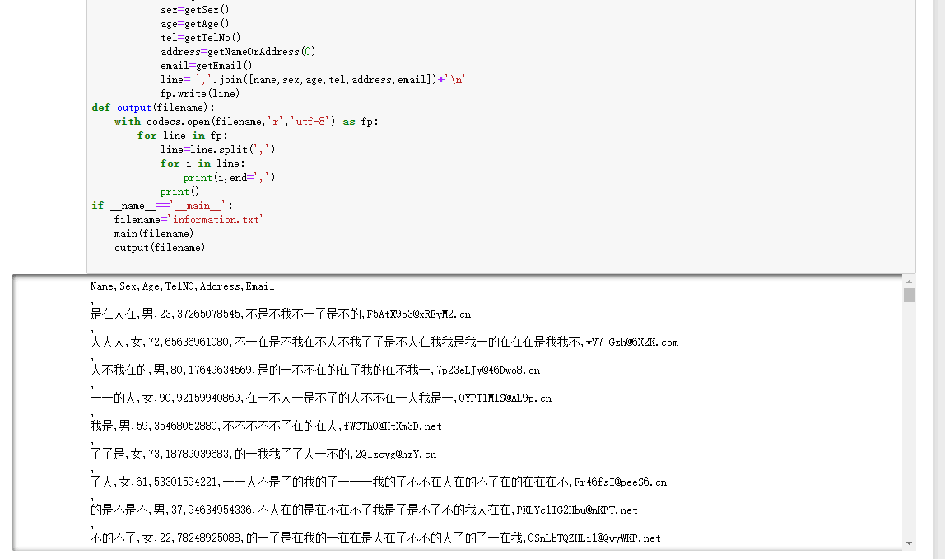

示例7-3

import string  
def check(pwd):  
    if not isinstance(pwd,str) or len(pwd)<6:  
        return'not suitable for password'  
    d={1:'weak',2:'below middle',3:'above middle',4:'string'}  
    r=[False]*4  
    for ch in pwd:  
        if not r[0] and ch in string.digits:  
            r[0]=True  
        elif not r[1] and ch in string.ascii_lowercase:  
            r[1]=True  
        elif not r[2] and ch in string.sacii_uppercase:  
            r[2]=True  
        elif not r[3] and ch in ',.!;?<>':  
            e[3]=True  
    return d.get(r.count(True),'error')  
print(check('a2cd,'))

