Lottery for picture of Blessed Mary

|  |  |  |  |  |
| --- | --- | --- | --- | --- |
| Number | | «M_1» | رقم | |
| **Name** |  | | | **اسم** |
| **Mobile #** |  | | | **رقم الهاتف المحمول** |

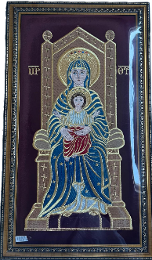

Lottery for picture of Blessed Mary

|  |  |  |  |  |
| --- | --- | --- | --- | --- |
| Number | | «M_1» | رقم | |
| **Name** |  | | | **اسم** |
| **Mobile #** |  | | | **رقم الهاتف المحمول** |

Lottery for picture of Blessed Mary

|  |  |  |  |  |
| --- | --- | --- | --- | --- |
| Number | | «M_1» | رقم | |
| **Name** |  | | | **اسم** |
| **Mobile #** |  | | | **رقم الهاتف المحمول** |

