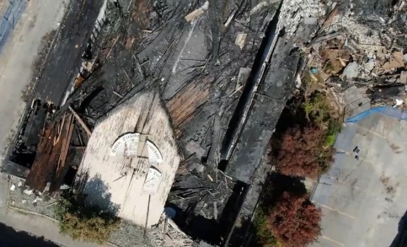

On July 19th, 2021, someone thoughtlessly chose to set fire to our beloved St-George Coptic Church in Surrey, BC; nothing remains except ashes and memories. This has left us homeless without a place to worship or hold our many services.

**Now, we need your help to rebuild our church.** We would greatly appreciate your support for our Walkathon fundraising event on September 7th, 2024. Tax receipt will be provided for a donation of $20 or more.

|  |  |  |  |
| --- | --- | --- | --- |
| Name | Address | Telephone | Amount |
|  |  |  |  |
|  |  |  |  |
|  |  |  |  |
|  |  |  |  |
|  |  |  |  |
|  |  |  |  |
|  |  |  |  |
|  |  |  |  |
|  |  |  |  |
|  |  |  |  |
|  |  |  |  |
|  |  |  |  |
|  |  |  |  |
|  |  |  |  |
|  |  |  |  |
|  |  |  |  |

On Behalf of the St-George Coptic Orthodox Church Board