Overview

In this practical, we were asked to write a simplified version of chess using Object-Oriented programming. Out of the 4 parts of the specification, I properly implemented the first 3 parts of the specification while only just starting on part 4. In my current implementation all the pieces have their usual functionality, with the exception of pawns being unable to perform ‘en passant’ and castling. The win condition in my implementation is also not complete.

This section should contain a short overview of the practical:
- What were you asked to do?
- What did you achieve?
- Which parts have you completed and to what extent?

Design

The starter code provided to me contained two main classes, Game and Board, with the W08 class acting as the driver class for these.

I chose to minimise the modifications I made to the Board class. I could have chosen to create a Piece class and change the game board to be an array of piece objects, but I thought this would require rewriting the starter code, and I wasn’t sure if I was allowed to do that. I do believe this would have made for a more elegant solution, but I chose not to take that risk.

I decided that the Game class should contain the behaviour of checking legality of moves, moving pieces, and checking win conditions. I do believe that this makes sense for the Game class, as these are the main component actions of the game and are executed every loop. For moving the data of the each move from the different methods of the class, I chose to use a String with 4 chars, for e2 to e3, the String would be e2e3.

I believe that the interesting design decisions are in the isMoveLegal() method. This method has some helper functions that go along with it. I chose to split the legality of the move into six flags
- isPathValid:
  - This flag calls its own special functions called checkPath(), that checks all the squares between two points, making sure that no piece obstructs this path.
- isRuleBound:
  - This flag just checks if the move follows the given piece’s move set according to the rules of chess. This is executed in a switch statement based on the piece’s type.
- isColourCorrect:
  - This flag makes sure that only the pieces of the current player can be moved in the current turn.
- isTargetValid:
  - This makes sure that the target is able to be captured.
- isOutOfBounds:
  - This flag stops the piece from leaving the edges of the board.

My attempt at part 4:
The main way I thought to check if the king was in check was the concept of a ‘reachability’ function. This function given the coordinates of a square on the board, and a certain colour, would tell you whether a piece of that colour could reach that square, either to capture or to move. My idea was to run this reachability function for the King every turn, and if a piece of the other colour was able to reach the King, the King would be placed in check.

I have implemented this method as the isReachable(), but it isn’t used in the code.
Testing

Describe how you tested your program. This should include the stacscheck output, but also any other way you made sure that your program is complete and works correctly. If you include screenshots like the one shown below in Figure 1, make sure to add a caption and refer to it from the text of the report.
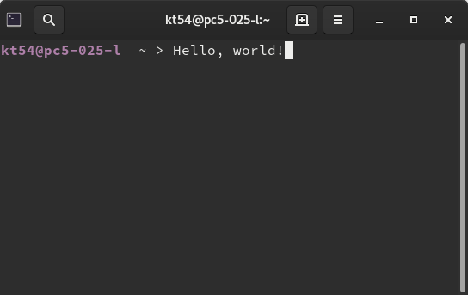Figure 1: All stacscheck tests successfully passed.
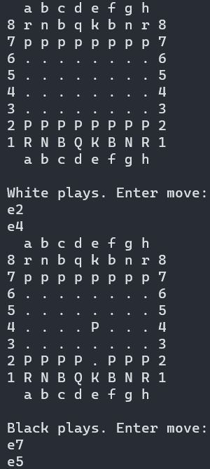
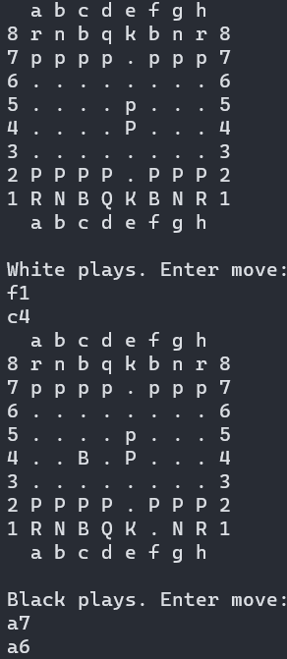
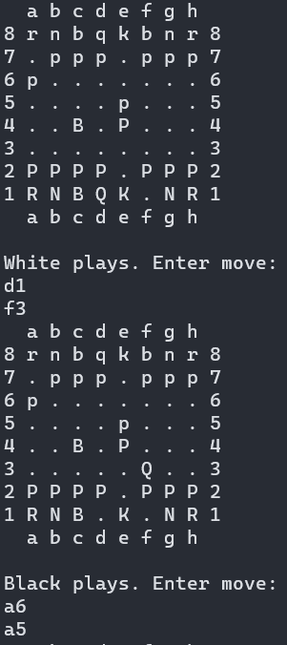

Evaluation

Evaluate the success of your program against what you were asked to do.

Conclusion

Summarise what you achieved, what you found difficult, and what you would like to do given more time.

