Functional & Technical

Requirements Document

Data Structures (CS-221) | WVUP | Fall 2016

glFreecell

**groovyLlama DevTeam**

Casey Murphy Brandon Wharton Ryan Whytsell Gordon Finnie

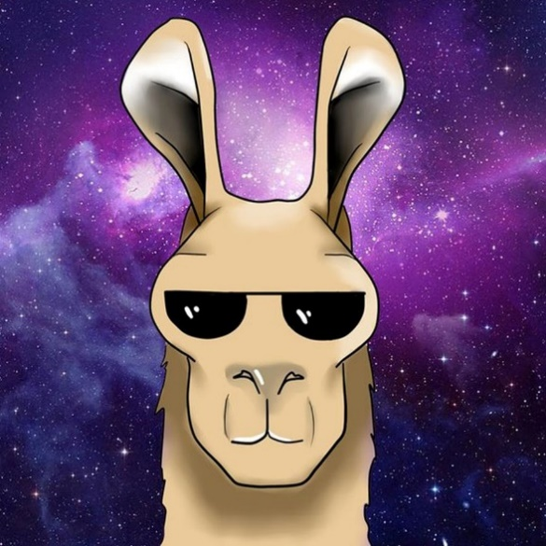

# Table of Contents

1. PROJECT INFORMATION
   1. Purpose………………….…………………………………………………………………………………………………………………3
   2. Scope…………………….………………………………………………………………………………………………………………….3
   3. Objectives…………………………………………………………………………………………………………………………………3
   4. Communication…………………………………………………………………………………………………………………………4
   5. Collaboration…………………………………………………………………………………………………………………………….4
2. GAME DESIGN
   1. Game Rules…………………….…………………………………………………………………………………………………………4
   2. Game Specifications…………………….………………………………………………………………………………….……..…5
3. FUNCTIONAL REQUIREMENTS
   1. Object Types…………………….………………………………………………………………………………………………………6
   2. Object Interaction…………………….………………………………………………………………………………………………6
4. TECHNICAL REQUIREMENTS
   1. Project Structure…………………….………………………………………………………………………………………………...7
   2. Data Structures…………………….…………………………………………………………………………………………....…….8
5. SOFTWARE
   1. Interfaces…………………….…………………………………………………………………………………………………………..8
      1. CLI…………………….……………………………………………………………………………………………………………..8
      2. GUI…………………….…………………………………………………………………………………………………………….9
   2. Integration………………………………………………………………………………………………………………………………..9
   3. License…………………….………………………………………………………………………………………………………………..9
6. DIAGRAMS
   1. UML Class Diagrams…………………………………………………………………………………………………………………10
   2. Relational Diagram.……….…………………………………………………………………………………………………………16

# 1. PROJECT INFORMATION

1.1 Purpose

For the final project in Data Structures, we are to work as a team to plan, develop, and fully realize a GUI-based Freecell game with all functionality one would normally see in such a game. Freecell will be written with Java 1.8+ and will utilize coding techniques covered throughout the course of this semester, including the implementation of customized data structures unique to Freecell and solving Freecell games.

1.2 Scope

Development progression will be reviewed weekly by our peers and teacher in a classroom environment. The project will culminate in a presentation of our finished product to the class, school officials, and members of the development community.

1.3 Objectives

Week 1 –

* Plan the overall structure as a rough draft.
* Determine a list of objects that will be needed.
* Build initial diagrams.

Week 2 –

* Discuss refinements to the design and update diagrams accordingly.
* Build basic structures that will be needed (i.e. Card, Deck, Cell).
* Design interfaces (CLI, GUI).

Week 3 –

* Define mechanics (Engine, Turn, Board) and game rules.
* Build basic versions of game classes.
* Build a lightweight and functioning model of the design.

Week 4 –

* Make any necessary tweaks to the design.
* Complete game mechanics.
* Develop solver structures and algorithms.

Week 5 –

* Test and debug mechanics that are in place.
* Refine and tweak codebase for improvements in design and efficiency.
* Game fully playable in CLI and GUI.

Week 6 –

* Optimize solver algorithms for speed.
* Full game with complete interface integration.
* Update all documentation (JavaDocs) and diagrams.

1.4 Communication

We will meet in person as our schedules permit. Primarily, we will use our designated Slack channel as our means of communication throughout the project. For conference calls, we will use our designated Discord channel.

For task assignment and issue handling we will use the GitHub software repository framework. It will allow us to maintain real-time updates and tracking at each stage of development. If an issue arises, any team member has the ability to add, update, and/or close the issue. Utilizing this tool will greatly aid in development flow.

1.5 Collaboration

Our project is hosted on GitHub and has six branches. Master will house stable versions and will be updated when the team deems fit. Develop will house working versions that still have issues to be resolved. The other four branches are for each team member, respectively. Each team member will work from their branch. We will collaborate by pulling from one another as we see fit and to ensure that we are working from the same codebase. Develop is the branch designated to that end, but if multiple team members are working on a specific task they may choose to keep the work in their own branch until a stable point is reached to merge. Both Master and Develop will be free from execution errors to ensure a clean working/testing environment.

# 2. GAME DESIGN

2.1 Game Rules (adapted from: <http://www.casteel.org/Pages/FreeCellrules.html>)

As the game begins, glFreecell deals all the cards from the deck face up into the playing piles, starting from left to right, top to bottom.

The object of the game is to build all the cards face up on the home cells (top right). Each home cell builds upward, in sequence, starting with the Ace. Only aces may be moved to an empty home cell, and only the next higher card of the same suit can be added to the home cell.

Only one card at a time may be moved in free cell, either the top card of a playing pile (bottom columns) or the single card which was placed in a free cell. As a short cut, glFreecell allows you to move a legal sequence of cards from one column to another, provided there are enough empty cells to have made this move one card at a time. The move will be scored as if you had moved one card at a time.

Only the next higher card of the same suit can be added to each home cell. Cards may be moved to the home cells from the playing piles or from a free cell. Cards cannot be removed from a home cell.

Any card may be moved to an empty free cell or an empty playing pile.

A card may be added to a non-empty playing pile only if it is the next lower value than the current top card and of alternating color. For example, only the 9 of hearts or diamonds (red suits) may play on the 10 of spades (a black suit).

2.2 Game Specifications

* On the deal, glFreecell will automatically stack appropriate cards into the home cells (i.e. Aces on the top of a playing pile will stack into a home cell). For any amount auto-stacked, the turn increment for that action will be only one.
* If the next card in a home cell sequence is opened up, it will automatically be placed in the appropriate home cell and the turn will be incremented once per card stacked.
* Double-clicking a card will place it in its home cell if it is valid. If it cannot go into a home cell, the action will place the card into the first available free cell.
* Card sequences can be pulled from a playing pile if there are available slots to make the sequenced move (i.e. moving a group 9, 8, 7 to a pile with a 10 on top).
* The ‘New Deal’ button deals a new hand of glFreecell and resets engine statistics. Can be done at any time.
* The ‘Undo’ button sets the board to the state it was in one move ago. If there are no moves to undo, the button is grayed out (GUI) or the option is unavailable (CLI).
* The ‘Redo’ button sets the board to the state it was in one move ahead. If there are no moves to redo, the button is grayed out (GUI) or the option is unavailable (CLI).
* The ‘Hint’ button will highlight all available moves from that specific turn. For instance, if a free cell is open, then all top cards in the playing piles will be highlighted.
* The ‘Solve’ button will initiate program generated movement on the board towards the calculated solution.
* All resources (images, sounds, artwork, notes) can be found in the project folder under /resources/.

# 3. FUNCTIONAL REQUIREMENTS

3.1 Object Types

* Card
* Deck
* Board
* Free Cell
* Home Cell
* Playing Pile
* Game Engine
* Game Turn
* Solver Engine
* Solver Search
* CLI Client
* GUI Client
* System Utilities

3.2 Object Interaction

*For a detailed layout of object relationships please refer to section 6.*

*This is a basic depiction of the main objects used in each break down.*

main 🡪 GUI, CLI

GUI 🡪 Engine

CLI 🡪 Engine, Turn, GUI

Engine 🡪 Board, Turn

Turn 🡪Board, Solver

Solver 🡪 Solver Engine, Solver Search

Board 🡪 Deck, Free Cell, Home Cell, Playing Pile

Deck 🡪 Card

# 4. TECHNICAL REQUIREMENTS

4.1 Project Structure

glFreecell includes six top-level packages:

* board
  + Board – game board; houses all other components in this package
  + CellInterface – interface for cell objects
    - FreeCell – top leftmost of board
    - HomeCell – top rightmost of board
  + PlayingPile – columned piles
* client
  + cli
    - CLI – command line interface
    - Debugger – toggles all debug switches
    - Tester – runs all class unit tests and holds customized tests
  + gui
    - FreeGUI – graphical user interface
  + Driver – entry point into program
* engine
  + Engine – drives the game; houses main game loop
  + Turn – represents one turn as the successful movement of a single card
* playingCards
  + CardInterface – interface for card objects
    - StdCard – standard playing card
  + DeckInterface – interface for deck objects
    - StdDeck – standard deck of 52 playing cards (no jokers)
  + DeckException – for error handling of a deck object
* solver
  + Pattern – solver algorithms
  + Search – search pattern
  + Engine – drives solver through turns with no human interaction
* utils
  + SysUtils – access to system utilities such as path building to game resources (images, sound effects, etc)

4.2 Data Structures

* Playing cards are generated based on several in-class arrays of card values and card suits.
* A deck is generated by passing looped modulo expressions into the playing card constructor.
* The game board contains a deck and mapped regions pointing to each free cell, each home cell, and each playing pile. The free cell, home cell, and playing pile regions are fixed-size arrays of their respective type.
* A free cell can contain one card or no card.
* A home cell can contain one card or no card. As each subsequent card in the sequence is added to the home cell it becomes the top card and the underlying cards are no longer accessible. They can be retrieved within the board history. As cards cannot be removed from a home cell, so nothing is lost in utilizing this method of home cell storage.
* A playing pile contains an ArrayList of the cards currently in that pile. As the cards need to be accessed by index when the board is painted/printed, the ArrayList provides a perfect mechanism for working within the given constraints.
* The engine holds the current board, board history, move number (as dictated by the game loop), and the source and destination mapping for a played turn. The board history is a stack of boards corresponding to each move played.
* The turn holds the game board that is passed in from the main loop with its move number and the source and destination mapping. The turn checks a move for validity before it returns to the engine.
* Once the solver is in place the turn will run a check every time a move is played to see if the layout is winnable. The solution and winnable status will be associated with the turn so that if the move is undone and redone, turn does not have to recalculate a solution.

# 5. SOFTWARE

5.1 Interfaces

glFreecell will have two types of interface. The GUI will be default for execution. The CLI will be accessed through a command-line option. For the purposes of our final presentation, we will demonstrate both interfaces.

5.1.1 CLI

A playable, command-line version of the game will be accessible through an in-game command prompt. This mode will have an option to start a game in GUI or CLI. There will be an integrated testing and debug framework within the program so that execution steps and debug statements may be observed while playing/testing.

5.1.2 GUI

A playable Freecell game will be dealt and await user input on program execution. If started from the CLI in debug mode, the debug statements will print to track program execution while in the GUI. (Layout design shown below)

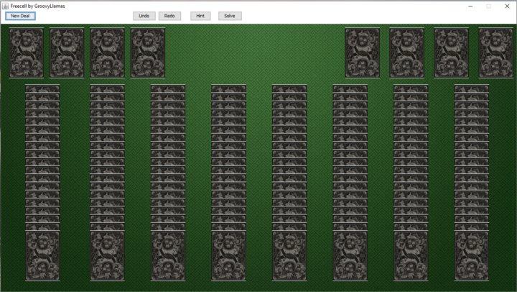

5.2 Integration

The GUI integrates with the game engine and touches no other components. Within the main game loop, the board is rendered after each turn is played. The transitions will be animated and flow with user action so that the re-render is an invisible transition.

Likewise, GUI event handling happens within the client.GUI package and is transferred to engine.Engine.

5.3 License

GNU GENERAL PUBLIC LICENSE

Version 3, 29 June 2007

<https://www.gnu.org/licenses/gpl-3.0.txt>

# 6. DIAGRAMS

6.1 UML Class Diagrams













6.2 Relational Diagram

