Nkumbu Kalyepe

CLDV6212
ST10446547

5 Records in Table Storage
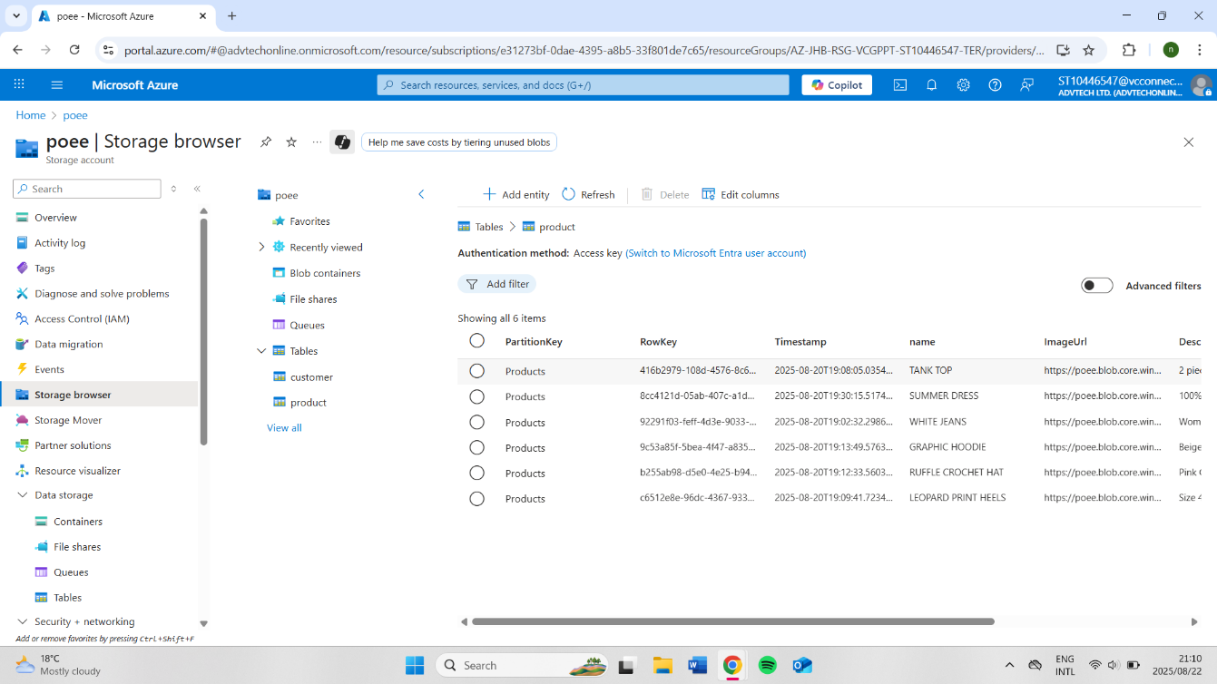
5 Records in Blob Storage
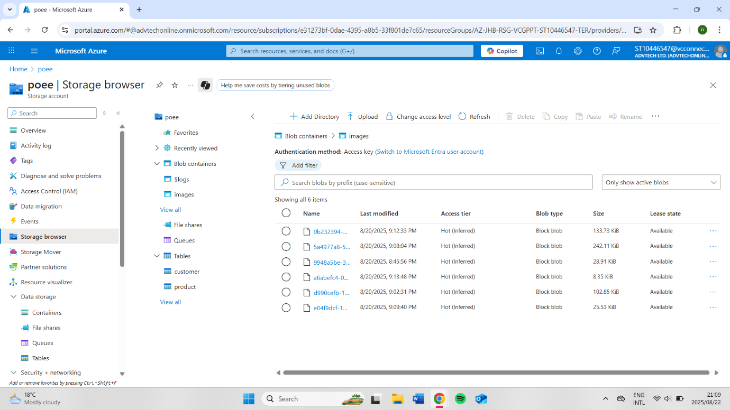

5 Records in Queues
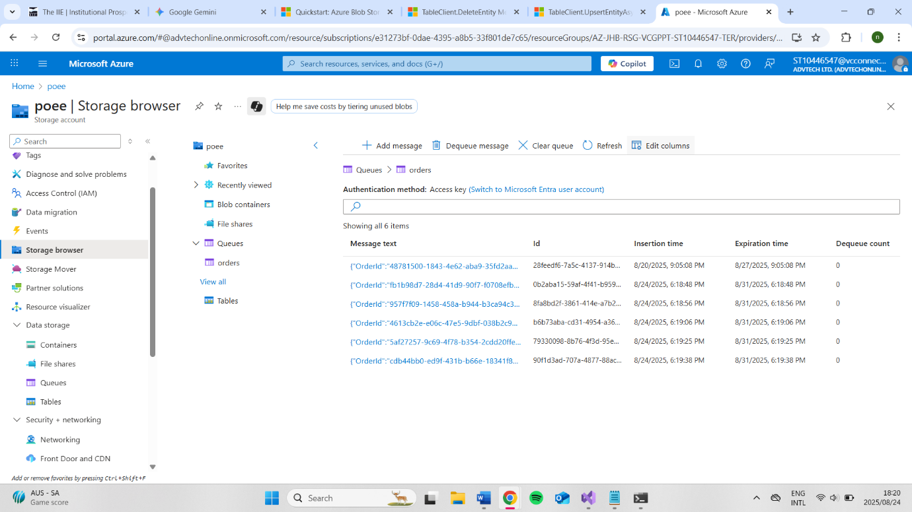
5 Records in Azure Files
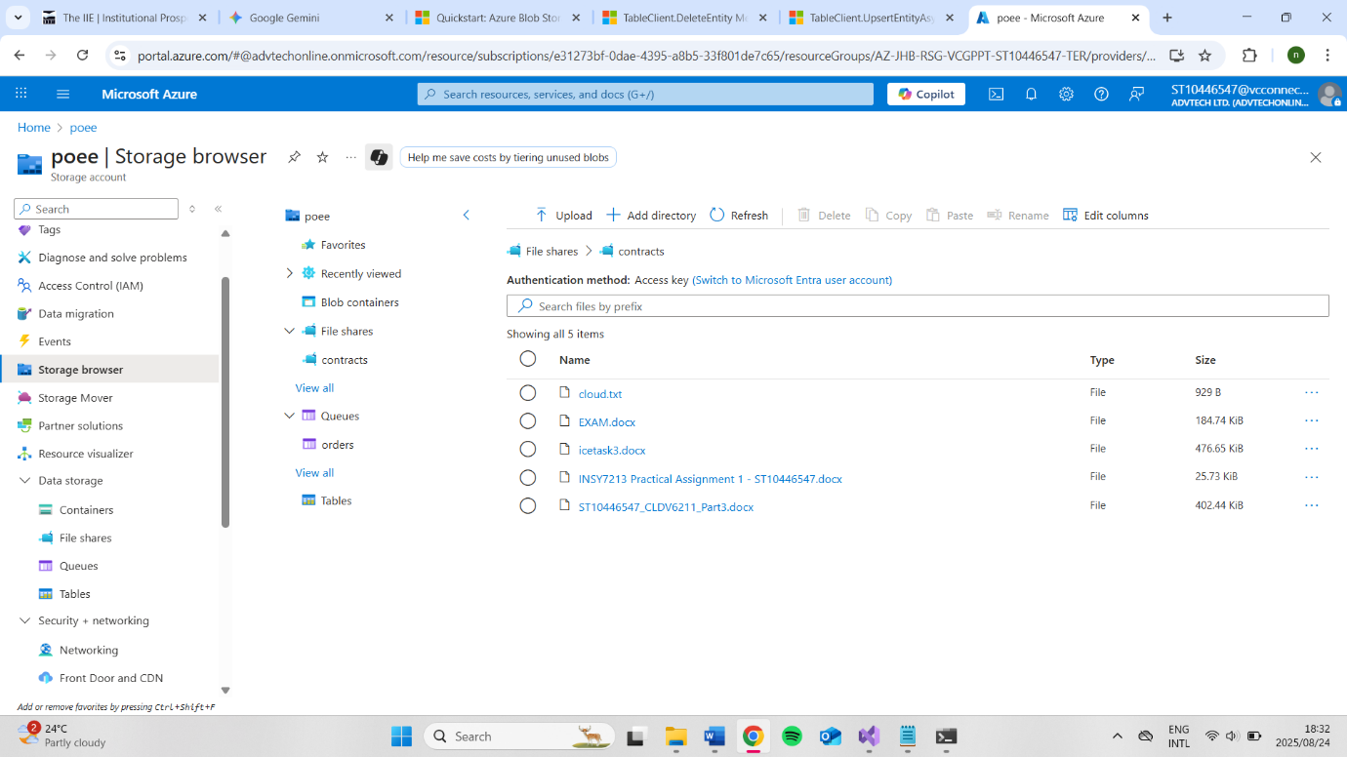

Azure Deployment Screenshot
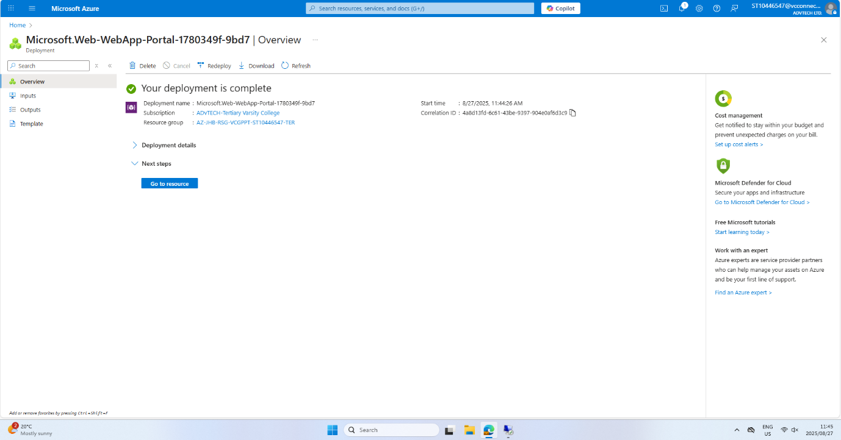
Website URL link
https://st10446547-crd0g4cvhshbbhaz.eastus-01.azurewebsites.net/
GitHub Link
https://github.com/VCPTA/bcad2-cldv6212-part-1-submission-NkumbuKalyepe
YouTube Link
https://youtu.be/eRIGMzW8WqY

