MODULE NAME: DATABASES

MODULE CODE: SBAS211

NAME: Onkgopotse Mopleoa

STUDENT NUMBER: ST10162586

**QUESTION 1**

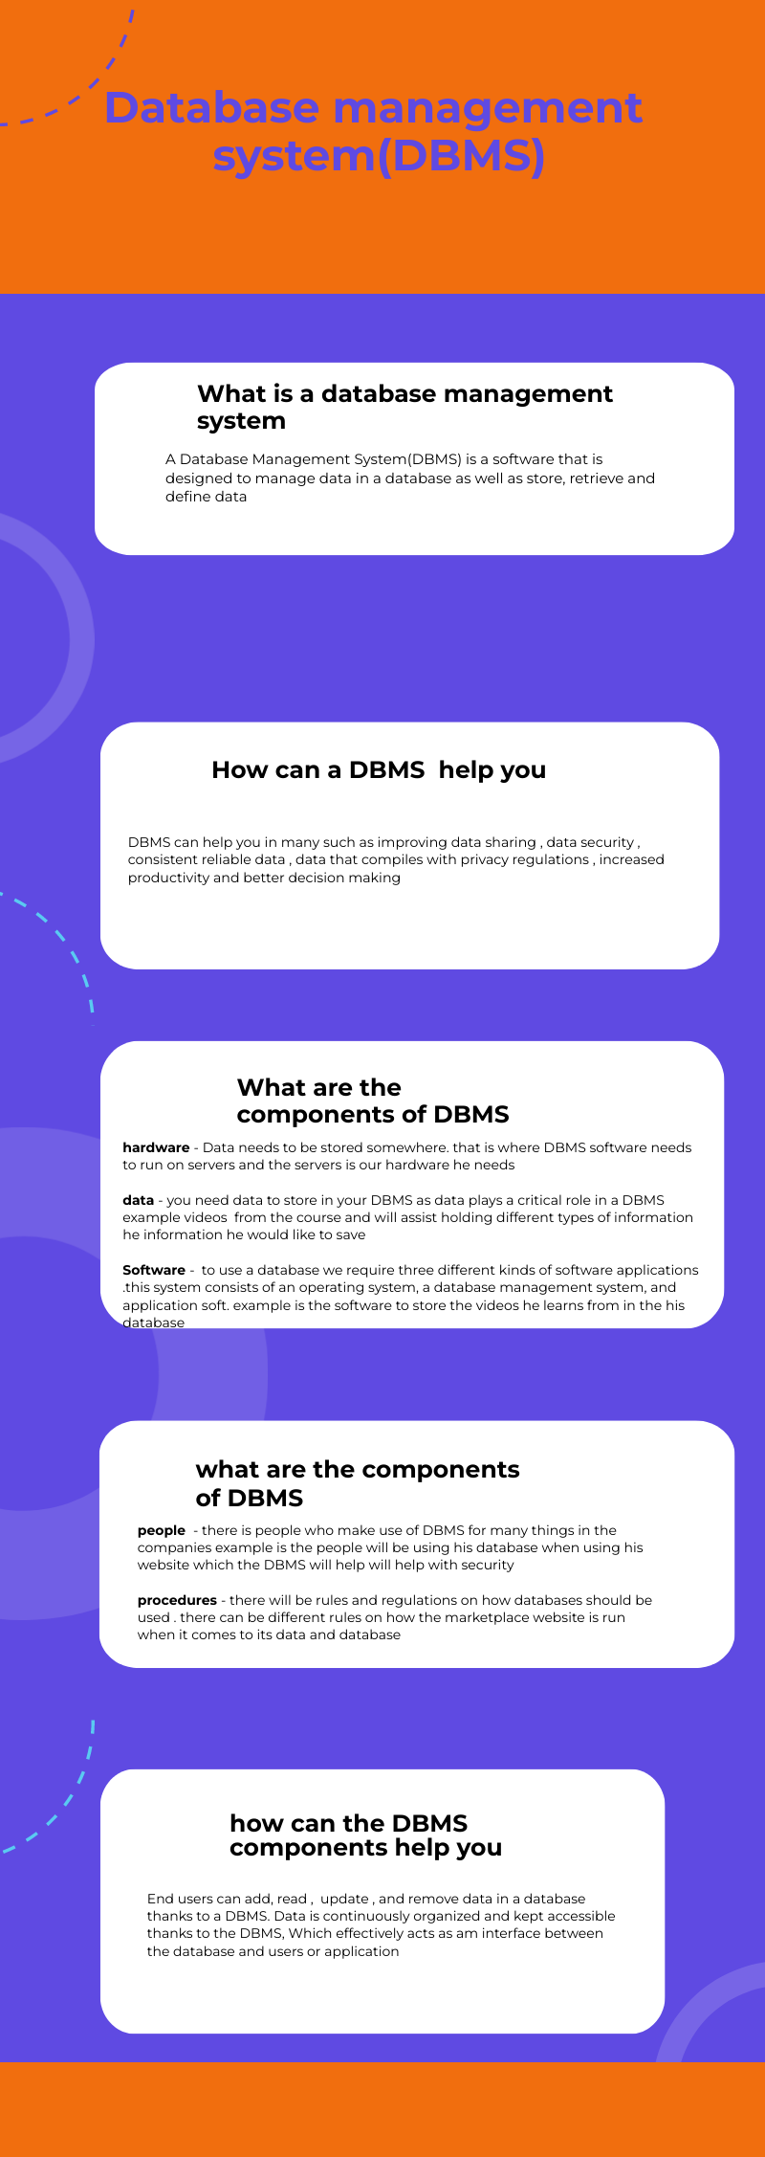

**QUESTION 2**

1. For data about courses for example the name of the course, name of the creator and category that course belongs I would advise Thato to use a rational database. data can be arranged into row or columns which create a table where data can be organized in a table or tables that can be linked together using a primary key or foreign key these Identifiers can show connections across tables that exist. Furthermore rational data bases would be easier for Thabo to use and it would be better and easier for Thabo to backup as rational databases are transactional. (Lutkevich, 2021)
2. For data such as videos, pictures, and files the courses creators want to make available to those purchasing their courses. I would advise Thabo to use a non-relational as it doesn’t use a table , rows, columns instead a non-rational uses a storage model that’s more effective for the type of data Thabo wants to store. The databases might be based on data structures like documents, for example a document can be highly detailed as well with a different types of information in multiple formats Non-rational is better at organizing different types of information side by side which makes it perfect for Thabo to use for the videos , pictures and files which can be large quantities of large complex data which is diverse unstructured data (Pattinson, 2022)

**QUESTION 3**

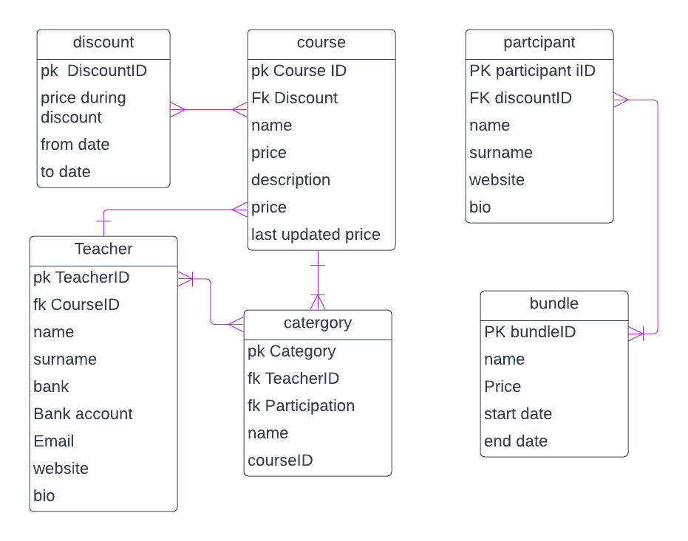

**QUESTION 4**

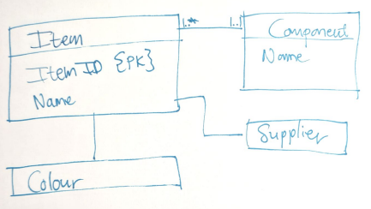

1. When it come to the supplier entity the supplier name must be a primary key
2. By the supplier entity there must be an itemID field as well as he should make it a foreign key because the supplier can supply a specific item
3. there should be a foreign key in the colour entity as well as add a itemID field in the colour entity
4. supplier name must be a primary key in the supplier entity.
5. The supplier and the component entity should also be connected as well. Given that a single supplier can provide several components, the relationship that should exist is a one-to-many relationship.
6. The supplier's relationship with the item entity must be a one-to-many relationship.
7. There should be field for component name in the item entity and it should be a foreign key since a component can be used to make different products.
8. Because a component can be utilized to create several goods, a component name field in the item entity should be a foreign key.
9. Another record of quantity of components must be added
10. Component and the item entity should be a one to many relationship as one component can be used for many things

# Bibliography

Lutkevich, B., 2021. *relational database.* [Online]   
Available at: https://www.techtarget.com/searchdatamanagement/definition/relational-database  
[Accessed 11 April 2023].

Pattinson, T., 2022. *Relational vs. Non-Relational databases.* [Online]   
Available at: https://www.pluralsight.com/blog/software-development/relational-vs-non-relational-databases  
[Accessed 11 April 2023].