KHENSANE SIBANDE
ST10208042
WEDE5020
GR15


KHENSANE SIBANDE 1
1. Organisation Overview 4
2. Website Goals and Objectives 4
3. Current Website Analysis 5
4. Proposed Website Features and Functionality 5
5. Design and User Experience 5
6. Technical Requirements 6
7. Timeline and Milestones 6
8. Budget 7
9. Sitemap and File Structure 7
10. Wireframe Plan 8
11. References 9
Submission Checklist 9
WEBSITE STRUCTURE AND PLANNING 10
6.1 Sitemap 10
6.2 Sitemap Hierarchy 10
6.3 Low-Fidelity Wireframes 12
6.4 File and Folder Structure 13

1. Organisation Overview
Khency Beauty & Wellness Spa is a proposed small beauty and wellness business based in Johannesburg, South Africa. The organisation provides personal-care and relaxation services including facial treatments, massage therapy, manicures, waxing and cupping therapy. The purpose of the business is to provide clients with a welcoming environment where they can access professional beauty and wellness services.
The proposed website will create a professional online presence for the organisation and provide one central place where customers can learn about the business, view available services, enquire about treatments and find contact and location information. The target audience includes adults and young adults who value personal grooming, relaxation, skincare and accessible wellness services.

2. Website Goals and Objectives
The main goal of the website is to create an attractive, informative and easy-to-navigate online presence that increases awareness of Khency Beauty & Wellness Spa and encourages customers to make enquiries.
- Clearly present the organisation, its services and its value to customers.
- Allow visitors to view beauty and wellness services with relevant images and descriptions.
- Provide a simple enquiry form so potential customers can request information.
- Provide accurate contact information, opening hours and more than one business location.
- Build trust through consistent branding, professional content and a clear website structure.
- Provide a responsive foundation that can be expanded with additional functionality in later development phases.
Key Performance Indicators (KPIs) will include:
- Number of website visits and returning visitors.
- Number of visits to the Products & Services page.
- Number of enquiry-form submissions.
- Number of clicks on contact information.
- Successful navigation between all website pages.

3. Current Website Analysis
Khency Beauty & Wellness Spa is being treated as a proposed organisation for this project and therefore does not have an existing website that can be formally evaluated. The absence of a dedicated website creates an opportunity to establish a central digital presence. Customers would otherwise have to rely on direct communication or separate social-media channels to obtain service, location and enquiry information. The proposed website addresses this gap by organising the information into clear pages with consistent navigation.

4. Proposed Website Features and Functionality
The website will contain the following five core pages and functionality:
- Home page – introduces the spa, its brand message and services, with a visual spa video and a call-to-action.
- About Us page – provides the organisation history, mission, vision, team information and target audience.
- Products & Services page – presents facial treatments, massage therapy, manicures, waxing and cupping therapy with images and descriptions.
- Enquiry page – provides a form for a customer's name, email, telephone number, preferred service and enquiry message.
- Contact page – provides contact information, opening hours, two locations, embedded maps and a contact form.
- Consistent navigation menu – allows users to move between all main pages.
- Images and multimedia – supports visual presentation of services and the spa environment.
- Future-ready structure – a JavaScript folder is included so interactive features can be developed in later parts of the project.

5. Design and User Experience
The visual design uses a soft pink theme to communicate beauty, calmness and femininity while maintaining a simple layout. The website uses clear headings, readable body text, centred content and consistent navigation across pages. Service images are used to help visitors understand the treatments visually. Sections on the About page are separated into clear content areas so that information is easy to scan.
The user journey is designed to be straightforward: a visitor can enter through the Home page, learn about the organisation through About Us, review treatments on Products & Services, submit an enquiry, or find contact and location information. The call-to-action on the Home page links directly to the services page.
Proposed colour scheme: soft pink, white and neutral/dark text tones.
Typography: a clean, readable sans-serif font for accessibility and consistent presentation.
Layout: responsive, centred content with clear sections, consistent navigation and visually separated service information.

6. Technical Requirements
- HTML5 for page structure and semantic elements such as header, nav, main, section and footer.
- CSS3 for layout, typography, spacing, colours and visual presentation.
- JavaScript support through a dedicated js folder for later interactive functionality.
- Image assets in JPEG/JPG formats and an MP4 multimedia asset.
- Visual Studio for development and Microsoft Edge for browser testing.
- A structured project folder containing HTML pages, CSS, JavaScript and images.
- Git/GitHub for version control, project history and repository documentation in the later workflow.

7. Timeline and Milestones
Week | Milestone | Deliverable
Week 1 | Research and planning | Organisation research, proposal, requirements
Week 2 | Information architecture | Sitemap, page plan and wireframe plan
Week 3 | HTML development | Core website pages and navigation
Week 4 | CSS and multimedia | Styling, images and video
Week 5 | Forms and testing | Enquiry/contact forms, browser testing and corrections
Week 6 | Documentation | README, changelog, references and final submission preparation

8. Budget
The following is an estimated project budget for planning purposes. Costs may change depending on the final hosting provider, domain choice and whether paid assets are required.
Item | Estimated Cost
Domain registration | R250
Web hosting | R800
Images/assets | R0 – existing/project assets
Initial website development | R2,500
Maintenance allowance | R500
Estimated total | R4,050

9. Sitemap and File Structure
Proposed sitemap:
Khency Beauty & Wellness Spa
├── Home (index.html)
├── About Us (about.html)
├── Products & Services (products.html)
├── Enquiry (enquiry.html)
└── Contact (contact.html)
Current project structure:
khency's beauty spa/
├── css/
│ └── style.css
├── js/
├── images/
├── document/
├── index.html
├── about.html
├── products.html
├── enquiry.html
└── contact.html

10. Wireframe Plan
Low-fidelity wireframes should be included in the final submission as simple black-and-white page layouts. The Home wireframe should show the header/navigation, brand heading, introductory content, call-to-action and multimedia area. The Products & Services wireframe should show the page heading followed by repeated service sections/cards containing an image, service name and description. The Contact wireframe should show contact details, two location blocks with maps and the contact form.
Suggested Home wireframe:
[ HEADER / LOGO / NAVIGATION ]
[ PAGE TITLE + TAGLINE ]
[ INTRODUCTION ]
[ CALL-TO-ACTION ]
[ VIDEO / HERO AREA ]
[ FOOTER ]
Suggested Contact wireframe:
[ HEADER / NAVIGATION ]
[ CONTACT HEADING ]
[ CONTACT DETAILS ]
[ JOHANNESBURG LOCATION + MAP ]
[ SANDTON LOCATION + MAP ]
[ CONTACT FORM ]
[ FOOTER ]

11. References
GitHub Docs (2026). Best practices for repositories. Available at: https://docs.github.com/en/repositories/creating-and-managing-repositories/best-practices-for-repositories (Accessed: 14 August 2026).
GitHub Docs (2026). About README files. Available at: https://docs.github.com/en/repositories/managing-your-repositorys-settings-and-features/customizing-your-repository/about-readmes (Accessed: 14 August 2026).
Statistics South Africa (2026). Personal Services Industry, 2023. Available at: https://www.statssa.gov.za/publications/Report-90-01-01/Report-90-01-012023.pdf (Accessed: 14 August 2026).
W3C Web Accessibility Initiative (2026). Using semantic elements to mark up structure. Available at: https://www.w3.org/WAI/WCAG22/Techniques/general/G115 (Accessed: 14 August 2026).

Submission Checklist
- Confirm student name and student number on the cover page.
- Update the Table of Contents in Word.
- Check that all proposal sections are present.
- Insert final wireframe images if required by the lecturer.
- Check spelling, grammar and formatting.
- Confirm that the website files and screenshots required by the submission instructions are included.
- Confirm the final document is exported to PDF if PDF submission is required.

WEBSITE STRUCTURE AND PLANNING

6.1 Sitemap
The sitemap below shows the hierarchical structure and navigation relationships of the Khency Beauty & Wellness Spa website.
Main Page | Page / Section | Purpose
Home (index.html) | Hero, introduction, call-to-action | Introduces the spa and directs visitors to key services.
About Us (about.html) | History, mission, vision, team, target audience | Provides background and builds trust.
Products & Services (products.html) | Facials, massage, manicure, waxing, cupping | Displays available beauty and wellness services.
Enquiry (enquiry.html) | Enquiry form | Allows visitors to request information or a treatment.
Contact (contact.html) | Contact details, two locations, maps, contact form | Allows visitors to locate and contact the organisation.

6.2 Sitemap Hierarchy
KHENCY BEAUTY & WELLNESS SPA
├── Home (index.html)
├── About Us (about.html)
├── Products & Services (products.html)
│ ├── Facial Treatments
│ ├── Massage Therapy
│ ├── Manicure
│ ├── Waxing
│ └── Cupping Therapy

6.3 Low-Fidelity Wireframes
The following low-fidelity wireframes illustrate the proposed layout, content hierarchy, navigation, calls-to-action, service sections and contact form for key website pages.
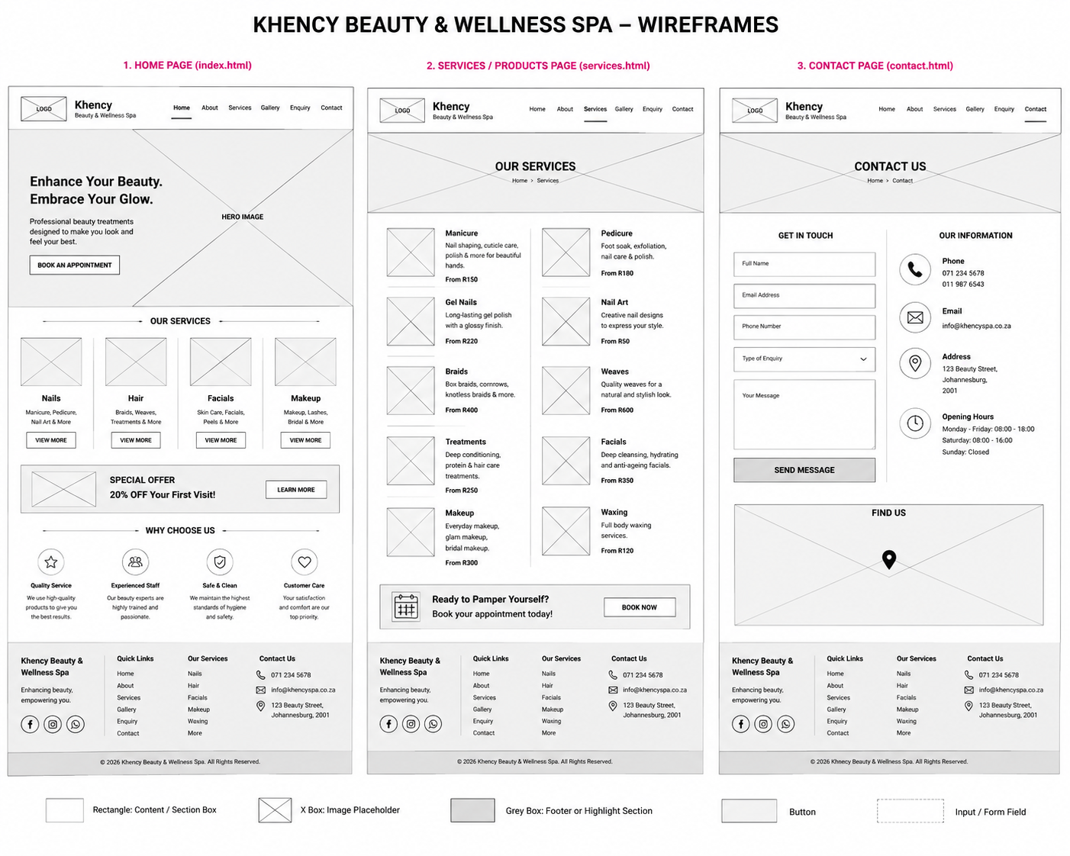
Wireframe pages shown: Home (index.html), Services/Products (services.html), and .

6.4 File and Folder Structure
The proposed project will use a logical and consistent folder structure to separate HTML pages, stylesheets, scripts and image assets.
Khency-Beauty-Spa/
├── index.html
├── about.html
├── products.html
├── enquiry.html
├── contact.html
├── css/
│ └── style.css
├── js/
│ └── script.js
├── images/
│ ├── kbs.jpeg
│ ├── facial.jpg
│ ├── massage.jpg
│ ├── manicure.jpeg
│ ├── waxing.jpeg
│ ├── cupping therapy.jpg
│ ├── spa.mp4
├── README.md
└── CHANGELOG.md

