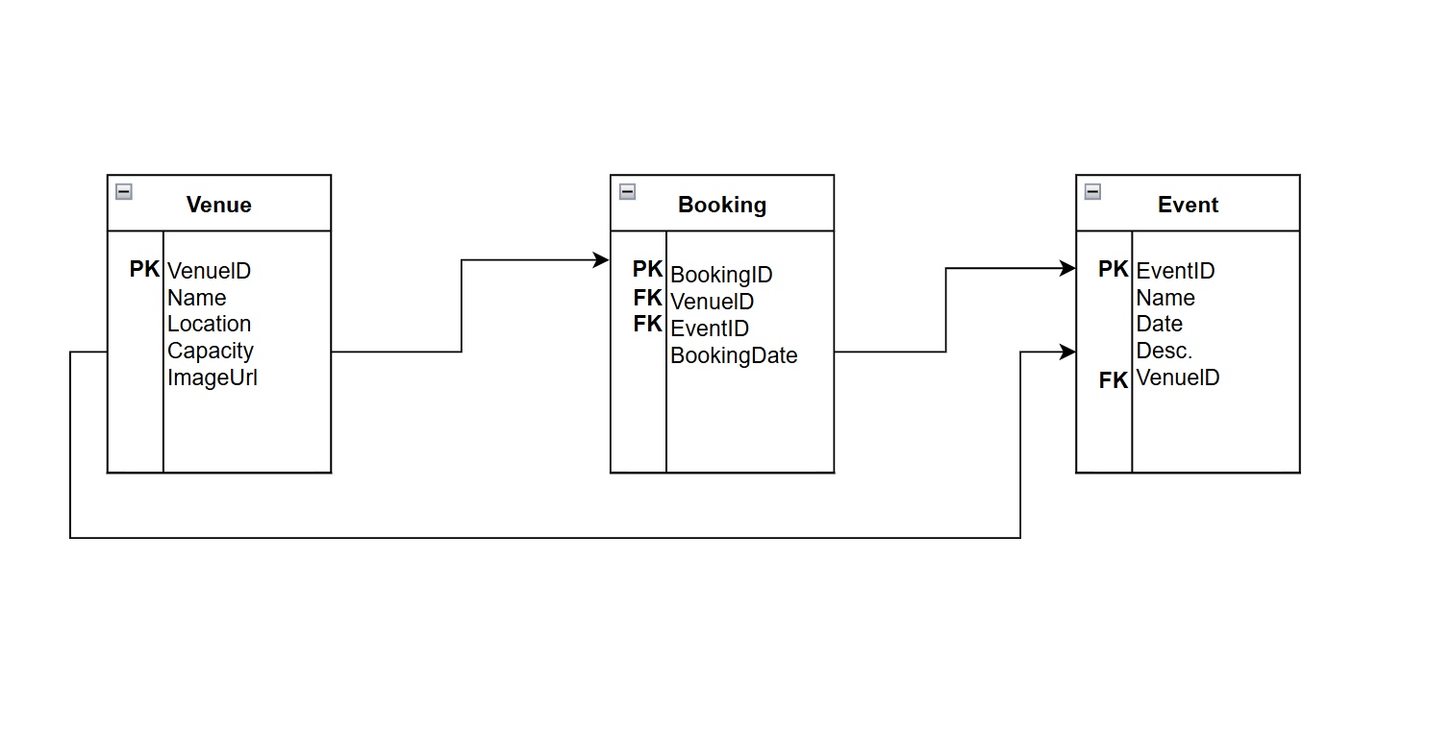

**1. Differences Between Cloud and On-Premises Deployment**

Deploying applications in the cloud is quite different from doing so on-premises, especially when it comes to security, speed, and resource management.

**Security**

* **On-Premises**: Organizations are responsible for securing every layer—from the physical servers to the data itself. While this offers complete control, it also adds complexity and increases the risk of security lapses if systems aren't kept up to date.

*Example*: A financial institution storing sensitive data may maintain its own data center with strict physical access controls and a dedicated cybersecurity team.

* **Cloud**: Cloud providers like AWS, Azure, and Google Cloud handle many aspects of security automatically. Features like encryption, identity management, and monitoring tools are built-in and constantly updated, making it easier for teams to stay secure without a large investment in infrastructure.

*Example*: A startup can rely on AWS IAM to enforce role-based access and implement two-factor authentication without building those systems from scratch.

**Deployment Speed**

* **On-Premises**: Deployments tend to be slower because they involve purchasing hardware, setting up environments manually, and dealing with long testing cycles. This often results in slower delivery of new features.

*Example*: A retail company may face weeks of delay launching a new feature if it first needs to procure and install physical servers.

* **Cloud**: Cloud platforms streamline the entire process with automation tools like CI/CD pipelines and infrastructure-as-code. Applications can be launched or updated in minutes.

*Example*: With Azure DevOps, a development team can roll out changes to production quickly and automatically, allowing for faster innovation and fixes.

**Resource Management**

* **On-Premises**: Organizations have to estimate and purchase resources in advance. This can lead to over-provisioning (wasting money) or under-provisioning (hurting performance). Scaling usually involves buying and setting up more servers, often with downtime.

*Example*: If a company sees a sudden spike in traffic but didn’t plan ahead, they might not have enough server capacity to handle it.

* **Cloud**: Cloud services offer dynamic scaling, adjusting resources automatically based on traffic or usage. This optimizes performance while keeping costs under control.

*Example*: An event app running on Google Cloud can scale up seamlessly when a big event goes live and scale down afterward to save on costs.

**2. Comparing IaaS, PaaS, and SaaS and Why PaaS is Best for EventEase**

**Infrastructure as a Service (IaaS)**  
IaaS provides the foundational computing infrastructure—like virtual machines, storage, and networks. While it offers flexibility and control, users must handle everything else, including the OS and app environment.

* *Example*: With Amazon EC2, users can create and manage their own servers and install software as needed.
* *Best for*: Teams that require complete control over their systems, like managing legacy applications or custom infrastructure.

**Platform as a Service (PaaS)**  
PaaS offers a ready-to-use environment for developing, deploying, and scaling applications. Developers just manage the code and data, while the provider takes care of the infrastructure, runtime, and scaling.

* *Example*: Azure App Services or Google App Engine allow teams to focus on writing code, with the platform managing deployment, updates, and scalability.
* *Best for*: Startups and agile teams that want to build and launch apps quickly without dealing with infrastructure setup.

**Software as a Service (SaaS)**  
SaaS provides complete applications accessible via the web. Users interact with the app but don’t manage or control the backend.

* *Example*: Tools like Microsoft 365 or Dropbox are accessed directly through a browser and require no setup.
* *Best for*: Businesses and end-users who need functional software without the need for customization or infrastructure control.

**Why EventEase Should Choose PaaS**

For a new application like EventEase, PaaS offers the most advantages:

1. **Speedy Development**: PaaS provides built-in tools and frameworks, letting developers build and deploy apps faster.

*Example*: EventEase can use Azure App Services to quickly deploy features like user registration or ticketing, while the platform handles hosting.

1. **Less Maintenance**: The platform takes care of patches, updates, and infrastructure, freeing up the EventEase team to focus on improving features like scheduling or notifications.
2. **Easy Scalability**: PaaS solutions can automatically adjust resources during peak usage—ideal for events with sudden traffic surges.

*Example*: During a high-demand concert ticket release, the system can handle the traffic without downtime or extra setup.

1. **Cost-Effective**: EventEase only pays for what it uses, avoiding big upfront costs for servers and equipment.
2. **Enhanced Security**: Built-in security and compliance features ensure that sensitive data like payments and user info are protected, without EventEase having to build custom solutions.

While IaaS gives you control and SaaS gives you convenience, PaaS offers the perfect mix for EventEase. It enables fast development, scales effortlessly, reduces maintenance, and supports secure, cost-efficient operations—everything a growing event management platform needs.