Yasmin
ST10443542
PROG7312 Part 1, Task 1: Research Report
Smart-X IoT Mesh Ecosystem

Contents
1. Introduction 2
2. Five User Engagement / Dashboard Interactivity Strategies Considered 3
3. Chosen Strategy and Justification (500 words) 4
Real-Time Visual Feedback with Proactive Alert Escalation 4
References 6

1. Introduction
Smart-X collects a steady stream of various forms of telemetry from thousands of edge devices at once. A configuration and debugging console like this is only worth building if the engineers who use it return to it. In this report, I look at developer-focused engagement and dashboard interactivity strategies that could make all that high-throughput telemetry easier to read and act on while keeping operators from tuning out. I present five possible solutions below, all based on peer-reviewed research, and then defend the one I picked in further detail, evaluating it especially against the criterion of detecting unexpected data spikes and sensor disconnects.

2. Five User Engagement / Dashboard Interactivity Strategies Considered
- Real-time visual feedback, using colour, motion and small sparkline charts tied to a sensor's current state, so an operator can tell how healthy a sensor is just by glancing at it rather than reading raw numbers (Baudains et al., 2026).
- Proactive alerting that is tiered by severity and de-duplicated, so repeated or low-priority notifications get suppressed and only the events that actually need attention come through, which directly pushes back against alert fatigue in monitoring consoles (Tariq et al., 2025).
- Gamified operational milestones, things like badges, streaks and completion levels for configuration coverage, sustained uptime and fast incident acknowledgement, that help keep engineers motivated on tasks that would otherwise feel repetitive (Stol, Schaarschmidt and Goldblit, 2022).
- Gamified onboarding wizards built around progressive disclosure, which introduce a complex configuration console one guided step at a time instead of all at once, lowering the learning curve for new engineers (Kosa and Yilmaz, 2016).
- Individual or team performance feedback loops, such as a sensor-health leaderboard or a personal configuration-quality score, which turn routine maintenance data into feedback that people can actually see and compare (Foucault et al., 2019).

3. Chosen Strategy and Justification (500 words)

Real-Time Visual Feedback with Proactive Alert Escalation
For Smart-X, I decided to integrate real-time, state-based visual encoding (Baudains et al., 2026) and proactive, severity-tiered warning escalation (Tariq et al., 2025). Instead of displaying raw numeric streams, each sensor is represented as a compact tile whose colour, motion, and embedded sparkline indicate its current condition, which is normal, warning, critical, or disconnected, as seen in Figure 2. When an incoming TelemetryPacketT> is classified as anomalous by the validation and threshold engine, the pipeline in Figure 1 escalates that tile from a calm colour to a pulsing amber or flashing red state. If the condition persists, a de-duplicated toast or badge alert is raised instead of a raw log line.

I picked this above the other four options for three reasons, all of which are directly related to the assessment's focus on detecting aberrant spikes and disconnects. First, Baudains et al. (2026) demonstrate, through evaluation with domain experts, that consistent color-and-motion encoding in control-room-style interfaces significantly reduces the time it takes an operator to notice an out-of-range reading, because pre-attentive features such as colour, flicker, and size are processed before someone consciously scans a table of numbers. When used to Smart-X, a soil-moisture sensor that spikes outside its learning range changes tile colour and begins pulsating during the same render cycle, allowing an engineer to detect the anomaly peripherally rather than examining each number individually.

Second, Tariq et al. (2025) demonstrate that an undifferentiated stream of alerts causes operators to become used to warnings and eventually disregard legitimate situations, a well-documented alert fatigue issue. Smart-X handles this by tiering its alerts: a single transient spike only changes the tile's colour, whereas a sustained anomaly or a missed heartbeat after a configurable timeout triggers a badge or toast notification, and repeated identical alerts from the same device are de-duplicated rather than piling up. This keeps the volume of notifications proportional to the actual risk, so an escalated alert still means something rather than being lost in noise, and it directly addresses the disconnect-detection side of the requirement, as a silent sensor becomes visually distinct, shown as a greyed-out tile with a disconnect icon, long before anyone needs to look for it.

Third, I preferred this over gamification-only strategies (Stol, Schaarschmidt, and Goldblit, 2022; Kosa and Yilmaz, 2016) because Smart-X's primary users are engineers troubleshooting live infrastructure under time constraints, not newcomers in need of onboarding or employees whose motivation needs to be boosted with badges; a decorative points system would not help someone notice a power-wattage spike three seconds after it occurred. For the same reason, I picked it over a pure performance-leaderboard strategy (Foucault et al., 2019): leaderboards look backward and allow comparison, but detecting an anomaly necessitates something instantaneous and does not need much thinking in the present. That being said, what I've created is more than just a progress bar; it combines perceptual encoding, threshold-aware colour states, motion, and severity-tiered escalation into a single dynamic engagement element, which Task 2 executes via sensor tiles and a live alert stream.

Altogether, combining real-time visual feedback with proactive, tiered alerting gives Smart-X operators a design that's quick to scan, holds up against alert fatigue, and is tuned specifically to make both sudden data spikes and silent sensor disconnects obvious the moment they happen.

FIGURE 1
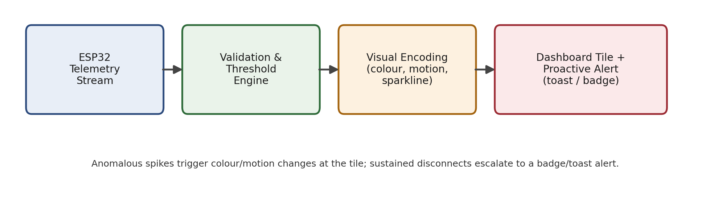
Figure 1: Real-time visual feedback → proactive alert escalation pipeline (own work).

FIGURE 2
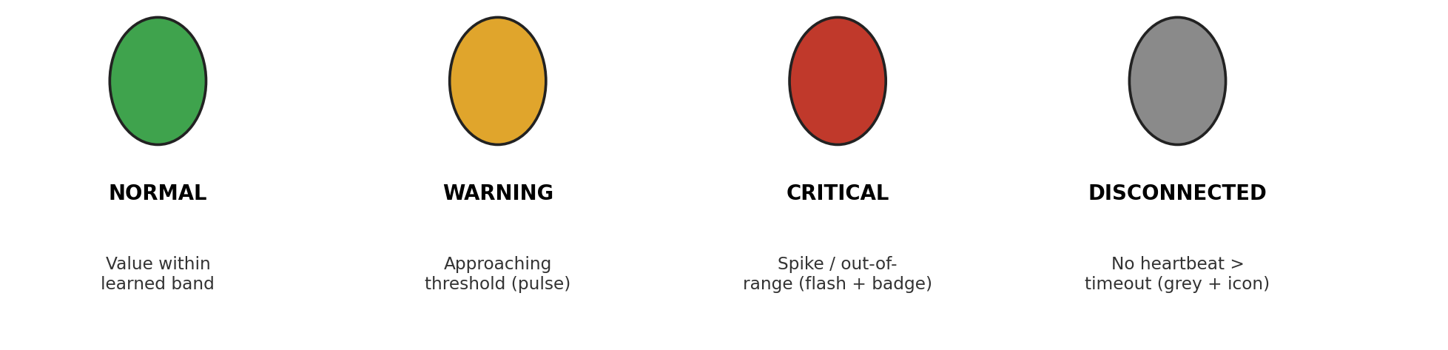
Figure 2: Sensor-tile state encoding legend used on the ingestion dashboard (own work).

References
Baudains, P., Meso, A.I., Todeschini, G. and Borgo, R. (2026). Visualization guidelines for the control room: an evaluation of visual alert encoding with domain experts. Computer Graphics Forum, Art. no. e70458. doi: 10.1111/cgf.70458.
Foucault, M., Blanc, X., Falleri, J-R. and Storey, M-A. (2019). Fostering good coding practices through individual feedback and gamification: an industrial case study. Empirical Software Engineering, 24(6), pp.3731–3754. doi: 10.1007/s10664-019-09719-4.
Kosa, M. and Yilmaz, M. (2016). Gamifying the onboarding process for novice software practitioners. In: Systems, Software and Services Process Improvement, Communications in Computer and Information Science. Cham: Springer. doi: 10.1007/978-3-319-44817-6_20.
Stol, K-J., Schaarschmidt, M. and Goldblit, S. (2022). Gamification in software engineering: the mediating role of developer engagement and job satisfaction. Empirical Software Engineering, 27(2), Art. no. 35. doi: 10.1007/s10664-021-10062-w.
Tariq, S., Baruwal Chhetri, M., Nepal, S. and Paris, C. (2025). Alert fatigue in security operations centres: research challenges and opportunities. ACM Computing Surveys, 57(9), pp.1–38. doi: 10.1145/3723158.

