WhatIsThat (Android)
Author: Mohammed Anas Patel

Overview
An Android app that identifies objects through the camera in real time — fully offline, no internet connection required. Built as a standalone app first, designed to later become the “engine” behind a Pokémon-style plant discovery app (point camera at a plant, “catch” it in a personal collection).

Why offline matters
Most object/plant ID apps require an internet connection to send the image to a cloud server. WhatIsThat runs the AI model directly on the device using TensorFlow Lite, so it:
- Works with zero connectivity (tested in airplane mode)
- Has no ongoing server costs
- Responds instantly (no network round-trip)
- Keeps all user data/photos private on-device

Tech Stack
Purpose | Tool
Language | Kotlin
IDE | Android Studio
UI toolkit | Jetpack Compose (Google, 2026a) — declarative UI, handles animations/theming/transitions natively
Camera | CameraX (Google, 2026b)
AI Model | TensorFlow Lite (Google, 2026c) (MobileNetV2 (Sandler et al., 2018) or EfficientDet-Lite (Tan, Pang and Le, 2020))
Min SDK | API 24 (Android 7.0+)
All tools and libraries used are free with no API keys or paid tiers.

Architecture
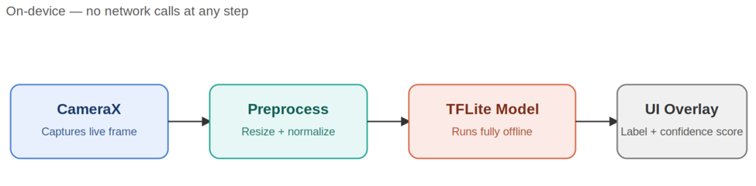
WhatIsThat architecture: CameraX captures a frame, preprocessing resizes/normalizes it, the on-device TFLite model runs inference, and the result is shown as a UI overlay — all steps happen on-device with no network calls.

Commit plan
Design-first approach: build and polish the full UI/UX with mock data before wiring in real camera + AI. Each commit should leave the app in a working, runnable state.
- Project scaffold + theme system — empty Jetpack Compose project, min SDK 24, navigation shell between 4 screens (Camera, Scanning, Result, Stumped) as placeholders, full Theme.kt with all 9 presets (Obsidian, Ocean, Ember, Forest, Rose, Slate, Paper, Sky, Sage) wired into working theme state.
- Static screen designs (mock data) — build all 4 screens matching the Figma layout exactly, using hardcoded sample data (e.g. a fixed “Rubber Duck — 94%” result). No camera, no AI yet — this is the “looks right” milestone.
- Animations + theme picker + transitions — every animation (corner pulse, ring expand, shutter flash, result bounce, wobble, scan line), the theme picker bottom sheet with custom accent color picker, and screen-to-screen transitions. After this commit the app is a fully animated, fully working prototype — indistinguishable from the Figma demo, just running on a real device.
- Real camera (CameraX) — swap the placeholder viewfinder for a live CameraX PreviewView feed.
- Real AI inference (TFLite) — bundle the .tflite model, wire live camera frames into it, replace the mock result with real predictions.
- Polish + offline proof — low-confidence handling (real Stumped triggers), explicit “Offline mode” badge already built in Commit 2, manual airplane-mode test, updated README, demo video recorded.

Model Options (both free, no training required)
- MobileNetV2 (Sandler et al., 2018) — general object classifier, 1000+ everyday categories, smaller/faster
- EfficientDet-Lite (Tan, Pang and Le, 2020) — slightly heavier, better accuracy, still runs smoothly on-device

Future Extension: Plant Discovery App
WhatIsThat’s detection engine becomes the core of a second app where:
- Users “catch” plants they scan into a personal collection (Pokédex-style)
- Each entry stores photo, date, and plant info (care tips, toxicity to pets, etc.)
- Built on Room (local database) for persistent, offline storage

Licensing & attribution
- LICENSE file: All Rights Reserved (see LICENSE) — the repository is public for portfolio/demonstration purposes, but no reuse, copying, or modification is permitted without explicit written permission from the author.
- Copyright header: every source file should start with a short header (see template below) — reinforces the LICENSE file at the source-file level and makes ownership obvious to anyone browsing the repo directly.
- Demo materials: any screenshots, GIFs, or demo videos used in a portfolio or resume should include a small watermark (name or GitHub handle in a corner) since that’s the content most likely to get reused without credit.
- Strongest proof of authorship: your public GitHub commit history (timestamps, incremental commits, commit messages) is harder to fake than the final code itself — commit often and with meaningful messages rather than one big upload.

Copyright header template
Add this to the top of key source files (e.g. MainActivity.kt, Classifier.kt):
/*
* WhatIsThat
* Copyright (c) 2026 Mohammed Anas Patel
* All Rights Reserved — see LICENSE file for details.
* https://github.com/[your-username]/WhatIsThat
*/

Status Log
- ☐ Commit 1: Project scaffold + theme system
- ☐ Commit 2: Static screen designs (mock data)
- ☐ Commit 3: Animations + theme picker + transitions
- ☐ Commit 4: Real camera (CameraX)
- ☐ Commit 5: Real AI inference (TFLite)
- ☐ Commit 6: Polish + offline proof + final docs + demo video

References
Google (2026a) Jetpack Compose UI app development toolkit. Android Developers. Available at: https://developer.android.com/compose (Accessed: 29 August 2026).
Google (2026b) CameraX overview. Android Developers. Available at: https://developer.android.com/media/camera/camerax (Accessed: 29 August 2026).
Google (2026c) LiteRT overview (formerly TensorFlow Lite). Google AI Edge. Available at: https://ai.google.dev/edge/litert (Accessed: 29 August 2026).
Sandler, M., Howard, A., Zhu, M., Zhmoginov, A. and Chen, L.-C. (2018) ‘MobileNetV2: inverted residuals and linear bottlenecks’, arXiv preprint, arXiv:1801.04381. Available at: https://arxiv.org/abs/1801.04381 (Accessed: 29 August 2026).
Tan, M., Pang, R. and Le, Q.V. (2020) ‘EfficientDet: scalable and efficient object detection’, in Proceedings of the IEEE/CVF Conference on Computer Vision and Pattern Recognition (CVPR), pp. 10781–10790. Available at: https://arxiv.org/abs/1911.09070 (Accessed: 29 August 2026).

