Evidence of Attendance and Engagement
Dungeons and Dialogue
Ember Willow Jones, St10450923
Part 3 - Portfolio of Evidence

Photographs

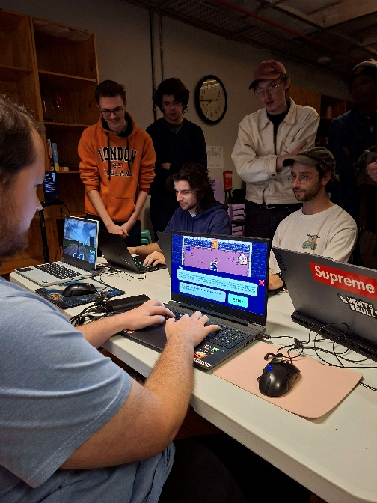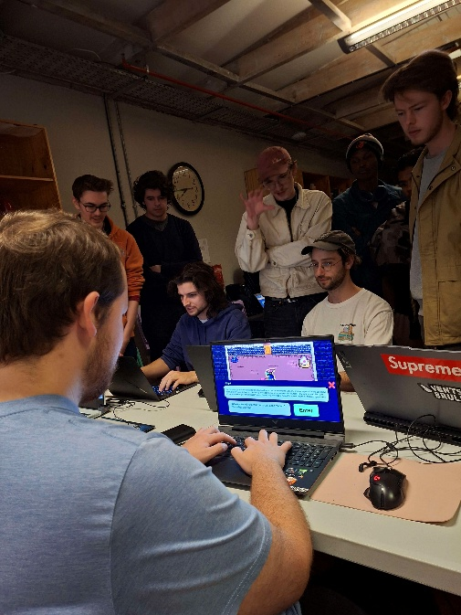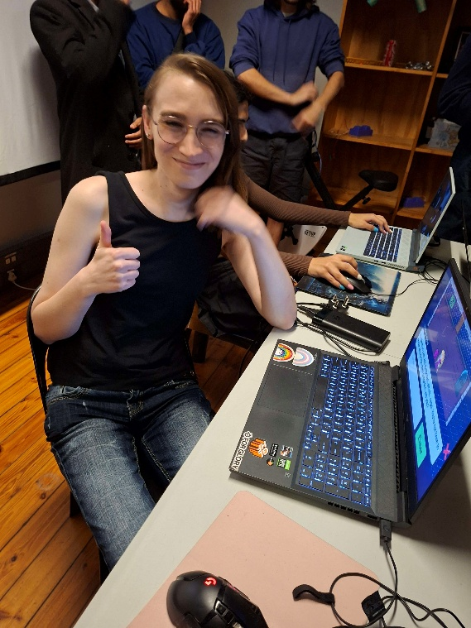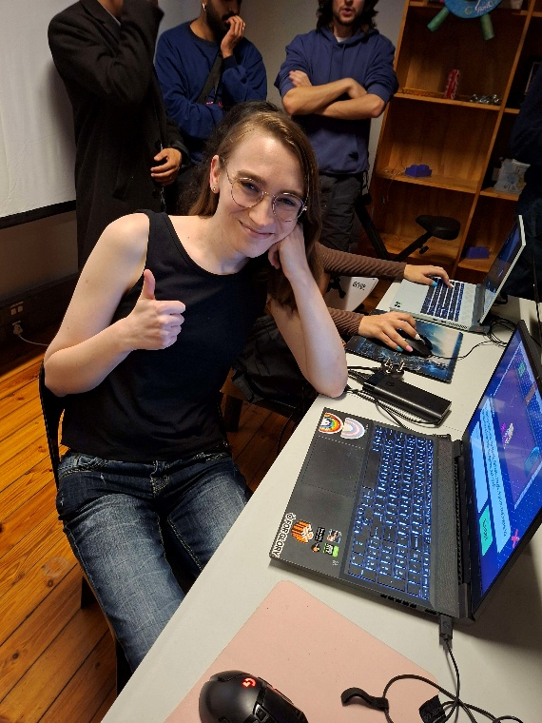

2. Feedback Notes
Makers Massive Notes
-polish art
-add some sound and music
-maybe add in voiceover to increase immersion
-potentially add in voice input to increase conversationalist.
-Add in keyboard inputs for UI such as enter to submit text and Escape to exit popups.
-Add in restart button to go back to main menu.
-Make game over button actually close the game.
-Add in different randomized personalities for each NPC to make the game more replayable

3. Event Description
The Makers Massive is a local game development community that hosts events where people can share their indie projects, listen to talks from guest speakers that are in the industry and even hosts monthly game jams that I’ve previously attended. This event specifically had a few guest speakers at the start, after which people set up their games around the venue and walked around to view/play other developers’ games and give them feedback. It was overall a very supportive community that I enjoyed interacting with and have continued attending their events since.

Feedback Respondents
All of the feedback that I took on my game was from indie developers that I had previously never met who were at Makers Massive. Three were programmers and developers working on independent solo projects, and one was an independent artist. The criticism on the games looks came mostly from the artist who could tell the assets were from different places and resolutions as they were somewhat cobbled together. The game system criticisms and ideas for new mechanics all came from two of the developers who were particularly interested in the game and wanted to know what it was going to look like going into the future. The one programmer game very little feedback and was not super interested in the game concept other than playing for a short while and stating that it had potential.
The programmer who gave me the ideas for adding in TTS and Voice-to-text tools was by far the most engaged, he played though the entire game and gave me feedback while doing so and stayed after the event to continue giving me feedback. He seemed really invested in the project and even asked if I had any social media or a GitHub that he could follow for the project, which gave me a lot of confidence going forward.

