
Proposal 2
Apex

[Date]
[Company name]
[Company address]

Contents
1. Company Name 2
Target Market 2
2. Company Overview 2
3. Vision 2
4. Mission 2
5. Company Objectives 3
6. Services 3
7. Proposed Website 3
8. Website Features 4
9. Website Design 4
10. Target Users 5
wireframe 5
References 5

Proposal 2: APEX STRUCTURES & DEVELOPMENTS

1. Company Name
Apex Structures & Developments
Tagline
“Strengthening the foundations for tomorrow.”
Business Type
A construction & property development company.

Target Market
Residential property owners
Property developers
Small businesses and medium-sized businesses.
Commercial property owners
Property investors

2. Company Overview

Apex Structures & Developments is a planned South African construction firm that offers expert building, renovating, maintenance and property development solutions.
The company's goals are to deliver clients dependable construction solutions and to emphasize on quality craftsmanship, project administration and client fulfillment.
Apex Structures & Developments will construct in a professional and modern way and will provide customers with information about their service, they will be able to see the completed projects and submit enquiries on their website.
Apex Structures & Developments will use its website as an effective medium for communicating with its customers.

3. Vision
To build a reputable and innovative construction company that will be known for quality building and sustainable property solutions.

4. Mission
We aim to deliver professional services, high standards of customer satisfaction, responsible construction and deliver a reliable service at an affordable price for our clients in order to achieve quality construction services.

5. Company Objectives

Apex Structures & Developments main goals are to:

Produce high-quality construction services.
Finish work in timely fashion.
Provide effective customer service.
Provide competitive construction solutions.
Develop long-term relationships with clients.
Encourage the safe and responsible construction practices.
Develop residential/commercial construction projects.
Develop a solid online reputation.

6. Services

Apex Structures & Developments will provide:
Residential Construction
Building of homes and housing.
Commercial Construction
Improvements and new construction of offices, shops and other business properties.
Renovations
Improvement and refurbishment of existing buildings.
Property Extensions
Expansion of existing buildings, including offices, other spaces and rooms.
Painting
Interior/exterior painting.
Paving
Paving of driveways, walkways and other projects.
Property Maintenance
Maintenance and improvement of buildings in general.

7. Proposed Website

The Apex Structures & Developments web site will feature the following pages:
Page Purpose
Home Introduction to the company
Explain the background of the company (About Us)
Services Show construction services.
Practice Practice completed projects
enquiry - Enable customers to send out quotations
Phone Number Include a phone number or numbers.Address Include the address.

8. Website Features

The website should include:
Responsive navigation
Company logo
Hero/banner section
Service cards
Project gallery
Contact information
Enquiry form
Call-to-action buttons
Social media links
Customer review/rating section
Responsive mobile design
Image hover effects
Form validation
Footer
Google Maps/location section

9. Website Design
Suggested colours
Navy Blue – professionalism and reliability
Gold – quality and premium service
White – simplicity and cleanliness
The building or industrial look is achieved with a dark Grey colour.
Typography
Use a current font that is sans-serif like:
It is best to use Arial, Aptos, Poppins or Montserrat.

10. Target Users
The web site will primarily be aimed at:
Homeowners
Property developers
Business owners
Property investors
People planning renovations
People interested in maintenance service

wireframe
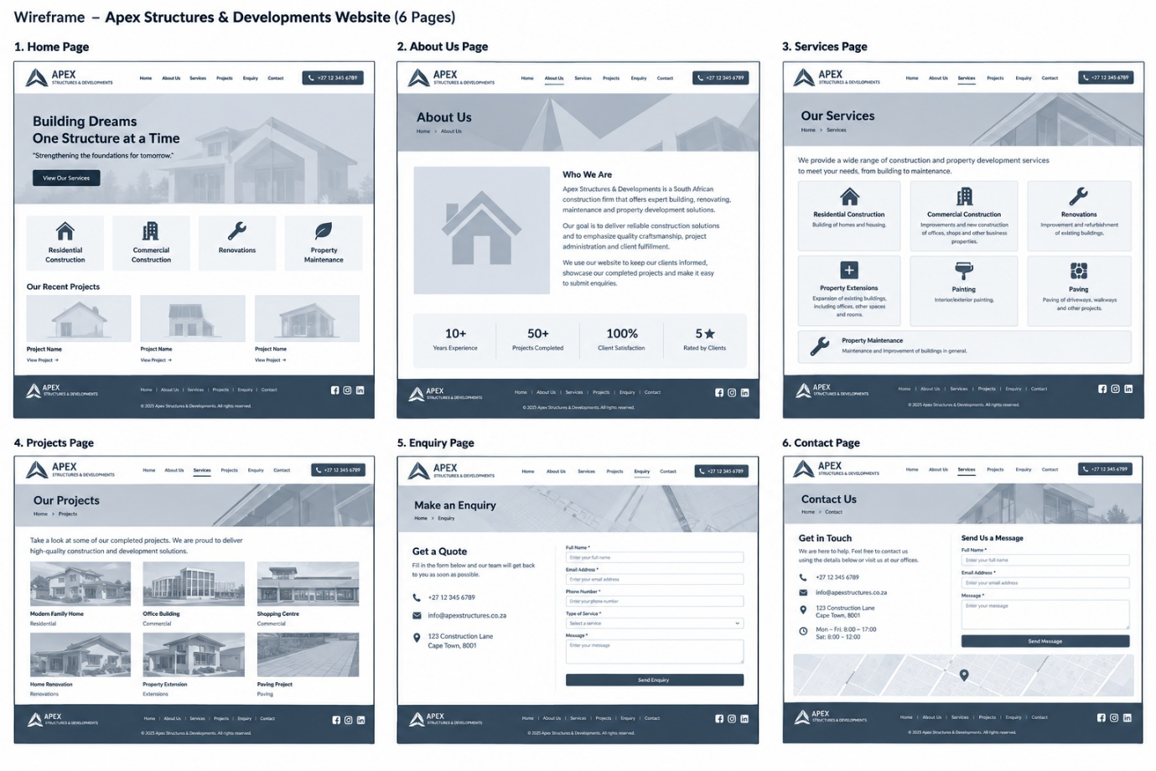

References
AI, o., 2025. chatGPT. [Online]
Available at: https://chat.openai.com
[Accessed 2026].
Android Developers, 2023. appllication fundamentals. [Online]
Available at: https://developer.android.com/guide/components/fundamentals
[Accessed 18 august 2026].
Android Developers, 2024. [Online]
Available at: https://developer.android.com
[Accessed 09 2026].
GoogLe, 2023. Google play protect. [Online]
Available at: https://support.google.com/android/answer/2812853?hl=en
[Accessed 10 August 2026].
IBM, 2023. Real Time Operating systems(RTOS). [Online]
Available at: https://www.ibm.com/think/topics/real-time-operating-system [Accessed 8 Aug. 2025]
[Accessed sep 2026].
IT Web, 2024. ITWeb. [Online]
Available at: https://www.itweb.co.za/article/capitec-uses-bi-ai-to-offer-safer-banking-experience/8OKdWMDXjQBMbznQ
[Accessed 2026].

