AT82.02 – Data Modeling and Management

Lab 6: MongoDB CRUD (READ) – Essential Assessment
Dataset: sample_restaurants (MongoDB Atlas Sample Dataset)
Objective
This lab evaluates students’ understanding of MongoDB READ operations using the restaurants collection. Students must demonstrate competence in: - Basic queries and projections - Filtering and comparison operators - Logical operators - Pagination and sorting - Pattern matching (regex) - Array and embedded document queries

Task 1: Load Sample Dataset
- Log in to MongoDB Atlas.
- Go to Clusters → Load Sample Dataset.
- Select sample_restaurants and wait until loading completes.

Task 2: MongoDB Queries
Write the MongoDB commands for each question below and capture screenshots of both the query and the output.

A. Basic Read & Projection
- Display all documents in the restaurants collection.
db.restaurants.find()
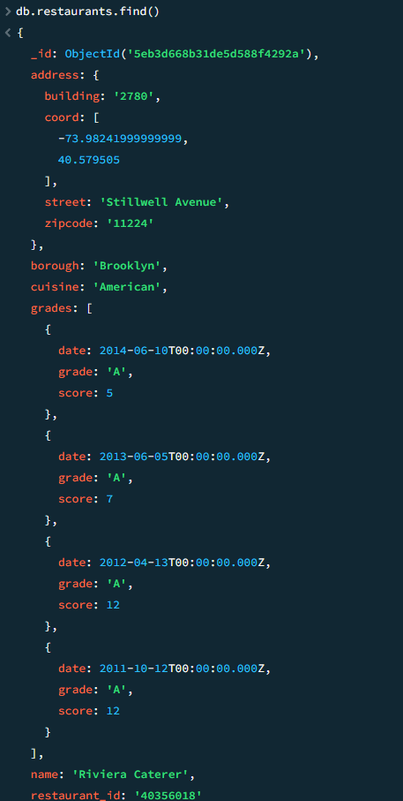
- Display restaurant_id, name, borough, and cuisine for all restaurants.

db.restaurants.find({},{restaurant_id:1,name:1,borough:1,cuisine:1})
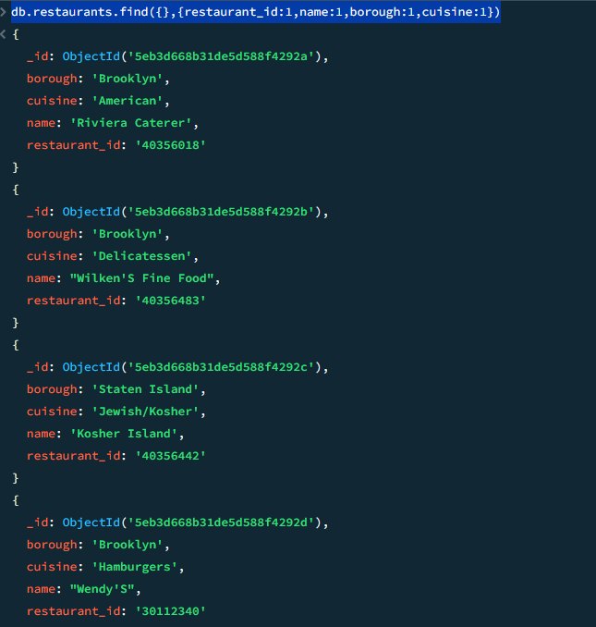

- Display restaurant_id, name, borough, and cuisine, excluding the _id field.
db.restaurants.find({},{_id:0,restaurant_id:1,name:1,borough:1,cuisine:1})
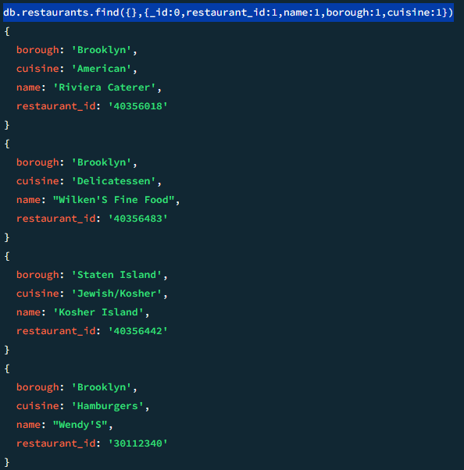

B. Filtering with Conditions
- Find all restaurants located in the borough Bronx.
db.restaurants.find({borough:"Bronx"})

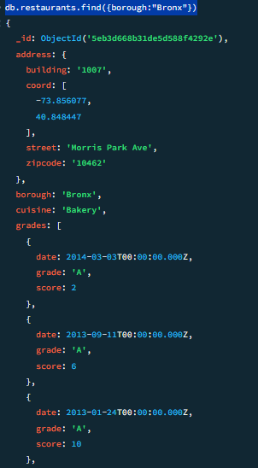

- Find restaurants that achieved a score greater than 90.
db.restaurants.find({"grades.score":{$gt:90}})
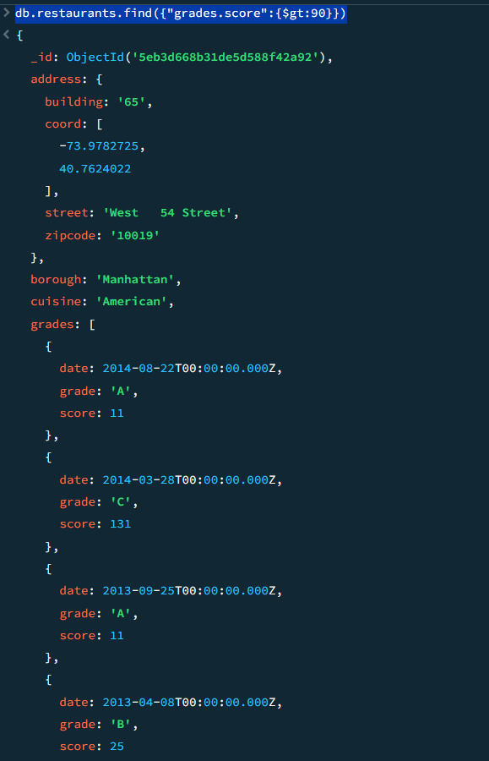

- Find restaurants that achieved a score between 80 and 100.
db.restaurants.find({"grades.score":{$gt:80,$lt:90}})
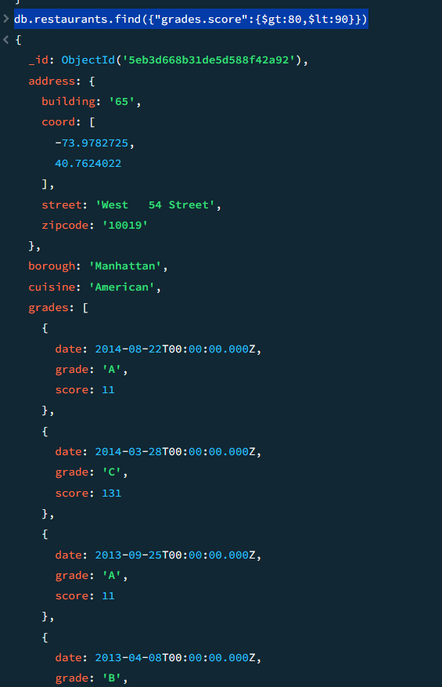

C. Pagination (Limit & Skip)
- Display the first 5 restaurants in the borough Bronx.
db.restaurants.find({borough:"Bronx"}).limit(5)
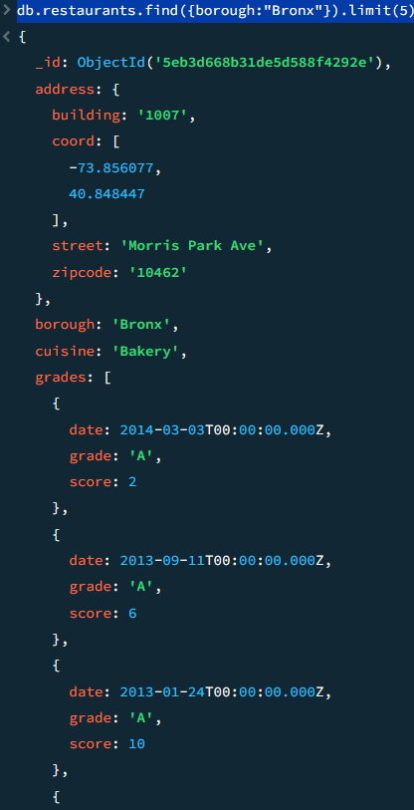

- Display the next 5 restaurants in the borough Bronx after skipping the first 5.
db.restaurants.find({borough:"Bronx"}).skip(5).limit(5)
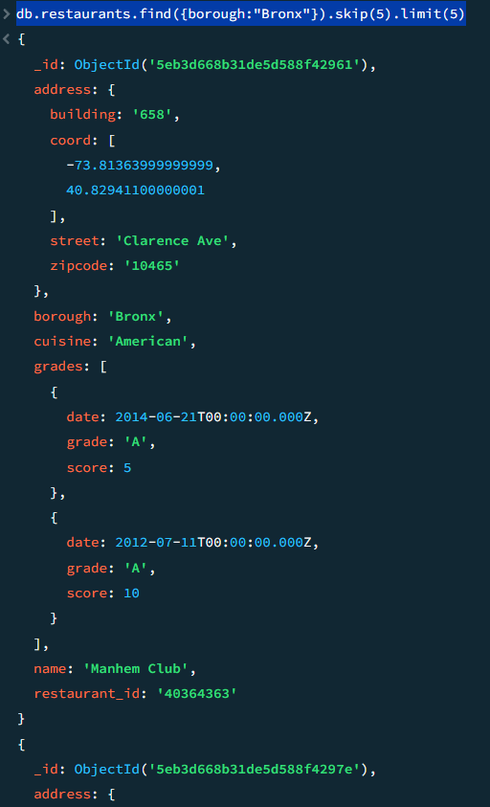

D. Logical Operators
- Find restaurants that do not prepare American cuisine, have a score greater than 70, and are located at a longitude less than -65.754168 (do not use $and).

db.restaurants.find({
cuisine: { $ne: "American" },
"grades.score": { $gt: 70 },
"address.coord.0": { $lt: -65.754168 }
})

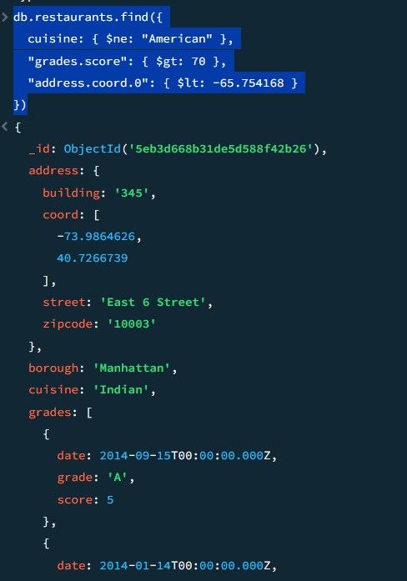

- Find restaurants in the borough Bronx that prepare either American or Chinese cuisine.
db.restaurants.find({
borough: "Bronx",
cuisine: { $in: ["American", "Chinese"] }
})

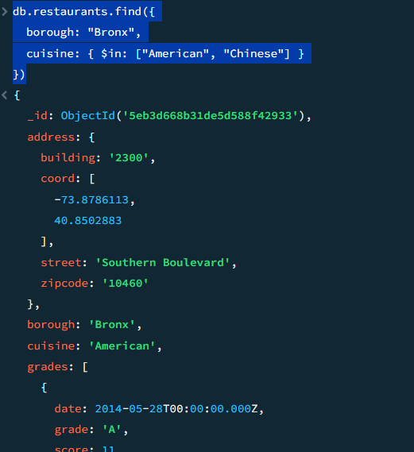
- Find restaurants that are not located in Staten Island, Queens, Bronx, or Brooklyn.
db.restaurants.find({
borough: { $nin: ["Staten Island", "Queens", "Bronx", "Brooklyn"] }
})
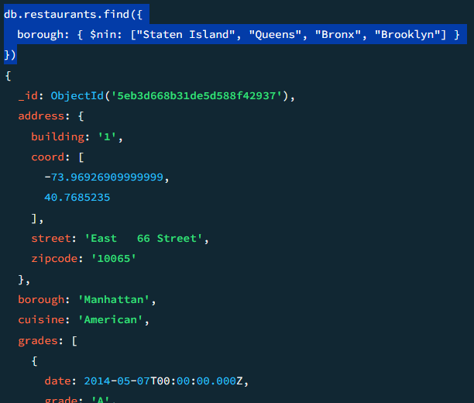

E. Sorting
- Display all restaurants sorted by name in ascending order.
db.restaurants.find().sort({ name: 1 })
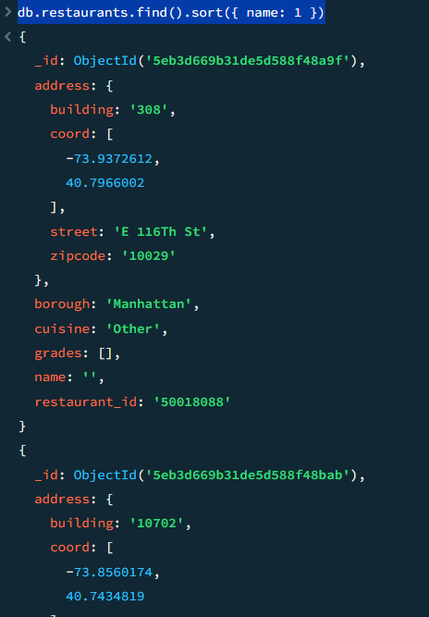

- Display all restaurants sorted by name in descending order.

db.restaurants.find().sort({ name: -1 })
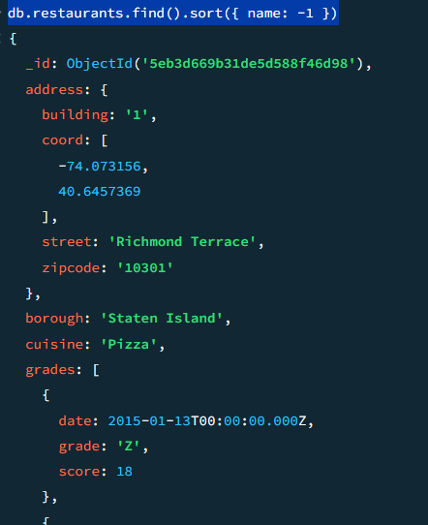

F. Pattern Matching (Regex)
- Find restaurants whose name starts with “Wil”. Display restaurant_id, name, borough, and cuisine.
db.restaurants.find(
{ name: { $regex: "^Wil" } },
{ restaurant_id: 1, name: 1, borough: 1, cuisine: 1, _id: 0 }
)
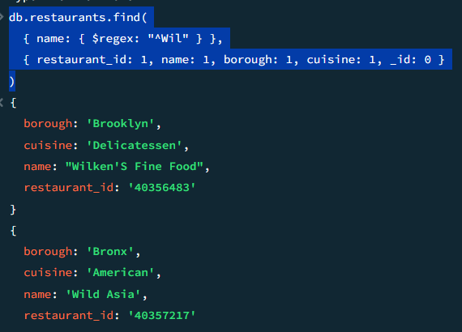
- Find restaurants whose name contains “Reg” anywhere. Display restaurant_id, name, borough, and cuisine.
db.restaurants.find(
{ name: { $regex: "Reg" } },
{ restaurant_id: 1, name: 1, borough: 1, cuisine: 1, _id: 0 }
)
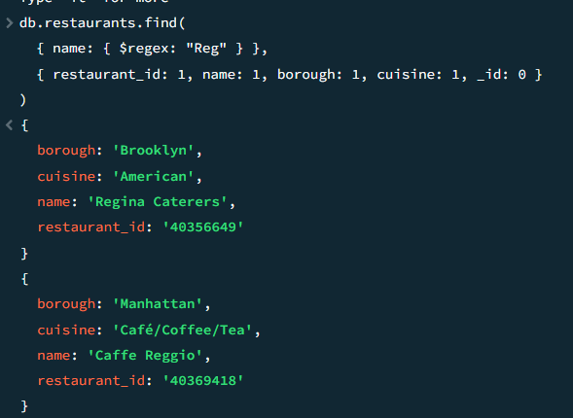

G. Array & Embedded Document Queries
- Find restaurants that achieved a grade “A” with a score of 11 on the date ISODate("2014-08-11T00:00:00Z").
db.restaurants.find(
{
grades: {
$elemMatch: {
grade: "A",
score: 11,
date: ISODate("2014-08-11T00:00:00Z")
}
}
}
)
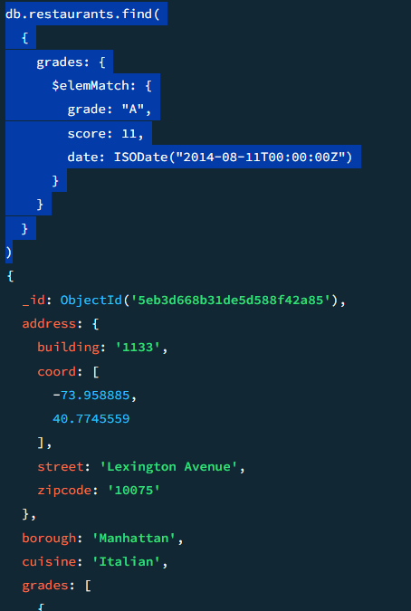

- Find restaurants where the second element of the grades array contains a grade “A” and score 9 on ISODate("2014-08-11T00:00:00Z").

db.restaurants.find(
{
"grades.1.grade": "A",
"grades.1.score": 9,
"grades.1.date": ISODate("2014-08-11T00:00:00Z")
}
)
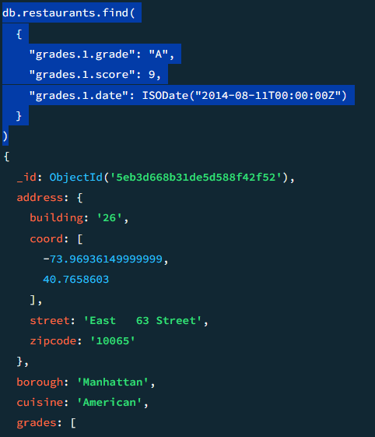

- Find restaurants that have at least one grade with a score less than 5.
db.restaurants.find(
{
grades: {
$elemMatch: {
score: { $lt: 5 }
}
}
}
)
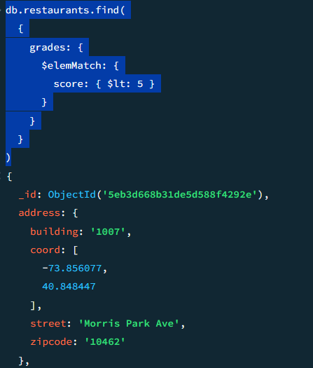

H. Advanced Array Logic
- Find restaurants that have both a grade with score 2 and a grade with score 6.

db.restaurants.find(
{
$and: [
{ grades: { $elemMatch: { score: 2 } } },
{ grades: { $elemMatch: { score: 6 } } }
]
}
)

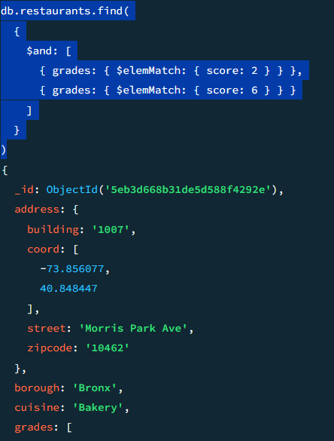

- Find restaurants that have either a grade with score 2 or 6.
db.restaurants.find(
{
grades: {
$elemMatch: {
score: { $in: [2, 6] }
}
}
}
)
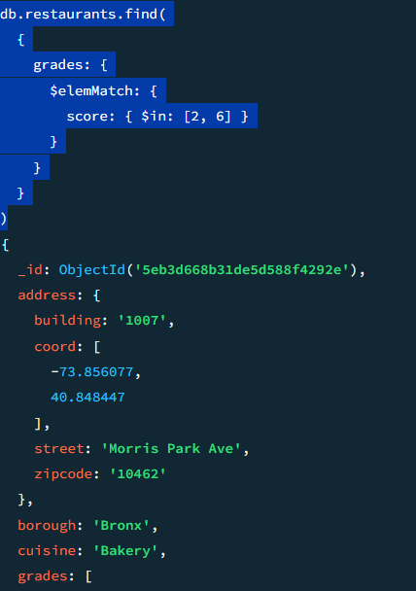

- Find restaurants where all grades have a score greater than 5.
db.restaurants.find(
{
grades: {
$not: {
$elemMatch: { score: { $lte: 5 } }
}
}
}
)

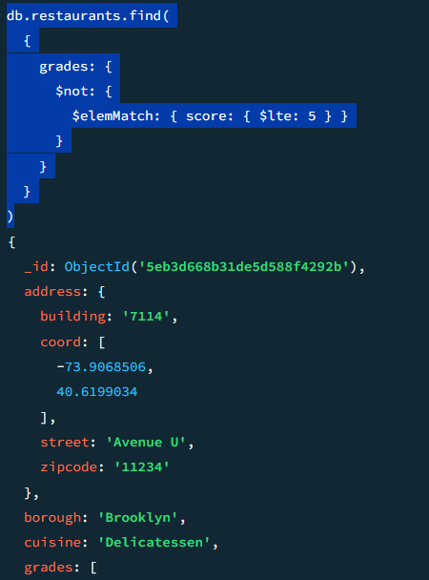

Submission Requirements
- MongoDB query code for each question
- Screenshots showing successful execution and results
- Submit as a single PDF or Word document

