
Where will landslides strike, and who is in the way?
An ML proposal for landslide susceptibility and rainfall-driven impact in southern Thailand
Asian Institute of Technology · Team: [add team member names] · October 2026
Summary. We propose to train a supervised classifier that ranks every 250 m cell of southern Thailand (14 provinces) by landslide susceptibility, using 15 free datasets and a labelled inventory of dated landslides. A transparent rule then combines the map with the NOAA GFS rainfall forecast, judged against each tambon's own rainfall climate, and with population and building exposure, to give a live, tambon-level triage view. The plan tests seven hypotheses about preprocessing, models, factor groups, negative sampling, spatial and temporal transfer, and robustness, and analyses why approaches work or fail. This is a proposal: no models have been trained yet.

1 Problem statement

Why it matters
Landslides are a recurring and under-recorded hazard. Worldwide they killed 55,997 people in 4,862 fatal events between 2004 and 2016, with Asia the dominant region [1], and the WHO estimates more than 18,000 deaths and 4.8 million people affected between 1998 and 2017 [2]. In Thailand, the Department of Mineral Resources placed 54 provinces, 332 districts and 1,084 tambons at landslide risk in 2019 [3]. Fatal landslides have occurred every year since 2004, yet the EM-DAT database records only 14 landslides for the country, and about 6,450 villages in 51 provinces lie in landslide-prone areas [4]. The south is among the most exposed regions: the 2011 debris flows in Krabi and Nakhon Si Thammarat caused 16 deaths and more than 10 billion baht in losses [4], and the November 1988 storm in Nakhon Si Thammarat and Surat Thani, with floods and landslides, killed about 350 people [5].
55,997  deaths in 4,862 fatal landslides worldwide, 2004–2016 [1] | 1,084 tambons  in 54 Thai provinces at landslide risk in 2019 [3] | >10 billion baht  lost in the 2011 debris flows of Krabi and Nakhon Si Thammarat [4]

The ML application, users and objectives
Authorities need to know where landslides are most likely and who lives there when heavy rain is forecast, so they can prioritise inspections, pre-position equipment and target warnings at tambon level. Few free tools combine these three pieces of information for the south. Our objectives are to (a) rank the ground by relative landslide susceptibility from open data only, (b) report the people, buildings and critical facilities on high-susceptibility ground, and (c) flag tambons where forecast rain is unusual for that place.
Intended users: provincial and district disaster-management offices, tambon administrations and land-use planners, and road and utility operators.

Prediction targets
- Primary (ML): binary classification of each location as landslide (1) or sampled non-landslide (0). The calibrated score of every 250 m cell is grouped into five susceptibility classes, very low to very high.
- Derived (rule, not ML): a live impact class per tambon from the terrain tier (share of high-susceptibility cells) and the local rain class (GFS 24 h forecast against the tambon's CHIRPS wet-day percentiles).

How success will be measured
Targets are provisional and will be fixed once the baseline is known.
Dimension | Measure | Provisional target
Ranking skill | ROC-AUC and PR-AUC under spatial block cross-validation | Best model beats logistic regression by at least 0.02 ROC-AUC
Decision value | Share of held-out landslides inside the highest-ranked area | At least 70% of held-out landslides in the top 20% of mapped area
Score quality | Brier score and calibration curve | Brier below the baseline; calibration slope near 1
Physical sense | Feature importance and partial dependence | Top drivers consistent with slope, wetness and land-use mechanisms

2 Proposed solution

2.1 Data
All fifteen datasets are free. Most are reached through the Google Earth Engine API; the rest are direct downloads. Only the inventory carries labels.
Group | Datasets (source) | Role
Label | Landslide inventory (ADPC): dated landslide points, 2000–2025, plus undated records | Positive class; exclusion zone for sampled negatives
Terrain, water | ALOS AW3D30 and SRTM DEMs; HydroSHEDS 15ACC and MERIT Hydro | Slope, curvature, TRI, TPI, LS factor, upstream area, TWI, SPI
Ground, surface | OpenLandMap soil; NDVI from Landsat 5/7/8/9 and Sentinel-2; SERVIR-Mekong land cover; GLiM lithology; OSM roads and rivers; GEM active faults | Soil strength, vegetation, land use, rock type, disturbance
Rainfall | GPM IMERG (antecedent rain), NOAA GFS (forecast), CHIRPS daily (1991–2020 climate) | Trigger experiment; live forecast; local percentiles
Exposure, units | WorldPop 2020 constrained; OSM buildings and facilities; GADM 4.1 boundaries | People and assets at risk; tambon join key; CV groups
Held in reserve: Sentinel-1 radar, ERA5-Land soil moisture, Hansen forest loss, Dynamic World, OpenLandMap soil organic carbon.

2.2 Data integration and preprocessing
Data are joined three ways: at points (latitude, longitude and event date) to build the training table, on a regular 250 m grid for the map, and per tambon (GADM id) for the impact view. One rule governs every join: nothing recorded after an event may feed its features, so NDVI and land cover come from before the event date.
1 Clean  Drop invalid points; thin near-duplicates | 2 Align  One CRS; common 250 m grid | 3 Engineer  Terrain, hydrology, distances, NDVI, rain | 4 Synthesise  Paired non-landslide points | 5 Fill, cap  Impute in folds; log and cap | 6 Select  VIF, leakage check, importance

- Cleaning and deduplication. Mapped inventories often contain near-duplicate points a few metres apart, sometimes with different dates. Left in, one copy could sit in training and the other in testing, inflating scores. We will keep one point per cluster (spatial thinning) and check that no test point has a training point closer than the validation buffer.
- Alignment and resolution. Inputs differ in resolution: 30 m terrain, about 90–460 m hydrology, 250 m soil, 0.05° CHIRPS and 0.25° GFS rain. All layers will share one coordinate system, and features are sampled at the same point locations and on one 250 m grid, so every row describes the same footprint. Coarse layers are kept as context variables, not as fine-scale signal.
- Feature engineering. From the DEM: elevation, slope, aspect, general and profile curvature, TRI, TPI and LS factor; from hydrology: upstream area, TWI and SPI; distances to roads, rivers and faults; NDVI shortly before the event and its change; antecedent rain windows from 1 hour to 30 days (IMERG) for the trigger experiment.
- Synthetic data. The inventory holds landslides only, so the negative class must be generated. We will place one non-landslide point per landslide, 2 to 10 km away in the same province, well clear of every recorded landslide and spaced from other negatives, and give it its landslide's date. Pairing keeps both classes in the same terrain and season, so the model cannot win by learning "mountain vs plain". Because absence is assumed, scores are read as a relative ranking, not a probability; experiment E4 compares this design with random and environment-matched negatives.
- Missing values. NDVI is missing under cloud and soil near water bodies. Imputation (median or k-nearest neighbours) is fitted inside each training fold, with a missing-value flag, so no information leaks from the test fold.
- Outliers. Upstream area, SPI and TWI are heavily skewed; we will log-transform and cap extreme tails, but keep physically real extremes such as very steep slopes.
- Encoding and scaling. Land cover and lithology are categorical: one-hot and Weight-of-Evidence encodings are compared (E1). Scaling is applied only for distance- and margin-based models.
- Feature selection. Correlation and variance-inflation screening removes redundant terrain indices, a leakage check removes anything computed after the event, and permutation importance and the ablation (E3) decide what stays. Factors that may only reflect mapping bias, such as distance to roads, are tested explicitly.

2.3 Model selection
The task is tabular binary classification on a few thousand labelled points per class, with mixed numeric and categorical inputs, where users need probabilities and explanations. That suits a transparent baseline and tree ensembles better than deep learning, which needs far more data and is hard to explain to officials.
Tier | Models | Why appropriate
Baseline | Logistic regression; frequency ratio / Weight-of-Evidence | Interpretable, the standard reference in landslide studies; sets the bar every other model must beat
Ensembles | Random forest, XGBoost, LightGBM | Capture non-linear effects and interactions such as slope × wetness; strong on tabular data
Kernel | SVM with RBF kernel | Smooth non-linear boundary in a compact, dense feature space
References | k-NN, decision tree, naive Bayes, AdaBoost | Cheap checks of how much complexity actually helps
All models share one scikit-learn pipeline (imputation, encoding, scaling, model), so preprocessing is refitted inside every fold. Scores of the selected model will be calibrated (isotonic or Platt) so that classes mean the same thing across the map.

2.4 Experimental design
Each experiment is written as a hypothesis with an expected outcome, so a result confirms or refutes something about the problem instead of only ranking models. All comparisons use identical spatial folds; hyperparameters are tuned by random search inside inner folds (nested cross-validation).
Experiment | Hypothesis (expected outcome) | Design
E1 Preprocessing | Imputation and encoding choices change rankings little | Median vs k-NN imputation; one-hot vs WoE; with and without log transforms
E2 Model family | Boosting beats logistic regression, but only by a small margin | All models on the same folds with nested tuning
E3 Ablation | Terrain carries most of the signal; NDVI, land cover and roads add some | Terrain only, then add hydrology, soil, vegetation, land cover, lithology, distances
E4 Negative sampling | Random negatives inflate scores relative to paired ones | Paired ring vs random vs environment-matched negatives
E5 Spatial transfer | Scores drop in provinces the model has never seen | Leave-one-province-out
E6 Temporal check | A model of earlier events still ranks later events | Train on earlier event years, test on later years (cut-off set after the data audit)
E7 Robustness | 5% label noise and a DEM swap move rankings little | Flip 5% of labels; ALOS vs SRTM terrain
Validation. Nearby points are alike, so random splits overstate accuracy. We will use spatial block cross-validation (0.5° blocks) with a buffer around each test block, plus a held-out region reported once at the end. Metrics: ROC-AUC and PR-AUC for ranking; sensitivity, specificity and balanced accuracy at a chosen threshold; Brier score and reliability curves for calibration; and the share of held-out landslides in the top 10% and 20% of area for decision value. We report the mean and spread across folds, not a single number.

2.5 Analysis plan
Analysis aims to explain why approaches work or fail, and when the map should not be trusted.
- Error analysis. Map false negatives and false positives and test whether they cluster by province, lithology, slope band, land cover or distance to roads.
- Drivers and interpretability. Permutation importance, SHAP values and partial-dependence curves; check that slope, wetness and land use behave as geotechnical knowledge predicts, and examine slope × TWI interactions.
- Performance across groups. Scores by province, land-cover class and elevation band; E5 shows how well the model transfers to unseen provinces.
- Sensitivity. Vary the negative-sampling distance, grid size, DEM source and label noise, and check whether conclusions hold.
- Failure conditions. Identify where the model is unreliable: provinces without labels, cloud-gap rows, steep road cuts, coarse soil cells.
- Uncertainty. Map the spread of scores across folds so that users can see where the ranking is uncertain.

3 Additional considerations

Data quality and limitations
- Representativeness. An initial look at the inventory shows that dated labels exist in 8 of the 14 provinces, and 99.9% of them lie in six (Figure 1). The six deep-south provinces have no labels, so the map there is extrapolation; E5 measures how much performance drops in unseen provinces, and the dashboard will flag those areas.
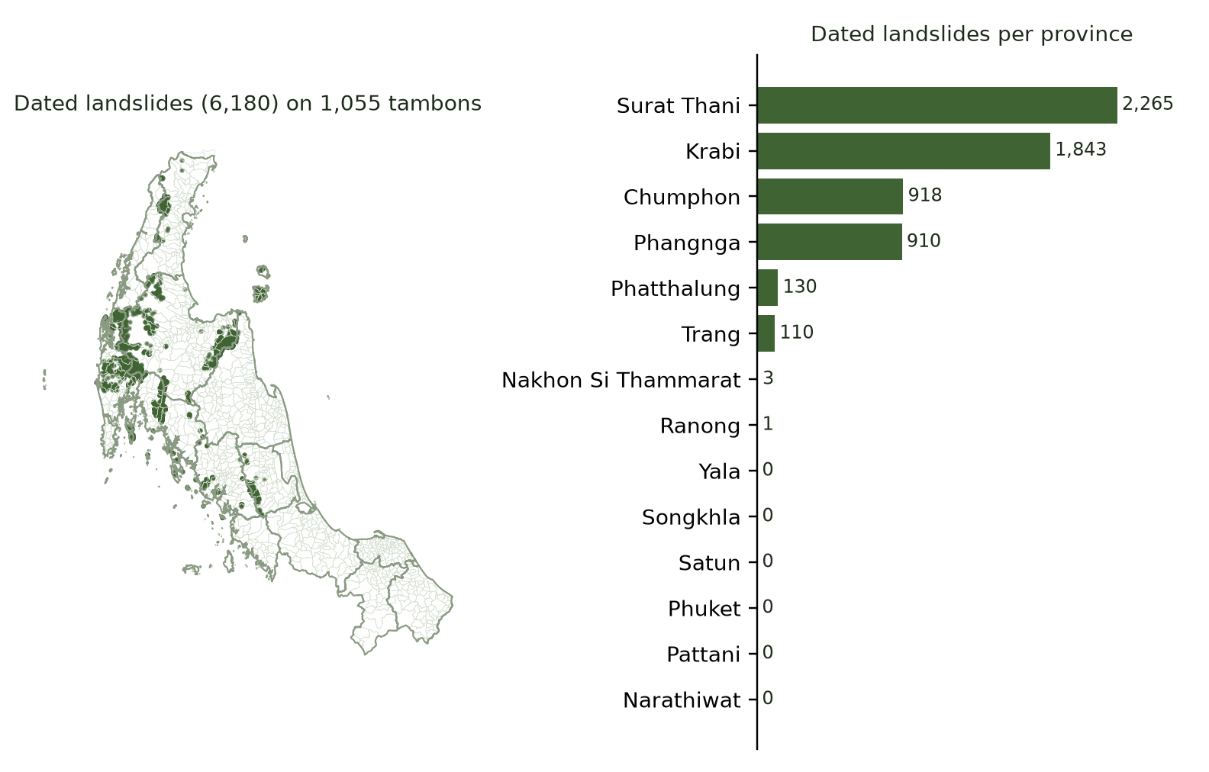
Figure 1. Dated landslides in the study area, by province (initial data audit).
- Label quality. Event dates appear to be satellite-image dates rather than occurrence dates, which limits any rainfall-trigger model; susceptibility, which needs no exact timing, is the primary target.
- Sufficiency. A few thousand labelled points with about 20 factors is ample for tabular models; the binding constraint is spatial coverage, not row count.
- Resolution. GFS (about 28 km) and soil (250 m) are much coarser than terrain (30 m), so the live view is a screening tool.

Practical value
The map tells officials where to look first; the live view adds when, by flagging tambons where unusual rain meets susceptible, populated ground. A what-if slider lets planners test a storm (for example 150 mm in 24 h). The impact rule is deliberately transparent:
Terrain tier \ rain vs local normal | < P75 | P75–P90 | P90–P95 | > P95
Low | Low | Low | Moderate | Moderate
Moderate | Low | Moderate | High | High
High | Low | Moderate | High | Very high
It is a triage rule tested for consistency, not a validated forecast; local officials make the final decision.

Deployment plan (AWS) and CI/CD
A FastAPI backend serves the model, map and scenario endpoints, and a Next.js dashboard shows the map and an early-warning page. Both run as Docker containers on an AWS EC2 instance behind nginx (HTTPS) and Traefik. GitHub Actions runs the pipeline on every push: tests, image build, deployment over SSH, health check and automatic rollback.
Data snapshot  versioned inputs | Train, validate  spatial CV in CI | Model registry  model + metadata (data version, features, scores, commit) | Promotion gate  must beat the current model | Serve  API loads the tagged model
The model is treated like code: each trained model is stored with its metadata and only promoted if it passes the gate. Retraining is triggered by a new inventory batch, a quarterly schedule, or drift in input distributions. A scheduled job refreshes the GFS forecast and the impact layer.

Risks and alternatives
Risk | Effect | Backup plan
Image dates, not event dates | No reliable trigger timing | Keep susceptibility as the target; rainfall trigger is an optional experiment
Assumed absences | Scores are relative, not probabilities | Compare sampling designs (E4); report rankings and calibrated classes
Mapping bias near roads | Model learns visibility, not instability | Ablate road distance (E3); inspect road-following patterns
No labels in the deep south | Unknown skill there | Leave-one-province-out (E5); flag extrapolated areas
Earth Engine quotas, asset access | Slow or blocked extraction | Batch and resume requests; Dynamic World as land-cover substitute
Licences (GADM, OSM) | Limits on redistribution | Keep data private; publish code and attribution only
Small server | Out-of-memory risk | Light deployment that loads data on demand; memory limits per container

Project management
Work runs over eight weeks with five members (roles to be confirmed): M1 inventory and negative sampling, M2 factor extraction and preprocessing, M3 rainfall, exposure and impact rule, M4 modelling and experiments, M5 analysis, deployment and CI/CD. The team coordinates through GitHub (issues, pull-request review, protected main branch), a weekly check-in and a shared drive.
Workstream | Owners | W1 | W2 | W3 | W4 | W5 | W6 | W7 | W8
Data access and audit | M1, M2
Preprocessing | M2, M1
Baselines and CV set-up | M4
Experiments E1–E7 | M4, M5
Analysis and interpretation | M5, M4
Impact layer and app | M3, M5
Report and slides | All
Milestones |  |  | Data ready | Baseline |  | E1–E7 | Analysis | App demo | Report

4 Expected contributions
- A reproducible open-data pipeline joining fifteen free sources by location, date and tambon, with explicit leakage and deduplication rules.
- Evidence, not just a score: tested hypotheses on preprocessing, model complexity, factor groups, negative sampling, and spatial and temporal transfer, with analysis of why approaches work or fail.
- A live impact prototype on AWS that combines susceptibility, forecast rain judged against local climate, and exposure, with a what-if scenario.

References
- Froude, M. J. and Petley, D. N. (2018). Global fatal landslide occurrence from 2004 to 2016. Natural Hazards and Earth System Sciences, 18, 2161–2181. doi:10.5194/nhess-18-2161-2018
- World Health Organization. Landslides (health topic page). who.int/health-topics/landslides (accessed October 2026).
- Thai PBS World (26 June 2019). Department of Mineral Resources on landslide watch.
- JICA and AHA Centre (2015). Country Report Thailand: Natural Disaster Risk Assessment and Area Business Continuity Plan Formulation for Industrial Agglomerated Areas in the ASEAN Region.
- Asian Disaster Reduction Center. Disaster databook, Thailand (entry FL-1988-0512-THA, November 1988).
- Data sources: JAXA ALOS AW3D30; NASA/USGS SRTM (Farr et al., 2007, doi:10.1029/2005RG000183); WWF HydroSHEDS (Lehner et al., 2008); MERIT Hydro (Yamazaki et al., 2019, doi:10.1029/2019WR024873); OpenLandMap (Hengl, 2018); USGS Landsat Collection 2; ESA Sentinel-2; SERVIR-Mekong RLCMS (Saah et al., 2019, doi:10.3389/fenvs.2019.00150); GLiM (Hartmann and Moosdorf, 2012, doi:10.1029/2012GC004370); OpenStreetMap via Geofabrik (ODbL); GEM Global Active Faults (Styron and Pagani, 2020, doi:10.1177/8755293020944182); NASA GPM IMERG V07 (doi:10.5067/GPM/IMERG/3B-HH/07); NOAA GFS; CHIRPS (Funk et al., 2015, doi:10.1038/sdata.2015.66); WorldPop (doi:10.5258/SOTON/WP00685); GADM 4.1.

