Sneha Tandon

LinkinLegal

10 July 2024

ARTIFICIAL INTELLIGENCE INTERVIEWER

The AI Interviewer project aims to revolutionize the hiring process by leveraging advanced AI technologies. Utilizing natural language processing, computer vision, and speech recognition, this tool will automate interviews, analyze resumes and job descriptions, and adapt questions based on candidate responses. Optional features include emotional state assessment and noise cancellation to enhance communication clarity. The project follows a structured development timeline, ensuring thorough testing and seamless integration, ultimately providing a reliable and efficient AI-powered interview solution.

**PROJECT HISTORY**

The AI Interviewer project was conceived to revolutionize the hiring process by leveraging advanced AI technologies. Initial research and feasibility studies identified key areas for innovation, such as natural language processing for parsing resumes and job descriptions, adaptive questioning based on candidate responses, and optional features like emotional state detection and noise cancellation. This project aims to enhance the efficiency, accuracy, and fairness of interviews, laying a solid foundation for a comprehensive AI-driven interview solution designed to meet modern recruitment needs.

**POTENTIAL STAKEHOLDERS**

The AI interviewer product has a diverse set of stakeholders, each with unique interests and concerns. Job seekers seek fair and accurate assessments of their skills, while employers and recruiters prioritize efficiency in identifying suitable candidates. HR departments aim to streamline hiring processes compliantly, and developers focus on technical functionality and maintenance. Legal teams ensure adherence to hiring laws and data privacy, while data scientists work on optimizing AI models. Customer support manages user inquiries and feedback, while investors assess market potential and profitability. Ultimately, understanding these stakeholders ensures the AI interviewer meets user expectations and business objectives effectively.

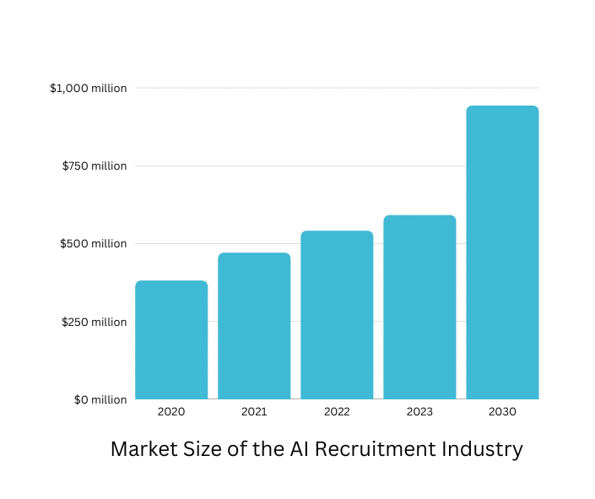

**RESEARCH**

Conducting a comprehensive feasibility study for an AI interviewer involves analyzing various critical aspects derived from current market trends and existing tools in the field. The market for AI interviewers is rapidly expanding, driven by the demand for more efficient and scalable hiring processes that can mitigate bias and enhance decision-making consistency. Recent launches and developments, such as Apriora's entry into the market, underscore a growing industry interest and readiness for innovative AI-driven recruitment solutions.

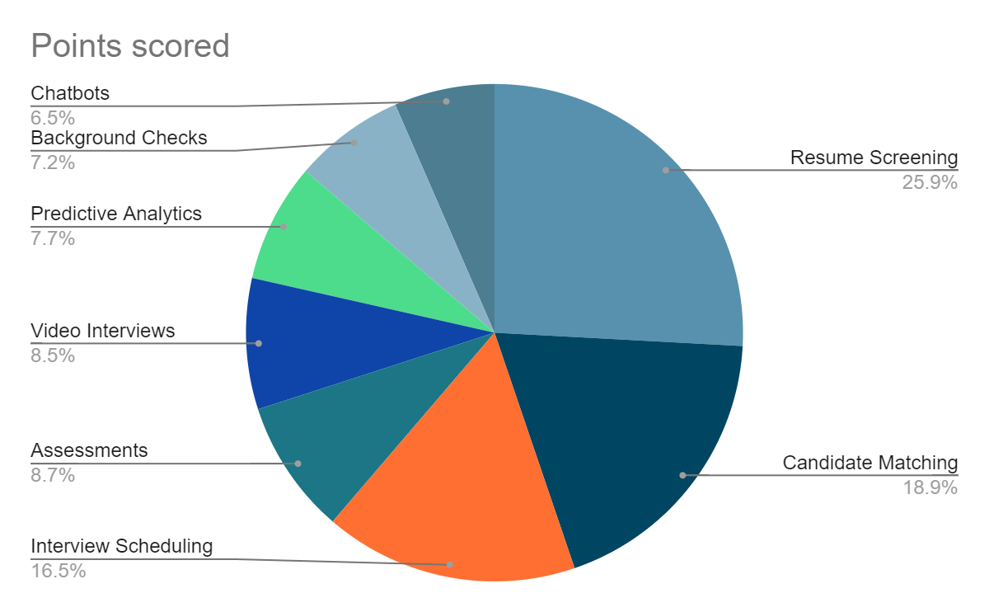

Technological advancements in natural language processing (NLP) and machine learning (ML) are pivotal to the success of AI interviewers. These technologies enable the automation of candidate assessments, ensuring consistent evaluation criteria and the ability to analyze complex responses effectively. Understanding the competitive landscape through in-depth research of tools like HireVue, Pymetrics, and Mya Systems provides valuable insights into feature sets, user experiences, and market strategies. This knowledge helps in identifying opportunities to innovate and differentiate in the crowded market space.

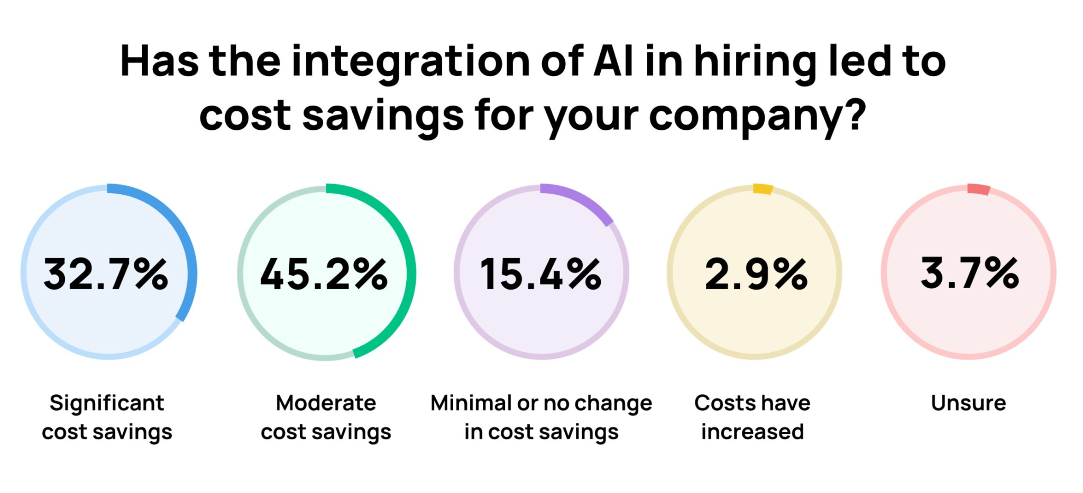

In the digital age, AI technology has become indispensable in talent acquisition, transforming HR processes by automating tasks like sourcing, screening, and interviewing candidates. Understanding the ROI of AI recruitment is crucial for CEOs, as it not only justifies technology investments but also enhances cost efficiency and productivity in hiring. Metrics such as cost per hire, time-to-fill, and quality of hires are pivotal in assessing AI's impact, highlighting its ability to reduce hiring costs, expedite time-to-fill, and improve overall candidate quality through objective evaluation methods. Embracing AI recruiting strategies equips organizations with tools to streamline processes, engage top talent effectively, and gain a competitive edge in the evolving recruitment landscape.

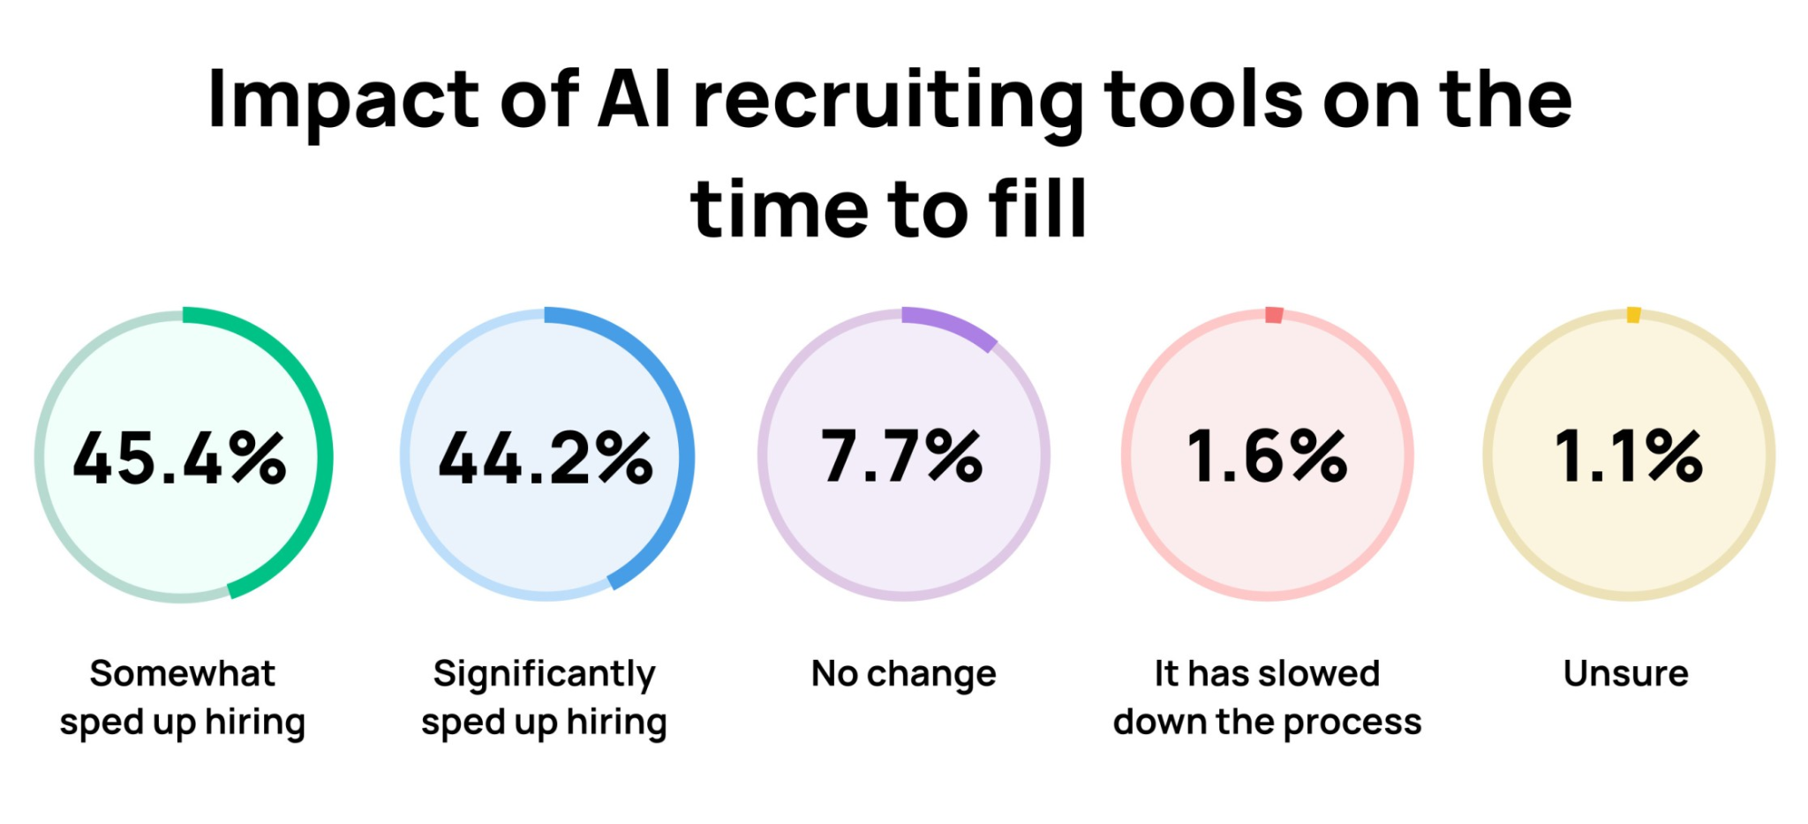

User experience is paramount in the adoption of AI interviewers. Insights from discussions on platforms like LinkedIn highlight the importance of providing candidates with a seamless and transparent interview process. This involves clear communication about how AI is utilized, ensuring candidates feel fairly evaluated and respected throughout the process.

Ethical considerations play a significant role in the development and deployment of AI interviewers. Addressing concerns related to algorithmic bias, data privacy regulations (such as GDPR or CCPA), and fairness in decision-making are crucial. Tools that incorporate blind scoring techniques or utilize diverse training datasets showcase efforts towards mitigating bias and promoting ethical AI practices.

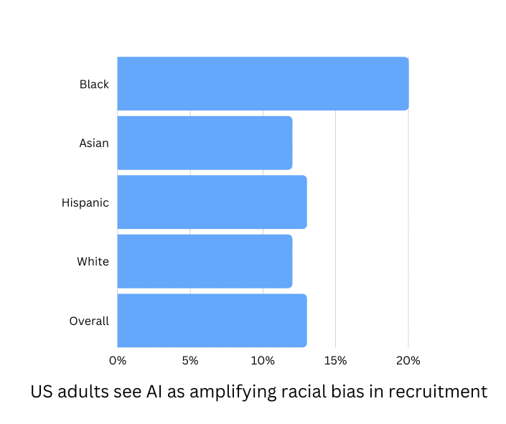

Regulatory compliance is another critical factor. Ensuring adherence to global data protection laws and industry standards is essential for safeguarding candidate data, obtaining consent for data usage, and implementing robust security measures.

Looking ahead, future trends in AI interviewers point towards more personalized interactions tailored to individual candidate profiles, deeper integration with applicant tracking systems (ATS), and advancements in predictive analytics for better candidate matching and retention. By synthesizing these insights, a well-informed feasibility study can guide the strategic development and positioning of an AI interviewer product, ensuring it meets market demands, complies with regulations, and addresses ethical considerations while leveraging emerging opportunities in AI-driven recruitment solutions.

**KEY STATISTICS**

A survey from Resume Builder indicates that 82% of companies use some form of AI in their hiring process. The market size of AI recruitment tools is projected to grow from $300 million in 2020 to $1.8 billion by 2030, reflecting a compound annual growth rate (CAGR) of 19.8%. AI recruitment tools can reduce the time to hire by up to 75%, and companies using AI for recruitment report a 30% increase in the quality of hires. Pew Research Center found that 67% of Americans believe AI in hiring can amplify racial bias, while 55% see it as a way to reduce human bias. Additionally, 80% of job seekers are comfortable with AI-driven initial interviews, but 60% still prefer a human touch in the final stages of the hiring process. The demand for AI-driven recruitment solutions is highest in the technology, finance, and healthcare sectors. Furthermore, 72% of recruiters plan to increase their investment in AI recruitment tools over the next three years. However, 45% of HR professionals are concerned about the transparency of AI algorithms, and 58% of job applicants are worried about the privacy of their data when interacting with AI-driven recruitment platforms.

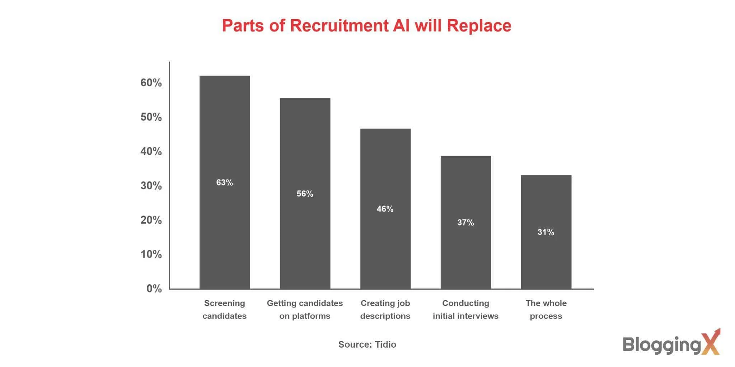

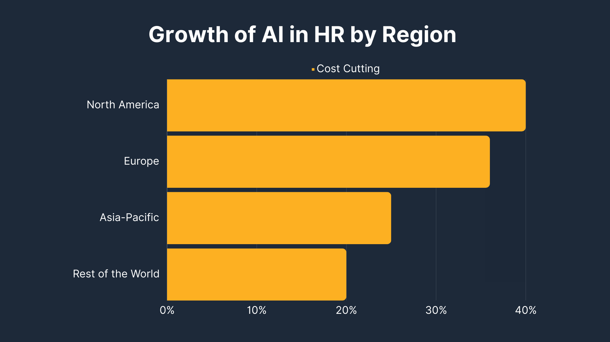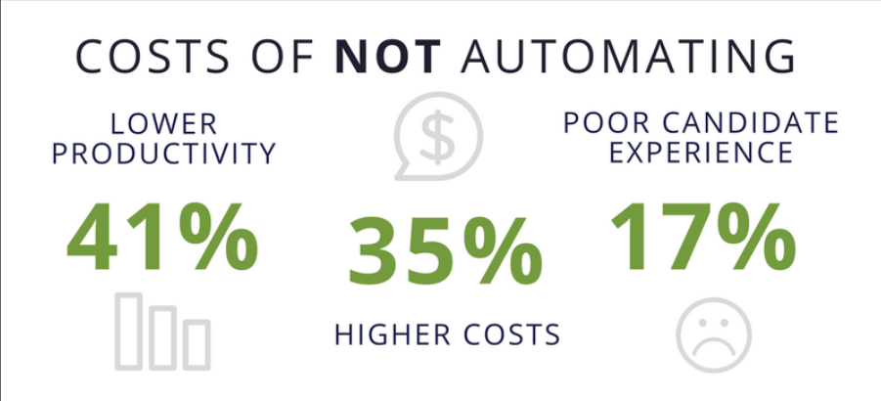

**SIMILAR EXAMPLE**

Comparing the AI Interviewer project with GPTInterviewer reveals several key similarities and areas for improvement. Both tools use AI to simulate interview scenarios and generate customized questions based on an applicant's resume and job descriptions. They aim to provide personalized and interactive experiences, leveraging AI to enhance the relevance and effectiveness of the interview process. GPTInterviewer features multiple interview screens for different skills and easy session refresh capabilities, focusing on creating a seamless and engaging user experience. The AI Interviewer project shares these goals, emphasizing tailored interview experiences and user engagement.

However, there are areas where the AI Interviewer project can differentiate and improve. GPTInterviewer plans updates to enhance AI capabilities and expand its question database, which is an opportunity for the AI Interviewer project as well. Ethical considerations, such as reducing bias and ensuring transparency, are emphasized by tools like Sapia.ai, which focuses on blind scoring of video interviews to promote hiring diversity. Implementing strict guidelines for ethical AI practices and actively seeking user feedback for continuous improvement can enhance the credibility and effectiveness of the AI Interviewer project. Additionally, expanding the question database to cover a wider range of industries and roles can make the tool more versatile and applicable to a broader audience.

**REFERENCES**

1. “The Journal by Fondo | Apriora launches your AI interviewer to identify the best candidates faster,” *www.tryfondo.com.*

<https://www.tryfondo.com/blog/apriora-launches> (accessed Jul. 10, 2024)

1. “My First AI Job Interview Explained (Plus Tips!),” *www.linkedin.com*. <https://www.linkedin.com/pulse/my-first-ai-job-interview-explained-plus-tips-supriya-vaidya-b0hxf/?trackingId=HcaouwzaQMaYvQCu%2BdlJAA%3D%3D> (accessed Jul. 10, 2024)
2. “The Future of Recruitment: Exploring the Benefits of Automated AI Interviews,” *www.linkedin.com*. <https://www.linkedin.com/pulse/future-recruitment-exploring-benefits-automated-ai-interviews-dxckc/?trackingId=SmI%2B9LVYSnC5D%2FPVrAYMZg%3D%3D> (accessed Jul. 10, 2024)
3. “The Responsible Use of LLMs in Structured Interviews,” *Sapia.ai*, May 29, 2024. <https://sapia.ai/resources/blog/the-responsible-use-of-llms-in-structured-interviews/> (accessed Jul. 10, 2024)
4. “How blind scoring of Video Interviews improved hiring diversity by 20%,” *Sapia.ai*. <https://sapia.ai/resources/blog/improving-hiring-diversity-with-blind-scoring-of-video-interviews/> (accessed Jul. 10, 2024)
5. H. Jia, “jiatastic/GPTInterviewer,” *GitHub*, Jul. 09, 2024. <https://github.com/jiatastic/GPTInterviewer> (accessed Jul. 11, 2024)
6. R. Thakkar, “Top 100 Hiring Statistics for 2022,” *www.linkedin.com*, Jul. 16, 2022. <https://www.linkedin.com/pulse/top-100-hiring-statistics-2022-rinku-thakkar/>
7. “35 AI Recruitment Statistics for Employers and Candidates,” *mspoweruser.com*, Jul. 20, 2023. <https://mspoweruser.com/ai-recruitment-statistics/>
8. L. R. Gelles-Watnick Monica Anderson, Colleen McClain, Emily A. Vogels and Risa, “1. Americans’ views on use of AI in hiring,” *Pew Research Center*, Apr. 20, 2023. <https://pewresearch.org/internet/2023/04/20/americans-views-on-use-of-ai-in-hiring/> (accessed Jul. 11, 2024)
9. A. Waller, “‘My anxiety loves you right now’: Man gets AI clone to do job interview for him,” *The Daily Dot*, Mar. 27, 2024.

<https://www.dailydot.com/news/ai-clone-job-interview/> (accessed Jul. 11, 2024)

1. A. Demopoulos, “The job applicants shut out by AI: ‘The interviewer sounded like Siri,’” *The Guardian*, Mar. 06, 2024. Available: <https://www.theguardian.com/technology/2024/mar/06/ai-interviews-job-applications#:~:text=A%20survey%20from%20Resume%20Builder>
2. B. Stefanowicz, “AI Recruitment: The Future of Hiring or HR’s Nightmare?,” *Tidio*, Jan. 05, 2023. <https://www.tidio.com/blog/ai-recruitment/>
3. “AI Interview Software Market Research Report 2024,” *www.linkedin.com*. <https://www.linkedin.com/pulse/ai-interview-software-market-research-report-2024-ib-market-updates-xirpf/> (accessed Jul. 11, 2024)
4. “Measuring the ROI of AI Recruitment,” *www.linkedin.com*. <https://www.linkedin.com/pulse/understanding-roi-implementing-ai-recruitment-ceo-processica-8npcf/> (accessed Jul. 11, 2024)