INTERNSHIP REPORT
On
CGPA Calculator and Login & Registration System Using C++
Submitted To
School of Computer Science and Engineering
IILM University, Greater Noida, U.P.
In partial fulfilment of the requirement of degree of
B.Tech CSE

By
Roll Number of Student: 25SCS1003004966
Name of Student: SUNNY
Batch: 2026-27

CANDIDATE'S DECLARATION
I, SUNNY, do hereby declare that the internship report titled "CGPA Calculator and Login & Registration System Using C++" has been completed by me to fulfil the requirement for the award of the degree of Bachelor of Technology in CSE. All the references have been quoted and I have not taken as such any material from any other source. I affirm that this report is my own work and has not been submitted to any other institute for any degree/diploma requirement, and further I shall be solely responsible for any kind of copyright violation in this regard.
Signature: ____________________
Student Name: SUNNY
Roll No.: 25SCS1003004966

ACKNOWLEDGEMENT
I am using this opportunity to express my gratitude to everyone who supported me throughout the Internship Program at CodeAlpha. I am thankful for their aspiring guidance, invaluably constructive criticism and friendly advice during this work. I am sincerely grateful to them for sharing their truthful and illuminating views on a number of issues related to this internship.
I would also like to thank the School of Computer Science and Engineering, IILM University, for providing me the opportunity to undertake this internship as part of my academic curriculum.
Finally, I express my gratitude to my parents for their constant support and blessings.
Signature: ____________________
Student Name: SUNNY
Roll No.: 25SCS1003004966

TABLE OF CONTENTS
1. Candidate's Declaration
2. Acknowledgement
3. Internship Completion Certificate
4. Project Description
4.1 Introduction
4.2 Organization Profile
4.3 Problem Statement
4.4 Project Objectives
4.5 Scope of the Project
4.6 Technologies and Tools Used
4.7 System Architecture
4.8 Methodology
4.9 Expected Outcomes
4.10 Certificates of Completion and Communication Proof
5. Bibliography / References
Annexure: Source Code

4. Project Description

4.1 Introduction
This report presents the work carried out during a one-month Virtual Internship Program in C++ Programming at CodeAlpha, undertaken from 1st August 2026 to 30th August 2026, as part of the academic curriculum of the B.Tech CSE program at IILM University. The internship was aimed at strengthening core C++ programming skills through the design and development of practical, console-based applications.
During the internship, two projects were completed: a CGPA Calculator, which computes semester-wise and overall CGPA based on course grades and credit hours, and a Login & Registration System, which implements user registration and authentication using file handling. Both projects were built using standard C++ concepts such as structures, control flow, functions, vectors, and file input/output operations.

4.2 Organization Profile
CodeAlpha is a technology-focused organization that provides virtual internship programs to students and early-career learners across domains such as C++, Python, web development, Android development, data science, and cybersecurity. The organization's mission, as stated on its platform, is to help learners gain hands-on, project-based experience that bridges the gap between academic learning and industry requirements. CodeAlpha internships are conducted remotely, with tasks assigned to interns that they complete independently and submit for review, followed by a Letter of Recommendation and a Certificate of Completion upon successful completion.

4.3 Problem Statement
Academic institutions and individuals often need simple, reliable tools to perform routine but important tasks — such as calculating cumulative academic performance or managing secure access to a system. Manually calculating CGPA across multiple semesters is time-consuming and prone to human error, while systems that store user data need a basic mechanism to register and authenticate users securely. The two projects undertaken during this internship address these two independent but commonly encountered problems using fundamental C++ programming techniques.

4.4 Project Objectives
- To design a console-based CGPA Calculator that accepts course-wise grades and credit hours and computes semester GPA and overall CGPA accurately.
- To design a Login & Registration System that allows new users to register with a username and password, and existing users to log in with credential verification.
- To apply core C++ concepts including structures, loops, functions, vectors, and file handling in solving practical problems.
- To strengthen problem-solving and logical thinking skills through independent project development.
- To gain exposure to a real-world, industry-style internship workflow, including task assignment, independent development, and submission for review.

4.5 Scope of the Project
The CGPA Calculator is scoped to handle multiple semesters and multiple courses per semester within a single program run, computing both individual semester GPA and a final overall CGPA. It does not persist data between program runs. The Login & Registration System is scoped to handle basic username/password registration and authentication for a single application, storing credentials in a local text file (users.txt). It focuses on the core logic of registration and login rather than advanced security features such as password hashing or encryption, which were beyond the scope of this one-month internship.

4.6 Technologies and Tools Used
- Programming Language: C++
- Standard Library Headers: <iostream>, <iomanip>, <vector>, <fstream>, <string>
- Compiler / IDE: Code::Blocks / g++ compiler
- Operating System: Windows
- Version Control: Local development and testing

4.7 System Architecture
Both applications follow a simple, procedural, console-based architecture suited to standalone C++ programs.
CGPA Calculator architecture: The program uses a Course structure to hold a course's name, grade, and credit hours. For each semester, course records are collected into a vector of Course objects. The program computes semester-wise total credits and total grade points, derives the semester GPA, accumulates these totals across semesters, and finally computes the overall CGPA. Results are displayed to the console in a formatted, tabular manner.
Login & Registration System architecture: The program is organized into two core functions — registerUser() and loginUser() — invoked from a menu-driven main() function. User credentials are persisted in a plain text file, users.txt, using file streams (ifstream/ofstream). Registration checks the file for a duplicate username before appending a new record, while login reads the file and verifies the entered credentials against stored records.

4.8 Methodology
The development of both projects followed a structured, incremental approach:
- Requirement understanding: Studying the task description provided by CodeAlpha and identifying the core functional requirements.
- Design: Planning the data structures (e.g., the Course struct) and program flow (menu-driven loop for the login system) before writing code.
- Implementation: Writing modular C++ code using functions to separate concerns — input handling, computation, and output display.
- Testing: Running the programs with multiple test cases, including edge cases such as duplicate usernames and multiple semesters/courses, to verify correctness.
- Refinement: Improving output formatting using manipulators such as fixed and setprecision for clean, readable results.
The complete, tested source code for both projects is provided in the Annexure at the end of this report.

4.9 Expected Outcomes
- A fully functional CGPA Calculator that correctly computes semester GPA and overall CGPA for any number of semesters and courses entered by the user.
- A fully functional Login & Registration System that successfully registers new users, prevents duplicate usernames, and authenticates returning users.
- Improved proficiency in core C++ concepts: structures, vectors, functions, control statements, and file handling.
- Practical experience of an industry-style remote internship workflow, culminating in a Certificate of Completion and Letter of Recommendation from CodeAlpha.

4.10 Certificates of Completion and Communication Proof
The following pages present the Certificate of Completion and the Letter of Recommendation issued by CodeAlpha upon successful completion of the internship (1st August 2026 – 30th August 2026, Student ID: CA/DF1/231140).

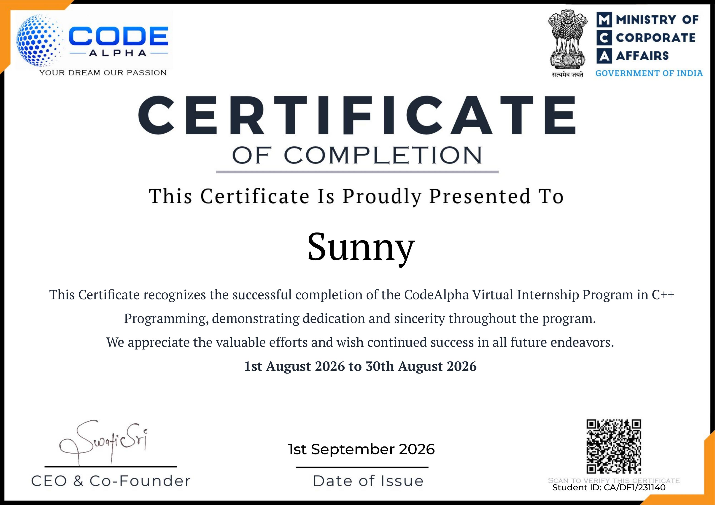

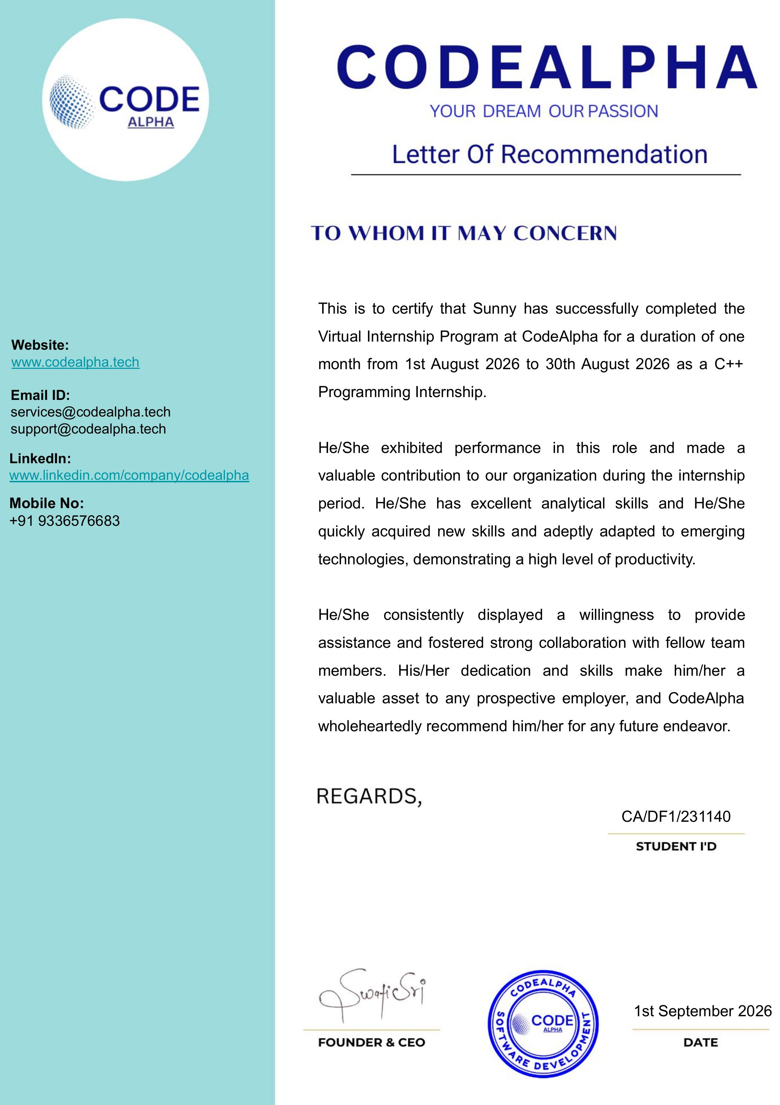

5. Bibliography / References
1. CodeAlpha Official Website — https://www.codealpha.tech
2. Stroustrup, B., "The C++ Programming Language", 4th Edition, Addison-Wesley.
3. cplusplus.com — C++ Language Reference.
4. GeeksforGeeks — C++ Programming Tutorials, https://www.geeksforgeeks.org/c-plus-plus/

Annexure: Source Code

A.1 CGPA Calculator (cgpa_calculator.cpp)

#include <iostream>
#include <iomanip>
#include <vector>
using namespace std;

struct Course {
string name;
float grade;
float credits;
};

int main() {
int numSemesters;

float overallTotalCredits = 0;
float overallTotalGradePoints = 0;

cout << "===== CGPA CALCULATOR =====\n";

// Input number of semesters
cout << "Enter number of semesters: ";
cin >> numSemesters;

for (int semester = 1; semester <= numSemesters; semester++) {

int numCourses;
vector<Course> courses;

float semesterTotalCredits = 0;
float semesterTotalGradePoints = 0;

cout << "\n===== SEMESTER " << semester << " =====\n";

// Input number of courses
cout << "Enter number of courses: ";
cin >> numCourses;

// Input course details
for (int i = 0; i < numCourses; i++) {
Course course;

cout << "\nCourse " << i + 1 << endl;

cout << "Enter course name: ";
cin >> course.name;

cout << "Enter grade points (0-10): ";
cin >> course.grade;

cout << "Enter credit hours: ";
cin >> course.credits;

// Calculate grade points
float gradePoints = course.grade * course.credits;

semesterTotalCredits += course.credits;
semesterTotalGradePoints += gradePoints;

courses.push_back(course);
}

// Calculate semester GPA
float semesterGPA =
semesterTotalGradePoints / semesterTotalCredits;

// Add semester data for final CGPA calculation
overallTotalCredits += semesterTotalCredits;
overallTotalGradePoints += semesterTotalGradePoints;

// Display semester results
cout << fixed << setprecision(2);

cout << "\n----- SEMESTER " << semester
<< " RESULT -----\n";

cout << "Individual Course Grades:\n";

for (int i = 0; i < courses.size(); i++) {
cout << courses[i].name
<< " | Grade: " << courses[i].grade
<< " | Credits: " << courses[i].credits
<< endl;
}

cout << "\nTotal Credits: "
<< semesterTotalCredits << endl;

cout << "Total Grade Points: "
<< semesterTotalGradePoints << endl;

cout << "Semester GPA: "
<< semesterGPA << endl;
}

// Calculate final overall CGPA
float finalCGPA =
overallTotalGradePoints / overallTotalCredits;

cout << "\n===== FINAL RESULT =====\n";

cout << "Overall Total Credits: "
<< overallTotalCredits << endl;

cout << "Overall Total Grade Points: "
<< overallTotalGradePoints << endl;

cout << "Final CGPA: "
<< finalCGPA << endl;

return 0;
}

A.2 Login & Registration System (login_registration_system.cpp)
#include <iostream>
#include <fstream>
#include <string>
using namespace std;

// Function for user registration
void registerUser() {
string username, password;

cout << "\n===== REGISTRATION =====\n";

cout << "Enter username: ";
cin >> username;

cout << "Enter password: ";
cin >> password;

// Input validation
if (username.empty() || password.empty()) {
cout << "Error: Username and password cannot be empty!\n";
return;
}

// Check for duplicate username
ifstream readFile("users.txt");

string storedUsername, storedPassword;

while (readFile >> storedUsername >> storedPassword) {
if (storedUsername == username) {
cout << "Error: Username already exists!\n";
readFile.close();
return;
}
}

readFile.close();

// Store new user credentials in file
ofstream writeFile("users.txt", ios::app);

writeFile << username << " " << password << endl;

writeFile.close();

cout << "Registration successful!\n";
}

// Function for user login
void loginUser() {
string username, password;

cout << "\n===== LOGIN =====\n";

cout << "Enter username: ";
cin >> username;

cout << "Enter password: ";
cin >> password;

ifstream readFile("users.txt");

string storedUsername, storedPassword;
bool found = false;

// Verify user credentials
while (readFile >> storedUsername >> storedPassword) {

if (storedUsername == username &&
storedPassword == password) {

found = true;
break;
}
}

readFile.close();

if (found) {
cout << "Login successful! Welcome, "
<< username << "!\n";
}
else {
cout << "Error: Invalid username or password!\n";
}
}

int main() {
int choice;

do {
cout << "\n===== LOGIN AND REGISTRATION SYSTEM =====\n";
cout << "1. Register\n";
cout << "2. Login\n";
cout << "3. Exit\n";

cout << "Enter your choice: ";
cin >> choice;

switch (choice) {

case 1:
registerUser();
break;

case 2:
loginUser();
break;

case 3:
cout << "Thank you! Exiting program...\n";
break;

default:
cout << "Invalid choice! Please try again.\n";
}

} while (choice != 3);

return 0;
}

