FMCG Receivables Passport
From idea to Demo Day — working note for Vladislav
The problem
FMCG distributors in the Balkans wait 30-120 days to collect on invoices. Classic factoring exists and is growing (Instant Factoring raised EUR 6.3M and expanded into Serbia; Factris is active regionally), but nobody runs it on-chain here. The core risk for any factor is double financing — the same invoice sold to two funders in the same week. It is the fraud that kills young factoring operations, and today there is no shared mechanism preventing it between competing funders.
Why blockchain, specifically
No funder accepts a competitor operating a shared registry. There is no natural neutral operator for this — exactly the situation where a decentralized registry solves something a normal database cannot, because someone would have to control it.
Recent validation
In December 2025, Serbia introduced by law a Central Factoring Registry (CFR), specifically for anti-double-financing. It is strictly national. An invoice crossing the border — Serbia to Romania, for example — is not covered by any registry. That is our opening. Full detail in the companion roadmap document.
Why not full factoring now
Factoring is a licensed activity in Serbia: minimum capital around EUR 340k, months of licensing. Not a permanent blocker, but it does not fit a 5-week sprint with two people. So we are not building the financing — we are building the layer underneath it.
What we are building for Demo Day: FMCG Receivables Passport
A registry that confirms an invoice is real, buyer-confirmed, and impossible to fund twice — without us ever touching the receivable. No license required.
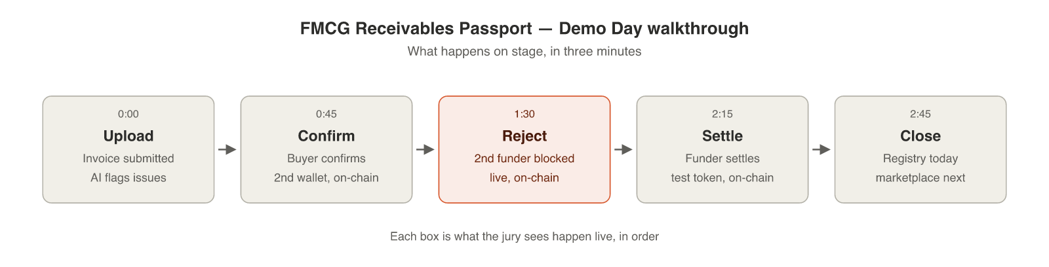
Solana Summit Serbia — Demo Day
10 teams, 3-minute pitch + 6-minute Q&A. Jury includes regulators, bankers and VCs, including someone from the Ministry of Finance. Priority-review applications close around August 2. Build window: August 5-26.
What I need from you
- Is double financing a real pain point for the distributors you know, or theory?
- What framing lands with your banking/regulatory contacts — anti-fraud, working capital, or infrastructure for licensed factors?
- Can you get an anonymized invoice plus a short interview with a distributor, ideally by Friday?
- Which licensed entities do you actually have access to, at what level — can we get a conversation before the Summit?
Proposal: 48-hour sprint, before any equity conversation
You deliver: the anonymized invoice, the interview, written confirmation of the time you can commit.
I deliver: the flow diagram, an upload/extraction prototype, one devnet transaction, a draft application.
Full roadmap, including layers 2 and 3, in the companion document: FMCG-Rail-Roadmap-Detail.docx

