FMCG Receivables Rail — Full Roadmap
Reference document — layers 2 and 3, for when you want the bigger picture
This goes deeper than the one-pager. It is not a near-term plan — it is a sequenced roadmap. Each layer below is built only after the previous one has real adoption, not on a fixed calendar.
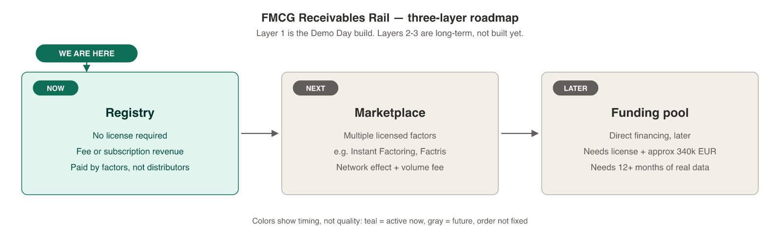
Layer 1 — Registry (now, Demo Day target)
Verification, buyer confirmation, and anti-double-financing. We never touch the receivable, so no factoring license is required. Revenue: a per-check fee (a few euros per invoice) or a monthly/annual subscription, paid by the factor, not the distributor — priced against the cost of a single double-financing fraud event, not against nothing.
The cross-border opportunity
Serbia's new Central Factoring Registry (CFR, live since December 2025) and Romania's existing pledge registry (RNPM) both solve double financing — but only domestically. Neither sees an invoice that crosses the border. That corridor is where we operate, and it is the one gap no national registry can close by itself.
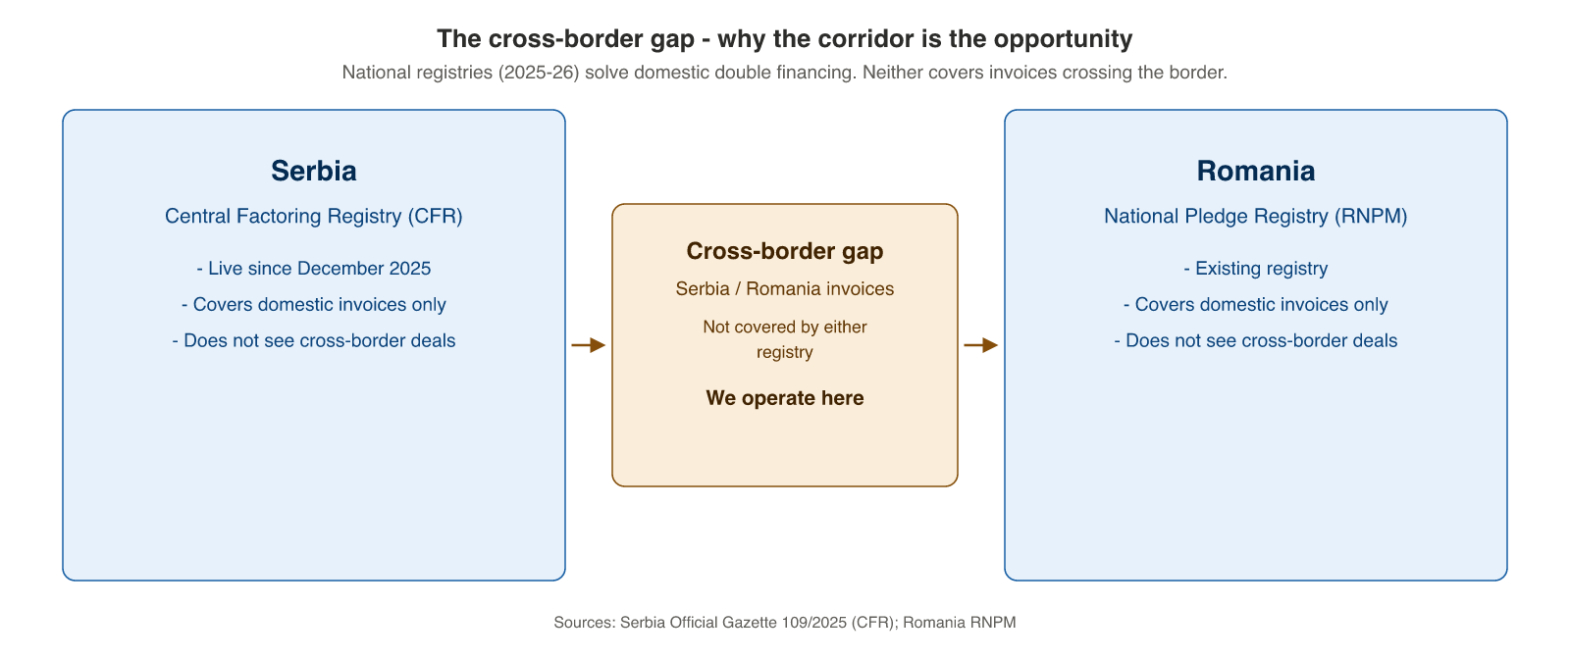
Layer 2 — Marketplace (after adoption)
Multiple licensed factors — for example Instant Factoring, Factris, or a bank's factoring desk — use the same registry independently of each other, including while competing with each other. We stay neutral: we do not finance anything, we only verify.
Why this does not collapse into “vendor to one factor”: non-exclusivity is structural, not just a promise. The first factor we onboard is a design partner, not a controlling partner — no equity for access, no exclusivity.
Network effect: every new factor that joins makes the registry more valuable for the others — fewer double-financing incidents slip through, more trust, more reason for the next factor to join.
Monetization at this stage: the same fee/subscription model, plus — once volume is real — a small percentage fee on the value of financing that flows through registry-verified invoices. This is the lever that scales with market size, not just with the number of checks.
Layer 3 — Own funding pool (later, only with real data)
What it is: a direct financing vehicle — either through our own factoring license or a partnership with a licensed factor — through which LPs can fund a pool of verified invoices and earn yield. This is, in essence, the original FMCG Receivables Rail vision, built last, not first.
Why not now: this needs three things we do not have yet — a factoring license (around EUR 340k minimum capital in Serbia, 6-12 months to obtain, or a partnership with an existing licensed factor), 12+ months of real repayment data to price risk honestly instead of guessing, and proven adoption, to negotiate a partnership from strength instead of from zero.
The conflict of interest, named directly: if the same company that operates the neutral registry also operates a funding pool, it becomes both infrastructure and a market participant — a direct competitor to the very factors using the registry. That is a real problem if we do not structure around it.
How we would resolve it, if we get there: a legally separate entity for the pool; pool infrastructure stays open to any licensed factor, not exclusive to us; clear governance so that, if asked “aren't you competing with your own customers”, the answer is “the pool is a separate entity that any licensed factor can plug into as a funding source.”
Why this order, not the reverse
- No real default data to calibrate a risk model → operating the registry for 12+ months with real data from multiple factors gets us exactly what a statistical default model needs before it can be trusted.
- Economics that were only illustrative, not measured → real loss rates, real collection costs, real payment behavior replace assumptions.
- No licensed factor partner identified → we would be negotiating from proven adoption, not from a cold outreach.
- Plans presented as if already executed → nothing gets claimed as done until it is actually built and used.
We are not skipping the original vision. We are sequencing it so that, by the time we attempt it, we have already solved what made it fragile the first time.

