Software Requirements Specification
For
Mess Management Service
(Manage all mess works of a mess manager)
Version 1.0 approved
Prepared by:
1.Shreshthajit Das(2017831013)
2.Fahim Tajwar Saikat(2017831020)
3.Abdullah-Al-Foysal(2017831032)

Date :10/4/2019

Submitted to:
Sayma Sultana Chowdhury
Assistant Professor,IICT,SUST

Date :30/4/2019
Table of Content

1.Introduction 3
1.1 Purpose 3
1.2 Document Convention 3
1.3 Reading Suggestion 3
1.4 Project Scope 4
1.5 References 4

2.Overall Description
5 2.1 Product Perspective 5
5 2.2 Product Features 5
2.3 User Classes & Characteristics 7
2.4 Operating Environment 9
2.5 Hardware Requirement 9
2.6 Design and Implementation Constraints 9
3. External Interface Requirements 10 3.1 User Interface : 12
3.2 Hardware Interface: 14
3.3 Software Interface : 14
3.4 Communication Interface :
4.System Features 15
4.1 System features elicitation : 15
4.2 Use-case Diagram : 18
4.2.1 System Log-In : 18
4.2.2 SOC news feeds : 19
4.2.3 System Notification : 20 4.2.4 Other Features : 21
4.3 Activity and Swimlane diagram : 22 4.3.1 Activity diagram of Searching : 22 4.3.2 Swimlane diagram of Searching :23
4.3.3 Activity diagram for creating post :24
4.3.4 Swimlane diagram for creating post : 25
4.4 DFD of Use Case of Database : 26
5.Nonfunctional Requirements 27
5.1 Product Requirements 27

5.1.1 Usability Requirements 27
5.1.2 Efficiency Requirements 27
5.1.4 Security 28
5.2. Organizational Requirements 28
5.2.1 Environmental Requirements 28
5.2.2 Operational Requirements 29
5.2.3 Development Requirements 29
5.3. External Requirements 29
5.3.1 Regulatory Requirements 29
5.3.2 Ethical Requirements 30
5.3.3 Legislative Requirements 30

Table of Contents ii
Revision History ii
1. Introduction 1
1.1 Purpose 1
1.2 Document Conventions 1
1.3 Intended Audience and Reading Suggestions 1 1
1.4 Product Scope 1 1
1.5 References 2 1
2. Overall Description 2 2
2.1 Product Perspective 2 2
2.2 Product Functions 2
2.3 User Classes and Characteristics 2 2
2.4 Operating Environment 2 2
2.5 Design and Implementation Constraints 2 2
2.6 User Documentation 2 2
2.7 Assumptions and Dependencies 3 3
3. External Interface Requirements 3 3
3.1 User Interfaces 3 3
3.2 Hardware Interfaces 3 3
3.3 Software Interfaces 3 3
3.4 Communications Interfaces 3 3
4. System Features 4 4
4.1 System Feature 1 4 4
4.2 System Feature 2 (and so on) 4 4
5. Other Nonfunctional Requirements 4 4
5.1 Performance Requirements 4 4
5.2 Safety Requirements 5 5
5.3 Security Requirements 5 5
5.4 Software Quality Attributes 5 5
5.5 Business Rules 5 5
6. Other Requirements 5 5
Appendix A: Glossary 5 5
Appendix B: Analysis Models 5
Appendix C: To Be Determined List 6 6

Revision History
Name | Date | Reason For Changes | Version
First Version | 11.03.19 | Initialize | 1.0

Introduction

Purpose
According to Mess Management ,This System will provide those Services, which users need immediately and co-Operating with all Member of a Mess.
Mess Management System will improve all Activities of a Mess those will be shown on product scope .
Our survey of what people want from us for a mess management system shown below:
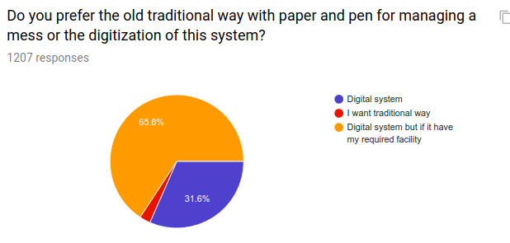
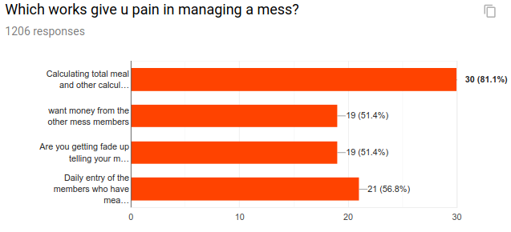

Document Conventions
- MMS : Mess Management Service
- Super Member: Mess Manager(Service maintainer)
- Member: Mess Member

Following are some of the important terms used throughout this
document:
- Daily meal update
- Add extra cost
- Task Remainder(schedule)
- Add extra cost and deposite calculation
- Activity logs: It captures the sequential actions that occur within any activity process or within a use case.

Intended Audience and Reading Suggestions

This is a prototype for an online based system that will serve all needed information about MESS Member & Activities of Mess . Some recommended topic for readers:
● Developers: Product feature, User characteristics,
Operating environment, System features.
● Designers: Project scope, User characteristics, System
features, External interface requirements.
● Domain: Product perspective, Product features, User
characteristics, System features,
● Public/User: Project scope, Product features, System features.

Product Scope

Mess Management Service is a online based software.MMS will enable the mess member to calculate all necessary information & calculation from any where.Any one of the member can access the mess activities and add necessary information such as Bazar cost,Add meal,Task reminder,Deposit money etc.

This srs will enable users to have an overview of the system features and it’s pursposes ,benfits,objectives ,goals.

Purpose:Different types of Reader will get overview of the Mess Management System.

Benefits: This document can make the readers to understand about all features and functions as the client wanted.MMS will save the time and space of calculation for all of the user of the system.

Goals: The main goals is to Save time and works of calcultation to the Mess members.The srs will give an totall overview of the system pupose and benefits to the system users ,client engineer,Architecture,client manager and developers.

Mess Management Service(MMS) has following scope:
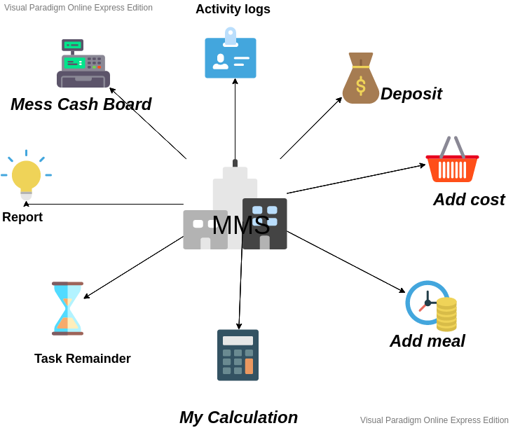

References
1.”Meal Manager” on Android Play Store.
2. “Meal Expense”

Overall Description

Product Perspective
Mess Management System is a software where all activity of a mess is done with digitalization system rather than pen and paper.As it is online base it will accessible from any where and maintain mess activities.
- Create Mess Account:
- Activities:

- Add Daily meal & update
- Add Daily cost & update
- Add extra cost & update
- Task Remainder(schedule)
- Calculation
- Report to manager
- Communication through notification
- Add & Delete member

Product Functions
- Daily Meal:
The members of the mess can book for meal daily before the bazar. They have option for auto meal book or cancellation any meal from this option.Previous meal count can’t update which has the only authentication to Mess Manager.
- Add extra cost:
The members of the mess can add extra cost except meal with the permission of the mess manager. For example if we buy a handwash for the mess it will obviously not go in the section of meal. Any members of the mess can add the cost of purchasing handwash to the extra cost section. Users have a short note section so that they can recall which item they had bought in future.
- Task Remainder:
In this section the user can get the suggestion for bazar. In this section there will be a section of recipe . There will be a huge collection of famous recipe. As our users are not master at cooking , we will provide the ingredients of that recipe. And that member , who have to bazar will not face any dilemma for bazar.
Manual suggestion edition is only applicable for Mess Manager.

Global flatform such as Daraz,Amazon will also included in this section.

- Add Bazar Cost: Any member can add bazar cost which is belongs to Meal.
Irrevant cost will add to Add extra cost.
Only Mess Manager can update any information with will notify to all Members.

- Deposit Money:
This section is only for Mess Manager or super admin.After getting money from any member, super admin will add Deposit Money.

- Mess Cash Board: Current Deposit ,cost,Meal Rate will auto update here.

- My Calculation: Meal Rate, Deposite money,need to pay .

User Classes and Characteristics
- Users: who are able to use Smart phone or Personal Computer .
- Users Education Level:A Good command in English.
- Frequent User: Student community, A group of People with Different Jobs.

Operating Environment
- Touch screen for convenience
- keypad (on screen and keyboard)
- Will run the Latest version of Application
- Ability to connect to web server or network
- Ability to take input from user(mess member)

Design and Implementation Constraints

User Documentation
See product scope & product function..

Assumptions and Dependencies
- System won’t Failure or crash
- Hardware won’t fails to load
- Always Connect to internet or web server.

External Interface Requirements

User Interfaces
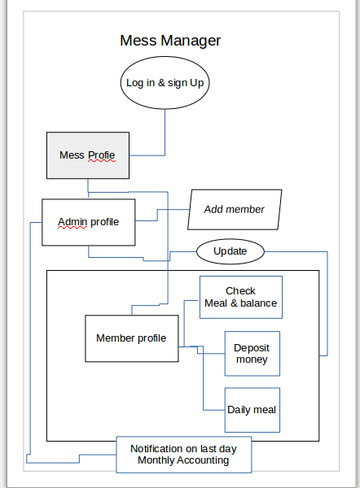

Hardware Interfaces

Operating system | Windows: Windows XP SP3, Windows Vista SP2, Windows 7,Linux,Mac
CPU | Pentium processor at 90 MHz or higher
Memory | 2 GB RAM
Hard drive | 50 MB available in the hard disk
Media | 2x or higher
Graphics hardware | DirectX 3.0 or higher

Software Interfaces
Mess Management Service software interface:

*Operating system:Windows,linux,MacOs,IOS, android.

*Database:Oracle databas,Goggle cloud

*Platform:Java,python,Netframework,NodeJs,Angular
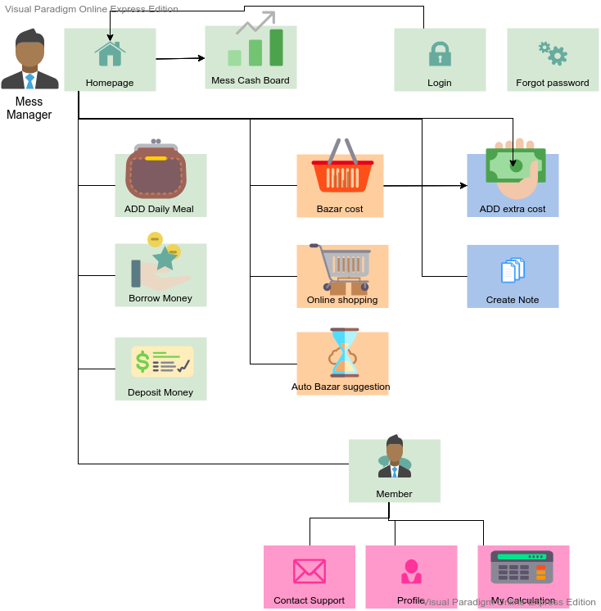

Communications Interfaces

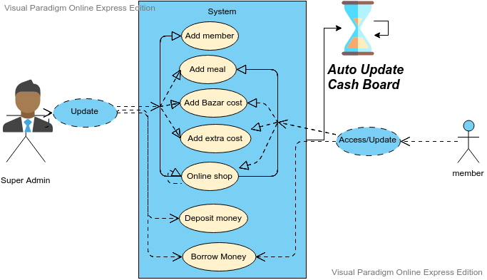
Connecting to Mess Management service:

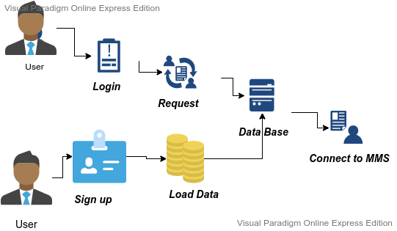

Communication interface

System Features

System Feature 1
Mess Cash board
4.1.1 Description and Priority:
Here Mess Cash board updates automatically after user input. It is an overview of total collected money and spend money.
4.1.2 Stimulus/Response Sequences:
Users have to add data of bazar and meal manually and these response will be used to calculate the mess cash board
4.1.3 Functional Requirements

REQ-1: A simple Database
REQ-2: Network connectivity

System Feature 2
Auto Bazar Suggestions
4.2.1 Description and Priority:
In this section the user can get the suggestion for bazar. In this section there will be a section of recipe . There will be a huge collection of famous recipe. As our users are not master at cooking , we will provide the ingredients of that recipe. And that member , who have to bazar will not face any dilemma for bazar.
4.2.2 Stimulus/Response Sequences:
We will get data of Bazar items from a particular place and if the bazar of the mess will not contain those items we can suggest that items
4.2.3 Functional Requirements

REQ-1: A huge collection of food recipe
REQ-2: AI Algorithm
REQ-3: A huge collection of other users data

Other Nonfunctional Requirements
5.1.1 Usability Requirements

5.1.1.1 Graphical User Interface

The system shall provide a uniform look and feel between all the web pages.The system shall provide use of icons and toolbars.The user interface for the software shall be compatible to any browser such as Internet Explorer,Chromium, Mozilla or Netscape Navigator by which user can access to the system. The user interface shall be implemented using any tool or software package like Java Applet, MS Front Page, EJB etc.

5.1.1.2 Accessibility
The system shall provide handicap access.The system shall provide multi language support

5.1.2 Efficiency Requirements :

5.1.2.1 Performance Requirements :

The website should use as less animations and pop ups as possible to lessen the pressure on client’s device.The SOC shall be based on web and has to be run from a web server.The News Feed shall take initial load time depending on internet connection strength which also depends on the media from which the system is run.

5.1.2.2 Space Requirements

Every user should have a limited number of storage.

5.1.3 Dependability Requirements:
There should be described terms and conditions page, open for everyone, so that users can depend on the system. SOC should display the disclaimers, copyright & word marks etc.

5.1.4 Security

5.1.4.1 Data Transfer

The system shall use secure sockets in all transactions that include any confidential user information. The system shall automatically log out all users after a period of inactivity. The system shall confirm all transactions with the customer’s web browser.

5.1.4.2 Data Storage:
The user’s web browser shall never display others password. It shall always be encoded with special characters representing typed characters. The user’s web browser shall never display an information tagged private after retrieving from the database

5.2. Organizational Requirements

5.2.1 Environmental Requirements

This app should run responsively on various devices.

5.2.2 Operational Requirements

As the website should be used by mass people, the page elements should be as simple as possible. Since the application must run over the internet, all the hardware shall require to connect to the internet will be hardware interface for the system. As for e.g. Modem, WAN – LAN, Ethernet Cross-Cable. There should be a technical team to answer the questions asked by the user in the FAQ page.

5.2.3 Development Requirements

5.2.3.1 Standard Development

Tools The system development shall be built using a standard web page tool that conforms to either IBM’s CUA standards or Microsoft’s GUI standards.
5.2.3.2 Web Based Product
There are no memory requirements

5.3. External Requirements

5.3.1 Regulatory Requirements
The website should have a well-planned Terms and Conditions Policy. Those policy should be open to users.

5.3.2 Ethical Requirements

User should be ensured that his data will not be sold to other companies or person. There should be one or more than one lawyer to keep an eye on the behavior of the website.

5.3.3 Legislative Requirements

5.3.3.1 Accounting Requirements

A user account should have the privacy option, so that users can have a choice who can see which part from his/her account.

5.3.3.2 Safety Requirements
All the users’ data will be safe and secure. The app will not use user’s microphone, camera or any extra computational power without his/her permission. No user can see other users private info

