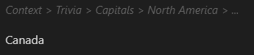
#flashcards

# Trivia

## Capitals

### Africa

Kenya::Nairobi

### North America
Canada::Ottawa
1
2
3
3
3
2
1
Obsidian Heading Level
3
2
1
3
2
1

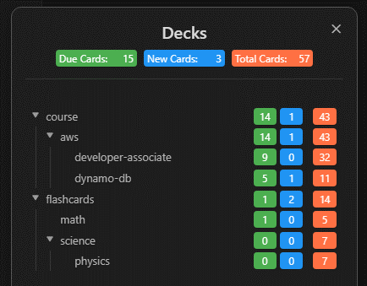
New
Due
Total

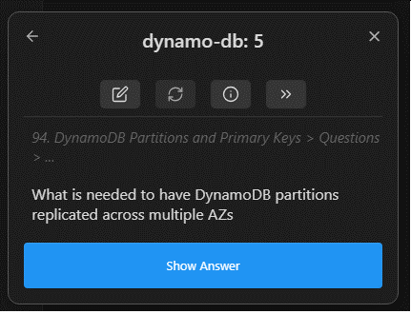
1
2
3
4

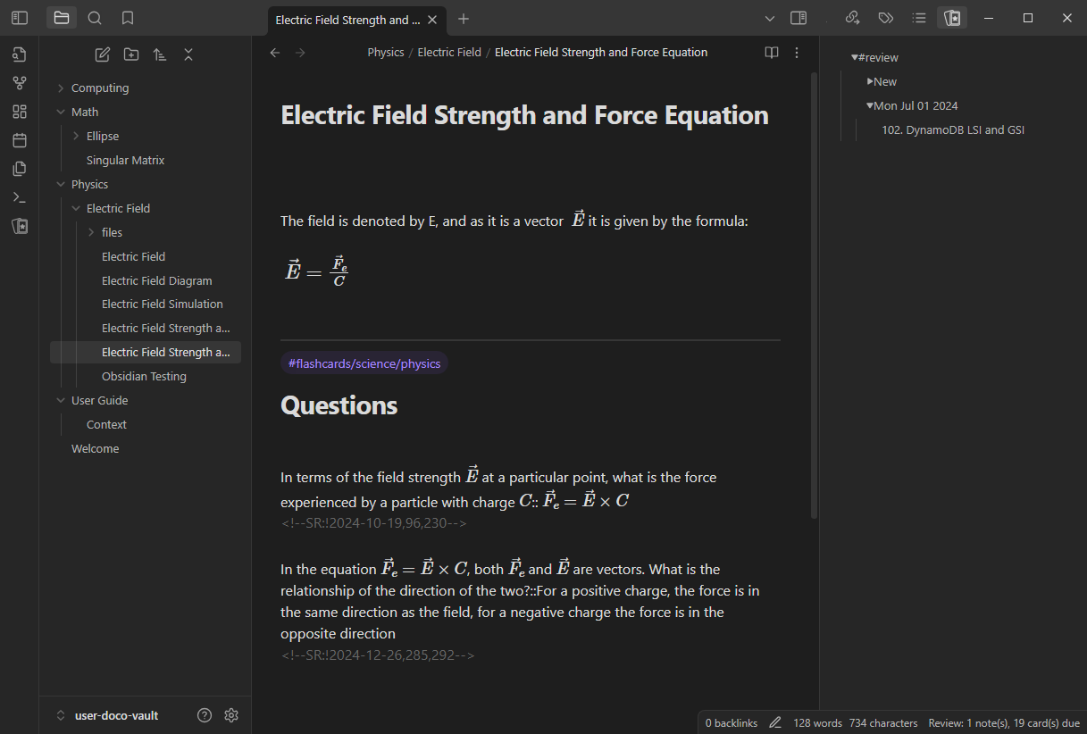
4
5
1
8
2
6
7
3
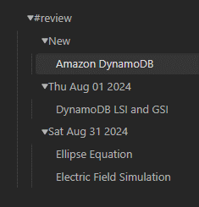
2
3
4
1
5

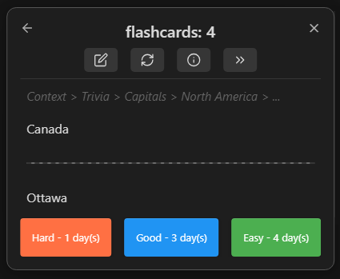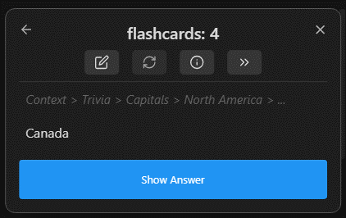
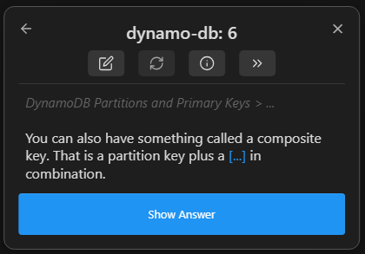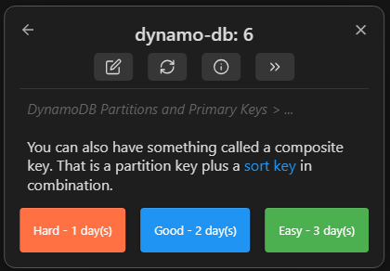
Cloze Deletion

