
Centennial College
Software Engineering Technology -AI-

LumiAI Chatbot
(Version 1.0.1 approved)

Software Requirements Specification
Software Requirements Engng - Team Project

Abhijeet Singh - 301549680
Amandeep Singh - 301547745
Erlin Shao - 301530574
Shiori Takeda – 301545004

Mahsa Emami-Taba
08.14.2026

List of Figures

Table of Contents ............................................................................................................... ii
Revision History ................................................................................................................. iii
- Introduction ................................................................................................................... 1
  - Purpose .................................................................................................................. 1
  - Document Conventions ........................................................................................ 1
  - Intended Audience and Reading Suggestions ............................................... 1, 2
  - Product Scope ....................................................................................................... 2
  - References .............................................................................................................. 3
- Overall Description ....................................................................................................... 3
  - Product Perspective .............................................................................................. 3
  - Product Functions ................................................................................................. 4
  - User Classes and Characteristics ......................................................................... 4
  - Operating Environment ................................................................................... 4, 5
  - Design and Implementation Constraints ............................................................ 6
  - User Documentation ............................................................................................. 6
  - Assumptions and Dependencies .......................................................................... 7
- External Interface Requirements .................................................................................. 7
  - User Interfaces ........................................................................................................ 7
- Student ................................................................................................................. 7
- Applicants ............................................................................................................ 7
- Professor .............................................................................................................. 7
- System administrator .......................................................................................... 8
  - Hardware Interfaces ................................................................................................ 8
  - Software Interfaces ............................................................................................... 8
  - Communications Interfaces .................................................................................. 8
- Stakeholder Register ............................................................................................... 9, 10
- Interview Question ........................................................................................ 10, 11, 12
- Functional Requirements List ................................................................ 12, 13, 14, 15
- Nonfunctional Requirements List ................................................................. 15, 16, 17
- Use Case Table .............................................................................................. 17, 18, 19
- Use-Case Formal Descriptions ............................................................................ 20, 21
- Activity Swim Lane Diagrams ................................................................................... 22
- Use Case Diagram ............................................................................................... 23, 24
- Domain Class Diagram ............................................................................................... 25
- CRC Index Cards ........................................................................................................ 26
- Class Diagram ............................................................................................................. 26
- Output to the Report ................................................................................................. 27
- State Diagrams ............................................................................................................ 28
- Sequence Diagram ...................................................................................................... 29
- Header Gen AI Sequence .......................................................................................... 30
- Updated Class Diagram .............................................................................................. 31

. Revision History
Name | Date | Reason For Changes | Version
S. Takeda | 2026-07-13 | Modified Stakeholder Register, Interview Question, Functional Requirements List, and Nonfunctional Requirements List | 1.0.1

- Introduction
  - Purpose
The Software Requirements Specification (SRS) document contains comprehensive information about an AI Chatbot for a college system at Centennial, to be developed by college students. The purpose of this document is to support the school lives of college students and applicants and to enhance their understanding of the use of Centennial Luminate. This new software product will address the problem of student and applicant manipulation in Centennial Luminate and will be integrated into the main college system. This is version 1.0.0.

The document urges an understanding of all stakeholders and outlines the purpose, function, and circumstances under which the LumiAI Chatbot will be utilized. This is the foundation for the subsequent system design and development phases.

  - Document Conventions
Acronyms | Description
AI | Artificial Intelligence
SQL | Sequential query language
DB | Database
LMS | Learning management system
API | Application program interface

Requirement Number | Description
FR-XX | Functional Requirements
NFR-XX | Non-Functional Requirements

  - Intended Audience and Reading Suggestions
Stakeholder | Role
Centennial College | Officials who will review and approve the requirements and solution owner.
Project owner | Who will be responsible and will be a final decision maker for a project.
Project manager | Who will be a professional and will be responsible for planning, organizing, and executing proper goals for a project.
Development team | Who will design and implement the system
System administrators | Who will maintain and support the system (mainly are the system administrators from Centennial College)
Professors at Centennial College | Who teach students and advice about their assignments and projects
Students at Centennial College | Who belong to Centennial College and use Centennial Luminate
Applicants at Centennial College | Who apply to courses at Centennial College and use Centennial Luminate

  - Product Scope
Some students and applicants struggle with Centennial Luminate for its variety of content and complexity. LumiAI Chatbot is a chatbot including Centennial Luminate, which instructs students and applicants on how to use Centennial Luminate. Students can understand the usage of Centennial Luminate more easily by using LumiAI Chatbot; they only need to ask where they want to access, or with what purpose they try to access the specific location in Centennial Luminate. LumiAI Chatbot refer to the URLs that help the progress of the students’ and applicants’ assignments and projects from inside Luminate or outside it. The basic references are made by their professors and alumni; additionally, as supplementary references, the websites that the students who have already passed the courses is introduced to if there is. The users can also register their schedules through LumiAI Chatbot. By converse with LumiAI Chatbot, the students and applicants are able to schedule their events in Luminate’s calendar. As the same function, LumiAI Chatbot reminds the due dates of the students’ and applicants’ assignments and projects if they are set.
More effectively, LumiAI Chatbot supports the applicants’ applications; this takes full advantage of one of AI’s representative features. Usually, the application forms are not very intuitive yet like people tell others in conversations. However, LumiAI Chatbot realizes such a more intuitive operation. At first, the users tell LumiAI Chatbot what kinds of courses they want to apply to. Then, LumiAI Chatbot asks for the required information from the users; the users only need to answer these questions. Finally, LumiAI Chatbot shows the previews of the application forms and asks if the users hope to submit immediately or not. If the users convince the application forms which LumiAI Chatbot shows, they are able to answer ‘yes.’ Whereas the users do not convince against all or some of the parts of the application forms, they can start over again or modify some parts manually.

  - References
Enabel. Software Requirements Specification for AI-Driven Job Matching Platform. Ministry of Labor (MoL), Palestinian Employment Fund (PEF) and Enabel. 2025 (Reference: SRS_AI_JMP_V1.0_May_2025)

- Overall Description
  - Product Perspective
LumiAI Chatbot is a new module that will interface with the existing college system. It will operate as a dependent web-based system and assist Centennial Luminate; the system will be available 24/7.

The following context diagram illustrates the system’s position within its environment and its interactions with external and internal entities:

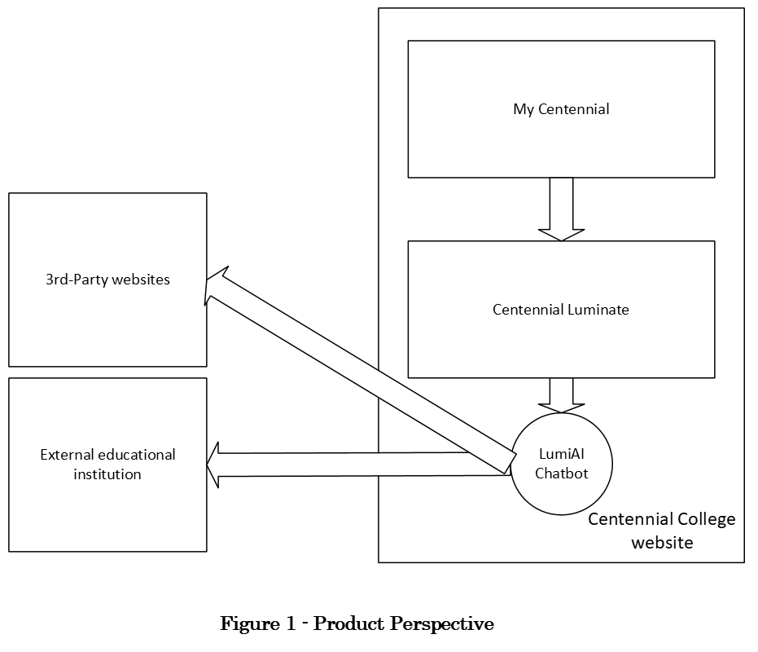
  - Product Functions
- Collect and store references about assignments and projects
- Show references of assignments and projects as needed
- Connect to Wi-Fi
- Answer users’ questions
- Guide about Centennial Luminate (It includes the replies for users’ questions)
- Schedule users’ events (one of the time managements)
- Reminder due date of users’ assignments and projects (one of the time managements)
- Help writing application forms

  - User Classes and Characteristics
- Students: will use Centennial Luminate to join their courses, obtain information, and apply new courses, and so on.
- Applicants: will use Centennial Luminate to join their courses, obtain information, and apply new courses, and so on.
- Professors: will store references of assignments and projects to offer to students.
- System administrators: will manage the whole system, including Centennial Luminate, and update new information or more beneficial functions.

  - Operating Environment
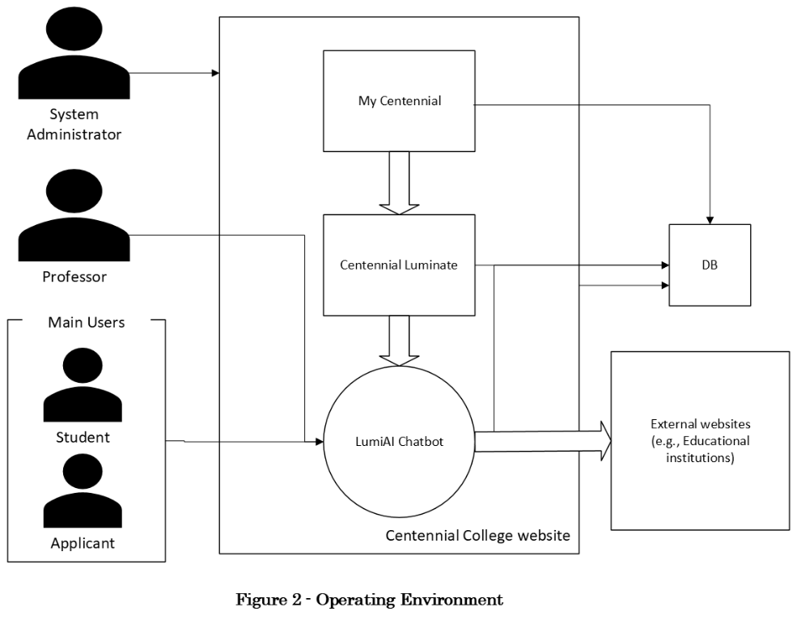

LumiAI Chatbot has four active actors and exists as a cooperating system for Centennial Luminate. All of actors (the professor, system administrator, student, or applicant) accesses Centennial College website at first. The student, applicant, or professor connects with LumiAI Chatbot via MyCentennial and Centennial Luminate. The system administrator accesses LumiAI Chatbot directly.

The software:
- will run on Windows, Linux/Unix server
- will use NoSQL DB (Document DB) to store references of assignments and projects
- supports the following browsers: Firefox, Chrome, Microsoft Edge
- will be developed using JavaScript and C#
- supports iOS, Android for the mobile version
- will be embedded inside Centennial Luminate (LMS)
- will be secured by user authentication (application form)
- will own a multilingual user interface (English, French, Spanish, and Chinese)

  - Design and Implementation Constraints
- Technical Constraints
- Must be able to integrate with the existing MyCentennial and Centennial Luminate systems and databases
- Must be able to load student numbers and passwords from MyCentennial
- Must support accessing internal applications and external websites
- Must be accessible via standard web browsers without special plugins or settings
- Must function effectively in areas with limited internet connectivity
- Must be user-friendly, especially with people with disability

- Regulatory Constraints
- Must adhere to international standards for data security (e.g., GDPR principles)
- Must support legal requirements for students and applicants

- Business Constraints
- Must be implemented in phases, with basic functionality prioritized
- Must be scalable to accommodate future expansion
- Must be maintainable by a system administrator with appropriate training

- User Constraints
- Must accommodate all of the students and applicants
- Must support accessibility standards for users with disabilities
- Must provide multilingual support (English, French, Spanish, and Chinese)

  - User Documentation
- User manuals
- On-line help
- Training materials
- IT Service Desk (internal entity)
- Luminate Support (internal entity)
- Technology Help (internal entity)

  - Assumptions and Dependencies
- Assumptions
- Centennial College will provide timely access to existing systems and databases for integration
- External educational institution will cooperate in the integration process
- Adequate infrastructure will be available for system deployment
- Stakeholders will participate actively in the requirements validation process
- The system will be implemented in phases, with basic functionality prioritized
- The proper security system will be implemented to protect users’ personal information
- The system administrator with appropriate training will be assigned to address any issue
- The professor will offer references to assignments or projects to the database

- Dependencies
- Availability of accurate and up-to-date data from Centennial Luminate, MyCentennial, and the professor
- Cooperation from the external educational institution for integration
- Availability of technical resources for system implementation
- Approval of necessary policies and procedures for system operation
- Successful procurement process for Phase Two implementation
- Implementation of high-level security software

- External Interface Requirements
  - User Interfaces
All actors access from Centennial College website; from that website, the way to access is separated depending on the user’s position (refer to 2.4 Operating Environment). There will be a mobile interface; the platforms that the system support are smartphones, and the browsers are Safari and Google Chrome. JavaScript and C# will be used as its back end.

- Students
- Chatbot interface
- Description interface (application forms)
- Search interface
- Time management interface
- Notification and messaging interface

- Applicants
- Chatbot interface
- Description interface (application forms)
- Search interface
- Time management interface
- Notification and messaging interface

- Professor
- Storing interface
- Course management interface

- System administrator
- User/roles/permissions management interface
- System configuration interface
- AI management interface
- Reporting and analytics interface

  - Hardware Interfaces
- Server Infrastructure
- Application servers
- Database servers
- Storage systems
- Backup systems

- Network Infrastructure
- Load balancers
- Firewalls
- Network monitoring devices

- User Devices
- Desktop computers
- Laptops
- Smartphones
- Tablets

  - Software Interfaces
- A calendar
- An AI application program interface (API)
- Centennial Collage databases
- Email and Application form gateways
- Analytics and Reporting Tools

  - Communications Interfaces
- Network Protocols
- API Communications
- Data Exchange Formats

- Stakeholder Register
Stakeholder
Register
Stakeholder  Name | Stakeholder  Position | External/  Internal | Stakeholder  Contact  details | Operational/  Executive | Interest  (high, medium, low)
Logan Routhier | CCSAI Student Association President | External | lrouthier@ccsai.ca | Operational | High
Dr. Craig Stephenson | College President & CEO | Internal | cstephenson@centennialcollege.ca | Executive | High
Nilsen Cruz | Microsoft Azure Solutions Architect | External | ncruz@microsoft.com | Operational | High
Lisa White | AVP of Enrolment Services & Registrar | Internal | lwhite@centennialcollege.ca | Executive | Medium
Kanishka  Dhir | AI Software Engineer / Capstone Lead | Internal | kdhir@my.centennialcollege.ca | Operational | High
Nath Bob | IT Systems Administrator | Internal | nathbob@centennialcollege.ca | Operational | Medium
Mary Ying | Python & NLP Developer | Internal | maryying@gamil.com | Operational | Medium
John Smith | External Systems Consultant | External | johnsmith@gmail.com | Operational | High
Chloe Bennett | Domestic Student | External | cbennett@my.centennialcollege.ca | Operational | High
Alex Mercer | International Student | External | amercer@my.centennialcollege.ca | Operational | High
Amy Watoson | Domestic Applicant | External | amyw@gmail.com | Operational | High
Bob Brown | International Applicant | External | bobb@gmail.com | Operational | High

- Interview Question
Question | Stakeholder position | Answer
Why is your position not ”Executive” but “Operational”? | CCSAI Student Association President | Our responsible parts are not only Luminate, but also jobs, clubs, and so on. We cannot only focus on Luminate.
Why did you accept introducing LumiAI Chatbot in Luminate? | College President & CEO | Because Canada is a multinational country; I predict that it can contribute many kinds of people.
What role are you in charge of in LumiAI Chatbot as “External”? | Microsoft Azure Solutions Architect | Design, implement, secure, and optimize the cloud-based AI infrastructure that powers LumiAI and integrates it with Blackboard/Luminate, ensuring reliable and secure AI services for students and faculty.
Why is your position “Exective”? | AVP of Enrolment Services & Registrar | It is my responsibility for students and applicants to understand the proper procedures. I have to manage whether the information AI provides is correct or not.
How do you integrate LumiAI Chatbot into Luminate? | AI Software Engineer / Capstone Lead | I do below:  - Analyze requirements  - Connect LumiAI to Blackboard/Luminate  - Build the AI backend  - Create the user interfaces  - Implement security and privacy controls  - Test the integration  - Deploy and monitor
What do you think that your interest is “Medium”? | IT Systems Administrator | AI Software Engineer / Capstone Lead create most of parts, and I just keep these systems. It is normal that their interest is higher than me.
In what system are you interacting with? | Python & NLP Developer | As the Python & NLP Developer, I am interacting with the LumiAI Chatbot system, which is integrated with Centennial Luminate. My role focuses on developing the chatbot’s natural language processing capabilities so that students and applicants can communicate with the system using conversational language instead of navigating complex menus and interfaces.
What sort of impact is it having in LumiAI Chatbot if you do not engage in the development? | External Systems Consultant | LumiAI has linked up with some external systems; It is not an independent system. If the connection of each external system were insufficient, LumiAI Chatbot would not work well.
What are the changes if Luminate includes LumiAI compared to without it? | Domestic Student | LumiAI Chatbot helps us 24/7. Also, it is possible that we can access the information we need faster than we look for it.
In what kind of situation this AI chatbot supports you? | International Student | If English is not my first language, LumiAI can explain difficult concepts in a clearer and simpler way.
Why would you like to use LumiAI Chatbot? | Domestic Applicant | I do not know all benefit as domestic applicant at Centennial College, so I want to ask what benefit I can obtain to enter this school.
What obstacle LumiAI solve for you? | International Applicant | For me, language problem is very serious, but I heard there is a translator in the AI. I could apply easier if AI translate an application form.

- Functional Requirements List
Requirement ID | Requirement title | Short  Description | Priority | Requester
FR01 | Calendar Synchronization | The system shall automatically pull assignment due dates and test schedules from Centennial Luminate course shells into a unified user view. | High | CCSAI Staff  Domestic Student,  International Student,  Domestic Applicant,  International Applicant
FR02 | Automated Due Date Nudges | The system shall analyze upcoming deadlines and push active notification reminders to students 48 hours prior to an assignment close date. | High | CCSAI Student Association President  Centennial Staff  (professors)
FR03 | Resource Navigation Support | The system shall provide instant direct links to campus resources (such as academic advising and tutoring) via natural language chat requests. | Medium | CCSAI Student Association President  Domestic Student,  International Student,  Domestic Applicant,  International Applicant
FR04 | Admission Eligibility Analyzer | The system shall evaluate academic background parameters typed by prospective applicants and cross-reference them with program prerequisites to verify entry status. | High | AI Software Engineer / Capstone Lead  Centennial Staff (AVP Enrolment & Registrar)  International Student
FR05 | Real-Time Status Retrieval | The system shall securely fetch and display live, up-to-date tracking information regarding the applicant's current enrollment application status. | Medium | AI Software Engineer / Capstone Lead  Centennial Staff (AVP Enrolment / IT Staff)  Domestic Student,  International Student,  Domestic Applicant,  International Applicant
FR06 | Document Status Scanner | The system shall allow prospective students to upload admission files and instantly check if they match mandatory application checklists. | Medium | Microsoft Azure Solutions Architect  Domestic Student,  International Student,  Domestic Applicant,  International Applicant
FR07 | FAQ Knowledge Retrieval | The system shall parse campus database archives to answer common user questions regarding total tuition fees, campus parking, and housing options. | Low | Python & NLP Developer  Domestic Student,  International Student,  Domestic Applicant,  International Applicant
FR08 | Automated Course Recommendations | The system shall match student career interests with available AI Software Engineering elective tracks to suggest upcoming term schedules. | Medium | College President & CEO  IT Systems Administrator  Domestic Student,  International Student,  Domestic Applicant,  International Applicant
FR09 | Professor Notification Portal | The system shall allow instructors to broadcast instant course-wide text alerts regarding sudden lab deadline updates or room switches. | High | Professors at Centennial College
FR10 | Smart Escalation Routing | The system shall automatically route a user's conversation to a live staff member if the AI cannot successfully answer a query after two attempts. | Medium | External Systems Consultant  Domestic Student,  International Student,  Domestic Applicant,  International Applicant

- Nonfunctional Requirements List
Requirement ID | Requirement title | Short Description | Priority | Requester
NFR01 | Identity Authentication Security | The chatbot platform must interface directly with Centennial's secure single sign-on (SSO) protocols to safely verify student identities before pulling data. | High | IT Systems, Administrator  External Systems Consultant  Microsoft Azure Solutions Architect
NFR02 | Natural Language Response Time | To ensure a fluid conversational experience, the system's text processing backend must return natural language query results within 2.0 seconds. | Medium | Python & NLP Developer  Domestic Student,  International Student,  Domestic Applicant,  International Applicant
NFR03 | High-Availability Infrastructure | The chatbot framework must maintain a 99.5% operational uptime, displaying a structured "System Maintenance" notification if connection drops. | High | AI Software Engineer / Capstone Lead  IT Systems Administrator  External Systems Consultant
NFR04 | Repository Data Privacy | The system database configuration must fully encrypt all stored user interaction histories and session profile structures at rest. | High | IT Systems Administrator  Microsoft Azure Solutions Architect
NFR05 | Browser Interoperability | The client user interface layout must render seamlessly across standard mobile and desktop web browsers including Chrome, Safari, and Edge. | Medium | Microsoft Azure Solutions Architect  Domestic Student,  International Student,  Domestic Applicant,  International Applicant
NFR06 | Multi-Tenant Session Capacity | The application architecture must support a scalability target of up to 5,000 active, concurrent client interactions without processing degradation. | High | College President & CEO  Microsoft Azure Solutions Architect

- Use Case Table
Use Case name | List of related Requirements ID | Actor(s) | Brief Description
Ask a question | FR03, FR07, FR10 | Domestic Student,  International Student,  Domestic Applicant,  International Applicant | The actor will open the system and input a list of questions. If the actor does not like the answer of the system, the actor will rephrase the question and ask again. If the system fails twice, the live staff member will take over and answer instead.
Make a description | FR04, FR05, FR06 | Domestic Applicant,  International Applicant | The actor will open the system and ask the system to make an application form. The system will ask the actor input fields in a conversation in order. The system will show a confirmation screen and ask whether the actor will apply or not. If there is an item that should be modified, the actor will tell the system to alter the item.
Search information | FR03, FR07 | Domestic Student,  International Student,  Domestic Applicant,  International Applicant | The actor will open the system and tell the system what kinds of information the actor looks for. The system will refer to the DB and show a result. If the actor hopes more detailed information, the actor will add information, the system integrates the actor’s requirement and show the new result in seconds.
Do time management | FR01, FR02, FR09 | Domestic Student,  International Student | The actor will open the system and order to create a new reminder, or will ask to check the due dates of all assignments and projects and add in a calendar. The system will adjust the calendar to make reminders. If the professor changes the due date, the system will automatically revise the set date in the calendar.
Receive notification | FR05, FR08, FR09 | Domestic Student,  International Student | The actor will receive the alarm when the set date in a calendar arrives. Besides it, the system will mechanically send the notification related to the actor’s career interests. The system will customize the type of the notification if the actor searches about new interests.
Translate a language | FR03 | International Student,  International Applicant | The actor will select the language which the actor usually uses. The system will access the data base, pick proper language data up, change the language the system uses and speak to the actor with the different language from English.

- Use-Case Formal Descriptions
Use Case Name | Ask a question
Primary actor (s) | Student / Applicant
Goal in context | To obtains the essential information anytime through approaching the system
Preconditions | System has to be available to access the DB which includes the necessary information for the actor.
Trigger | The student or applicant decides to request the relevant information for their interests.
Scenario details | Actor | System
 | 1- Logs onto Centennial Website.
 | 2- Enters his or her user ID.
 | 3- Enters his or her password.
 | 4- Access to Centennial Luminate.
 | 5- Access to LumiAI Chatbot.
 |  | 6- Displays all major list of questions.
 | 7- Selects one of questions or type directly.
 |  | 8- Answers in seconds.
 | 9- Choices or inputs another question if necessary
 |  | 10- Shows the new answer.
Exceptions | 1- ID or passwords are incorrect or not recognized – see use case Validate ID and passwords.
 | 2- Surveillance list not configured for this system – system displays appropriate error message; see use case Configure surveillance list.
 | 3- The network is congested – see use case Restore the network.
 | 4- The system cannot successfully answer a query after two attempts – see Replace with a live staff member.
 | 5- Student or applicant requests to contact with a live staff member – see Contact with a live staff member.
Priority | Medium.
When available | Third increment.
Frequency of use | Infrequent.
Channel to actor | Via PC-based browser and Internet connection.

- Activity Swim Lane Diagrams
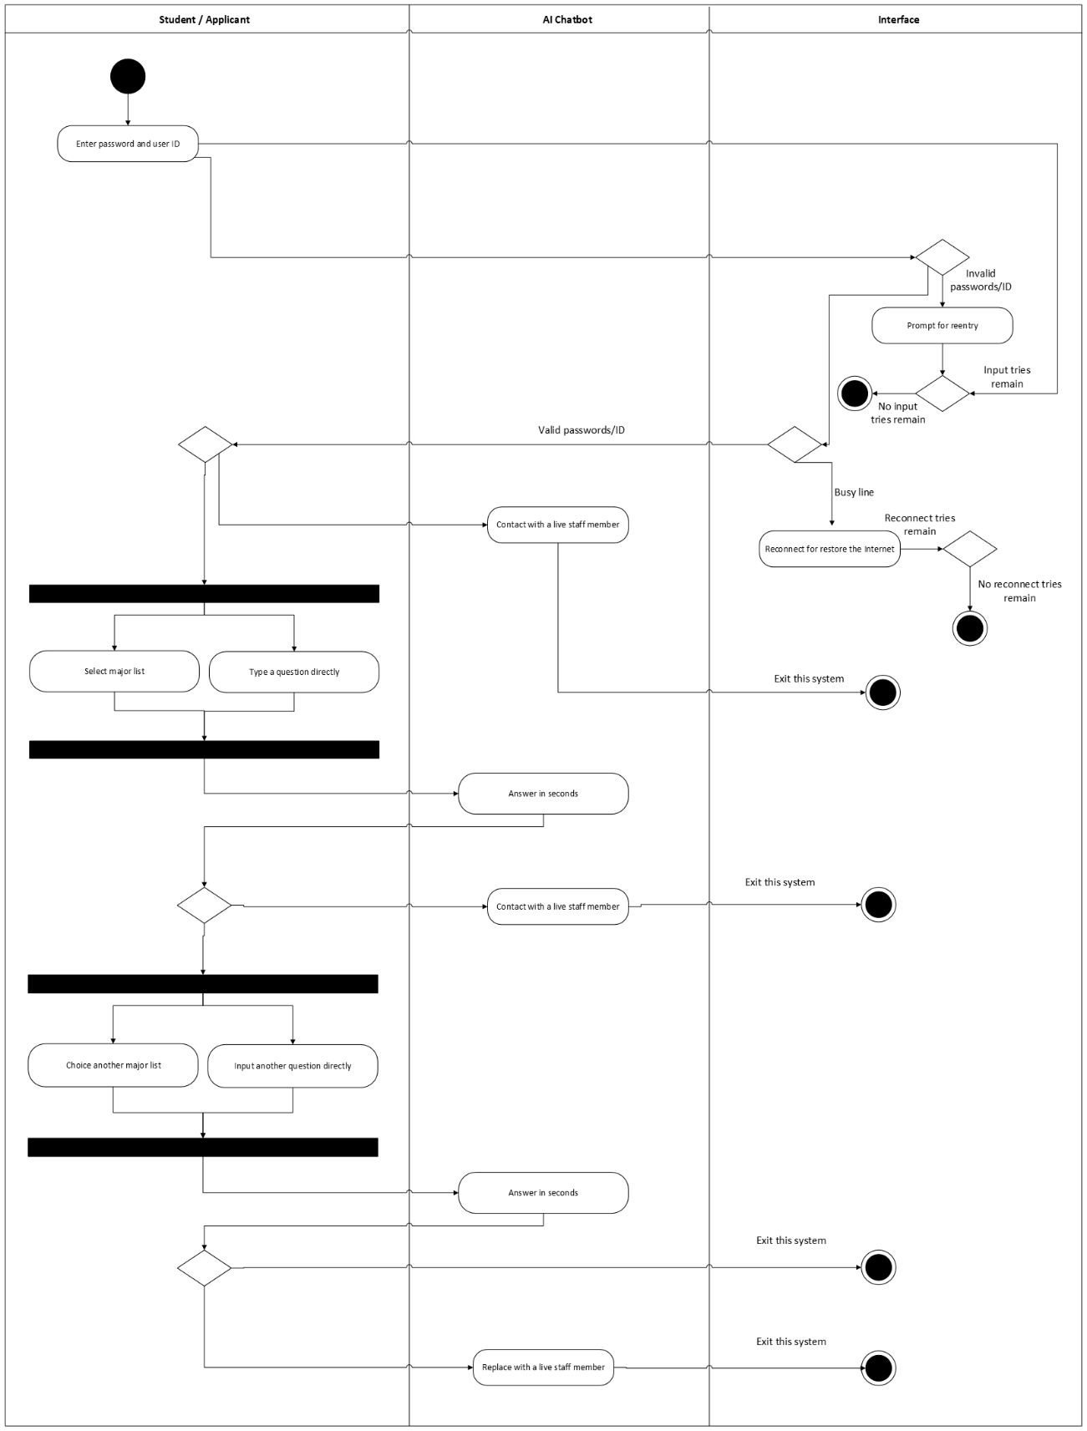

- Use Case Diagram
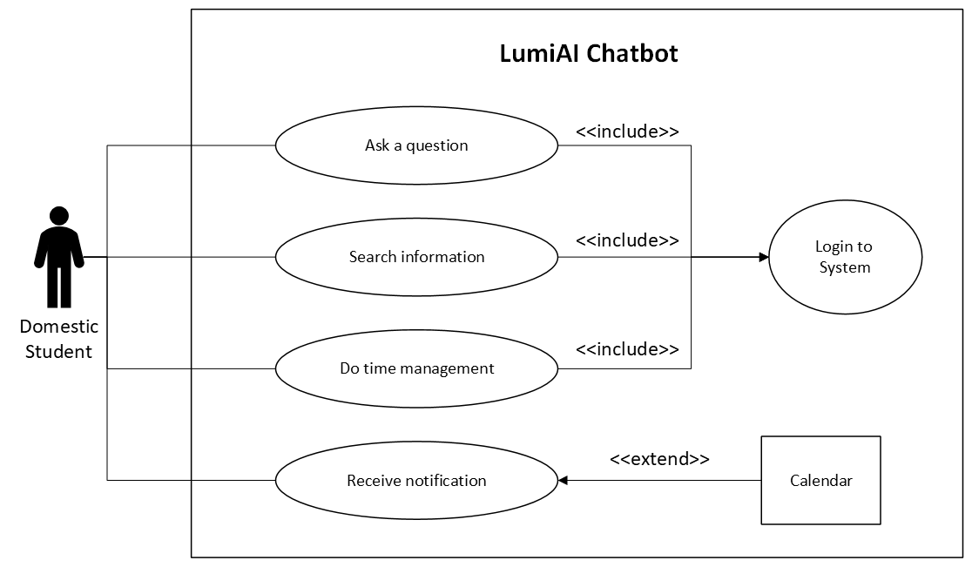

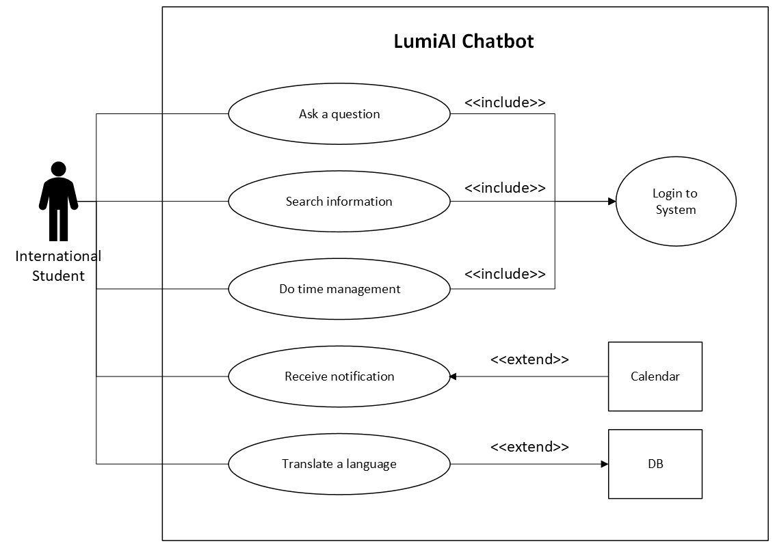

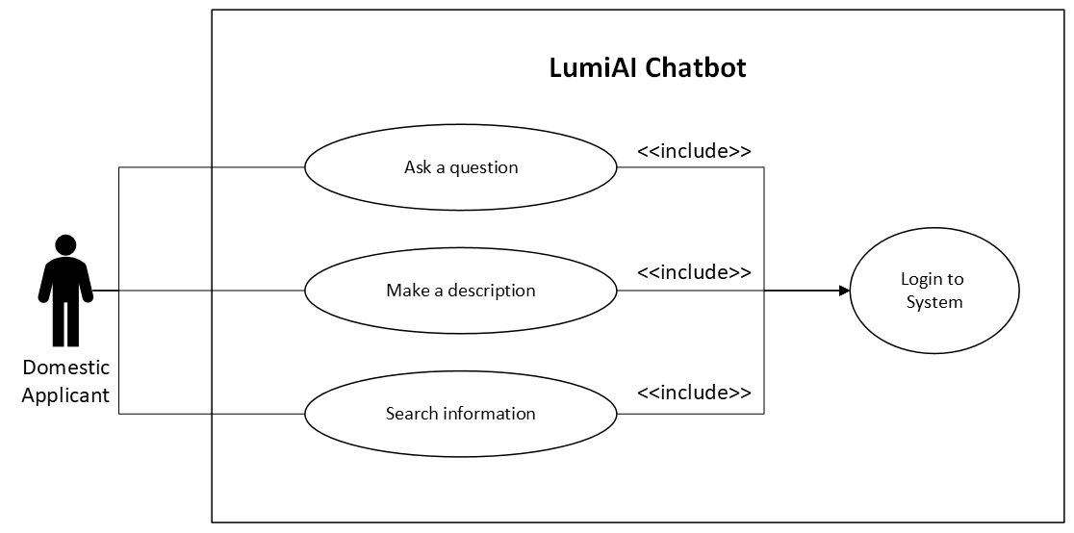

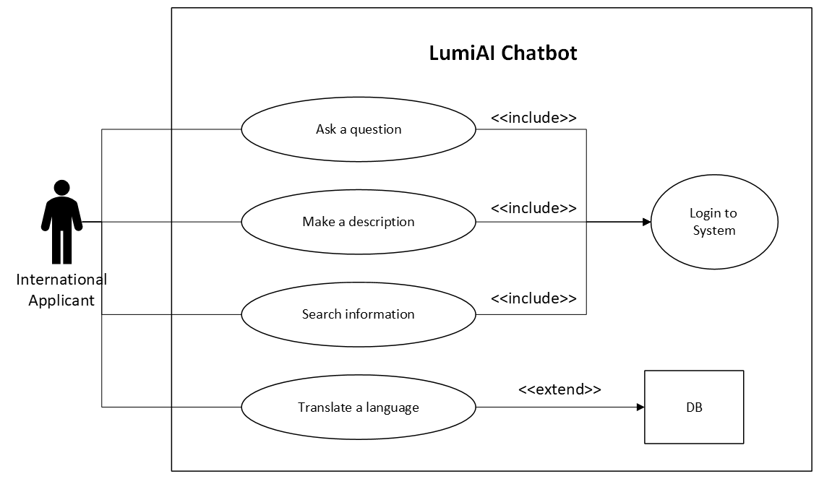

- Domain Class Diagram
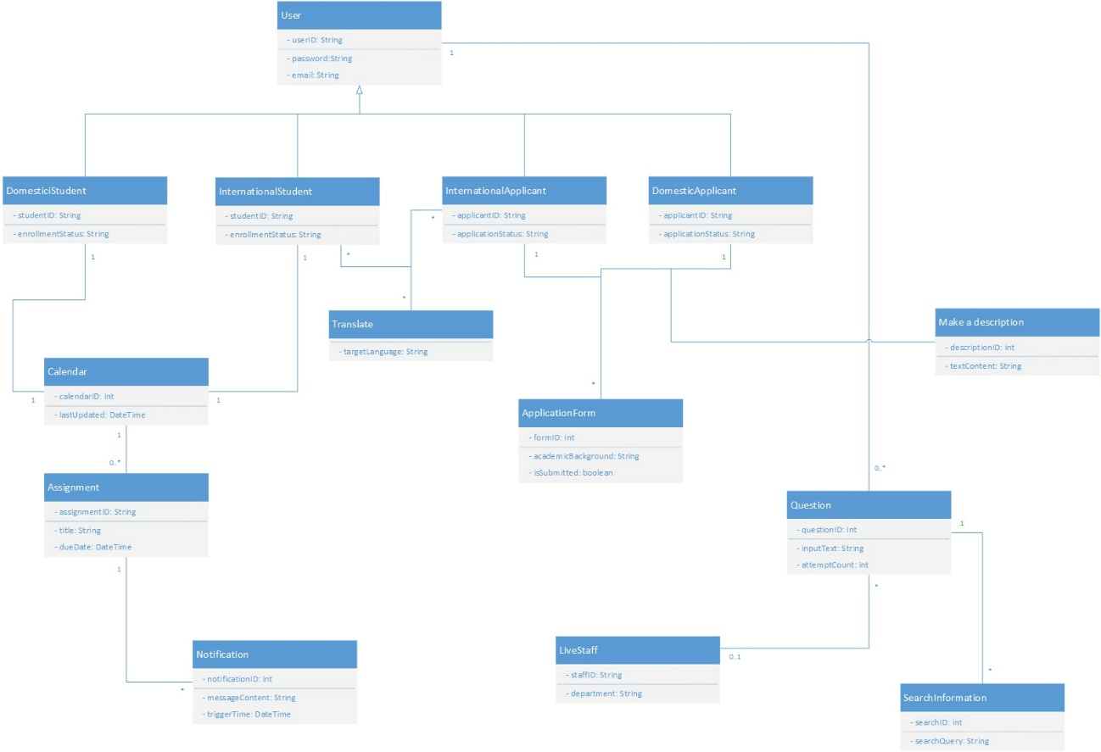
The domain class diagram above illustrates the first-cut logical architecture of the LumiAI Chatbot system, standardizing entity relationships and multiplicities in accordance with the project's functional requirements.

- CRC Index Cards
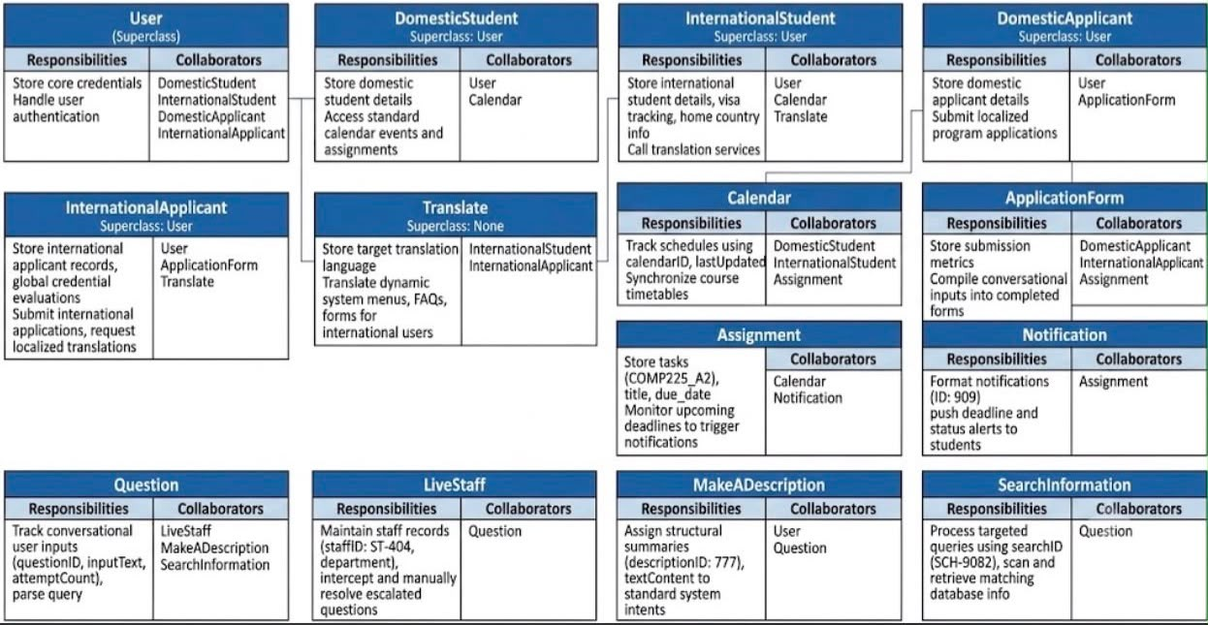

- Class Diagram
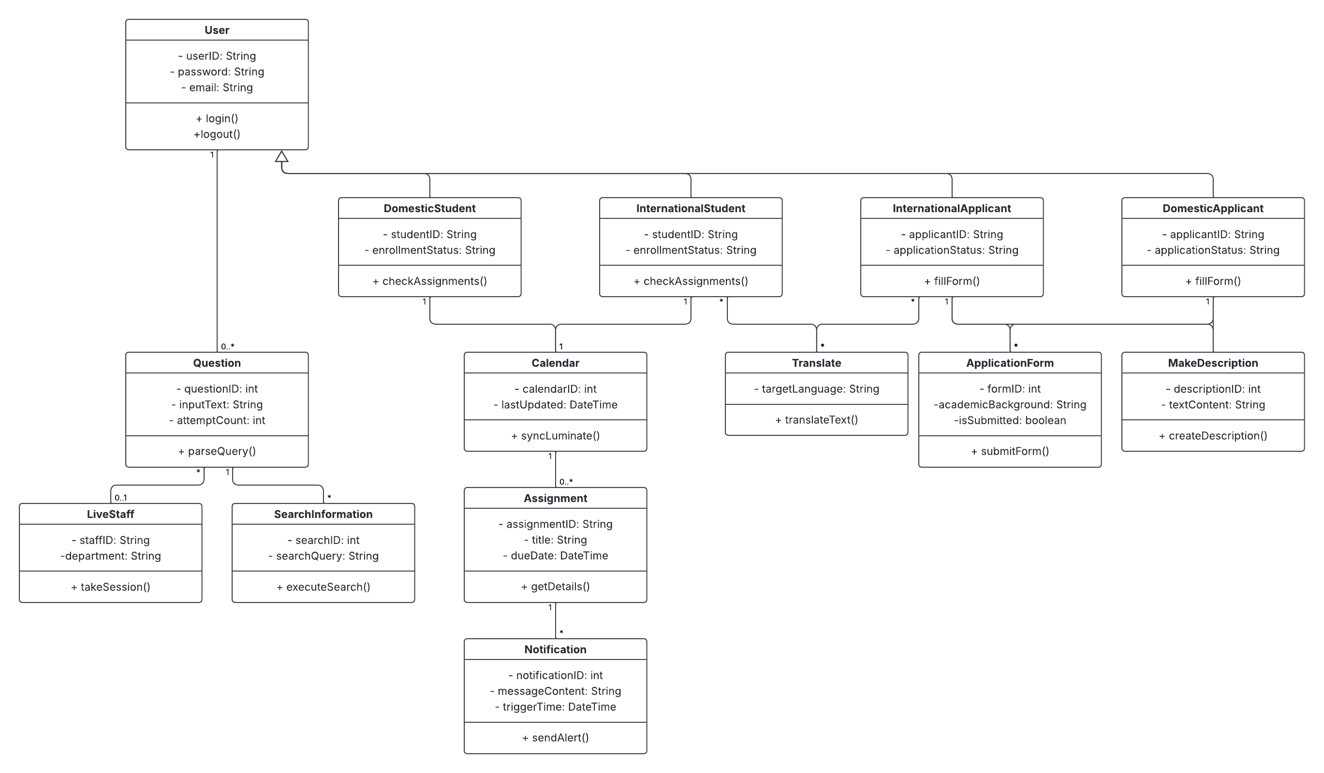

- Output to the Report
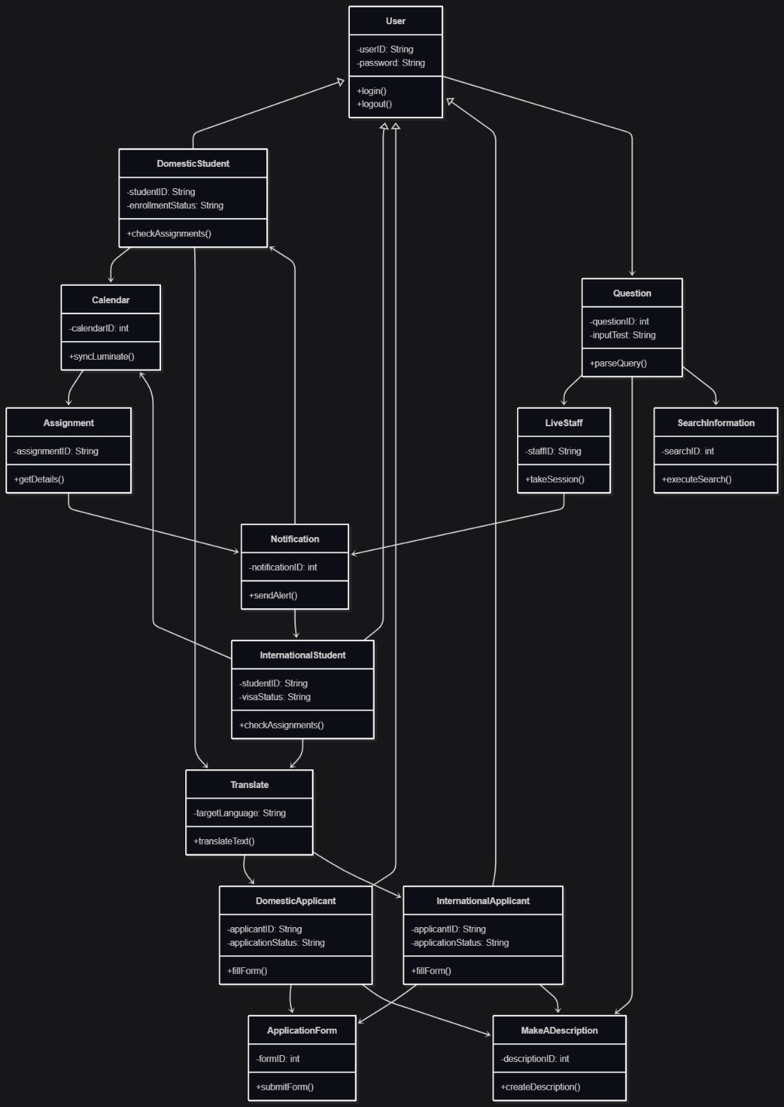
- State Diagrams
“Question”
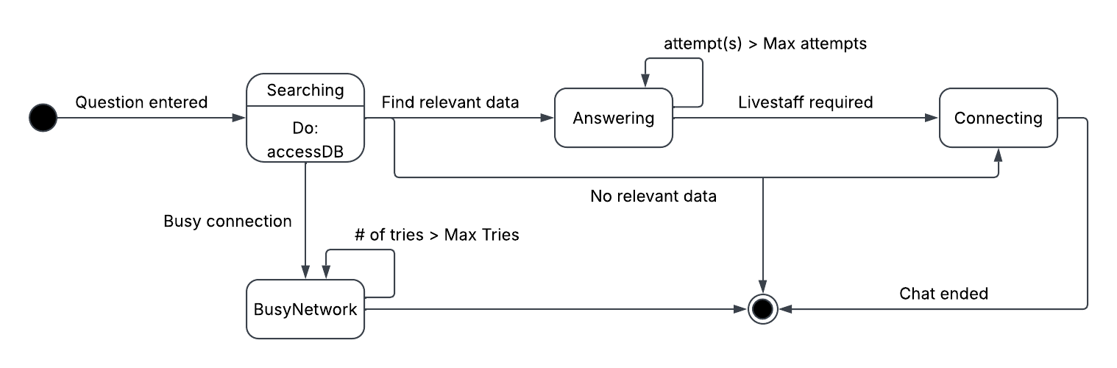

“Translate”
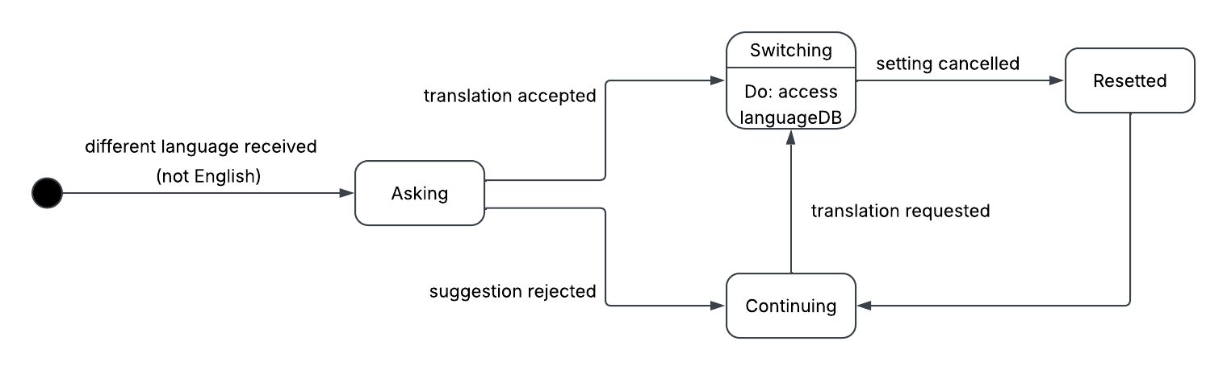

- Sequence Diagram
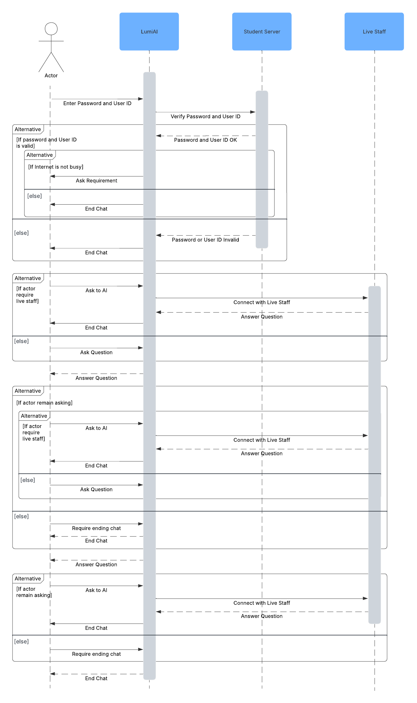
- Header Gen AI Sequence
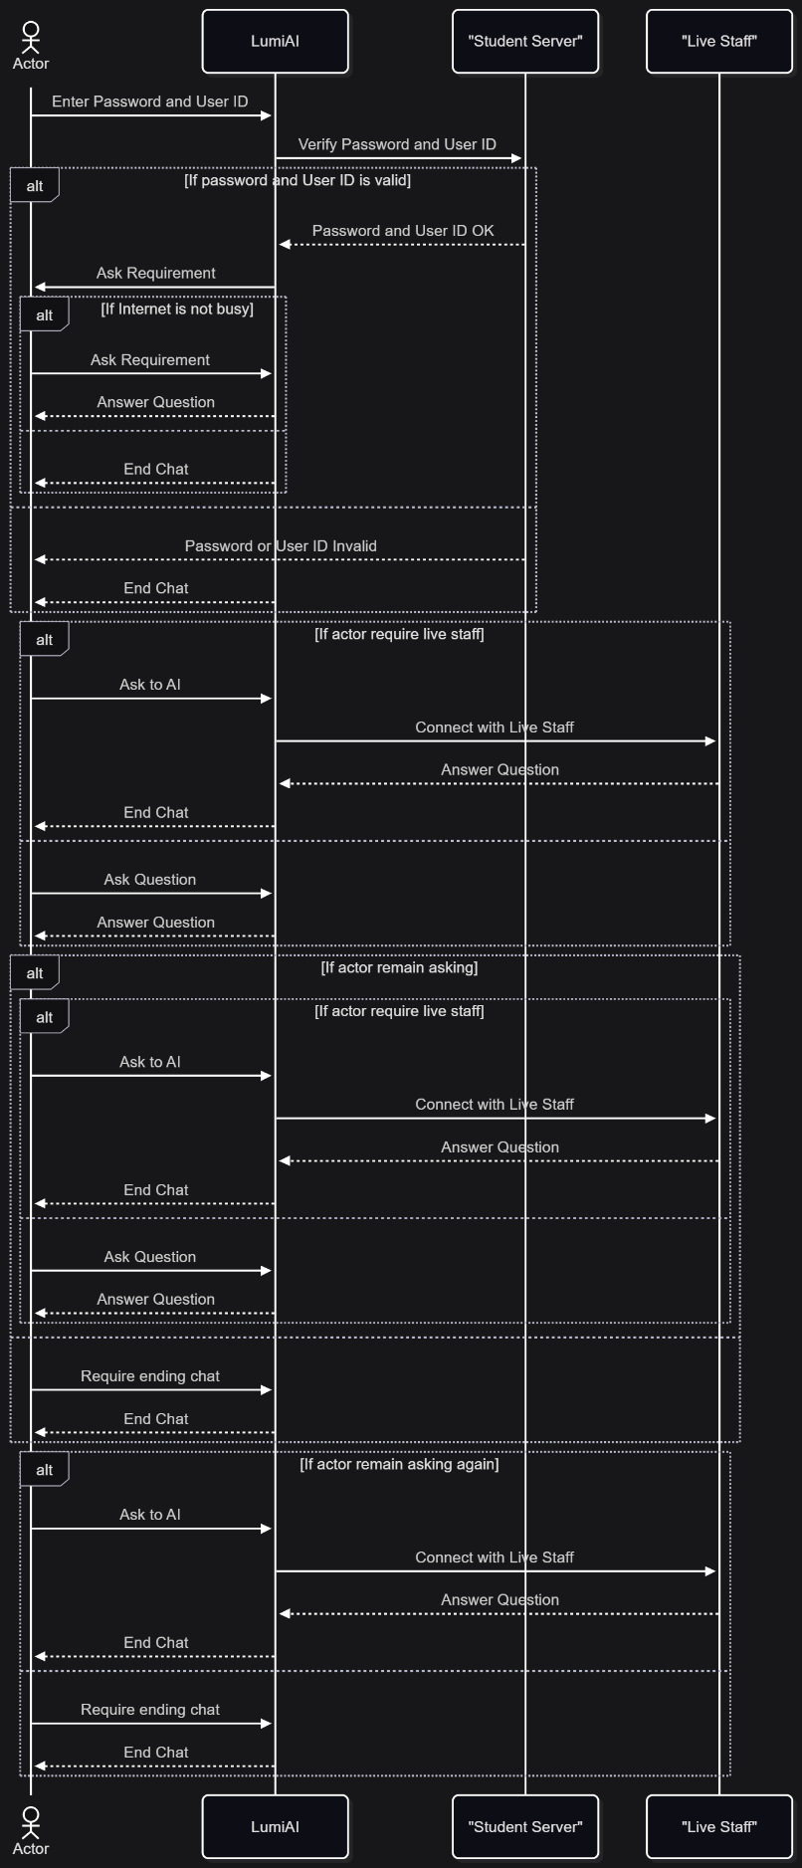

- Updated Class Diagram
The refined domain class diagram below incorporates the Party Analysis Pattern, successfully refactoring our previous rigid user inheritance structure into a flexible, role-based architecture.
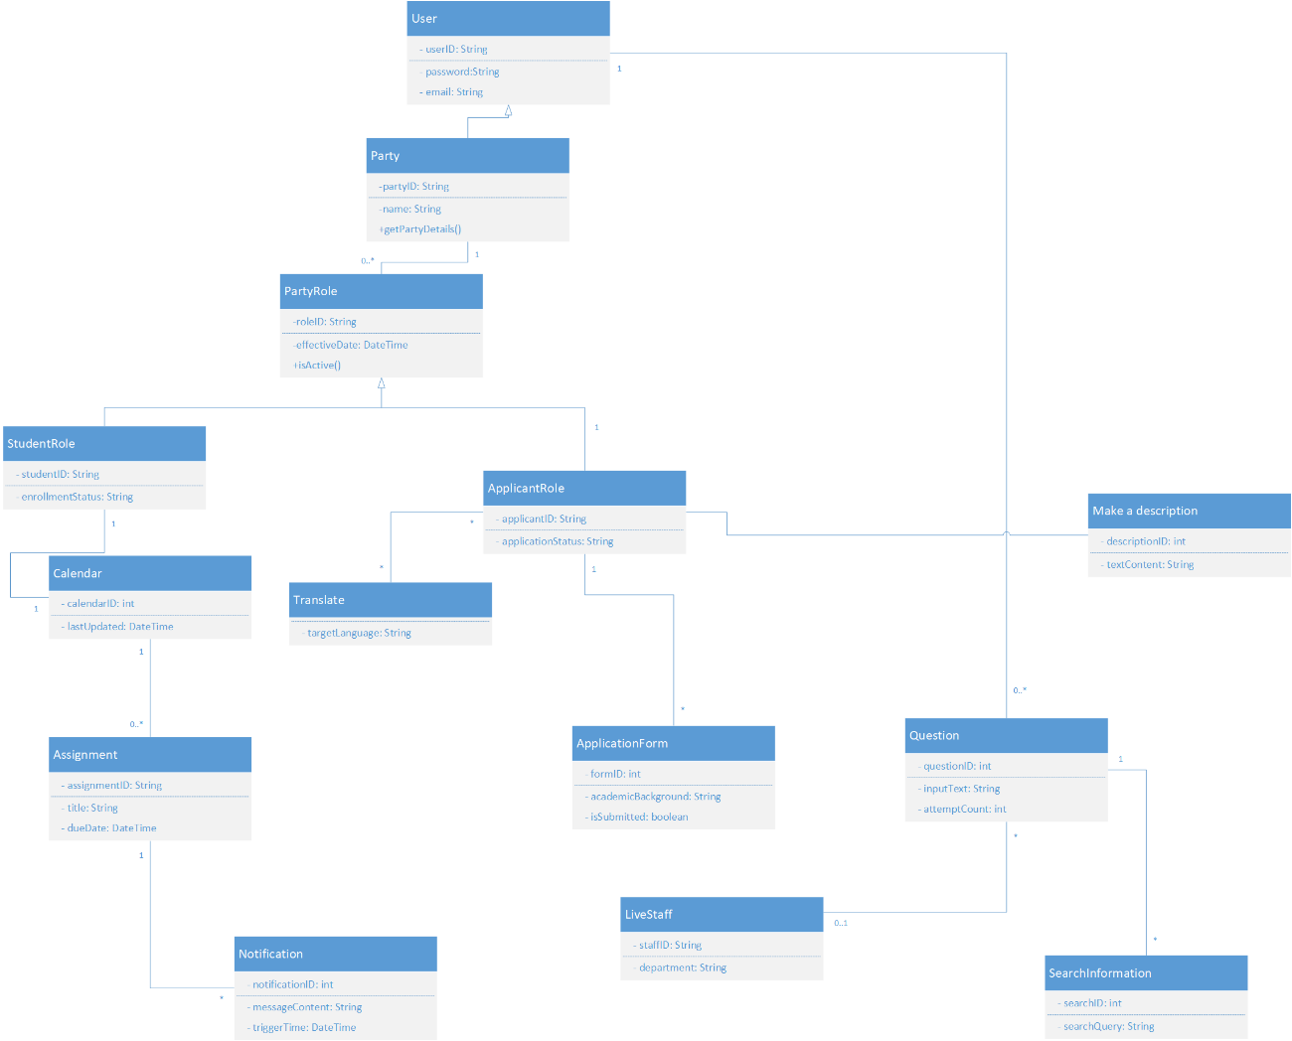
Figure 19.1
Originally introduced by Martin Fowler in his book Analysis Patterns: Reusable Object Models (Chapter 02), the Party Analysis Pattern provides a robust framework for handling entities that share common characteristics while maintaining distinct operational roles. Within the context of LumiAI Chatbot, transitioning to this pattern offers significant architectural value. By separating the core Party (representing an individual person or entity) from their specific operational PartyRole (such as StudentRole or ApplicantRole), the system avoids redundant class hierarchies and tight coupling. Furthermore, in a realistic academic environment, a single user often transitions through multiple phases—starting as an ApplicantRole submitting forms and later evolving into an active StudentRole. The Party Pattern allows a single Party instance to hold multiple or sequential roles over time without requiring structural database duplication or account recreation. This architecture ultimately improves long-term maintainability and scalability, ensuring that if the institution introduces new user types later in the project lifecycle (such as Faculty members), developers can simply inherit a new role class from PartyRole without rewriting the core profile logic.

