TRANSPORT AND TELECOMMUNICATION INSTITUTE



ENGINEERING FACULTY

Laboratory work N2
Course: Programming 2
Theme: Structures, files and menu driven data processing

Student: Igors Oļeiņikovs
Student code: 93642
Group: 4501BTA

Riga
2026
CONTENTS

1. Laboratory work task 3
2. Individual task 3
3. Algorithm data flow 4
4. Algorithm description 7
5. Source code 8
6. Running program example 11
7. Testing 12
8. Conclusions 13

Laboratory work task
Create an algorithm according to individual task. User should be able to:
- save user entered data (stored in structure) to file;
- view file data (read data from file and print to the screen) in a clear way;
- perform additional operation according to the individual task.
Create a console application in C/C++ based on created algorithm where:
- data structure according to the individual task is created and used;
- if data are stored in array then only native arrays are used (vectors, lists etc. are not allowed here);
- user-defined functions are created and being used (at least one function for any subtask);
- files are being used (to store data);
- menu is available (should be at least 4 menu items: add data, view data, ind.task, exit);

Individual task
Individual task number is calculated as 93642 % 20 = 2.
Task 2: Structure fields: shop title, address, tel.number. Operation: define tel.number for shop with specified address.

Algorithm data flow
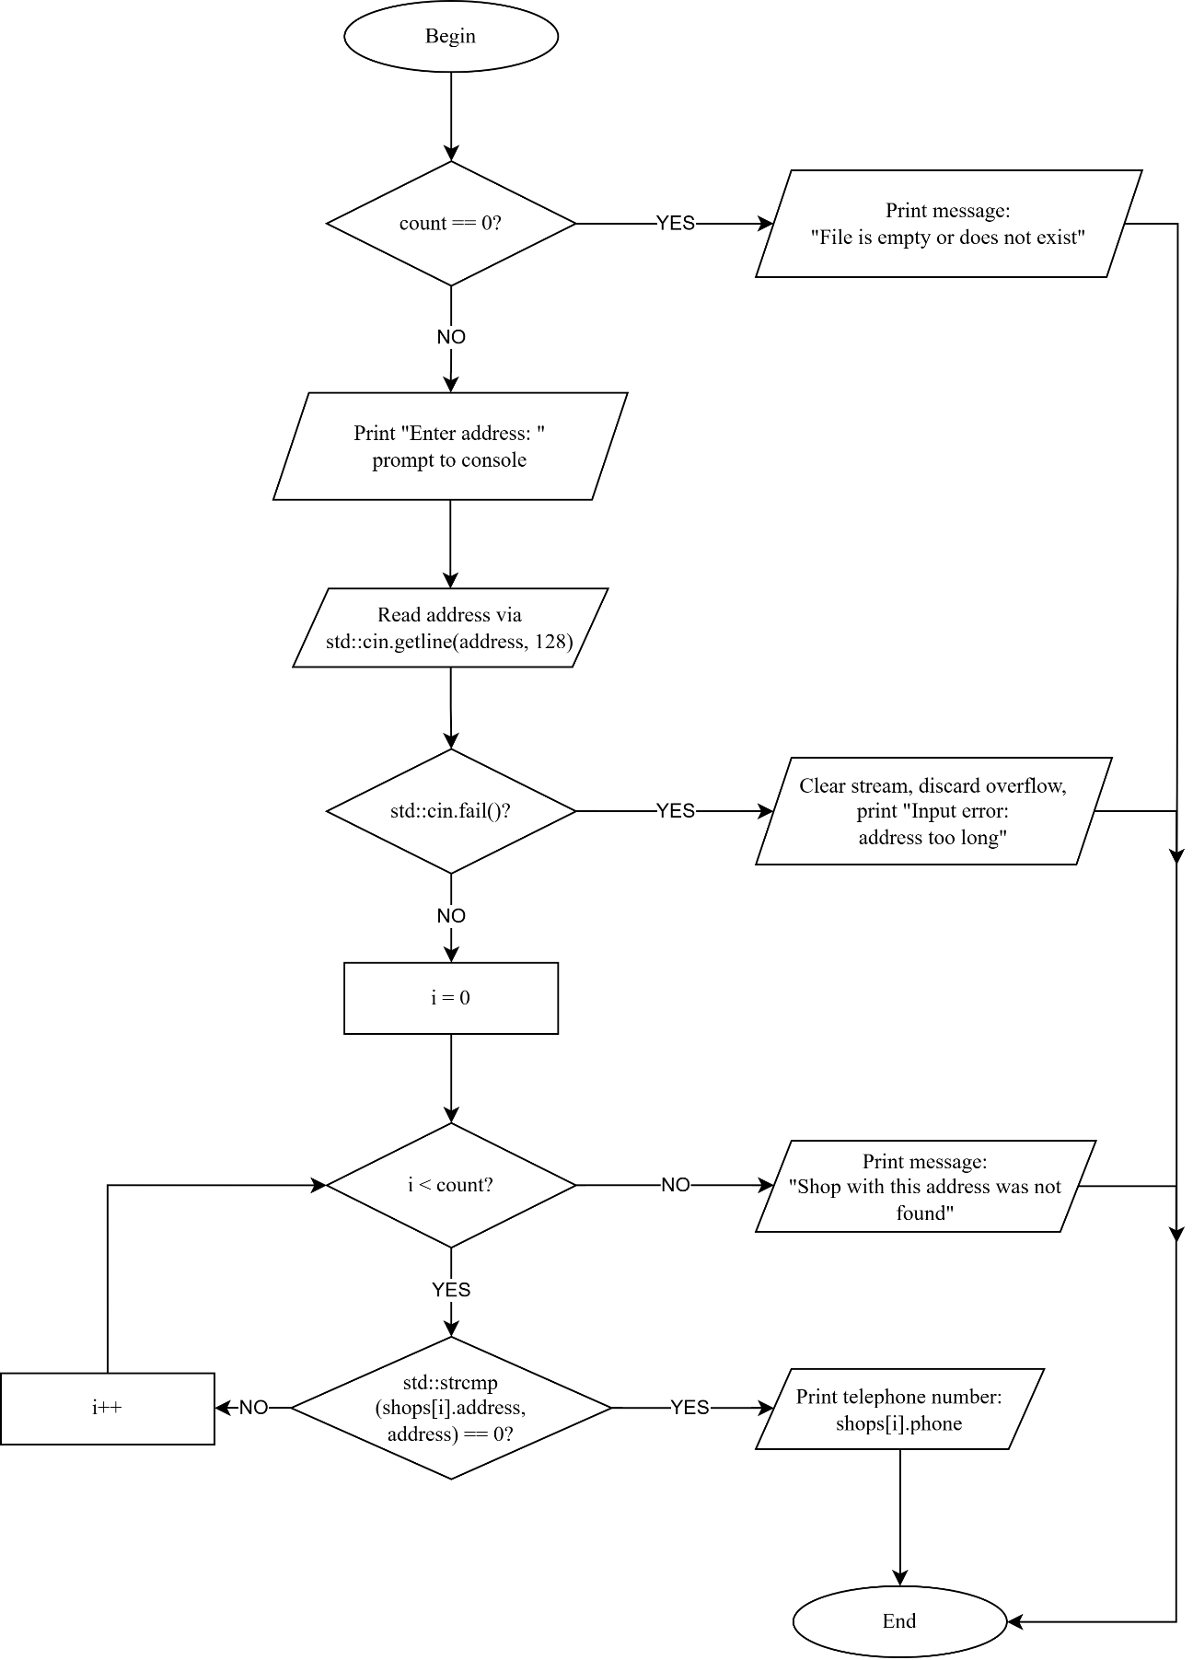
Fig. 1. definePhoneByAddress function

Algorithm description
The program manages a shop database using a fixed size array of Shop structures (MAX_SHOPS = 100). Data is persisted in the binary file shops.dat: the first 4 bytes store the record count as std::int32_t, followed by many Shop records written as raw bytes.
Structure: Shop
struct Shop
{
char title[64];
char address[128];
char phone[32];
};
Trivially copyable — contains only plain char arrays, which allows raw binary I/O via reinterpret_cast.
Why std::int32_t for the count header
The file header uses std::int32_t (from <cstdint>) instead of plain int or std::size_t. Plain int has a platform-dependent size (the C++ standard only guarantees at least 16 bits), and std::size_t varies between 4 and 8 bytes across architectures. std::int32_t is guaranteed to be exactly 32 bits on all platforms, ensuring the binary file format is consistent. Both readShops and writeShops use std::int32_t for the count header, keeping the read and write sides in agreement.
Input validation (stdin checks)
The program uses std::cin.getline() for all string input. After each getline call, std::cin.fail() is checked to detect buffer overflow (user typed more characters than the buffer can hold). On overflow:
  - std::cin.clear() resets the stream fail state.
  - std::cin.ignore discards the leftover input.
  - A field-specific error message is printed.
  - The operation is aborted without saving.
This pattern is used in:
- addData() for title, address, and phone fields.
- definePhoneByAddress() for the search address.
- main() for the menu choice (std::cin >> menuItem with fail() check for non-numeric input).

Functions
readShops(Shop *shops)
Opens shops.dat in binary input mode, reads the 4-byte std::int32_t count, validates it (non-negative and <= MAX_SHOPS), then reads count Shop records into the buffer. Returns the number of shops read or 0 on any error (does not distinguish between an empty file and an I/O error).
writeShops(const Shop *shops, std::size_t count)
Opens shops.dat in binary output mode (overwriting previous content), writes the count as a 4-byte std::int32_t, then writes all count Shop records as raw bytes. Returns true on success, false on failure. On failure the file may be left partially written — there is no atomic-write mechanism.
addData(Shop *shops, std::size_t *count)
Prompts for title, address, and phone via std::cin.getline() with overflow detection on each field. Stores the entry at index *count, increments the count, and persists via writeShops(). Rolls back *count if the write fails. Rejects when count >= MAX_SHOPS.
viewData(const Shop *shops, std::size_t count)
Iterates over the array and prints all records with a 1-based index. Prints a message if count is 0.
definePhoneByAddress(const Shop *shops, std::size_t count)
Prompts for an address with overflow detection, then performs a case-sensitive linear search using std::strcmp. Prints the phone number of the first match, or a "not found" message.
main()
Declares the shops array, loads data via readShops(), then runs an infinite menu loop (1-Add, 2-View, 3-Search, 4-Exit). Non-numeric menu input is caught via std::cin.fail() and the stream is cleaned. The loop exits on option 4.

Source code
#include <iostream>
#include <limits>
#include <string>

void shortestWord(const char *str, char *result)
{
size_t best_start = 0;
size_t best_len = 0;
size_t i = 0;
bool found = false;

while (str[i])
{
while (str[i] == ' ') i++;
if (!str[i])
break;
size_t word_start = i;
while (str[i] && str[i] != ' ') i++;
size_t len = i - word_start;
if (!found || len < best_len)
{
best_start = word_start;
best_len = len;
found = true;
}
}
if (found)
{
for (size_t j = 0; j < best_len; j++)
result[j] = str[best_start + j];
result[best_len] = '\0';
}
else
*result = '\0';
}

void shortestWord(const std::string &str, std::string &result)
{
size_t best_start = 0;
size_t best_len = 0;
size_t len = str.length();
size_t i = 0;
bool found = false;

while (i < len)
{
while (i < len && str[i] == ' ') i++;
if (i >= len)
break;
size_t word_start = i;
while (i < len && str[i] != ' ') i++;
size_t word_len = i - word_start;
if (!found || word_len < best_len)
{
best_len = word_len;
best_start = word_start;
found = true;
}
}
if (found)
result = str.substr(best_start, best_len);
else
result = "";
}

int main(void)
{
const int MAX_STRINGS = 10;
const int MAX_LEN = 256;
char c_arr[MAX_STRINGS][MAX_LEN];
std::string s_arr[MAX_STRINGS];
char result_c[MAX_LEN];
std::string result_s;
int n;
int i;

std::cout << "Task Nr " << 93642 % 25 << std::endl;
std::cout << "Enter number of strings: ";
if (!(std::cin >> n))
{
std::cout << "Invalid count" << std::endl;
return (1);
}
std::cin.ignore(std::numeric_limits<std::streamsize>::max(), '\n');

if (n <= 0 || n > MAX_STRINGS)
{
std::cout << "Invalid count" << std::endl;
return (1);
}

i = -1;
while (++i < n)
{
std::cout << "Enter string " << i + 1 << ": ";
if (!std::cin.getline(c_arr[i], MAX_LEN))
{
std::cout << "Invalid input" << std::endl;
return (1);
}
s_arr[i] = c_arr[i];
}

std::cout << std::endl << "Results (c-string version):" << std::endl;
i = -1;
while (++i < n)
{
shortestWord(c_arr[i], result_c);
std::cout << "\"" << c_arr[i] << "\" -> \""
<< result_c << "\"" << std::endl;
}

std::cout << std::endl << "Results (string version):" << std::endl;
i = -1;
while (++i < n)
{
shortestWord(s_arr[i], result_s);
std::cout << "\"" << s_arr[i] << "\" -> \""
<< result_s << "\"" << std::endl;
}

return (0);
}

Running program example
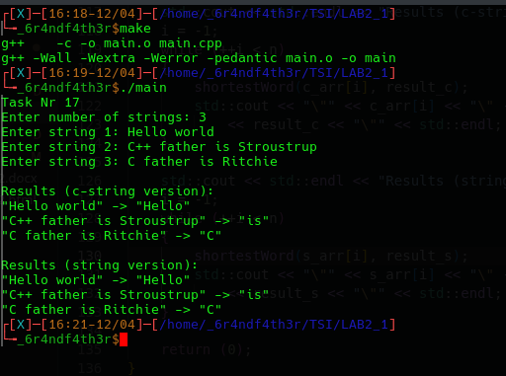
Fig. 4. Running program example

Testing
Table 1
Testing table
Test Nr. | Input data | Expected result | Actual result | Conclusion
1 | n = 1  hello world a test | Shortest word is "a" for both overloads | The program outputs "a" for both overloads | Pass
2 | n = 1  hello | Shortest word is "hello" for both overloads | The program outputs "hello" for both overloads | Pass
3 | n = 1  abc def ghi | Any 3-letter word may be returned. The implementation returns the first one: "abc" | The program outputs "abc" for both overloads | Pass
4 | n = 2  The quick brown fox  I am a programmer | For the first string, shortest word is "The". For the second string, shortest word is "I" | The program outputs "The" and "I" for both overloads | Pass
5 | n = 1  hello I world | Shortest word is "I" for both overloads | The program outputs "I" for both overloads | Pass
6 | n = 1  hello is world | Shortest word is "is" for both overloads | The program outputs "is" for both overloads | Pass
7 | n = 1  hello world a | Shortest word is "a" for both overloads | The program outputs "a" for both overloads | Pass
8 | n = 1  I love programming | Shortest word is "I" for both overloads | The program outputs "I" for both overloads | Pass

Conclusions
A C/C++ program was developed to identify the shortest word in user-provided strings, implemented using two overloaded functions - one operating on null-terminated c-strings and one on std::string objects. All requirements were fulfilled, including the use of const parameters, prohibition of direct conversions between string types, and keeping all user interaction confined to main.
The implementation iterates over each string character-by-character, tracking the start position and length of the shortest word found without relying on any string-splitting utilities. Both overloads produce identical results, confirming consistent logic across representations. Standard C/C++ library headers (<iostream>, <limits>, <string>) were used without complications. Input validation rejects non-numeric or out-of-range string counts with appropriate error messages.
Limitations include handling of only space-delimited words (no punctuation stripping) and a fixed maximum input length of 255 characters imposed by getline with a static buffer. The program performs reliably for all valid inputs tested. Key challenges: correctly handling edge cases such as single-word strings, strings where all words share the same length, and ensuring the c-string and std::string overloads behave identically. No algorithmic complications were encountered.
Skills acquired include function overloading, manual character-level string traversal, and robust input validation using cin with ignore. The task required approximately 2 hours, primarily spent testing edge cases. This lab reinforced practical understanding of function overloading, string representations in C++, and the differences between c-string and std::string manipulation.

