TRANSPORT AND TELECOMMUNICATION INSTITUTE



ENGINEERING FACULTY

Laboratory work N1
Course: Programming 2
Theme: User-defined functions

Student: Igors Oļeiņikovs
Student code: 93642
Group: 4501BTA

Riga
2026
CONTENTS

1. Laboratory work task 3
2. Individual task 3
3. Algorithm data flow 4
4. Algorithm description 7
5. Source code 8
6. Running program example 11
7. Testing 12
8. Conclusions 13

Laboratory work task
Create an algorithm for the function according to the individual task. Create in C++ two overloaded functions in one source file: the first function must process one c-string passed by pointer, the second function must process one value of type string passed by reference. If returning a value is required, it may be returned through the return operator or through output parameters. Parameters that are not changed must be declared as const. In main, create a two-dimensional array of chars that stores c-strings entered by the user and create a second array that stores the same values as objects of type string. Call the appropriate function for every string in each array and print the result. All input and output must be implemented only in main. Print the individual task number in the beginning of the program, test the application, and prepare a report.

Individual task
Individual task number is calculated as 93642 % 25 = 17.
Task 17: Function returns the shortest word in the string. Words are considered to be separated by one space. If there are several shortest words, the function may return any of them.

Algorithm data flow
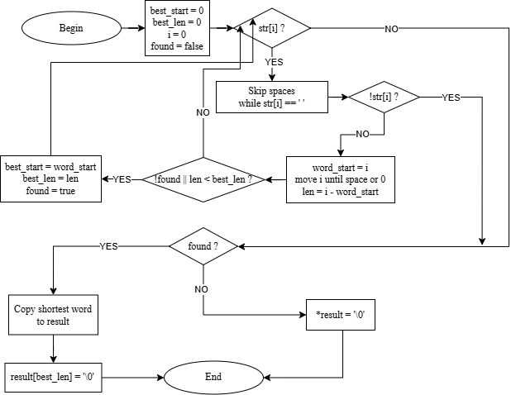
Fig. 1. Sum of positive elements

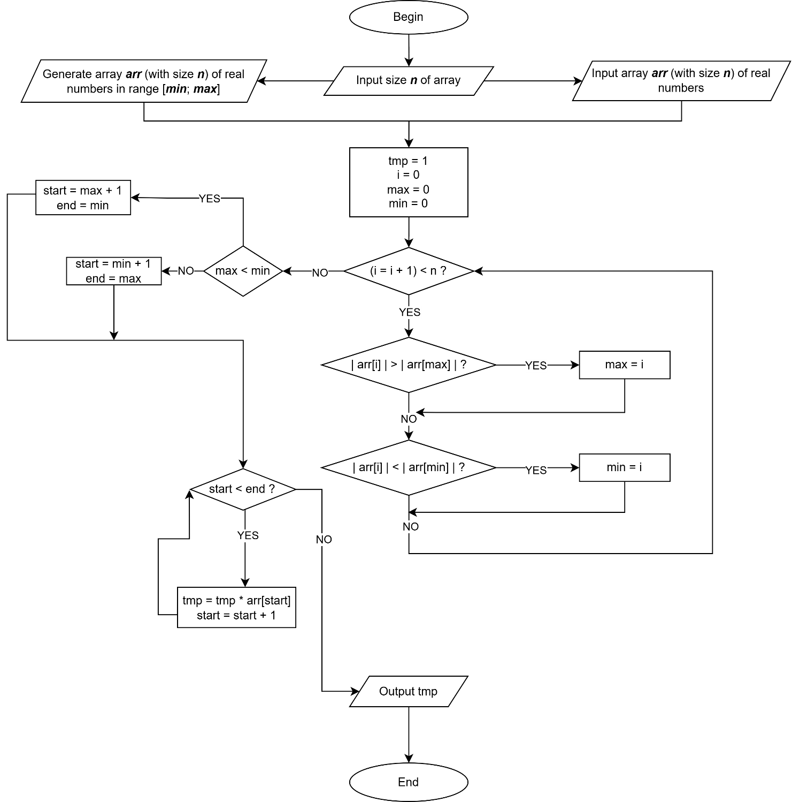
Fig. 2. Product of elements between extremes

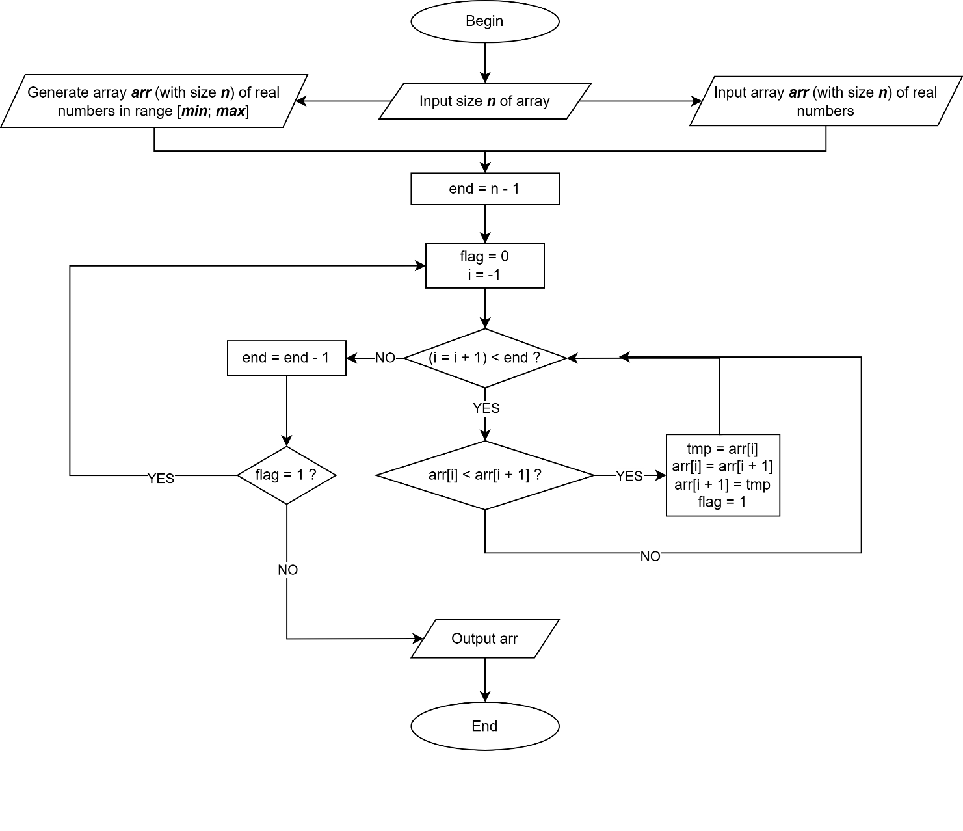
Fig. 3. Bubble sort (descending)

Algorithm description
The program contains two overloaded functions with the same name shortestWord. Both functions
solve the same task but work with different string representations. The first overload processes a c-string and writes the answer to an output character array. The second overload processes an object of
type string and writes the answer to an output object of type string.
For the c-string overload, the algorithm scans the source string from left to right. Spaces are skipped
first. After that, the current word beginning is saved, the index moves to the end of the word, and the
word length is calculated. If the current word is the first found word or is shorter than the previously
saved shortest word, its position and length are stored. After the scan is finished, the shortest word is
copied to the result array and terminated with the null character.
For the string overload, the same logic is used, but lengths and positions are applied to the string
object. After the shortest word is found, the answer is formed with the method substr.
The main function performs all user interaction. It prints the task number, reads the number of strings,
validates that the value is numeric and belongs to the allowed range from 1 to 10, and removes the
rest of the first input line from the stream. After that, it fills a two-dimensional character array with
user-entered c-strings and creates a second array of objects of type string by copying values from the
first array. Then main separately calls the c-string version for every element of the first array and the
string version for every element of the second array. The result of each call is printed on the screen.
If line input fails, the program prints an error message and terminates.

Source code
#include <iostream>
#include <limits>
#include <string>

void shortestWord(const char *str, char *result)
{
size_t best_start = 0;
size_t best_len = 0;
size_t i = 0;
bool found = false;

while (str[i])
{
while (str[i] == ' ') i++;
if (!str[i])
break;
size_t word_start = i;
while (str[i] && str[i] != ' ') i++;
size_t len = i - word_start;
if (!found || len < best_len)
{
best_start = word_start;
best_len = len;
found = true;
}
}
if (found)
{
for (size_t j = 0; j < best_len; j++)
result[j] = str[best_start + j];
result[best_len] = '\0';
}
else
*result = '\0';
}

void shortestWord(const std::string &str, std::string &result)
{
size_t best_start = 0;
size_t best_len = 0;
size_t len = str.length();
size_t i = 0;
bool found = false;

while (i < len)
{
while (i < len && str[i] == ' ') i++;
if (i >= len)
break;
size_t word_start = i;
while (i < len && str[i] != ' ') i++;
size_t word_len = i - word_start;
if (!found || word_len < best_len)
{
best_len = word_len;
best_start = word_start;
found = true;
}
}
if (found)
result = str.substr(best_start, best_len);
else
result = "";
}

int main(void)
{
const int MAX_STRINGS = 10;
const int MAX_LEN = 256;
char c_arr[MAX_STRINGS][MAX_LEN];
std::string s_arr[MAX_STRINGS];
char result_c[MAX_LEN];
std::string result_s;
int n;
int i;

std::cout << "Task Nr " << 93642 % 25 << std::endl;
std::cout << "Enter number of strings: ";
if (!(std::cin >> n))
{
std::cout << "Invalid count" << std::endl;
return (1);
}
std::cin.ignore(std::numeric_limits<std::streamsize>::max(), '\n');

if (n <= 0 || n > MAX_STRINGS)
{
std::cout << "Invalid count" << std::endl;
return (1);
}

i = -1;
while (++i < n)
{
std::cout << "Enter string " << i + 1 << ": ";
if (!std::cin.getline(c_arr[i], MAX_LEN))
{
std::cout << "Invalid input" << std::endl;
return (1);
}
s_arr[i] = c_arr[i];
}

std::cout << std::endl << "Results (c-string version):" << std::endl;
i = -1;
while (++i < n)
{
shortestWord(c_arr[i], result_c);
std::cout << "\"" << c_arr[i] << "\" -> \""
<< result_c << "\"" << std::endl;
}

std::cout << std::endl << "Results (string version):" << std::endl;
i = -1;
while (++i < n)
{
shortestWord(s_arr[i], result_s);
std::cout << "\"" << s_arr[i] << "\" -> \""
<< result_s << "\"" << std::endl;
}

return (0);
}

Running program example
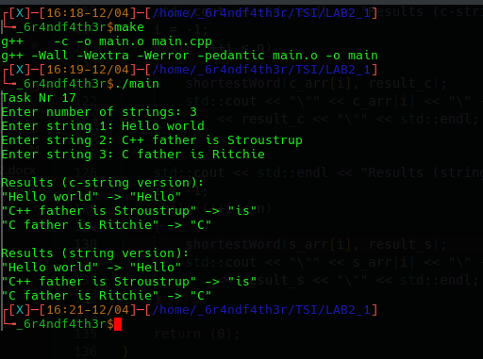
Fig. 4. Running program example

Testing
Table 1
Testing table
Test Nr. | Input data | Expected result | Actual result | Conclusion
1 | n = 1  hello world a test | Shortest word is "a" for both overloads | The program outputs "a" for both overloads | Pass
2 | n = 1  hello | Shortest word is "hello" for both overloads | The program outputs "hello" for both overloads | Pass
3 | n = 1  abc def ghi | Any 3-letter word may be returned. The implementation returns the first one: "abc" | The program outputs "abc" for both overloads | Pass
4 | n = 2  The quick brown fox  I am a programmer | For the first string, shortest word is "The". For the second string, shortest word is "I" | The program outputs "The" and "I" for both overloads | Pass
5 | n = 1  hello I world | Shortest word is "I" for both overloads | The program outputs "I" for both overloads | Pass
6 | n = 1  hello is world | Shortest word is "is" for both overloads | The program outputs "is" for both overloads | Pass
7 | n = 1  hello world a | Shortest word is "a" for both overloads | The program outputs "a" for both overloads | Pass
8 | n = 1  I love programming | Shortest word is "I" for both overloads | The program outputs "I" for both overloads | Pass

Conclusions
A C/C++ program was developed to identify the shortest word in user-provided strings, implemented using two overloaded functions - one operating on null-terminated c-strings and one on std::string objects. All requirements were fulfilled, including the use of const parameters, prohibition of direct conversions between string types, and keeping all user interaction confined to main.
The implementation iterates over each string character-by-character, tracking the start position and length of the shortest word found without relying on any string-splitting utilities. Both overloads produce identical results, confirming consistent logic across representations. Standard C/C++ library headers (<iostream>, <limits>, <string>) were used without complications. Input validation rejects non-numeric or out-of-range string counts with appropriate error messages.
Limitations include handling of only space-delimited words (no punctuation stripping) and a fixed maximum input length of 255 characters imposed by getline with a static buffer. The program performs reliably for all valid inputs tested. Key challenges: correctly handling edge cases such as single-word strings, strings where all words share the same length, and ensuring the c-string and std::string overloads behave identically. No algorithmic complications were encountered.
Skills acquired include function overloading, manual character-level string traversal, and robust input validation using cin with ignore. The task required approximately 2 hours, primarily spent testing edge cases. This lab reinforced practical understanding of function overloading, string representations in C++, and the differences between c-string and std::string manipulation.

