PLC Control Test No. 1 - Variant 1
Editable diagrams are available in PLC_CONTROL_TEST_variant_1_trees.drawio.

Task 1
Represent expressions in prefix and postfix notations and draw an abstract syntax tree.

Expression 1
a * b + c - 2
- Prefix notation: - + * a b c 2
- Postfix notation: a b * c + 2 -
- Abstract syntax tree:
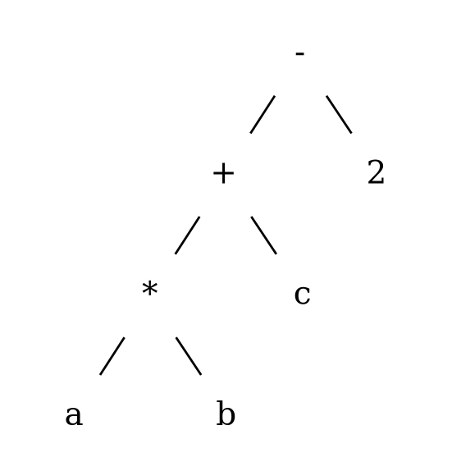
Task 1 Expression 1 AST

Expression 2
( b / 2 + sqrt ( ( b / 2 ) * ( b / 2 ) - a * c ) ) / a
- Prefix notation: / + / b 2 sqrt - * / b 2 / b 2 * a c a
- Postfix notation: b 2 / b 2 / b 2 / * a c * - sqrt + a /
- Abstract syntax tree:
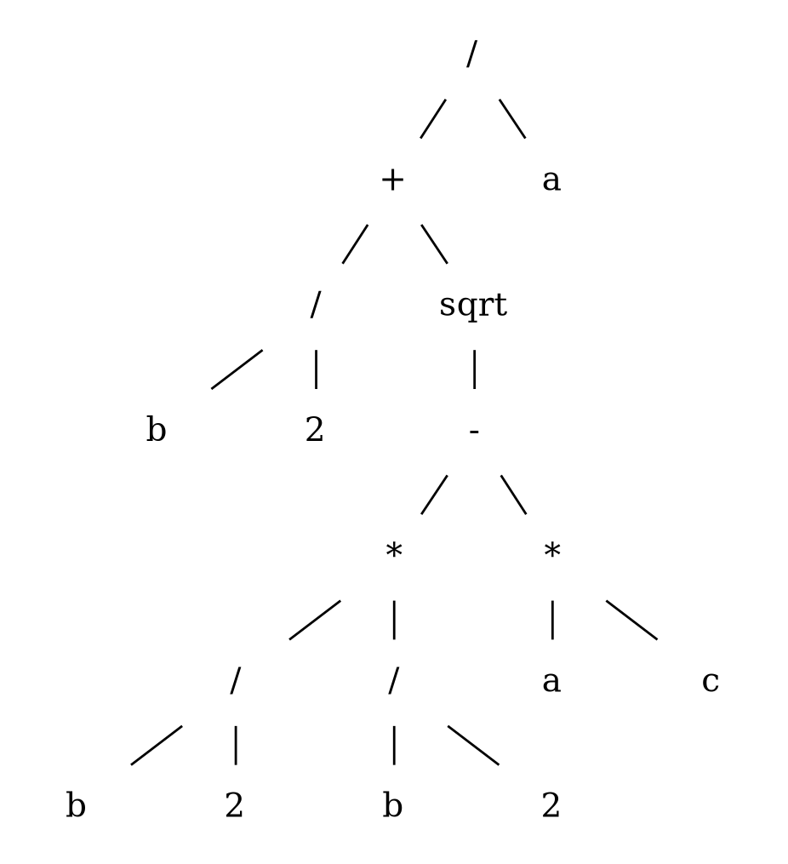
Task 1 Expression 2 AST

Task 2
Write a context-free grammar for strings of letters and/or digits that start with a digit.
Note: the table says “0 length or more”, but an empty string cannot start with a digit, so the grammar below generates strings of length 1 or more.
<S> ::= <digit> <tail>
<tail> ::= <symbol> <tail> | epsilon
<symbol> ::= <letter> | <digit>
<digit> ::= 0 | 1 | 2 | 3 | 4 | 5 | 6 | 7 | 8 | 9
<letter> ::= A | B | C | ... | Z | a | b | c | ... | z

Task 3
Using the grammar, show a parse tree and a leftmost derivation for string 1.23456.
<real_number> ::= <integer_part> . <fractional>
<integer_part> ::= <digit> | <integer_part> <digit>
<fractional> ::= <digit> | <digit> <fractional>
<digit> ::= 0 | 1 | 2 | 3 | 4 | 5 | 6 | 7 | 8 | 9

Leftmost derivation
<real_number>
=> <integer_part> . <fractional>
=> <digit> . <fractional>
=> 1 . <fractional>
=> 1 . <digit> <fractional>
=> 1.2 <fractional>
=> 1.2 <digit> <fractional>
=> 1.23 <fractional>
=> 1.23 <digit> <fractional>
=> 1.234 <fractional>
=> 1.234 <digit> <fractional>
=> 1.2345 <fractional>
=> 1.2345 <digit>
=> 1.23456

Parse tree
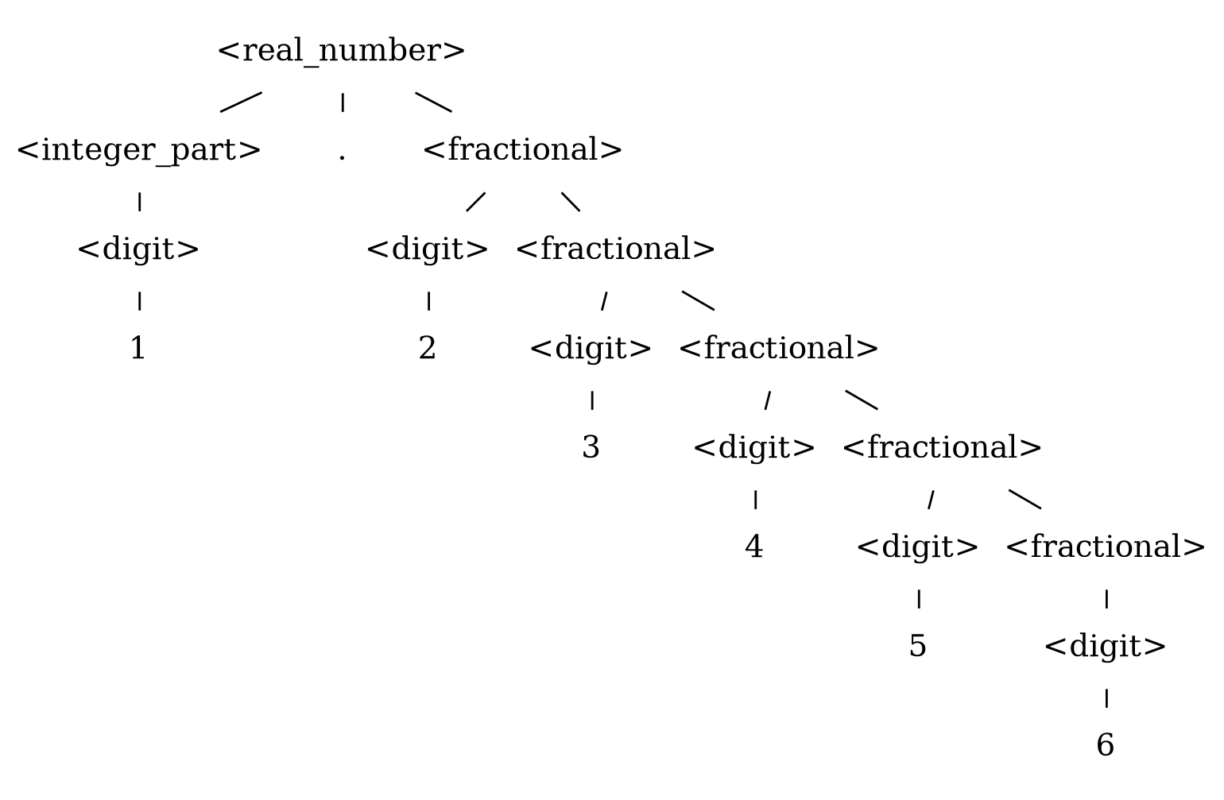
Task 3 Parse Tree

Task 4
Using the grammar, show a parse tree for the given expressions.
<E> ::= <E> + <T> | <E> - <T> | <T>
<T> ::= <T> * <F> | <T> / <F> | <F>
<F> ::= number | name | ( <E> )

Expression 1
(2 + a) * 5
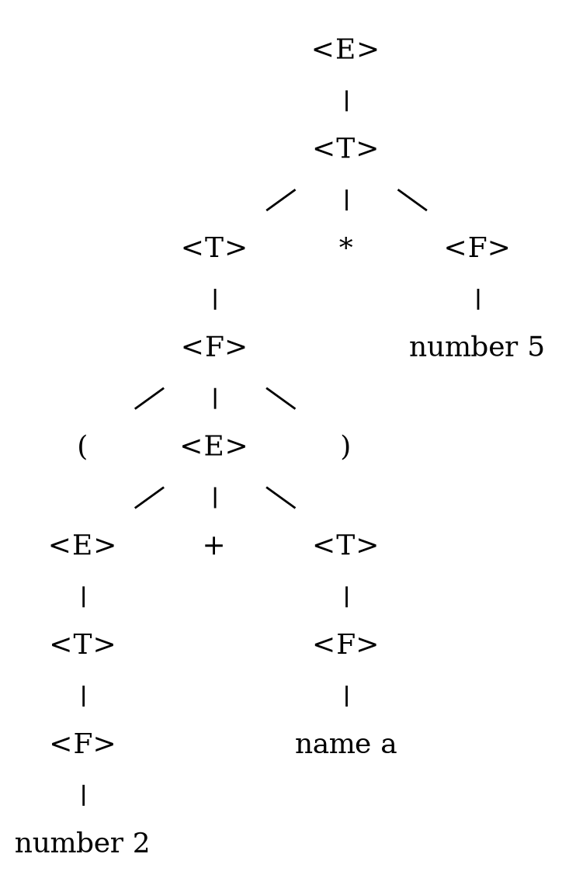
Task 4 Expression 1 Parse Tree

Expression 2
( 2 + ( a * b - a / ( b + 1 ) ) - 13 ) * a - c
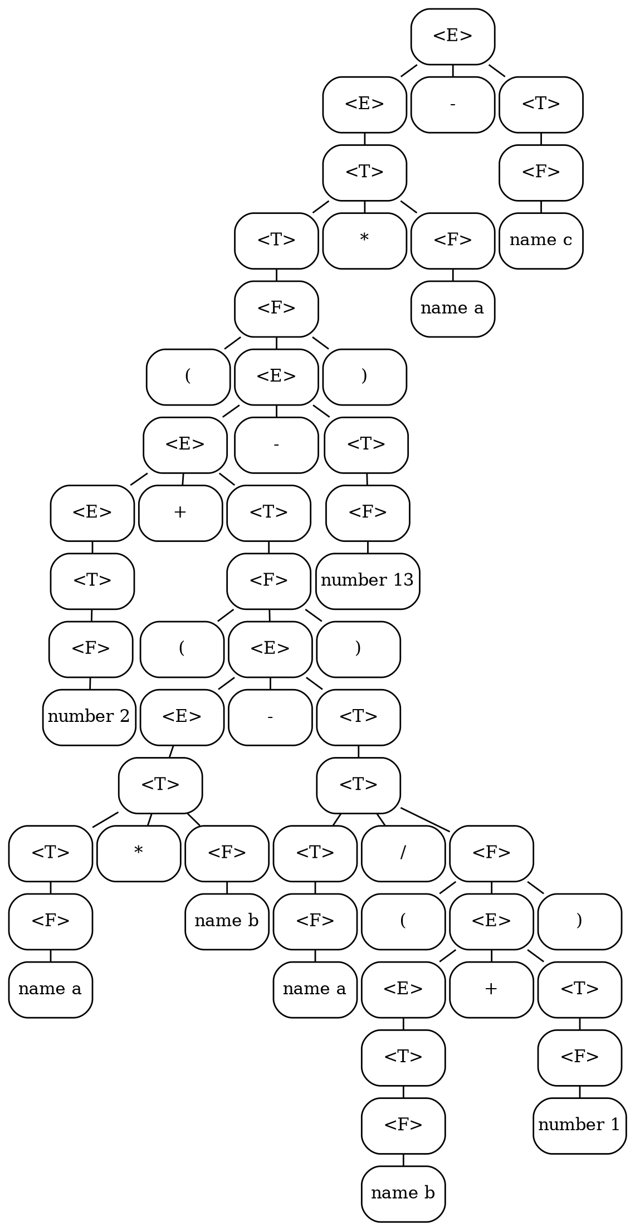
Task 4 Expression 2 Parse Tree

Task 5
Using the grammar for Pascal language, show a parse tree for the given construction.
<S> ::= <id> := <expression>
| if <expression> then <S>
| if <expression> then <S> else <S>
| while <expression> do <S>
| begin <SL> end
<SL> ::= <S> | <S> ; <SL>
Construction:
while <expression> do begin <id> := <expression>; <id> := <expression> end
Parse tree:
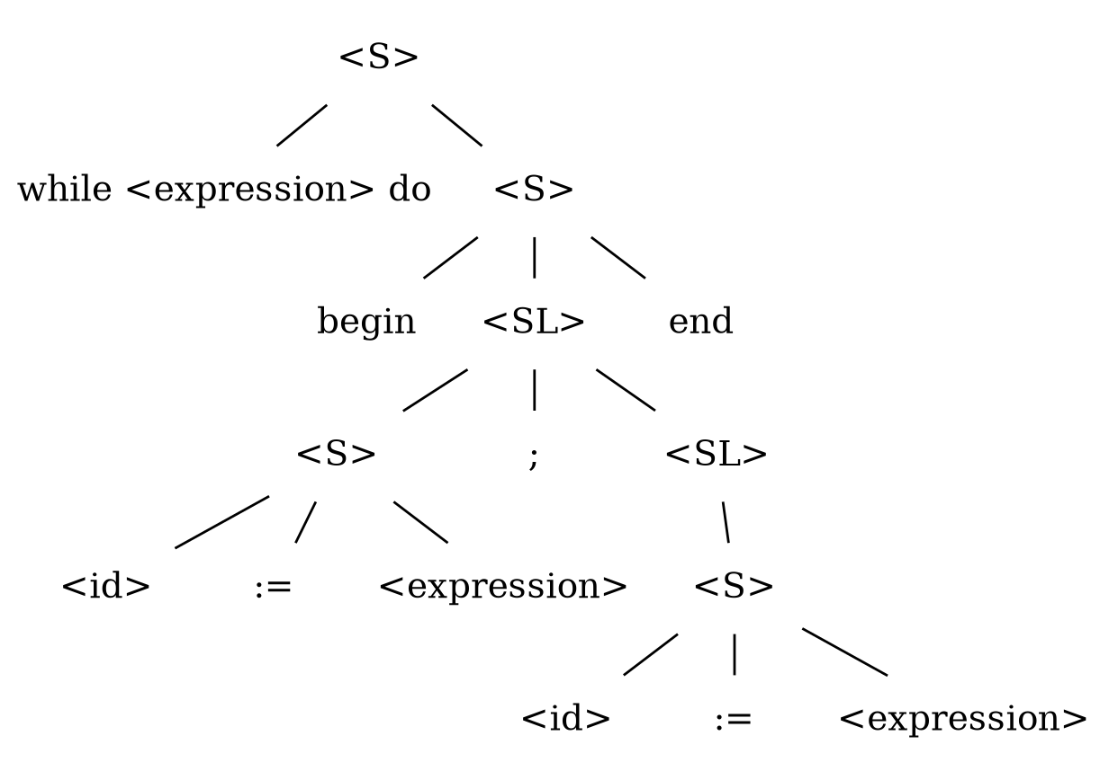
Task 5 Parse Tree

