TRANSPORT AND TELECOMMUNICATION INSTITUTE



ENGINEERING FACULTY

Exam Practical Task
Course: Computer Systems Structure
Theme: RISC Processor: AVR ASM

Student: Igors Oļeiņikovs
Student code: 93642
Group: 4501BTA

Riga
2026
CONTENTS

Contents
1. TASK DESCRIPTION 3
2. PIN MAPPING 3
3. IMPLEMENTATION SUMMARY 4
4. PROGRAM DESIGN AND LOGIC 5
5. KEY MECHANISM 9

TASK DESCRIPTION
The task requires creating a setup in the Wokwi simulation platform and writing a program in AVR Assembly for the Arduino Uno (ATmega328P). The program must drive five LEDs and one seven segment display, launched by a push button, without using any Arduino C/C++ functions - only direct AVR register and port manipulation
Seven segment display must show the numeric digits of the student code one by one, each for approximately one second. While a digit is shown, the LEDs must indicate whether the digit is odd (LEDs 1, 3, 5 ON) or even (LEDs 2, 4 ON). After all digits displayed, running light effect moves from LED1 to LED5 (0.5 s each) with the display blank. The system then returns to the initial alternating LED pattern and waits for the next button press.
Student code digits
Student code: 93642
Numeric sequence: 9 > 3 > 6 > 4 > 2
Step | Seven segment display | Digit type | LED output
1 | 9 | Odd | LEDs 1, 3, and 5 ON
2 | 3 | Odd | LEDs 1, 3, and 5 ON
3 | 6 | Even | LEDs 2 and 4 ON
4 | 4 | Even | LEDs 2 and 4 ON
5 | 2 | Even | LEDs 2 and 4 ON

PIN MAPPING
The following table shows which AVR port and bit is connected to each hardware component. All five LEDs are on Port B, the seven-segment segments A - F are on Port C, segment G is on Port D, and the button uses Port D with the internal pull-up resistor enabled.
Component | AVR port / bit | Arduino pin | Direction
LED1 (odd) | PB5 | 13 | Output
LED2 (even) | PB4 | 12 | Output
LED3 (odd) | PB3 | 11 | Output
LED4 (even) | PB2 | 10 | Output
LED5 (odd) | PB1 | 9 | Output
7-seg A | PC0 | A0 | Output
7-seg B | PC1 | A1 | Output
7-seg C | PC2 | A2 | Output
7-seg D | PC3 | A3 | Output
7-seg E | PC4 | A4 | Output
7-seg F | PC5 | A5 | Output
7-seg G | PD3 | 3 | Output
Button | PD2 | 2 | Input (pull-up)
7-seg COM | GND | — | Common cathode

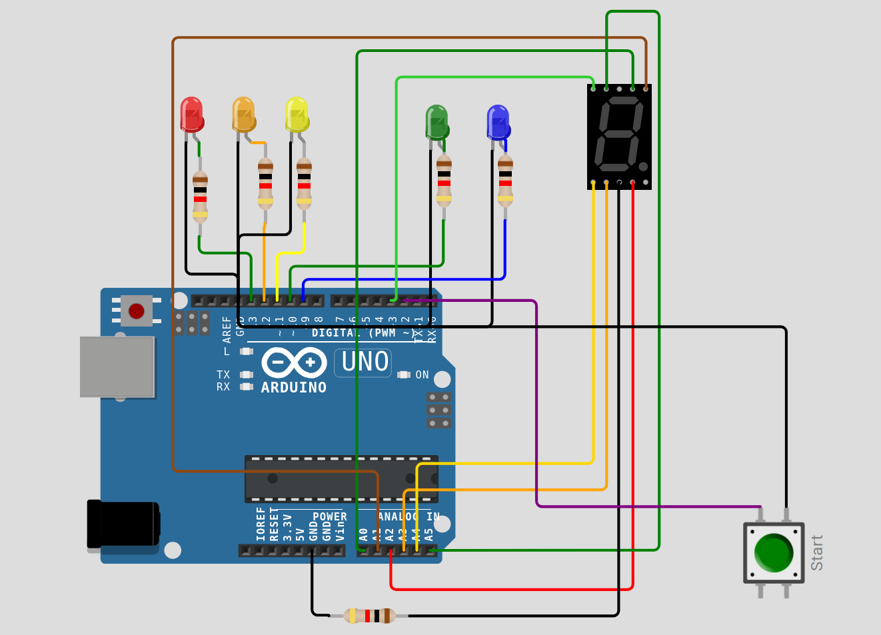
Fig.1 Wokwi circuit

IMPLEMENTATION SUMMARY
Five LEDs are connected to Arduino Uno pins 13 down to 9 through separate 1 kOhm resistors. These pins correspond to PB5, PB4, PB3, PB2 and PB1 on the ATmega328P. A common cathode seven segment display is driven from Port C (PC0 - PC5 for segments A - F) and PD3 for segment G. The common pin is connected to ground through a 1 kOhm resistor. A push button is connected to PD2 (pin 2) with the internal pull-up enabled, so the pin reads high when the button is released and low when it is pressed.
The program is organized into clearly separated sections: port initialization, the initial alternating LED state, button waiting with debounce, the student code display phase with odd/even LED selection, the running light finish phase and the return to the waiting state. Two lookup tables stored in program memory are read with the lpm instruction: one holds the seven segment patterns for digits 0 - 9 and the other holds the numeric digits of the student code in order.

PROGRAM DESIGN AND LOGIC
Port initialization
- DDRB = 0x3E configures PB5 - PB1 as LED outputs.
- DDRC = 0x3F configures PC5 - PC0 as outputs for segments A - F.
- PD3 is set as an output for segment G.
- PD2 is kept as an input and PORTD bit 2 is set high to enable the internal pull-up resistor on the button pin.
Initial state
- The seven segment display is blank (all segments off).
- PORTB is set to 0x2A, which turns on PB5, PB3 and PB1 - the alternating pattern LED1 ON, LED2 OFF, LED3 ON, LED4 OFF, LED5 ON.
- The program polls PD2 until the button is pressed.
Button launch
- The program waits for PD2 to go low (press), applies a 20 ms debounce delay, and confirms the press is still valid.
- It then waits for PD2 to return high (release) and applies another 20 ms debounce delay. This prevents a single long press from restarting the sequence multiple times.
Student code display phase
- A counter (r20) is set to 5, the number of digits in the student code.
- The Z register points to code_table in program memory. Each iteration loads the next digit with lpm r21, Z+.
- display_digit looks up the seven segment pattern in seg_table and writes the lower six bits to PORTC and bit 6 to PD3. The subroutine saves and restores Z internally so the caller's pointer is preserved
- The digit's least significant bit is tested with andi r22, 0x01: if set, the digit is odd and PORTB = 0x2A (LEDs 1, 3, 5) - if clear, the digit is even and PORTB = 0x14 (LEDs 2, 4).
- A ~1 sec delay is applied before moving to the next digit.

Running light finish phase
- The display is blank and a counter (r18) is set to 5.
- A single bit in r17 starts at 0x20 (LED1 / PB5) and is shifted right with lsr after each 0.5 s delay, lightning LED1 through LED5 in turn.
- After LED5 the program jumps back to initial state, restoring the alternating LED pattern and waiting for next button press

#define __SFR_OFFSET 0

#include "avr/io.h"

.global main

; LED patterns on PORTB bits PB5..PB1
; LED1=PB5, LED2=PB4, LED3=PB3, LED4=PB2, LED5=PB1
.equ LED_ODD, 0x2A ; LEDs 1,3,5 ON
.equ LED_EVEN, 0x14 ; LEDs 2,4 ON
.equ LED_RUN_1, 0x20 ; running-light start at LED1
.equ DIGIT_COUNT, 5

main:
; Port initialization
ldi r16, 0x3E
out DDRB, r16
ldi r16, 0x3F
out DDRC, r16
sbi DDRD, 3
cbi DDRD, 2
sbi PORTD, 2

; Initial state
initial_state:
call display_blank
ldi r16, LED_ODD
out PORTB, r16

; Button waiting
wait_press:
sbis PIND, 2
rjmp button_pressed
rjmp wait_press

button_pressed:
ldi r25, hi8(20)
ldi r24, lo8(20)
call delay_ms
sbis PIND, 2
rjmp wait_release
rjmp wait_press

wait_release:
sbis PIND, 2
rjmp wait_release
ldi r25, hi8(20)
ldi r24, lo8(20)
call delay_ms

; Student code display phase
ldi r20, DIGIT_COUNT
ldi ZH, hi8(code_table)
ldi ZL, lo8(code_table)

display_loop:
lpm r21, Z+
call display_digit
mov r22, r21
andi r22, 0x01
breq even_digit
odd_digit:
ldi r16, LED_ODD
out PORTB, r16
rjmp digit_hold
even_digit:
ldi r16, LED_EVEN
out PORTB, r16
digit_hold:
ldi r25, hi8(1000)
ldi r24, lo8(1000)
call delay_ms
dec r20
brne display_loop

; Running light finish phase
call display_blank
ldi r18, DIGIT_COUNT
ldi r17, LED_RUN_1
running_light:
out PORTB, r17
ldi r25, hi8(500)
ldi r24, lo8(500)
call delay_ms
lsr r17
dec r18
brne running_light

; Return to waiting state
rjmp initial_state

; Subroutine: display_blank
; Turns off every segment of display
display_blank:
ldi r16, 0x00
out PORTC, r16
cbi PORTD, 3
ret

; Subroutine: display_digit — show r21 (0-9) on 7-seg
; Saves and restores Z so callers Z is preserved
display_digit:
push r30
push r31
ldi ZH, hi8(seg_table)
ldi ZL, lo8(seg_table)
add ZL, r21
clr r19
adc ZH, r19
lpm r23, Z
mov r19, r23
andi r19, 0x3F
out PORTC, r19
sbrc r23, 6
rjmp seg_g_on
cbi PORTD, 3
pop r31
pop r30
ret
seg_g_on:
sbi PORTD, 3
pop r31
pop r30
ret

; Subroutine: delay_ms
delay_ms:
ldi r29, hi8(4000)
ldi r28, lo8(4000)
delay_inner:
sbiw r28, 1
brne delay_inner
sbiw r24, 1
brne delay_ms
ret

; Seven-segment patterns for digits 0..9
; Bit mapping: bit0=A bit1=B bit2=C bit3=D bit4=E bit5=F bit6=G
seg_table:
.byte 0x3F, 0x06, 0x5B, 0x4F, 0x66, 0x6D, 0x7D, 0x07, 0x7F, 0x6F
code_table:
.byte 9, 3, 6, 4, 2

KEY MECHANISM
How the button is checked
The button is connected to PD2 with the internal pull-up enabled, so the pin is HIGH when the button is released and LOW when pressed. The program uses sbis PIND, 2 to skip the next instruction when the pin is HIGH. A 20 ms debounce delay is applied both after detecting a press and after detecting a release. The program first waits for a press, then waits for a release, ensuring the main sequence launches exactly once per button cycle.
How the odd/even LED pattern is selected
After loading a digit from code_table, the program copies it into r22 and executes andi r22, 0x01 to isolate the least significant bit. If the bit is 1 the digit is odd and PORTB is loaded with 0x2A (LEDs 1, 3, 5 ON). If the bit is 0 the digit is even and PORTB is loaded with 0x14 (LEDs 2, 4 ON). The breq instruction branches to the appropriate pattern.
How the delay timing is created
The delay_ms subroutine accepts a 16-bit millisecond count in r25:r24. For each millisecond it runs an inner loop of approximately 4000 iterations, each consuming four clock cycles (sbiw + brne). At 16 MHz, four cycles x 4000 = 16000 cycles = approx 1 ms. The outer loop decrements r25:r24. For the digit display phase, a value of 1000 is passed for ~1 second per digit. For the running light phase, a value of 500 is passed for ~0.5 second per step. The Y register (r29:r28) is used for the inner loop to avoid conflicts with the Z register.

How the seven segment digit patterns are selected
A lookup table seg_table in program memory stores one byte per digit (0-9). Each byte is a 7-bit pattern where bit 0 = segment A, bit 1 = B, bit 2 = C, bit 3 = D, bit 4 = E, bit 5 = F, and bit 6 = G. The display_digit subroutine calculates the address as seg_table + r21, reads the byte with lpm, writes bits 0-5 to PORTC (segments A-F), and tests bit 6 to control PD3 (segment G). The subroutine preserves the caller's Z register by pushing it at entry and popping it on both return paths.
How the code table pointer is preserved
The display_digit subroutine internally modifies the Z register to access seg_table. To prevent this from corrupting the code_table pointer used by display_loop, display_digit saves r30 (ZL) and r31 (ZH) on the stack at entry and restores them before returning. Both the segment G-on and segment G-off return path include the pop instructions, ensuring correct Z restoration regardless of which path is taken. This allows display_loop to iterate through all five student code digits without any additional save/restore logic in the caller.
Video demonstration attached
Project saved at https://wokwi.com/projects/467947593630873601

