TRANSPORT AND TELECOMMUNICATION INSTITUTE



ENGINEERING FACULTY

Laboratory work N3
Course: Programming Languages Concepts
Theme: Basic Operators in Programming Language

Student: Igors Oļeiņikovs
Student code: 93642
Group: 4501BTA

Riga
2026
CONTENTS

1. LABORATORY WORK TASK 3
2. PROGRAM CODE AND RESULTS 3
3. CONCLUSIONS 14
4. REFERENCES 16

LABORATORY WORK TASK
The purpose of this laboratory work is to practise arithmetic operators, transformations, selection statements, loops, constants, input validation, and simple console interaction in a programming language. Ruby was selected for the implementation because its syntax is concise and expressive, which makes the small console programs easy to read and compare with other languages.
Implemented tasks:
1. Find the roots of a quadratic equation from coefficients a, b, and c.
2. Multiply two real numbers and output a rounded or truncated result.
3. Convert temperature either from Celsius to Fahrenheit or from Fahrenheit to Celsius.
4. Divide two integers and display the integer quotient with the remainder.
5. Calculate the average of three real numbers to two decimal places.
6. Calculate the area and perimeter of a rectangle.
7. Check whether the user is old enough to apply for a driving license.
8. Use a loop to sum whole numbers until the user enters 0.
9. Check whether a password is correct and discuss secure password handling.
10. Calculate the area and circumference of a circle using the constant pi = 3.14159.

PROGRAM CODE AND RESULTS
Task 1. Quadratic equation roots
The program reads the coefficients of the quadratic equation, calculates the discriminant, and then outputs two real roots, one repeated root, or a message that no real roots exist.
#!/usr/bin/env ruby
def read_float(prompt)
loop do
print prompt
input = gets&.strip
exit if input.nil?
value = Float(input, exception: false)
return value unless value.nil?
puts 'Please enter a valid number.'
end
end
a = read_float('Enter coefficient a: ')
b = read_float('Enter coefficient b: ')
c = read_float('Enter coefficient c: ')
if a.zero?
puts 'Coefficient a must not be zero for a quadratic equation.'
exit
end
discriminant = (b * b) - (4 * a * c)
puts format('Discriminant: %.3f', discriminant)
if discriminant.negative?
puts 'The equation has no real roots.'
elsif discriminant.zero?
root = -b / (2.0 * a)
puts format('x1 = x2 = %.3f', root)
else
sqrt_discriminant = Math.sqrt(discriminant)
first_root = (-b + sqrt_discriminant) / (2.0 * a)
second_root = (-b - sqrt_discriminant) / (2.0 * a)
puts format('x1 = %.3f', first_root)
puts format('x2 = %.3f', second_root)
end

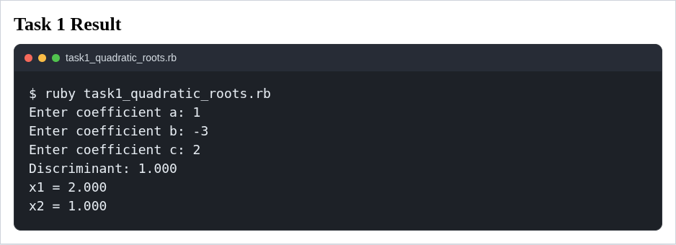
Task 2. Product with rounding or truncation
The program multiplies two real numbers and applies the user-selected output mode. In this implementation, the result is either rounded or truncated to a whole number, which clearly demonstrates the corresponding Ruby operations.
#!/usr/bin/env ruby
def read_float(prompt)
loop do
print prompt
input = gets&.strip
exit if input.nil?
value = Float(input, exception: false)
return value unless value.nil?
puts 'Please enter a valid number.'
end
end
def read_result_mode
loop do
print "Choose result type ('rounded' or 'truncated'): "
input = gets&.strip&.downcase
exit if input.nil?
return input if %w[rounded truncated].include?(input)
puts "Please type 'rounded' or 'truncated'."
end
end
first_number = read_float('Enter the first real number: ')
second_number = read_float('Enter the second real number: ')
result_mode = read_result_mode
product = first_number * second_number
puts format('Exact product: %.4f', product)
if result_mode == 'rounded'
puts "Rounded product: #{product.round}"
else
puts "Truncated product: #{product.truncate}"
end

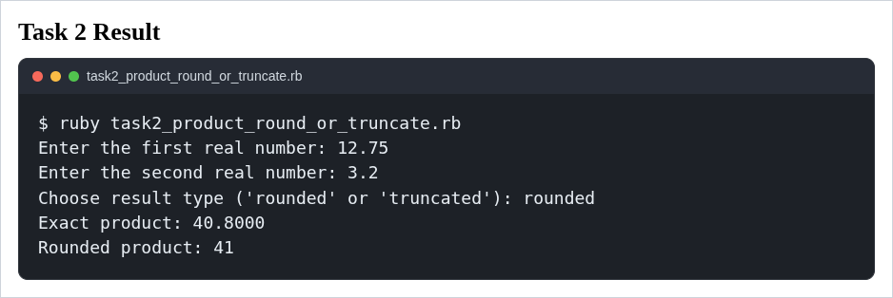

Task 3. Temperature conversion
The program demonstrates transformation formulas and a conditional choice between Celsius-to-Fahrenheit and Fahrenheit-to-Celsius conversion.
#!/usr/bin/env ruby
def read_float(prompt)
loop do
print prompt
input = gets&.strip
exit if input.nil?
value = Float(input, exception: false)
return value unless value.nil?
puts 'Please enter a valid number.'
end
end
def read_conversion_choice
loop do
print "Convert from C to F or from F to C? Enter 'C' or 'F': "
input = gets&.strip&.upcase
exit if input.nil?
return input if %w[C F].include?(input)
puts "Please enter 'C' or 'F'."
end
end
temperature = read_float('Enter the temperature value: ')
choice = read_conversion_choice
if choice == 'C'
converted_temperature = (temperature * 9.0 / 5.0) + 32
puts format('%.2f C = %.2f F', temperature, converted_temperature)
else
converted_temperature = (temperature - 32) * 5.0 / 9.0
puts format('%.2f F = %.2f C', temperature, converted_temperature)
end

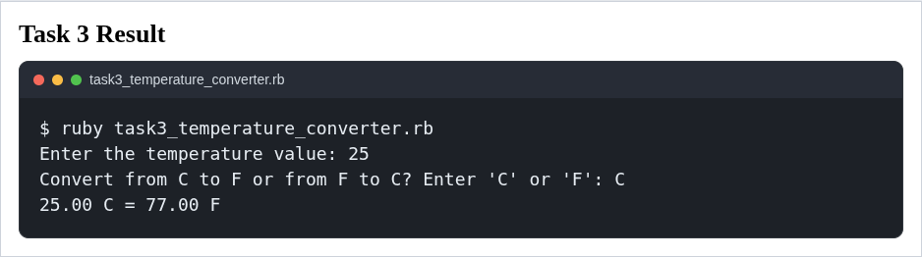

Task 4. Integer division with remainder
The program accepts two integers and uses Ruby’s integer division support to output the quotient and remainder in the required form.
#!/usr/bin/env ruby
def read_integer(prompt)
loop do
print prompt
input = gets&.strip
exit if input.nil?
value = Integer(input, exception: false)
return value unless value.nil?
puts 'Please enter a valid integer.'
end
end
dividend = read_integer('Enter the first integer: ')
divisor = read_integer('Enter the second integer: ')
if divisor.zero?
puts 'Division by zero is not allowed.'
exit
end
quotient, remainder = dividend.divmod(divisor)
puts "#{dividend}/#{divisor} = #{quotient} remainder #{remainder}"

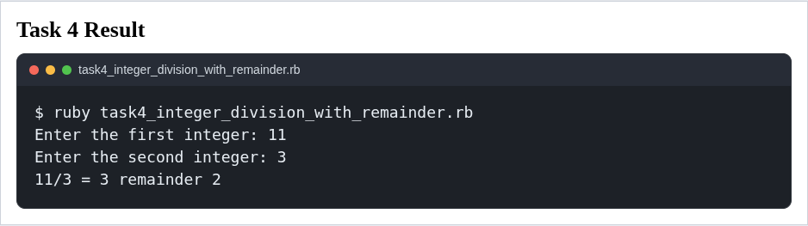

Task 5. Average of three real numbers
The program reads three real numbers, calculates their arithmetic mean, and formats the output to two decimal places.
#!/usr/bin/env ruby
def read_float(prompt)
loop do
print prompt
input = gets&.strip
exit if input.nil?
value = Float(input, exception: false)
return value unless value.nil?
puts 'Please enter a valid number.'
end
end
first_number = read_float('Enter the first real number: ')
second_number = read_float('Enter the second real number: ')
third_number = read_float('Enter the third real number: ')
average = (first_number + second_number + third_number) / 3.0
puts format('Average: %.2f', average)

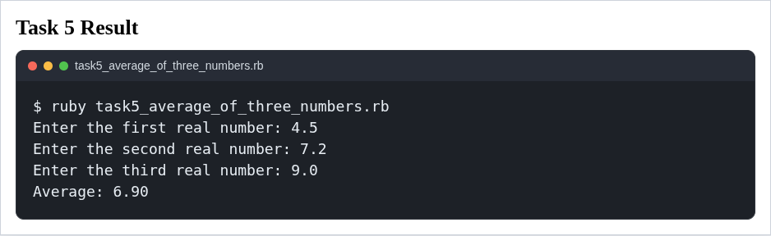

Task 6. Rectangle area and perimeter
The program uses non-negative input validation and then calculates the rectangle area and perimeter with simple arithmetic operators.

#!/usr/bin/env ruby
def read_float(prompt)
loop do
print prompt
input = gets&.strip
exit if input.nil?
value = Float(input, exception: false)
return value if !value.nil? && value >= 0
puts 'Please enter a valid non-negative number.'
end
end
length = read_float('Enter the rectangle length: ')
breadth = read_float('Enter the rectangle breadth: ')
area = length * breadth
perimeter = 2 * (length + breadth)
puts format('Area: %.2f', area)
puts format('Perimeter: %.2f', perimeter)

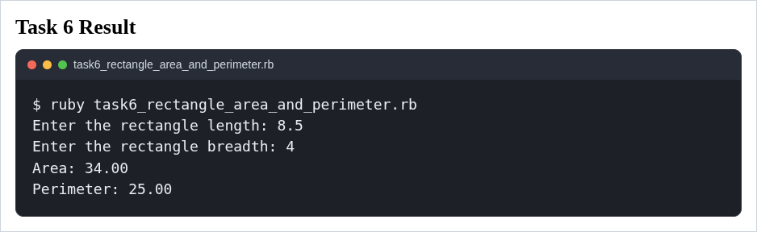

Task 7. Driving license eligibility
The program checks whether the user has reached the legal age of 18. If not, it calculates the remaining number of years.
#!/usr/bin/env ruby
def read_integer(prompt)
loop do
print prompt
input = gets&.strip
exit if input.nil?
value = Integer(input, exception: false)
return value if !value.nil? && value >= 0
puts 'Please enter a valid non-negative integer.'
end
end
age = read_integer('Enter your age: ')
if age >= 18
puts 'You are of legal age to apply for a driving license.'
else
years_remaining = 18 - age
puts "You can apply for a driving license in #{years_remaining} year(s)."
end

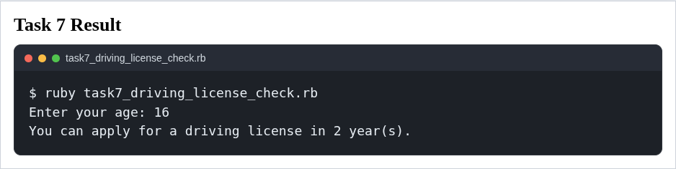

Task 8. Sum of whole numbers until zero
The program demonstrates a loop. It repeatedly reads whole numbers, adds them to the total, and stops when the user enters zero.
#!/usr/bin/env ruby
sum = 0
loop do
print 'Enter a whole number (0 to stop): '
input = gets&.strip
exit if input.nil?
value = Integer(input, exception: false)
if value.nil? || value.negative?
puts 'Please enter a valid whole number.'
next
end
break if value.zero?
sum += value
end
puts "Sum: #{sum}"

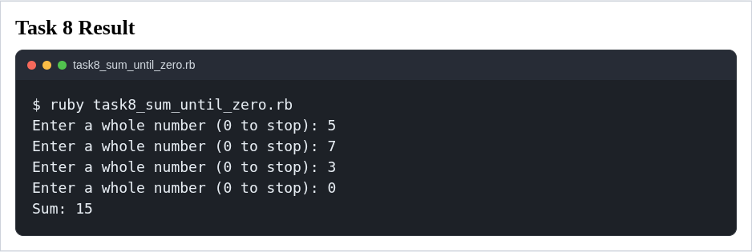

Task 9. Password check
The program checks a password and prints whether it is correct. To answer the security question from the assignment, the solution does not store the password in plain text. Instead, it stores a salted SHA-256 hash and compares it with the hash of the entered value. The program also hides the password when it is typed in a real terminal.
#!/usr/bin/env ruby
require 'digest'
require 'io/console'
PASSWORD_SALT = 'lab3-ruby-salt'
PASSWORD_HASH = 'faeb6e294eae93f9ca188c6646122fab2b2b2d8bbc9f1078e4a40cb9feb2301a'
print 'Enter password: '
if STDIN.tty?
password = STDIN.noecho(&:gets)
puts
else
password = gets
end
exit if password.nil?
entered_password = password.strip
entered_hash = Digest::SHA256.hexdigest("#{PASSWORD_SALT}#{entered_password}")
if entered_hash == PASSWORD_HASH
puts 'Password is correct.'
else
puts 'Password is incorrect.'
end
puts 'Security note: passwords should be stored as salted hashes and entered without displaying them on screen.'

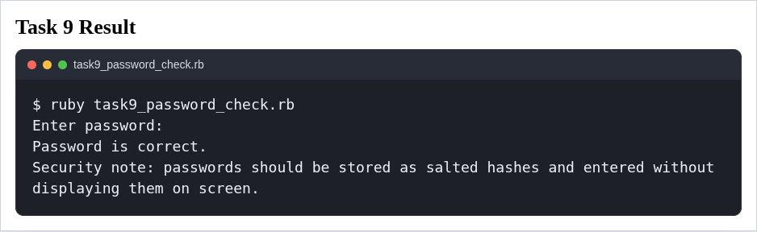

Task 10. Circle area and circumference
The program uses the constant value pi = 3.14159 and calculates both the area and the circumference of a circle for a non-negative radius.
#!/usr/bin/env ruby
PI_VALUE = 3.14159
def read_float(prompt)
loop do
print prompt
input = gets&.strip
exit if input.nil?
value = Float(input, exception: false)
return value if !value.nil? && value >= 0
puts 'Please enter a valid non-negative number.'
end
end
radius = read_float('Enter the radius of the circle: ')
area = PI_VALUE * radius * radius
circumference = 2 * PI_VALUE * radius
puts format('Area: %.4f', area)
puts format('Circumference: %.4f', circumference)

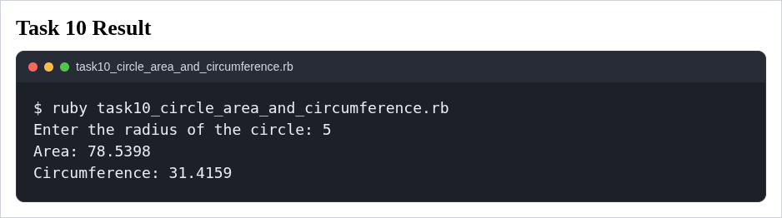

CONCLUSIONS
In this laboratory work, ten console programs were implemented in Ruby to demonstrate arithmetic operations, transformation formulas, conditions, loops, constants, and input handling. Ruby made the programs concise and readable, while still providing the required numerical operations and standard-library tools.
Compared with C++, Ruby requires much less boilerplate and no manual type declarations, which speeds up the development of small console tasks. Compared with Java, Ruby is again shorter and faster to write, although Java provides stronger compile-time type checking. Compared with Python, Ruby offers a similar level of productivity, both languages are suitable for educational console tasks, but Ruby’s block-oriented syntax and built-in methods make the solutions especially compact.
The password task also showed that Ruby can support better security practices even in a simple laboratory program: passwords should be stored as salted hashes rather than plain text, and user input should not be displayed while typing.

REFERENCES
- https://docs.ruby-lang.org/en/4.0/Integer.html
- https://docs.ruby-lang.org/en/4.0/Float.html
- https://docs.ruby-lang.org/en/4.0/Numeric.html
- https://docs.ruby-lang.org/en/4.0/Math.html
- https://docs.ruby-lang.org/en/4.0/IO.html
- https://docs.ruby-lang.org/en/4.0/Digest.html

