TRANSPORT AND TELECOMMUNICATION INSTITUTE



ENGINEERING FACULTY

Laboratory work N2
Course: Programming Languages Concepts
Theme: Basic Operators in Programming Language

Student: Igors Oļeiņikovs
Student code: 93642
Group: 4501BTA

Riga
2026
CONTENTS

1. LABORATORY WORK TASK 3
2. PROGRAM CODE AND RESULTS 3
3. CONCLUSIONS 10
4. REFERENCES 11

LABORATORY WORK TASK
The purpose of this laboratory work is to study basic arithmetic and conversion operators in a programming language and to compare the chosen language with other programming languages known by the student. Ruby was selected for implementation because it has concise syntax, expressive built-in numeric operations, and readable string interpolation.
Tasks completed in this report:
1. Read two integers and output their product and integer quotient.
2. Read three real numbers, compute their sum, and output the result with two decimal places.
3. Calculate the volume of a room in cubic metres and cubic centimetres.
4. Ask the user for age in years and output the age on the next birthday.
5. Express a number of days in weeks and days.
6. Express a number of seconds in hours, minutes, and seconds.
7. Convert kilometres per hour to miles per hour using 1 km = 0.62137 mile.

PROGRAM CODE AND RESULTS
Task 1
Write a program which reads two integers and displays their product and the integer quotient when the first is divided by the second.
Program Code:
#!/usr/bin/env ruby
def read_integer(prompt)
loop do
print prompt
input = gets&.strip
exit if input.nil?
value = Integer(input, exception: false)
return value unless value.nil?
puts 'Please enter a valid integer.'
end
end
first_number = read_integer('Enter the first integer: ')
second_number = read_integer('Enter the second integer: ')
product = first_number * second_number
puts "Product: #{product}"
if second_number.zero?
puts 'Integer quotient: undefined (division by zero).'
else
quotient = first_number.div(second_number)
puts "Integer quotient (DIV): #{quotient}"
end

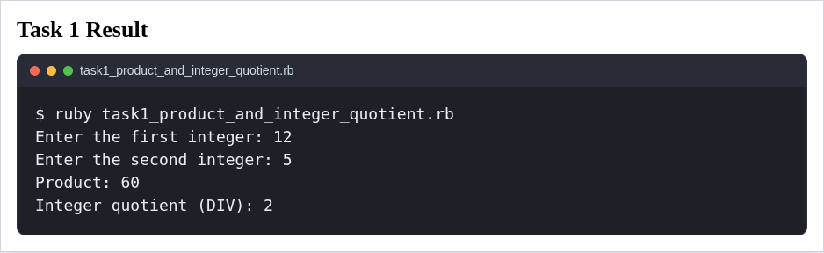
Task 2
Write a program which accepts three real numbers, computes their sum, and outputs the result. Amend the program so that the result is output to 2 decimal places.
Program Code:
#!/usr/bin/env ruby
def read_float(prompt)
loop do
print prompt
input = gets&.strip
exit if input.nil?
value = Float(input, exception: false)
return value unless value.nil?
puts 'Please enter a valid real number.'
end
end
first_number = read_float('Enter the first real number: ')
second_number = read_float('Enter the second real number: ')
third_number = read_float('Enter the third real number: ')
sum = first_number + second_number + third_number
puts "Sum: #{sum}"
puts format('Sum rounded to 2 decimal places: %.2f', sum)

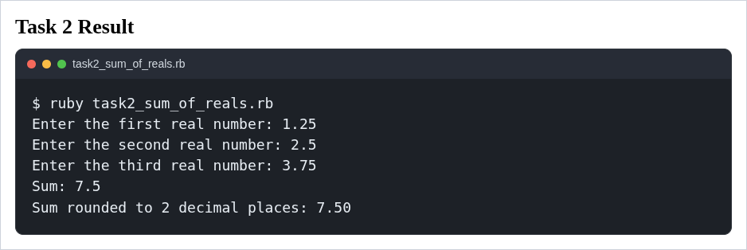

Task 3
Write a program that takes in the width, length, and height of a room in metres and returns the volume of the room in cubic metres and cubic centimetres.
Program Code:
#!/usr/bin/env ruby
def read_float(prompt)
loop do
print prompt
input = gets&.strip
exit if input.nil?
value = Float(input, exception: false)
if !value.nil? && value >= 0
return value
end
puts 'Please enter a valid non-negative number.'
end
end
width = read_float('Enter the room width in metres: ')
length = read_float('Enter the room length in metres: ')
height = read_float('Enter the room height in metres: ')
volume_cubic_metres = width * length * height
volume_cubic_centimetres = volume_cubic_metres * 1_000_000
puts format('Volume: %.3f cubic metres', volume_cubic_metres)
puts format('Volume: %.0f cubic centimetres', volume_cubic_centimetres)

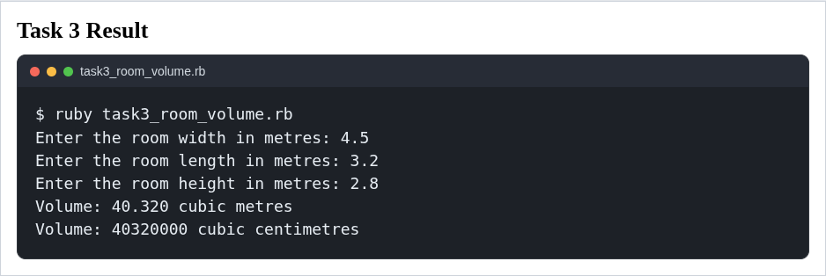

Task 4
Ask the user for age in years and then tell the user how old they are going to be on the next birthday.
Program Code:
#!/usr/bin/env ruby
def read_integer(prompt)
loop do
print prompt
input = gets&.strip
exit if input.nil?
value = Integer(input, exception: false)
return value if !value.nil? && value >= 0
puts 'Please enter a valid age in whole years.'
end
end
age = read_integer('Enter your age in years: ')
puts "On your next birthday you will be #{age + 1} years old."

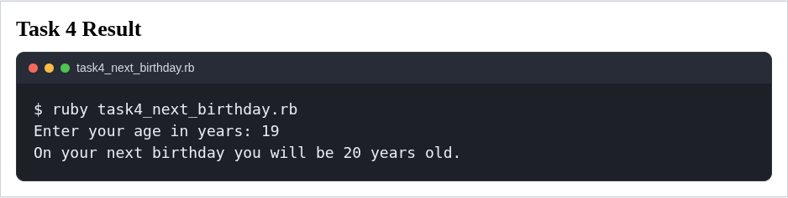

Task 5
Write a program to express a number of days in weeks and days.
Program Code:
#!/usr/bin/env ruby
def read_integer(prompt)
loop do
print prompt
input = gets&.strip
exit if input.nil?
value = Integer(input, exception: false)
return value if !value.nil? && value >= 0
puts 'Please enter a valid non-negative integer.'
end
end
total_days = read_integer('Enter the number of days: ')
weeks, days = total_days.divmod(7)
puts "#{total_days} day(s) = #{weeks} week(s) and #{days} day(s)."

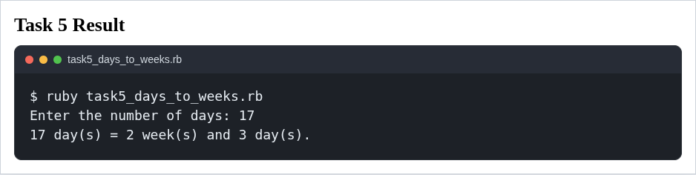

Task 6
Write a program to express a given number of seconds in terms of hours, minutes, and seconds.
Program Code:
#!/usr/bin/env ruby
def read_integer(prompt)
loop do
print prompt
input = gets&.strip
exit if input.nil?
value = Integer(input, exception: false)
return value if !value.nil? && value >= 0
puts 'Please enter a valid non-negative integer.'
end
end
total_seconds = read_integer('Enter the number of seconds: ')
hours, remaining_seconds = total_seconds.divmod(3600)
minutes, seconds = remaining_seconds.divmod(60)
puts "#{total_seconds} second(s) = #{hours} hour(s), #{minutes} minute(s), #{seconds} second(s)."

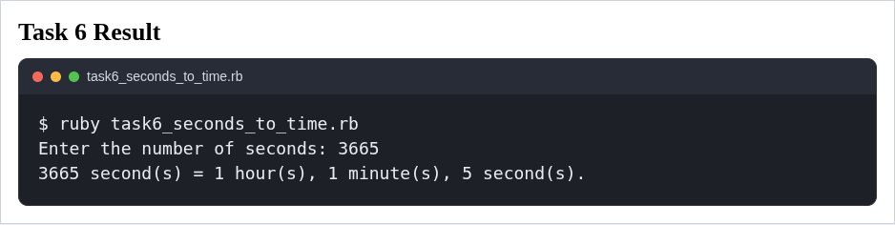

Task 7
Write a program to convert km/h into mph using 1 km = 0.62137 mile.
Program Code:
#!/usr/bin/env ruby
def read_float(prompt)
loop do
print prompt
input = gets&.strip
exit if input.nil?
value = Float(input, exception: false)
return value if !value.nil? && value >= 0
puts 'Please enter a valid non-negative speed.'
end
end
speed_kmph = read_float('Enter the speed in km/h: ')
speed_mph = speed_kmph * 0.62137
puts format('%.2f km/h = %.2f mph', speed_kmph, speed_mph)

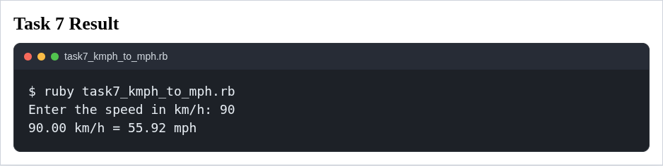

CONCLUSIONS
All seven tasks were successfully implemented in Ruby. The programs use the basic arithmetic
operations of the language, integer division with div, quotient and remainder extraction with
divmod, floating-point calculations, and formatted output through format. Sample runs confirm that
the expected results were achieved.
Ruby is very convenient for this kind of assignment because its syntax is concise and easy to read.
Compared with C++ or Java, Ruby requires much less boilerplate code: no explicit type
declarations, no semicolons, and no class wrapper for simple console programs. Compared with
Python, Ruby is similarly readable, but it provides some expressive numeric helpers such as div and
divmod that map naturally to the task requirements.
The main advantage of Ruby in this laboratory work is readability and speed of development. The
main disadvantage is that Ruby is dynamically typed, so some mistakes are detected only at runtime
rather than at compile time. For short educational programs, however, Ruby is a strong choice
because it lets the programmer focus on the task logic instead of language ceremony.

REFERENCES
- https://docs.ruby-lang.org/en/4.0/Integer.html
- https://docs.ruby-lang.org/en/4.0/Float.html
- https://docs.ruby-lang.org/en/4.0/Numeric.html
- https://docs.ruby-lang.org/en/4.0/Integer.html#method-i-div
- https://docs.ruby-lang.org/en/4.0/Integer.html#method-i-divmod
- https://www.convertunits.com/from/kilometres/to/mile+%5Binternational%5D

