TRANSPORT AND TELECOMMUNICATION INSTITUTE



ENGINEERING FACULTY

Control test Nr. 1
Individual Variant Nr. 1
Course: Programming Languages Concepts
Theme: PL Syntax

Student: Igors Oļeiņikovs
Student code: 93642
Group: 4501BTA

Riga
2026
CONTENTS

1. TASK 1 3
2. TASK 2 4
3. TASK 3 5
4. TASK 4 6
5. TASK 5 8

task 1
Represent expressions in prefix and postfix notations and draw an abstract syntax tree.
Expression 1
a * b + c - 2
• Prefix notation: - + * a b c 2
• Postfix notation: a b * c + 2 -
• Abstract syntax tree:

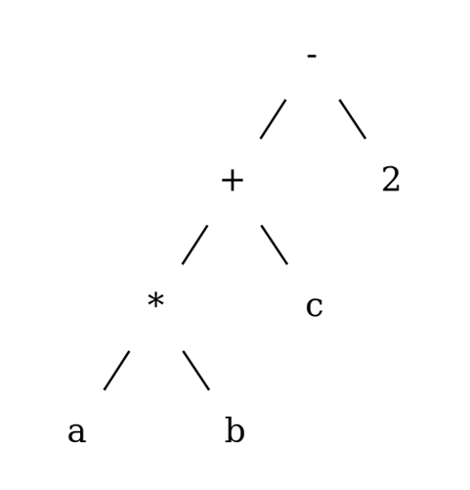
Expression 2
( b / 2 + sqrt ( ( b / 2 ) * ( b / 2 ) - a * c ) ) / a
• Prefix notation: / + / b 2 sqrt - * / b 2 / b 2 * a c a
• Postfix notation: b 2 / b 2 / b 2 / * a c * - sqrt + a /
• Abstract syntax tree:
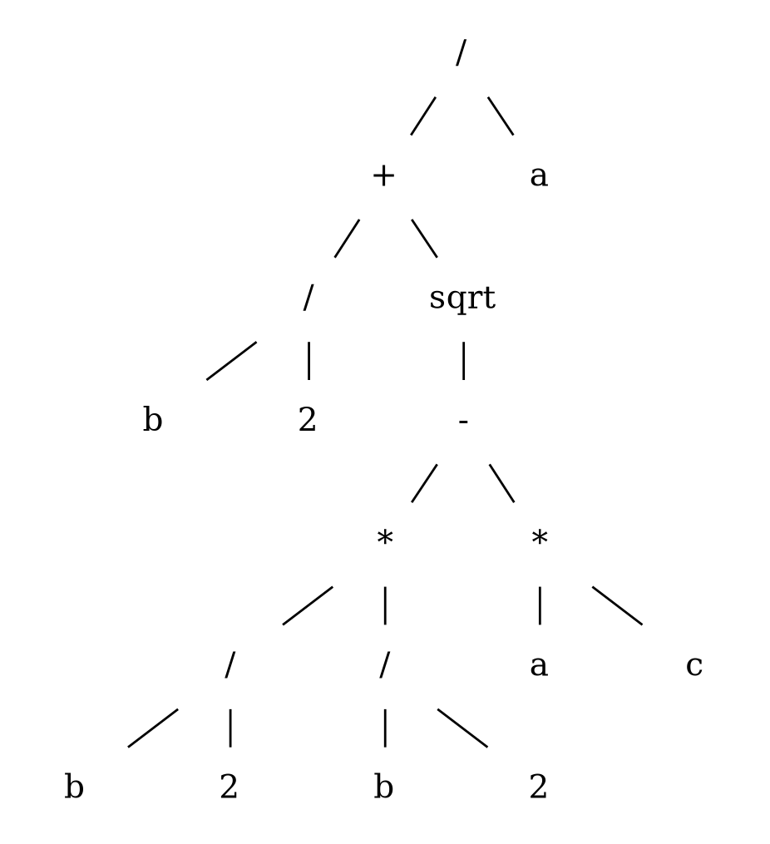

task 2
Get context-free grammar describing the syntax of the following construct:
Letters and/or digits sequence: a sequence has 0 length or more characters, starts with
digit.
Note: the task says “0 length or more”, but an empty string cannot start with a digit, so the grammar below generates strings of length 1 or more.
<S> ::= <digit> <tail>
<tail> ::= <symbol> <tail> | epsilon
<symbol> ::= <letter> | <digit>
<digit> ::= 0 | 1 | 2 | 3 | 4 | 5 | 6 | 7 | 8 | 9
<letter> ::= A | B | C | ... | Z | a | b | c | ... | z
Note: The ellipses in <letter> represent all 52 lowercase and uppercase letters.

TASK 3
Using the grammar, show a parse tree and a leftmost derivation for string 1.23456.
<real_number> ::= <integer_part> . <fractional>
<integer_part> ::= <digit> | <integer_part> <digit>
<fractional> ::= <digit> | <digit> <fractional>
<digit> ::= 0 | 1 | 2 | 3 | 4 | 5 | 6 | 7 | 8 | 9
Leftmost derivation:
<real_number>
=> <integer_part> . <fractional>
=> <digit> . <fractional>
=> 1 . <fractional>
=> 1 . <digit> <fractional>
=> 1.2 <fractional>
=> 1.2 <digit> <fractional>
=> 1.23 <fractional>
=> 1.23 <digit> <fractional>
=> 1.234 <fractional>
=> 1.234 <digit> <fractional>
=> 1.2345 <fractional>
=> 1.2345 <digit>
=> 1.23456
Parse tree:
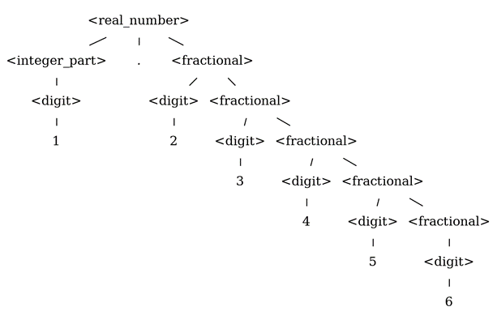

TASK 4
Using the grammar, show a parse tree for the given expressions.
<E> ::= <E> + <T> | <E> - <T> | <T>
<T> ::= <T> * <F> | <T> / <F> | <F>
<F> ::= number | name | ( <E> )
Expression 1
(2 + a) * 5
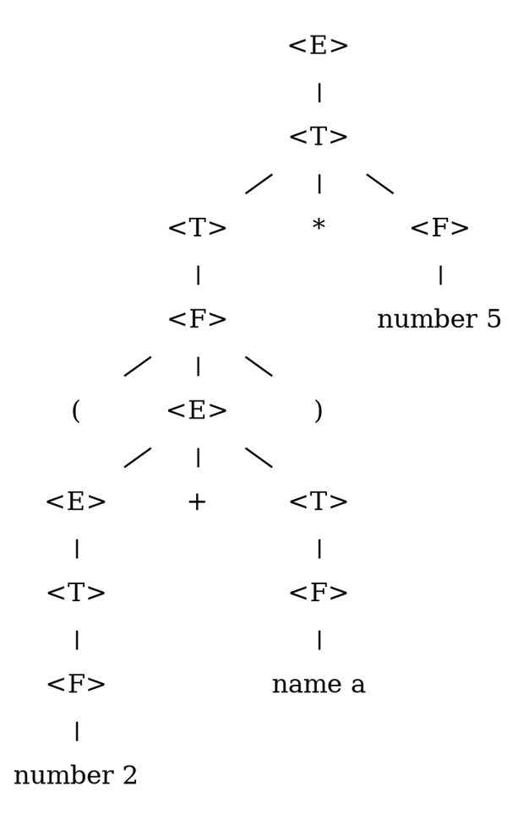
Expression 2
(2 + (a * b - a / (b + 1)) - 13) * a – c
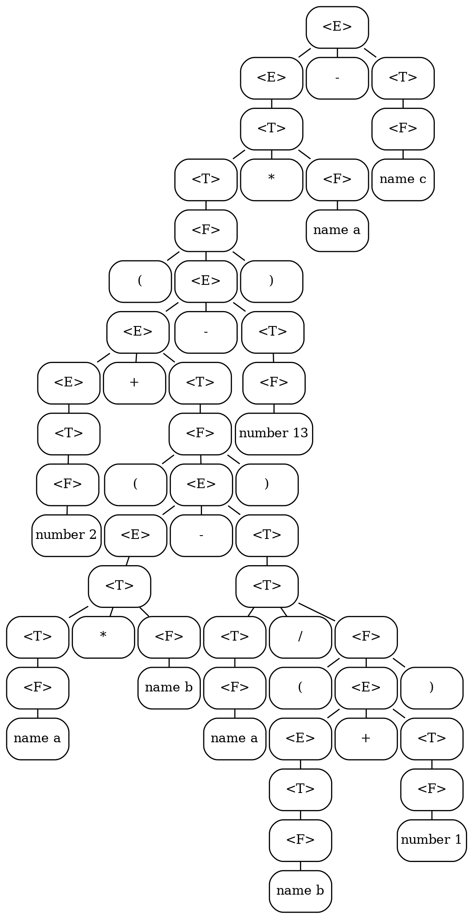

TASK 5
Using the grammar for Pascal language, show a parse tree for the given construction.
<S> ::= <id> := <expression>
| if <expression> then <S>
| if <expression> then <S> else <S>
| while <expression> do <S>
| begin <SL> end
<SL> ::= <S> | <S> ; <SL>
Construction:
while <expression> do begin <id> := <expression>; <id> := <expression> end
Parse tree:
