SOFTENG 364 Assignment 1

840454023, elee353

Task 1

Task 2

Q1.

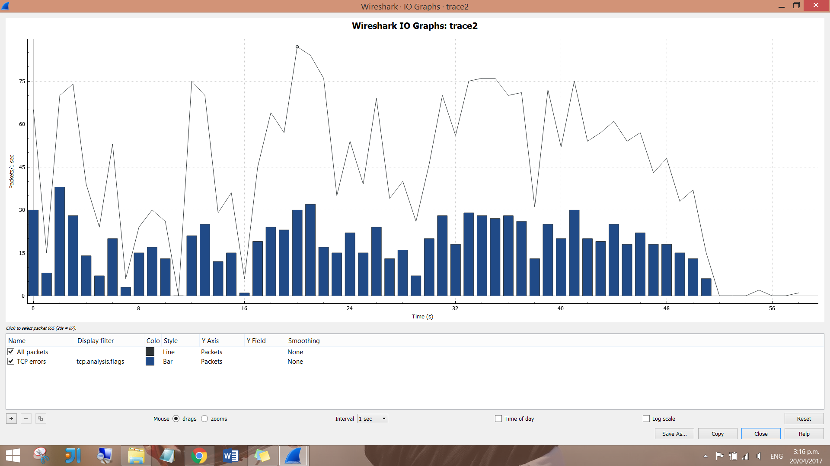

The highest packets-per-second value seen was 87 packets per second.

It occurred in the 20th second.

Q2.

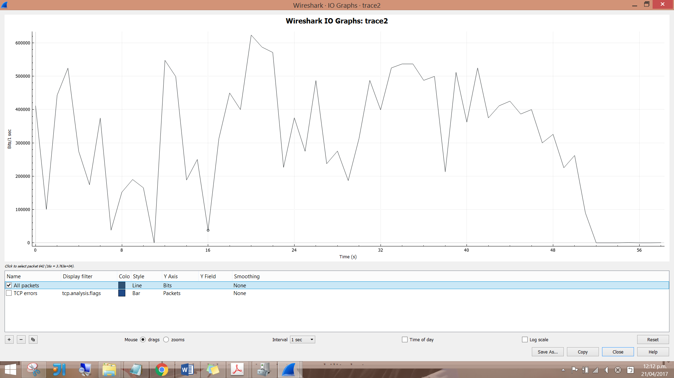

The highest bits-per-second value is 623500 bits per second.

It occurred in the 20th second.

Q3.

Apply filters: tcp.analysis.duplicate_ack, tcp.analysis.fast_retransmission, and tcp.analysis.retransmission.

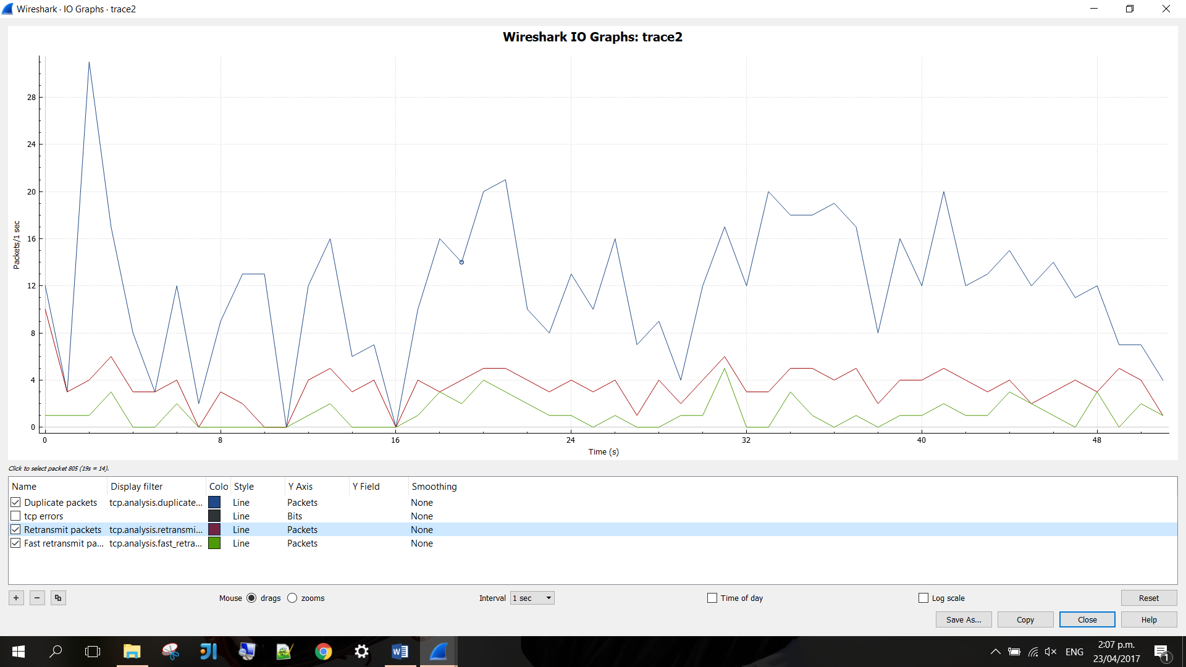

Q4.

Duplicate ACKs are sent when the receiver sees a gap in the packets it receives. The gap can be caused by a lost segment or just a reordering of segments.

The sender will wait for a small number of duplicate ACKs to be received. If there is only one or two duplicate ACKs received before the reordered segment is processed, there is just a reordering of the segments and a new ACK will be generated.

If three or more duplicate ACKs are received in a row, it is a strong indication that a segment has been lost.

Q5.



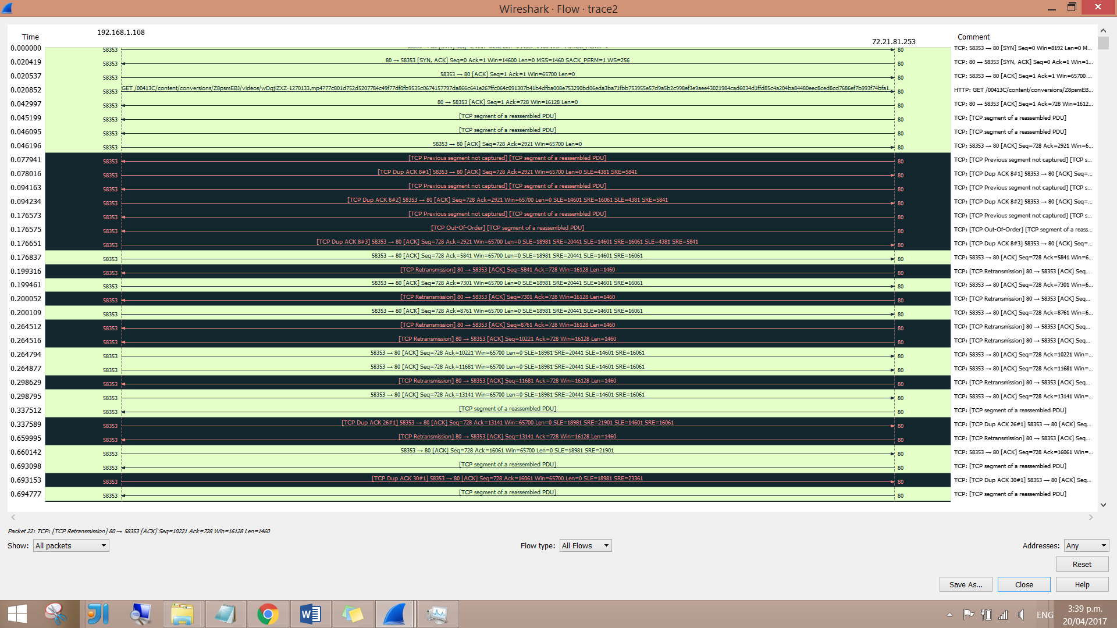

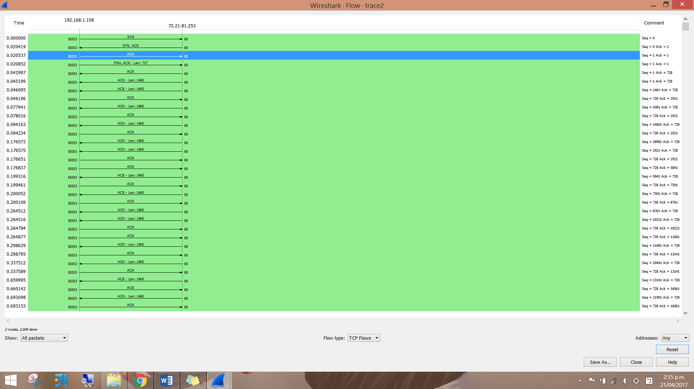There are 2584 TCP conversations.

Q6.

"Tcp previous segment not captured" means Wireshark did not see a packet that should have been in the trace.

This is caused by either the packet really wasn't seen on the wire due to a packet loss, or Wireshark did not record the packet fast and timely even though it **had been** on the wire.



There is 172 times “previous segment not captured” has been detected.

Q7.



There are 183 retransmissions.



There are 59 fast transmissions.

Task 3

Q1.

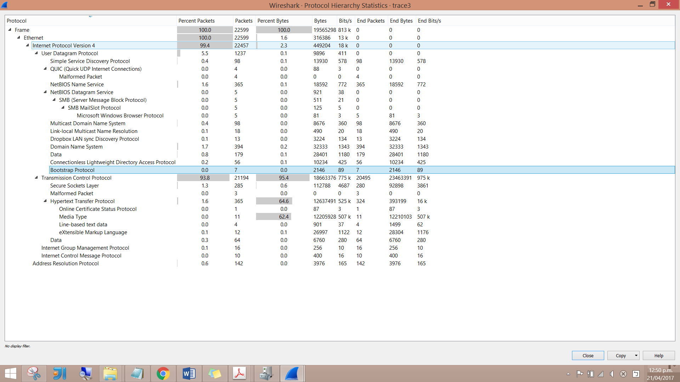

* ARP, NBNS, BROWSER, CLDAP, DB-LSP-DISC, DHCP, DNS, HTTP, OCSP, QUIC, SSDP, TCP, TLSv1, TLSv1.2, UDP
* 0 percent of the total was involved with DCHP messages.
* TCP is used the most here.

Q2.

Apply bootp, dns, tcp, and udp filters.

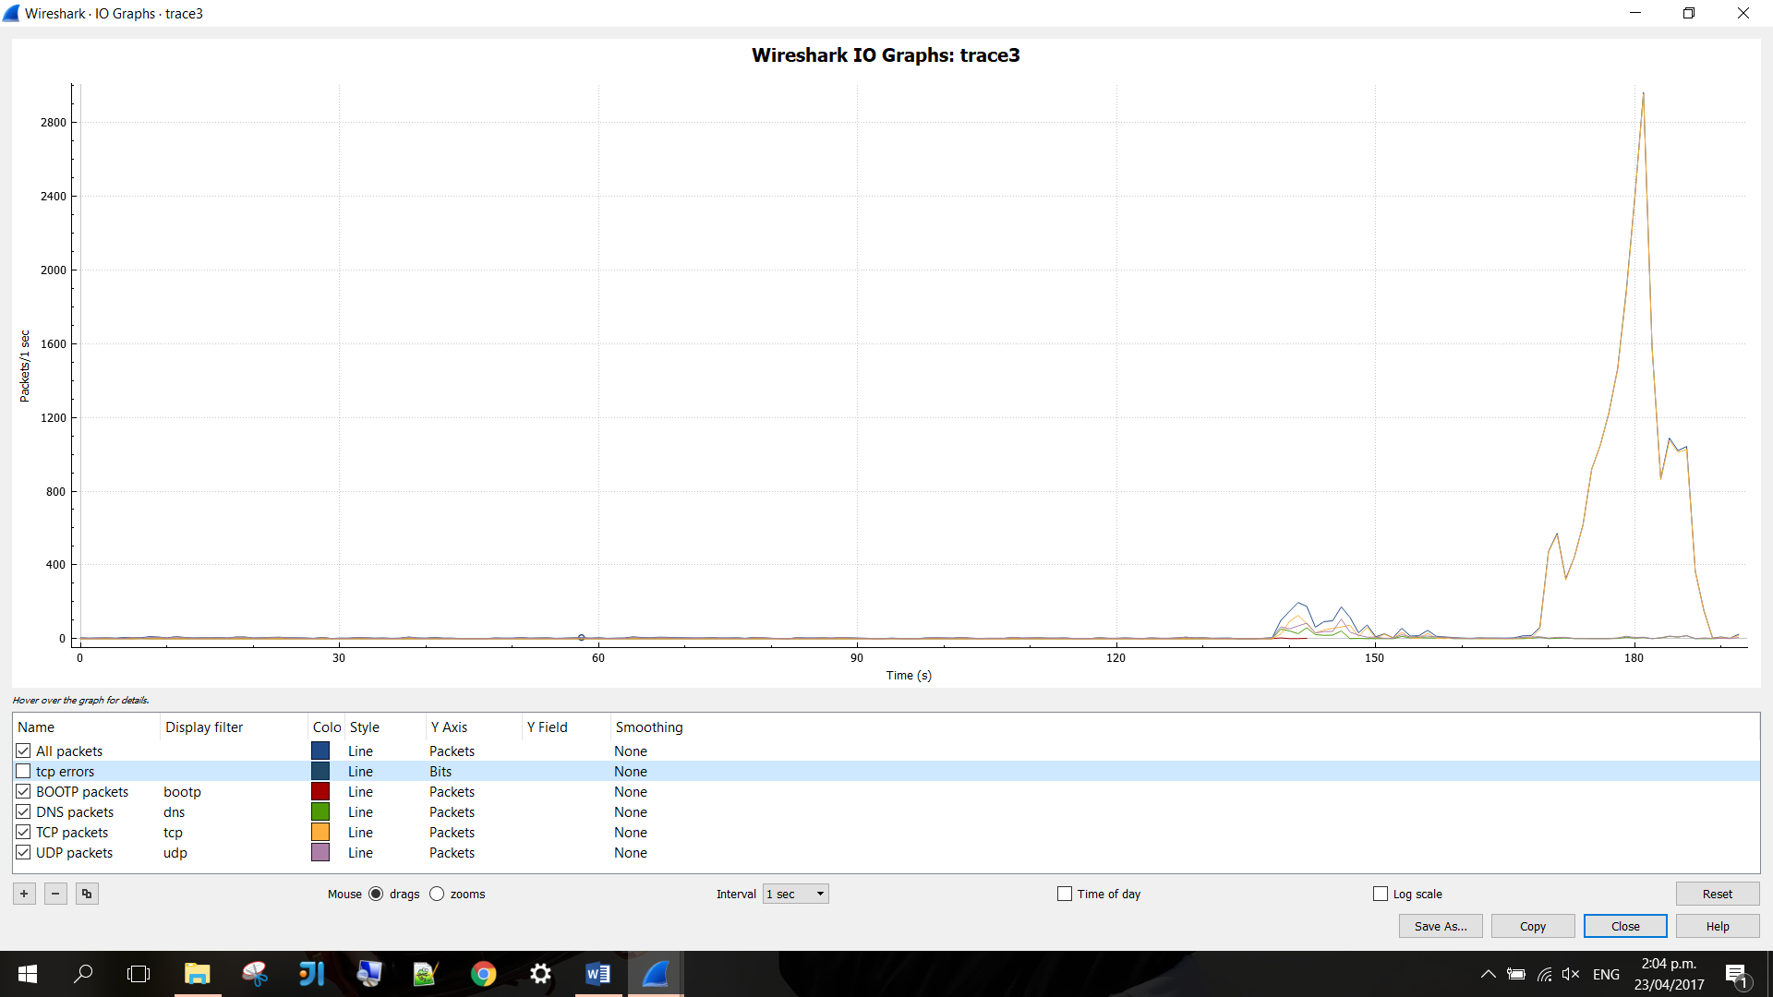

Q3.

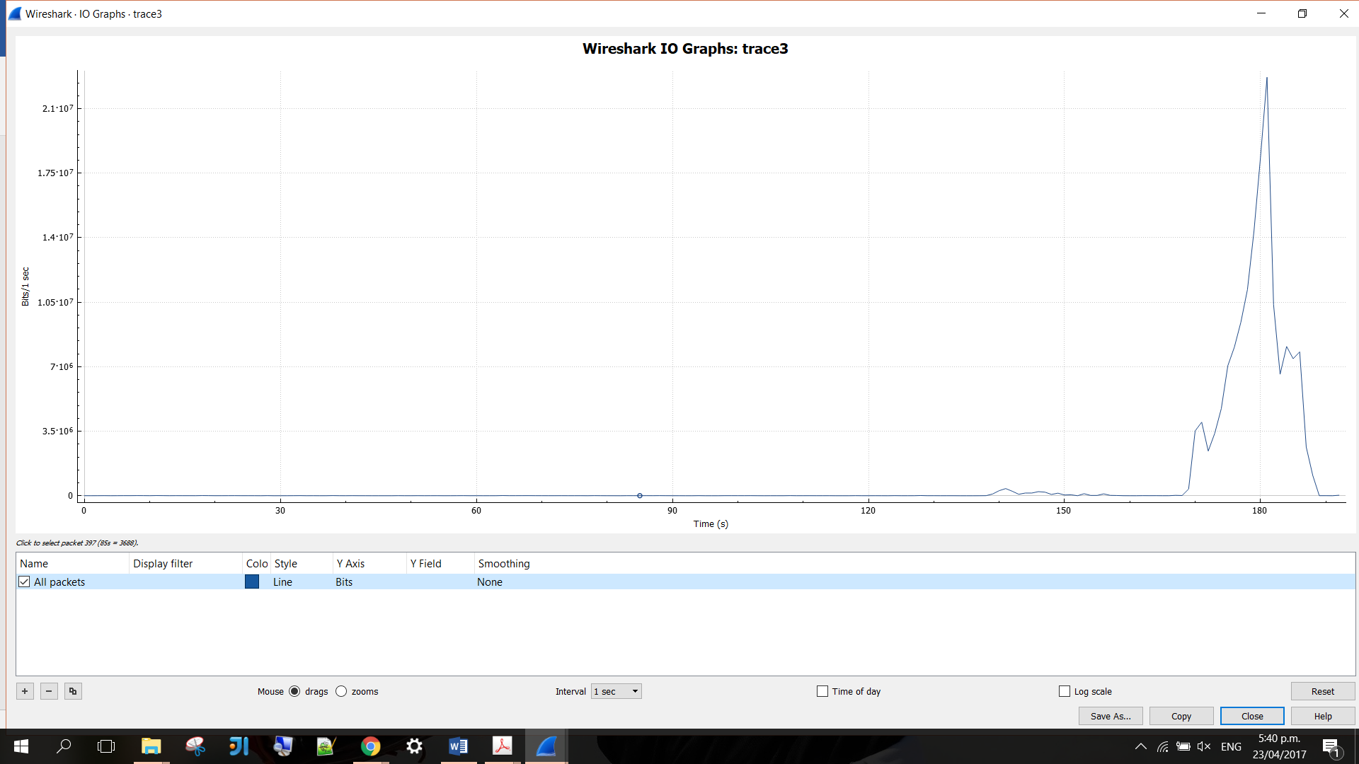

The highest bits-per-second rate is 22700000 bits per second.

It occurred in the 181st second.

Q4.

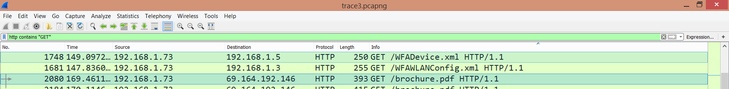

Request IP: 192.168.1.73

Response IP: 69.164.192.146

Q5.

* TCP conversation



Q6.

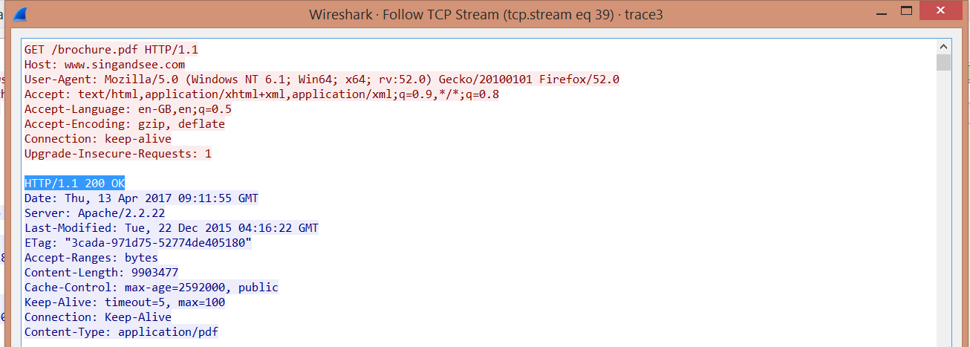





Download time = 192.372 – 169.269 = 23.103 seconds

Q7.

ToDo!!!

Q8.

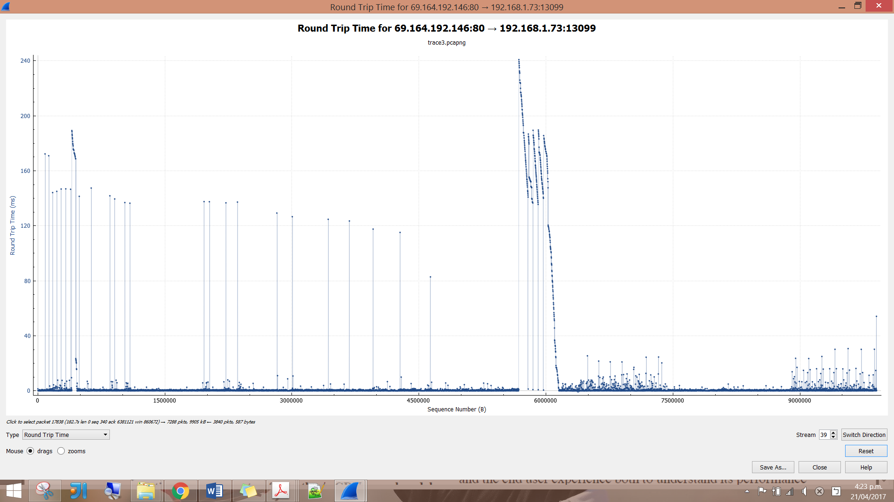

The longest RTT occurred in packet 17280, in the 182.268th second.

Task 4

* In General
* Video traffic is the major consumer of internet bandwidth, because multimedia files are generally large. Videos are a sequence of images displayed at a constant rate, while digital images are arrays of pixels.
* There exist a very diverse range of video communication and streaming applications, which have very distinctive operating conditions or properties.
* Video communication system designs significantly depend on the characteristics of the communication channel, such as bandwidth, delay, and loss.
* Some video channels support Constant Bit Rate (CBR), such as ISDN or DTV. On the other hand, some channels support Variable Bit Rate (VBR), for example, DVD storage and communication over shared packet networks.
* Several network protocols have been designed and standardised for communication between clients and streaming servers.
* The Internet protocol (IP) serves as the network-layer protocol for Internet video streaming.
* Netflix
* YouTube
* Youtube is one of the most popular services on the internet, being the most visited website in the world.[YOUTUBE’S dash]
* One disadvantage of DASH is the amount of storage required to host all the videos in various bit rates and segment lengths on Youtube.
* Lightbox
* CDN, DASH
* Discuss how video streaming on the internet is achieved in general
* then discuss the approaches taken by the above three services
* the protocols involved
* facts pertaining to New Zealand
* Pictures
* reference all your sources, including any images taken from other sources
* 1200 words