SOFTENG 364 Assignment 1

840454023, elee353

Task 2. Q1.

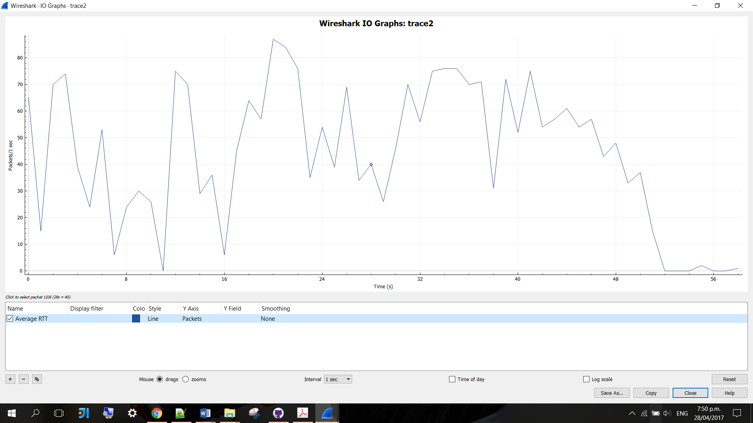

The highest packets-per-second value seen was 87 packets per second and it occurred in the 20th second.

Task 2. Q2.

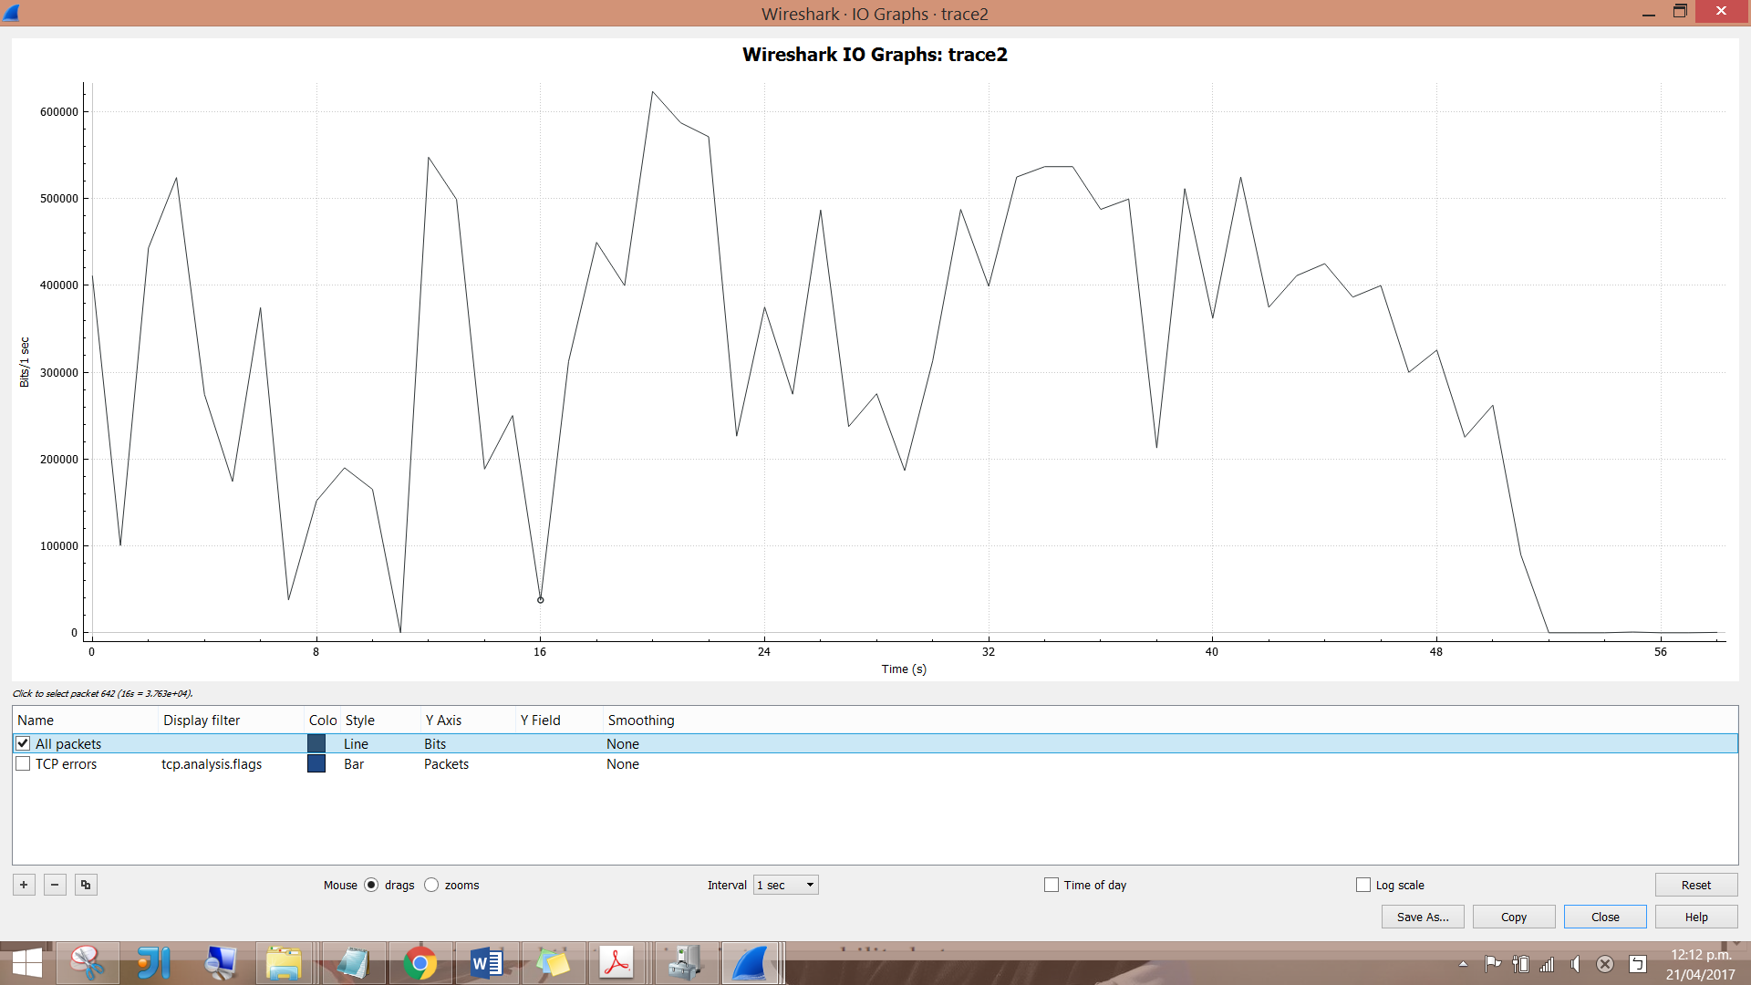

The highest bits-per-second value is 623500 bits per second and it occurred in the 20th second.

Task 2. Q3.

* Apply filters: tcp.analysis.duplicate_ack, tcp.analysis.fast_retransmission, and tcp.analysis.retransmission.

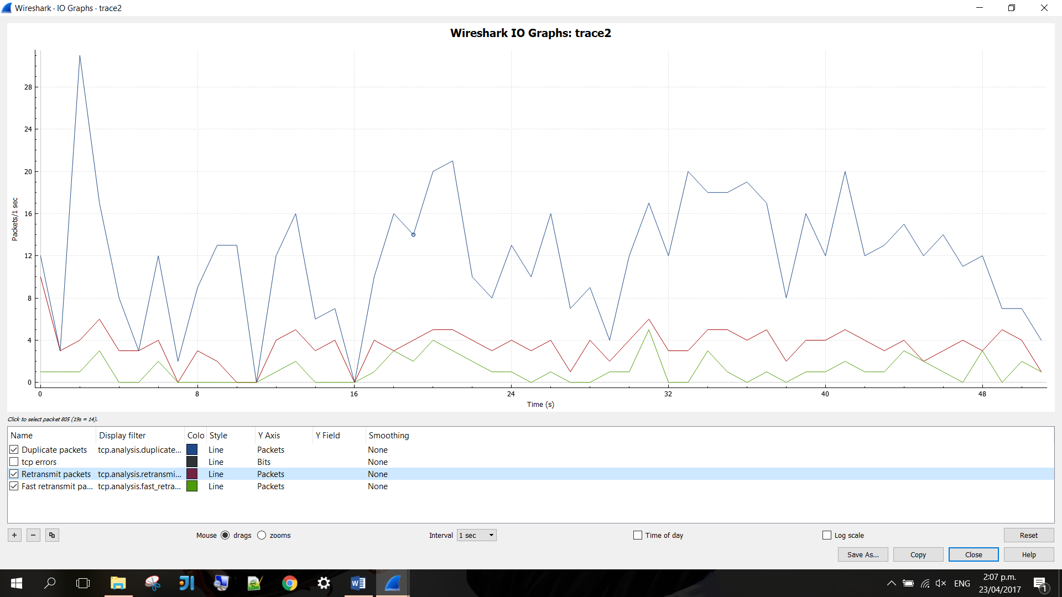

Task2. Q4.

Duplicate ACKs are two or more acknowledgements containing exactly the same information. They are sent when the receiver sees a gap in the packets it receives. The gap can be caused by a lost segment or just a reordering of segments.

The sender will wait for a small number of duplicate ACKs to be received. If there is only one or two duplicate ACKs received before the reordered segment is processed, there is just a reordering of the segments and a new ACK will be generated. If three or more duplicate ACKs are received in a row, it is a strong indication that a segment has been lost. Consequently, fast retransmission will occur.

Task2. Q5.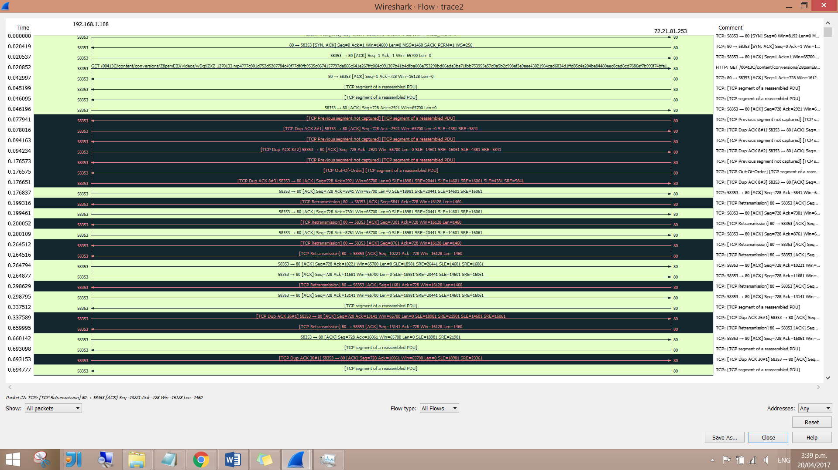

With only TCP flows selected:

* First 30:

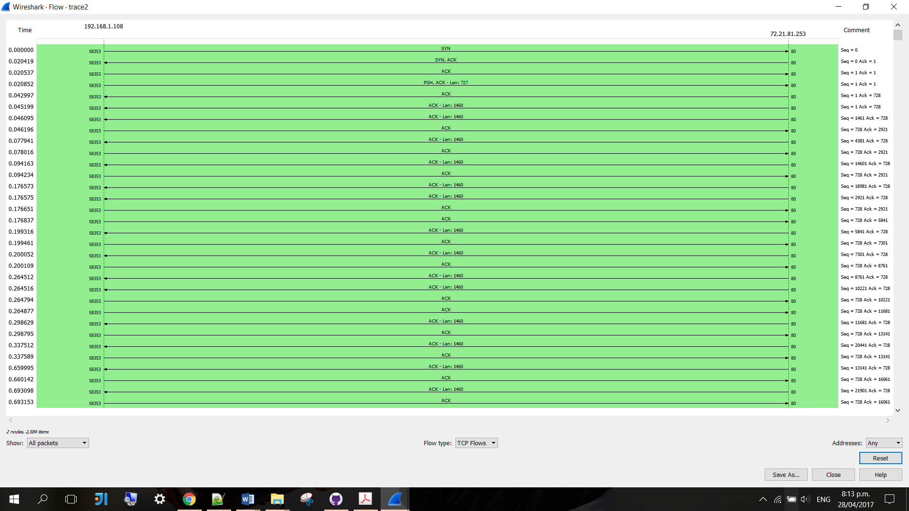

* Middle:

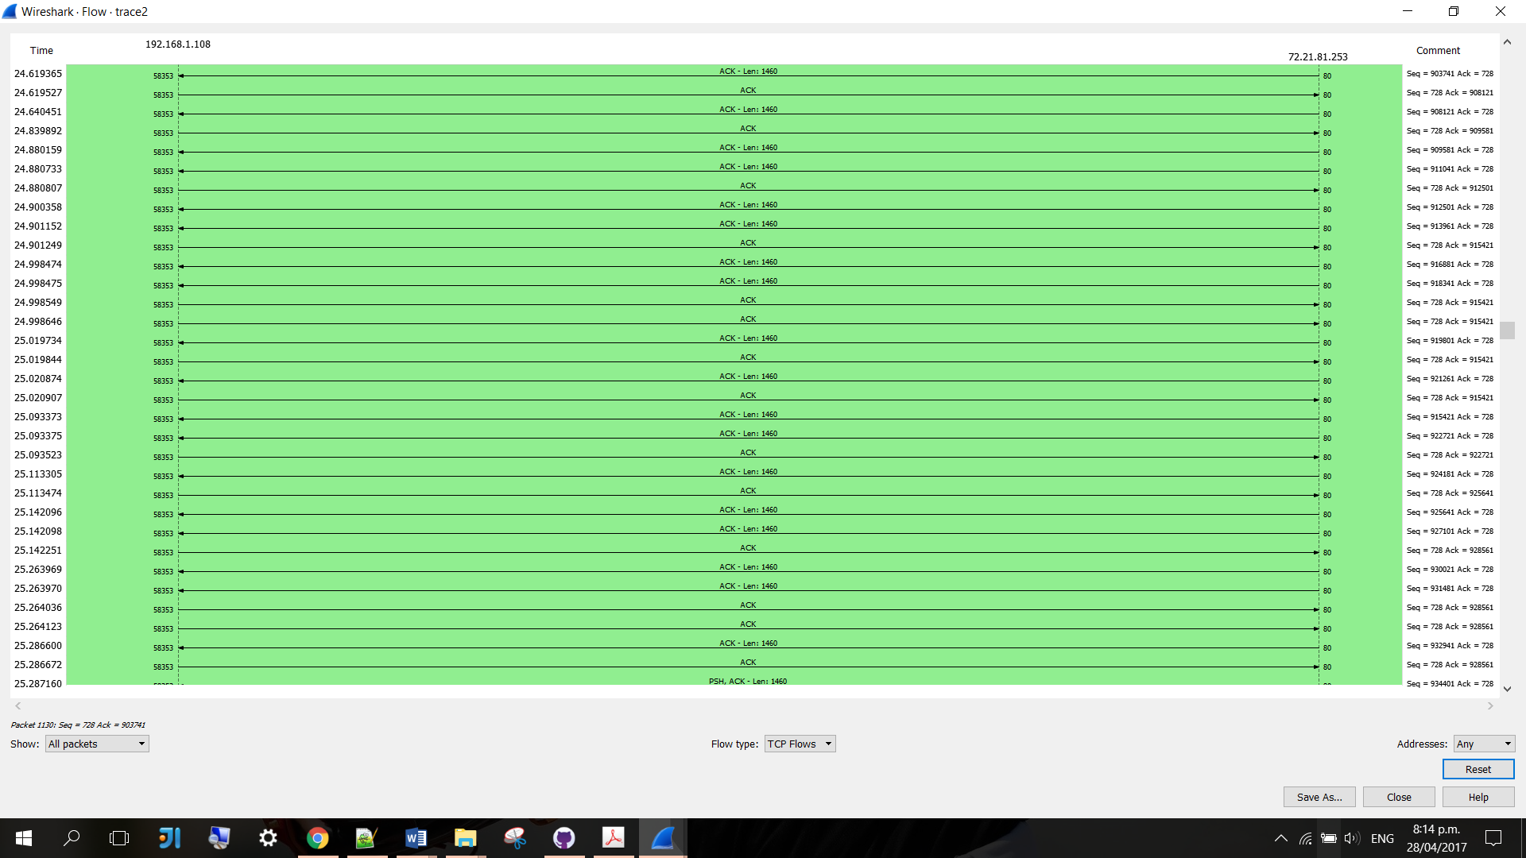

* Last 30:

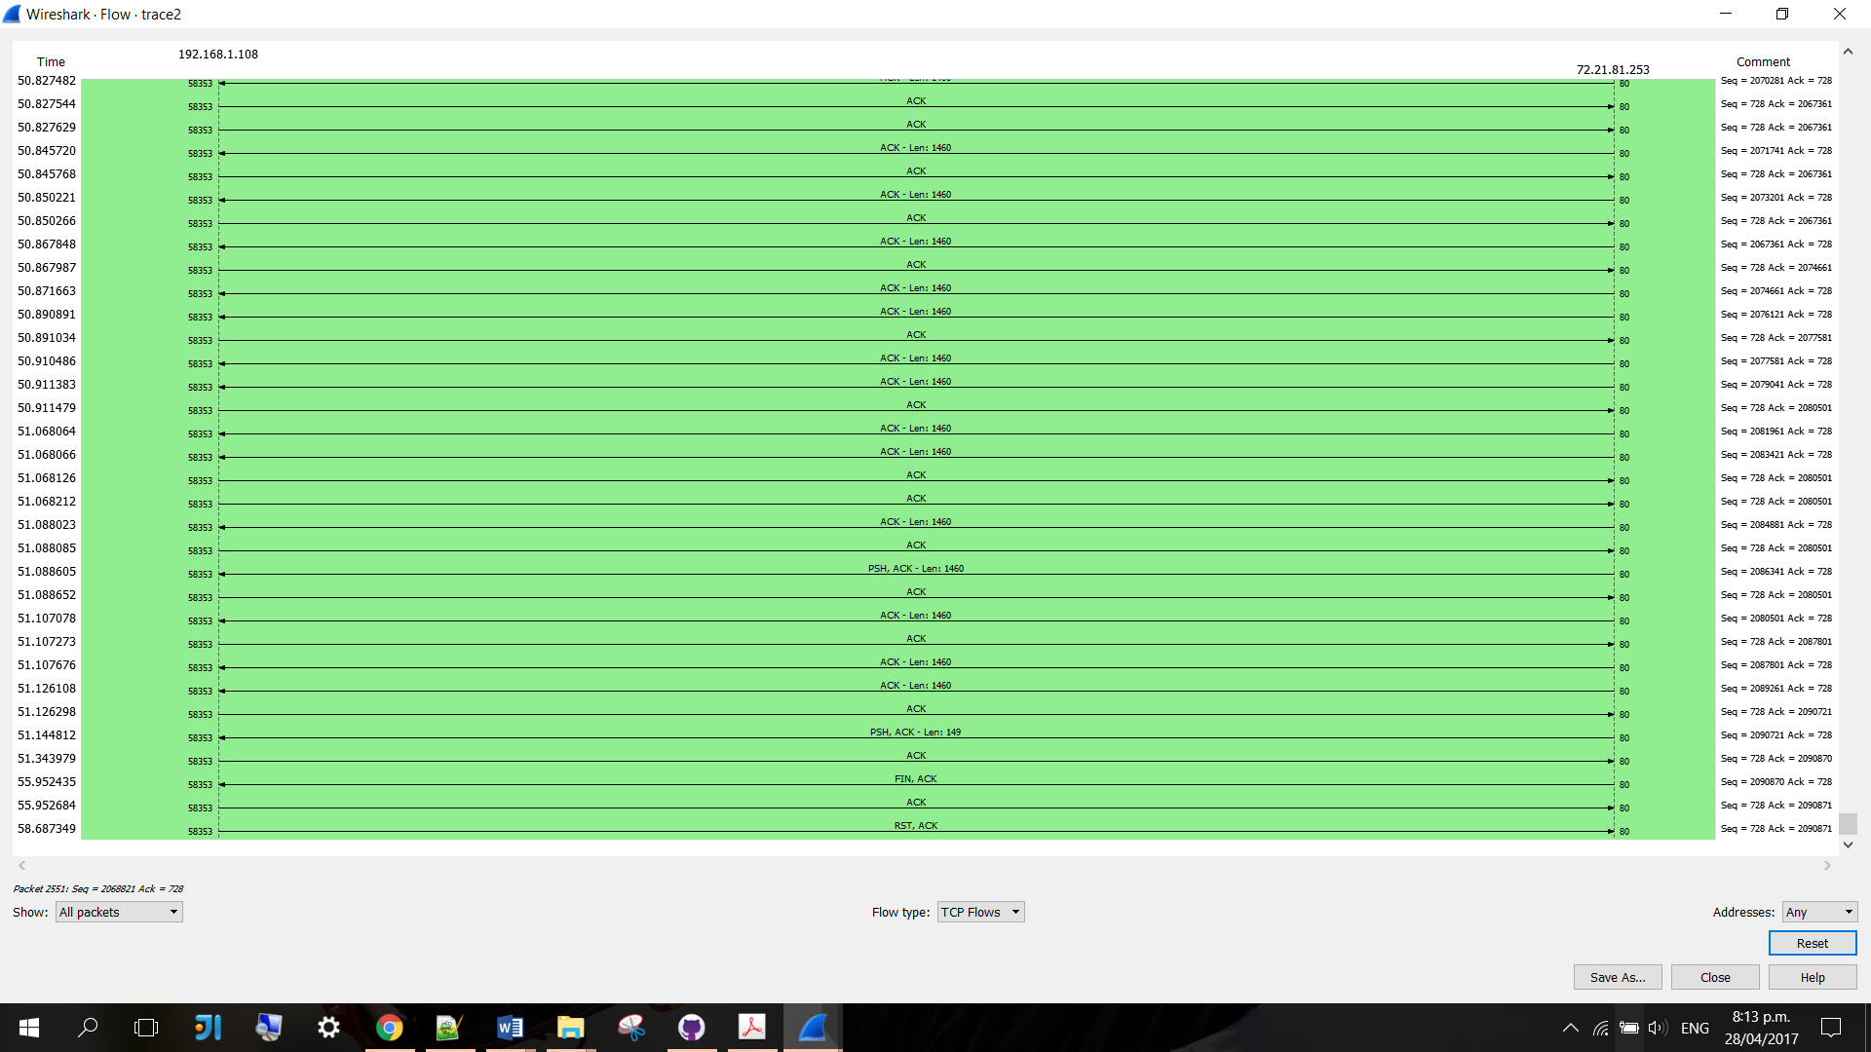

There is one TCP conversation between the two nodes.

Task2. Q6.

"Tcp previous segment not captured" means Wireshark did not see a packet that should have been in the trace; this means no packet from the same TCP session whose sequence number + byte length matches the sequence number of a present packet.

This is caused by either the packet really wasn't seen on the wire due to a packet loss, or Wireshark did not record the packet fast and timely enough even though it **had been** on the wire.



There is 172 times “previous segment not captured” has been detected.

Task 2. Q7.



There are 183 retransmissions in this trace file.



There are 59 fast transmissions in this trace file.

Task 3. Q1.

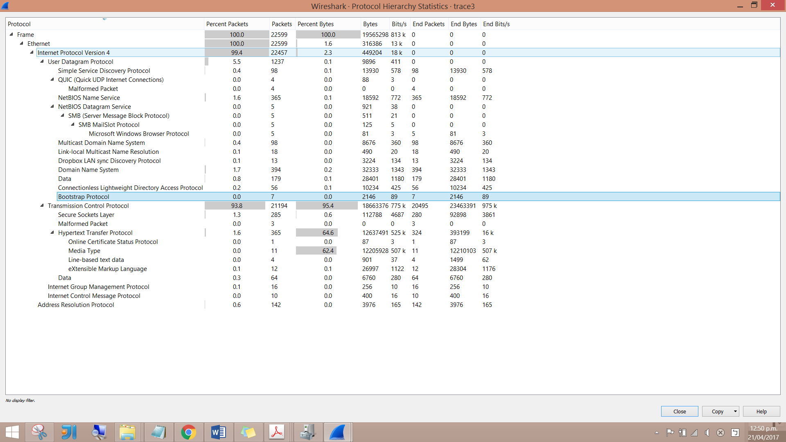

* The protocols include: ARP, BROWSER, CLDAP, DB-LSP-DISC, DHCP, DNS, HTTP, HTTP/XML, ICMP, IGMPv2, IGMPv3, LLMNR, MDNS, NBNS, OCSP, QUIC, SSDP, TCP, TLSv1, TLSv1.2, UDP
* 0 percent of the total was involved with DCHP messages.
* TCP is used the most here.

Task 3. Q2.

* Apply bootp, dns, tcp, and udp filters.
* Altogether:

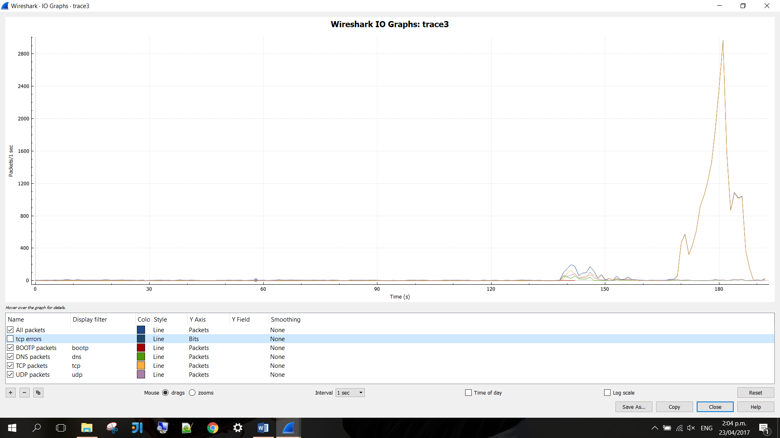

* All traffic:

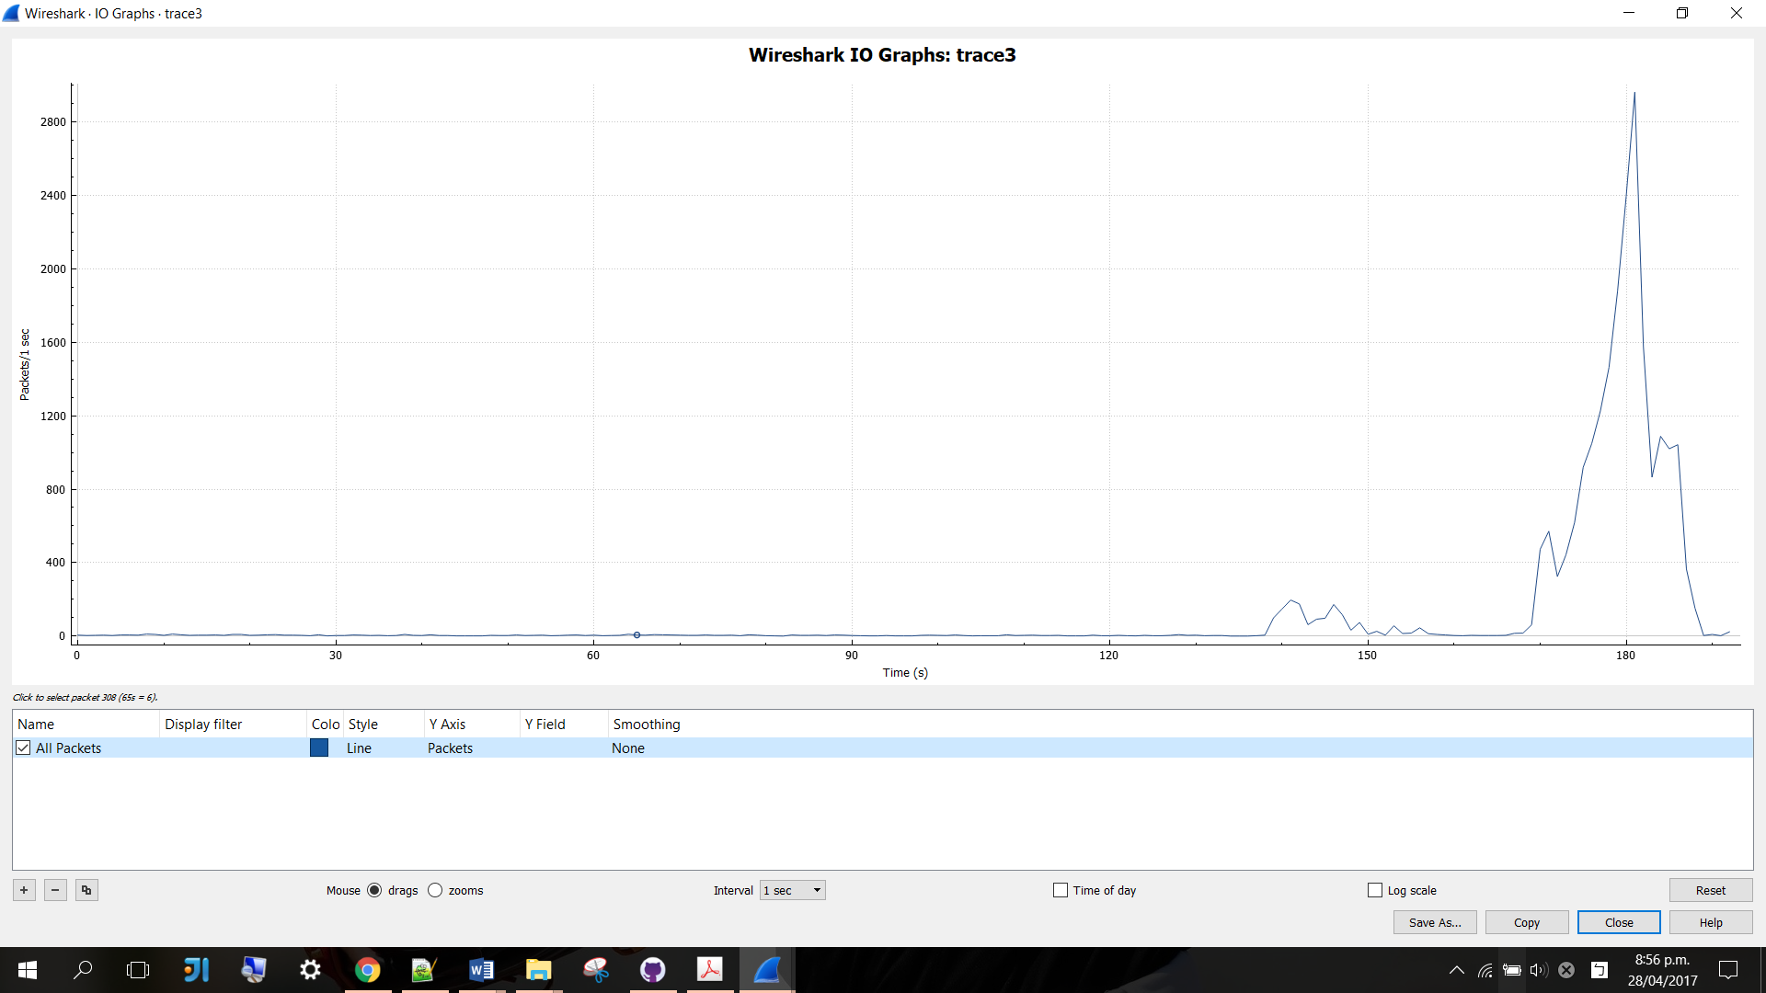

* DHCP filter:

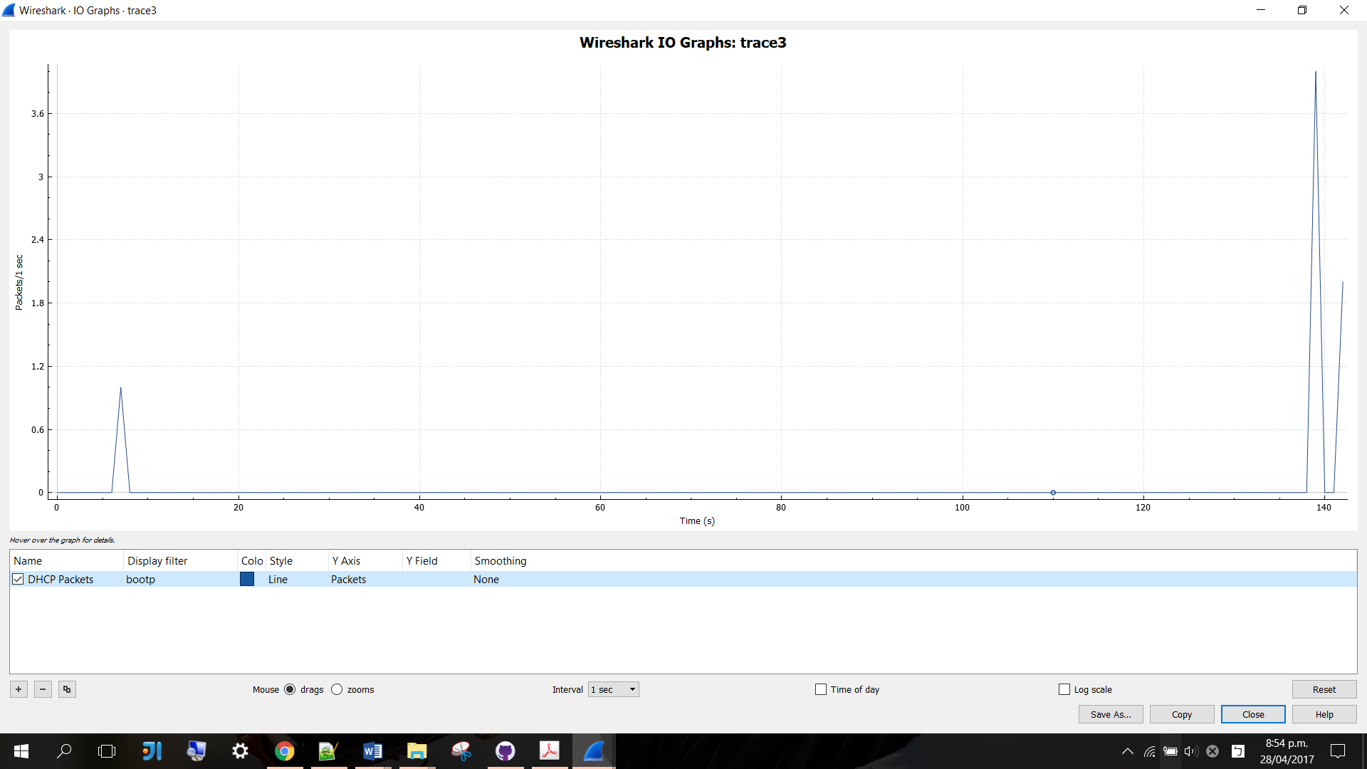

* DNS filter:

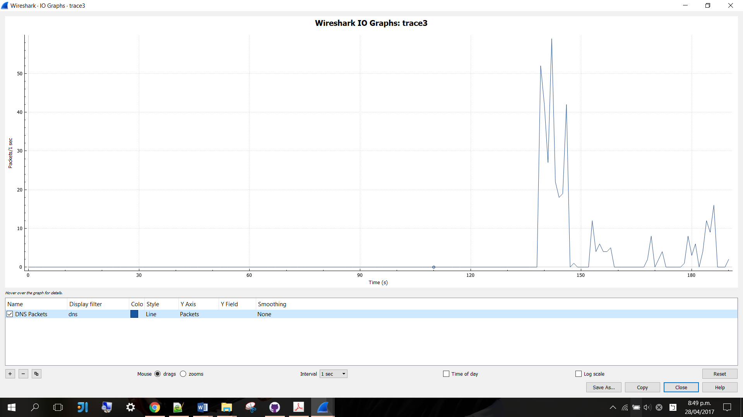

* TCP filter:

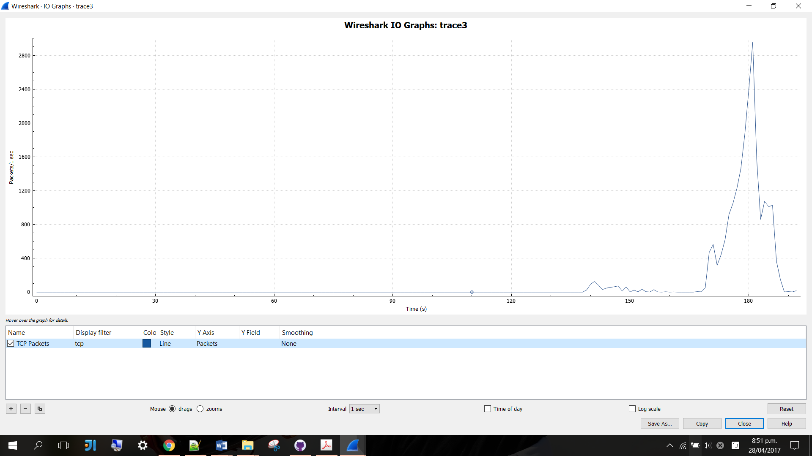

* UDP filter:

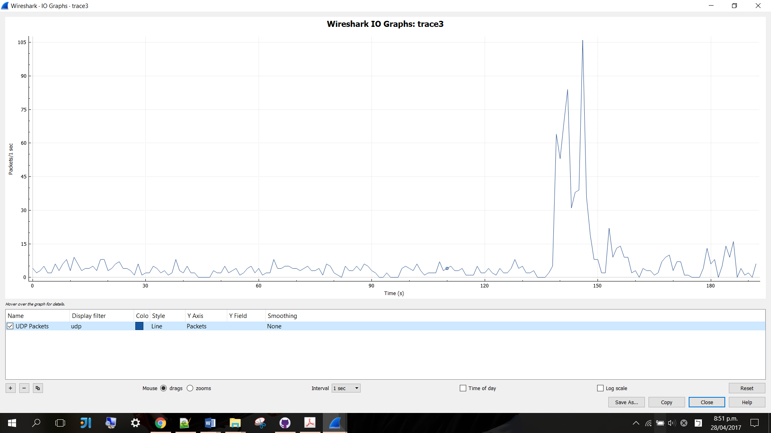

Task 3. Q3.

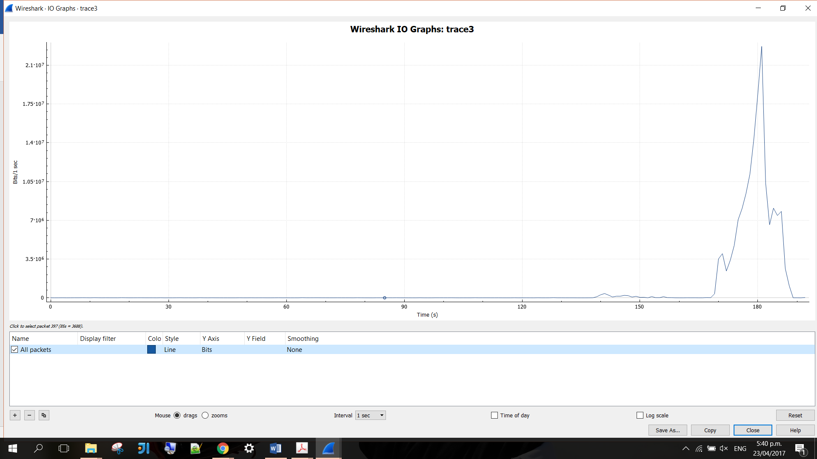

The highest bits-per-second rate is 22700000 bits per second and it occurred in the 181st second.

Task 3. Q4.

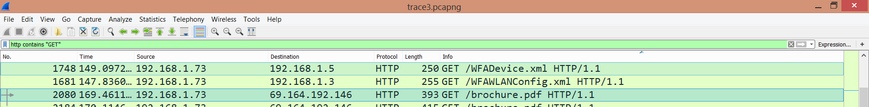

IP address of host: 192.168.1.73

IP address of client: 69.164.192.146

Task 3. Q5.

TCP conversation

* First 30:

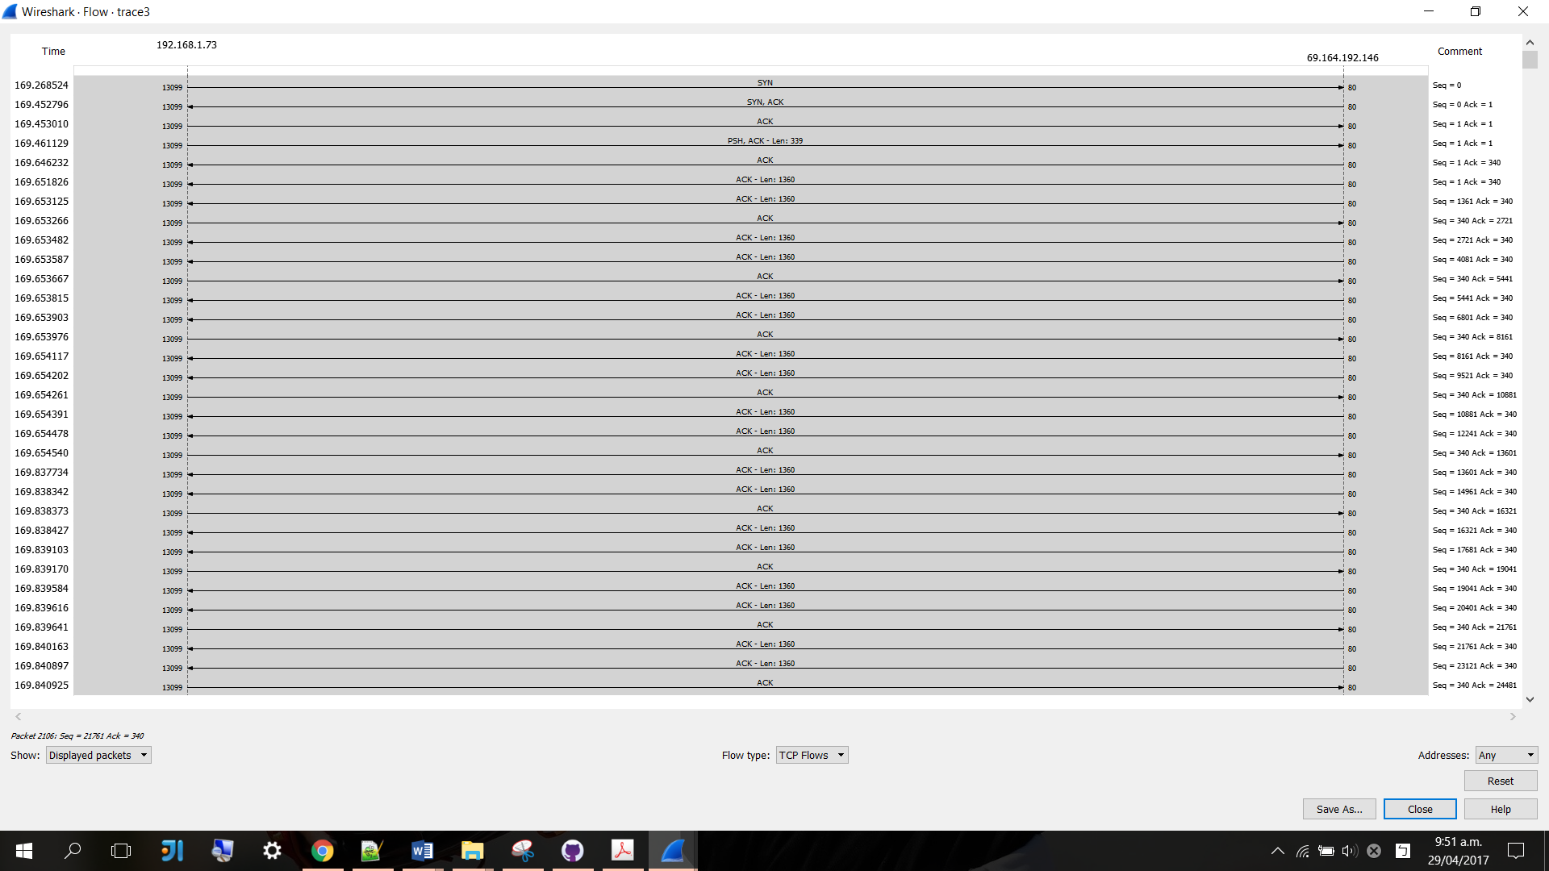

* Middle:

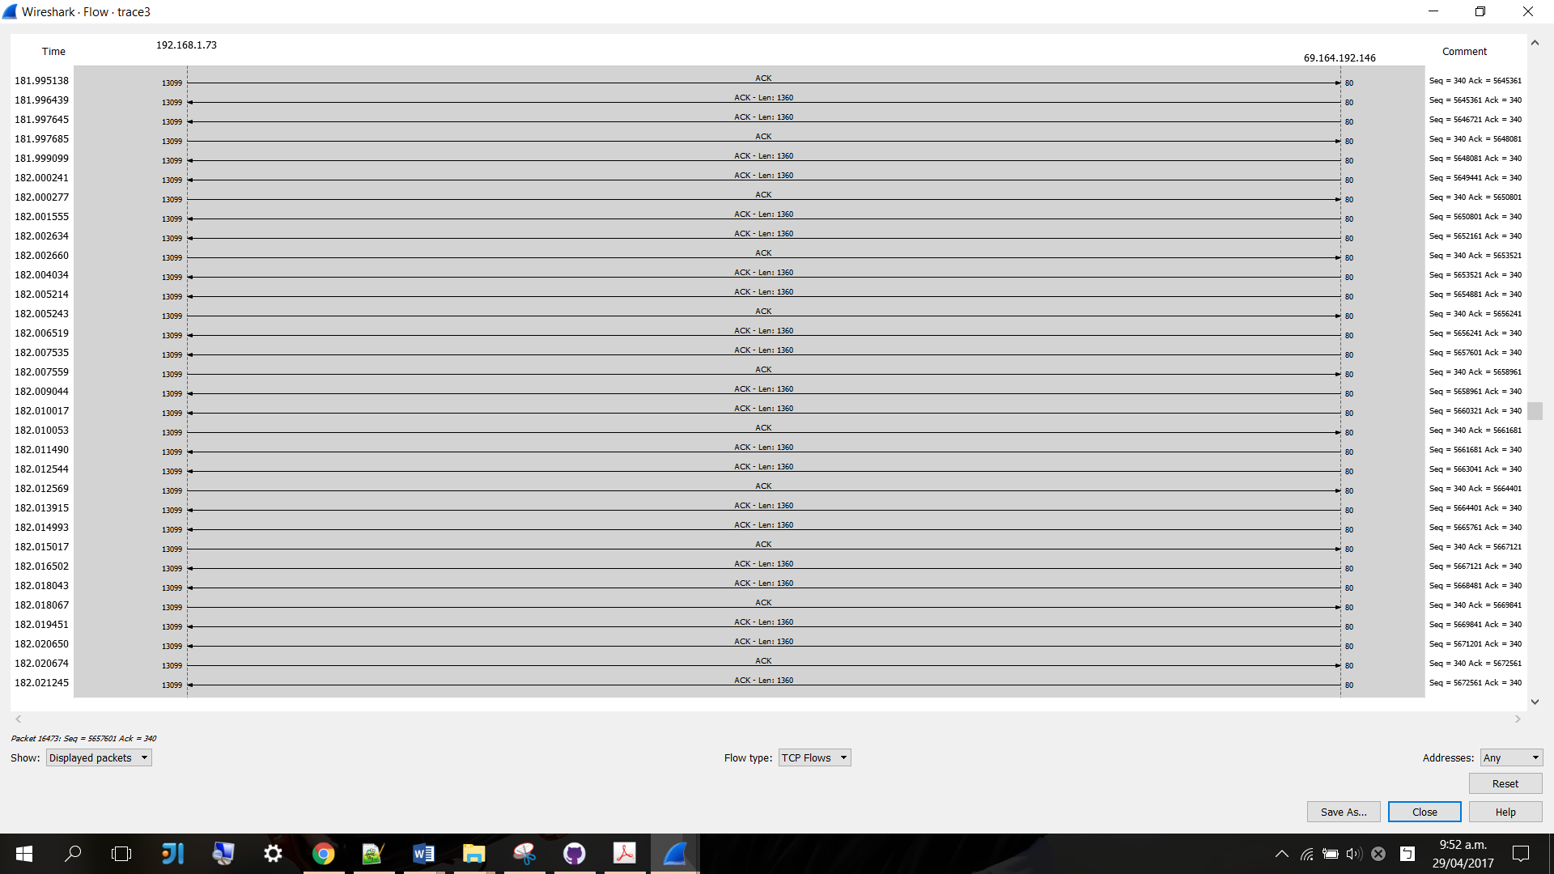

* Last 30:

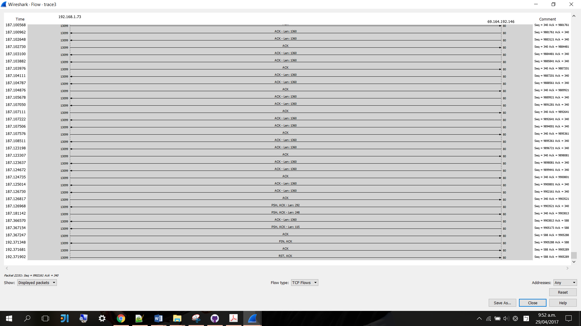

Task 3. Q6.

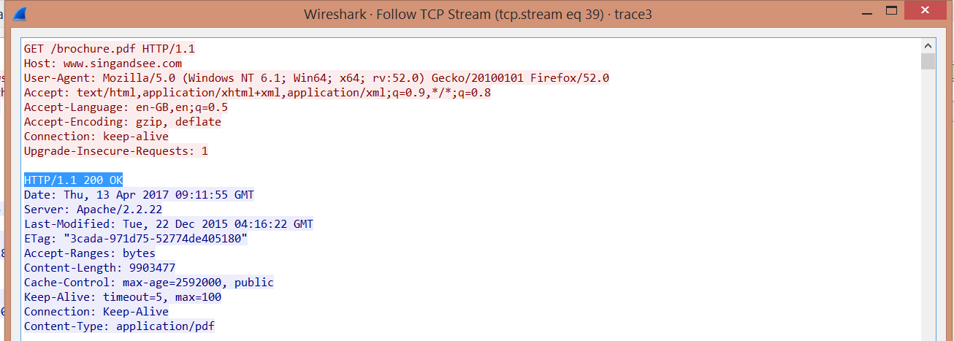







* Download time for the client side = 187.1269 – 169.4611 = 17.67 seconds

This includes the HTTP GET message because it is required for the client to set up the connection.

* Download time for the server side = 187.1269 – 169.646232 = 17.48 seconds

This excludes the HTTP GET message because the download session starts when the server starts sending the data segments.

Task 3. Q7.

Apply display filter:

tcp.stream eq 39 && frame.number >= 2080 && frame.number <= 22153 && tcp.analysis.ack_rtt



Export to a csv file and use the AVERAGE() function in column G.



The average RTT was 0.000254041 seconds.

Task 3. Q8.



The longest RTT was 0.185103 seconds and it occurred in the 169.646232 th second. This occurred in packet 2081.

Task 4

**Overview**

As at 30 June 2016, the number of fibre-optic connections in New Zealand has increased more than double the number of connections at the same time last year. Almost 50 percent of all broadband connections in New Zealand had no data cap. This is in response to a tremendous increase in demand for streaming or on-demand services such as TV or movie streaming, online radio or music streaming, online gaming, and content creation and sharing. (Statistics New Zealand, 2016)

Furthermore, each New Zealand residential connection used approximately 88 gigabytes on average, which equates to approximately 85 hours of streaming TV or movies per month. Since 2013, New Zealand has seen a proliferation of video streaming services launching. These include global market leader Netflix, Sky-TV’s Neon, Spark’s Lightbox service, as well as Quickflix. (MacMahon, R., & Milner, M., 2015) Nearly a quarter (24%) of New Zealanders subscribe to digital content such as Netflix and Spotify, and consume content at a time that suits them. (Nielsen, 2016)

|  |  |
| --- | --- |
| Graph, Broadband internet connections by data cap, at 30 June 2012–16.  Figure Broadband internet connections between 2012 and 2016  (Statistics New Zealand, 2016) | Graph, Monthly data use, June month 2011–16.  Figure Monthly data usage between 2012 and 2016  (Statistics New Zealand, 2016) |

Video traffic is the major consumer of internet bandwidth, because multimedia files are generally large in nature. Videos are a sequence of images displayed at a constant rate, while digital images are arrays of pixels.There exist a very diverse range of video communication and streaming applications, which have very distinctive operating conditions or properties. Video communication system designs significantly depend on the characteristics of the communication channel, such as bandwidth, delay, and loss.

Some video channels support Constant Bit Rate (CBR), such as ISDN or DTV. On the other hand, some channels support Variable Bit Rate (VBR), for example, DVD storage and communication over shared packet networks. (Apostolopoulos, J. G., Tan, W. T., & Wee, S. J., 2002) In a video streaming application, a client typically begins playout of the video while the file is being downloaded from the server. This means the client will be playing out the video from one location in the file while it is receiving later parts of the file from the server. Hence, streaming avoids having to download the entire file before beginning the playout, which can potentially incur a longer delay.

Several network protocols have been designed and standardised for communication between clients and streaming servers. The Internet protocol (IP) serves as the network layer protocol for Internet video streaming. The transport layer provides end-to-end network transport functions for streaming applications. Transport protocols include UDP, TCP, real-time transport protocol (RTP), and real-time control protocol (RTCP). UDP and TCP protocols support functions such as multiplexing, error control, congestion control, and flow control. RTP and RTCP are implemented on top of UDP/TCP. The application layer contains several protocols including HTTP and DASH. HTTP is used to exchange or transfer hypertext, while DASH is a technique that enables high-quality streaming of media content over the Internet to be delivered from conventional HTTP web servers. Moreover, DASH-based streaming is very different from UDP-based streaming as it involves adaptation both by the application and by TCP. (Martin, J., Fu, Y., Wourms, N., & Shaw, T., 2013)

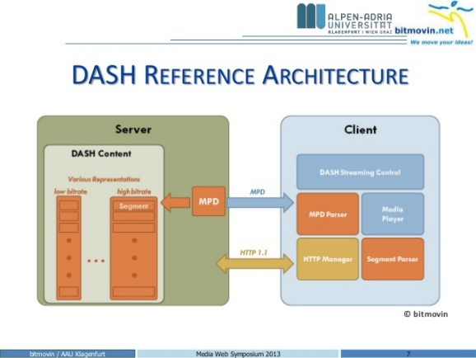

Figure DASH Reference Architecture (Stefan Lederer, 2013)

The media content exists on the server in two parts: a Media Presentation Description (MPD) and segments. MPD essentially describes a manifest of the available content and their URL addresses in XML format, while the segments contain data segments of the actual multimedia bitstreams. By parsing the MPD, the DASH client learns about the content details and starts fetching the segments using HTTP GET requests. (Sodagar, I., 2011)

The DASH standards focus primarily on the syntax required to describe content manifests and video segments. In order to prevent rebuffering due to buffer starvation, a bit rate level less than the measured available bandwidth is usually chosen. Because of the benefits that HTTP-streaming based technology implies and due to the fact that DASH is a company-independent standard, YouTube and Netflix have implemented DASH as the preferred streaming technology rather than Flash Video streaming.

Furthermore, contend distribution networks (CDNs) replicate stored content and put the replicated content at the edges of the Internet. Techniques such as local caches are used to stream content to potentially millions of users. There are two main types of CDNs: ‘enter deep’ and ‘bring home’.

‘Enter deep’ CDNs push a large number of CDN servers deep into many access networks. They are closer to the users for improved user-perceived performance in terms of both delay and throughput. However, they are more expensive and more challenging to manage. It also involves sophisticated algorithms to shuffle data among the servers across the public Internet. On the other hand, ‘bring home’ CDNs use a small number of larger clusters in Point of Presences near the access networks, but not within them. Consequently, large content distribution centres are built at only a few key locations and private high-speed connections are used. A typical key location is simultaneously near the POPs of many large ISPs. This approach typically results in lower maintenance and management overhead, possibly at the expense of higher delay to the end users. (Huang, C., Wang, A., Li, J., & Ross, K. W., 2008) Given that a large portion of the traffic flowing through the Internet is stored content such as multimedia, CDNs can significantly reduce the traffic loads on the ISPs and the related interfaces between ISPs. Leading commercial CDN representatives of ‘enter deep’ and ‘bring home’ are Akamai and Limelight respectively.

Over-the-top content (OTT) refers to audio, video, and other media transmitted via the Internet as a standalone product. OTT content includes Youtube and Netflix. It bypasses the traditional operator’s network. These operators are so-called multiple-system operators. Hence, the OTT players do not require any business or technology affiliations with network operators for providing such services. OTT services generally rely on streaming protocols such as HTTP adaptive bitrate streaming, where a video is split into fixed length chunks and stored on one or more HTTP servers or cached within the CDN for quick access.

Controlling the perceived video quality or quality of experience (QoE) is a major challenge for OTT service providers. (Satti, S. M., Bitto, R., Keyhl, M., Obermann, M., & Schmidmer, C., 2016) Sometimes it is hard for OTT content to reproduce the same video resolution as traditional cable television, especially when compared side-by-side to a larger screen. Although OTT videos are distributed over dedicated CDN infrastructures, OTT content is delivered over the more congestion-prone and less managed open Internet. Commonly known distortions in OTT are initial-loading, stalling, and coding/quality-switching. (Satti, S. M., Bitto, R., Keyhl, M., Obermann, M., & Schmidmer, C., 2016)

**Netflix**

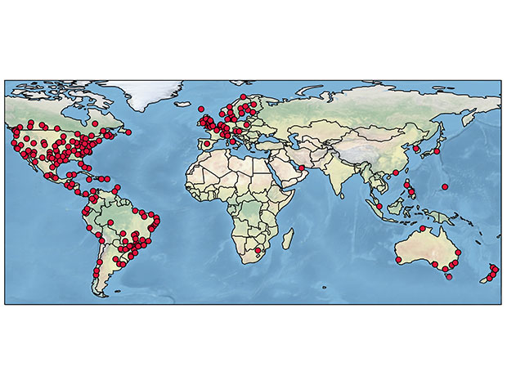

Figure This map depicts the location of Netflix servers found in a recent research (Amy Nordrum, 2016)

Netflix is the leading subscription service provider for TV shows and online movies. It is the single largest source of Internet traffic in the US, consuming 29.7% of peak downstream traffic. (Adhikari, V. K., Guo, Y., Hao, F., Varvello, M., Hilt, V., Steiner, M., & Zhang, Z. L., 2012) In March 2016, Netflix claimed to deliver about 125 million total hours of viewing to customers per day. (Netflix Media Center, 2016) There are approximately 4 Netflix servers in new Zealand, while there are 4669 servers in 243 global locations.(Amy Nordrum, 2016) Netflix servers have two main functionalities. The first is to capture payment and user registration information, while the second is user redirection. The users who are successfully logged in and those who are not are redirected to different IP addresses. In addition, the servers do not interact with the clients directly during video streaming.

Netflix uses cloud services such as Amazon AWS cloud, CDNs, and other public services. Amazon cloud provides key functionalities such as CDN routing and mobile device support. Video streaming of Netflix is served out of multiple CDNs, and UltraDNS, which is a public DNS service used as its authoritative servers. The encoded and DRM protected videos are sourced in Amazon and copied to CDNs. The average bandwidth of CDNs can vary significantly over time and over geographic locations.



Figure Netflix Architecture (Adhikari, V. K., Guo, Y., Hao, F., Varvello, M., Hilt, V., Steiner, M., & Zhang, Z. L., 2012)

Netflix’s content delivery strategy stores content at both IXPs and ISPs. In the United States, Netflix is primarily delivered through IXPs and Akamai’s ‘enter deep’ strategy is likely to be used. Meanwhile, there are no Netflix servers at IXPs in Canada or Mexico. Customers in those countries are served exclusively by servers within ISPs, as well as possibly through IXPs along the U.S. borders. (Amy Nordrum, 2016) Limelight’s ‘bring home’ strategy is likely to be used in these countries. Netflix’s centralised approach outside the U.S. is convenient because it has more control and scalability for the local market.

Netflix uses the DASH protocol over TCP for streaming. The DASH players of Netflix are allowed to freely switch between different quality levels at the chunk boundaries. However, Netflix clients do not try all possible available bitrates when trying to determine the optimal playback rate. Netflix video streaming is controlled by instructions in a manifest file that provides the DASH player metadata. The manifest files are client-specific and delivered via SSL connection. They also rank CDNs to indicate the preferred CDNs. (Adhikari, V. K., Guo, Y., Hao, F., Varvello, M., Hilt, V., Steiner, M., & Zhang, Z. L., 2012) In general, the Netflix client appears to stay with the same CDN as long as possible even if it has to degrade the quality level of the playback, while other CDNs appear to serve only as backups. Furthermore, Netﬂix’s adaptation appears to default to TCP control during periods of heavy, sustained network congestion. However, the application algorithm is clearly intertwined with TCP control during periods of volatile network conditions. (Martin, J., Fu, Y., Wourms, N., & Shaw, T., 2013)



Figure DASH System Model (Stefan Lederer, 2013)

The DASH client of Netflix contains three main functional areas: the HTTP access, the media engine, and the control engine that monitors the arriving video stream and determines the quality of stream to request. (Martin, J., Fu, Y., Wourms, N., & Shaw, T., 2013) The client will maintain a playback buffer that smooths variable content arrival rates to support the video playback. The client requests a new segment tagged with the desired bitrate once the playback buffer drops below a certain threshold. When the playback buffer is almost empty, the client is likely to go into a ‘buffering’ state where it requests segments at a high rate. (Martin, J., Fu, Y., Wourms, N., & Shaw, T., 2013)

Hence, the session operates in one of two states: buffering or steady state. While in a buffering state, the client requests data at a rate up to the available bandwidth over the path between the server and the client. If conditions permit, the session will attempt to ﬁnd a ‘steady state’ where it requests segments at a rate necessary to playback the content at a given encoded bitrate. (Adhikari, V. K., Guo, Y., Hao, F., Varvello, M., Hilt, V., Steiner, M., & Zhang, Z. L., 2012) Moreover, Microsoft Silverlight is used by Netflix to play, download, and decode its multimedia content. However, Netflix is gradually moving to HTML5 video.

**YouTube**

YouTube is one of the most popular services on the internet, being the most visited website in the world. Three hundred hours of video is uploaded to YouTube every minute. (FortuneLords, 2017)

YouTube’s content delivery strategy prefers to store content at IXPs. (Amy Nordrum, 2016) YouTube uses a Flash-based client which is embedded in the web page. The communication between the client and server is done over HTTP. Consequently, YouTube does not have to cope with lost or reordered packets. However, a stalling of the video may be caused by transmission problems. HTTP over TCP provides two advantages. First, TCP is more firewall friendly compared to UDP as firewalls are more likely to block UDP. Second, the client manages HTTP streaming without having to maintain a session state on the server. (Sodagar, I., 2011)

YouTube used conventional HTTP streaming and progressive downloads prior to 2013. It later adapted DASH to reduce the overhead transmissions created by the previous two approaches. By using DASH, YouTube is able to switch the video quality based on the recent link capabilities. This enables YouTube’s player quality parameter. If it is set to ‘auto’, YouTube can adapt the bitrate of the video based on the client’s available bandwidth. (Añorga, J., Arrizabalaga, S., Sedano, B., Alonso-Arce, M., & Mendizabal, J. , 2015)

YouTube’s streaming strategy has two phases: a burst phase and a throttling phase. The burst phase is the initial phase where there exists a significant burst of data. After this initial burst, the receiving download data rate of YouTube’s player is considerably reduced. (Krishnappa, D. K., Bhat, D., & Zink, M., 2013) This strategy reduces congestion in the network by eliminating the transmission of unused data.

DASH provides the advantages in bandwidth and cost saving for YouTube, especially when the majority of users do not watch more than the first 20% of a video. However, one disadvantage of DASH is the amount of storage required to host all the videos in various bit rates and segment lengths on YouTube. (Añorga, J., Arrizabalaga, S., Sedano, B., Alonso-Arce, M., & Mendizabal, J. , 2015) Furthermore, YouTube uses both HTML5 video and Adobe Flash for multimedia streaming. HTML5 is defaulted for mobile devices, while Adobe Flash is defaulted for Pcs.

**Lightbox**

Lightbox is a New Zealand subscription video on demand (SVOD) service owned by Spark New Zealand. The service offers a selection of television shows over a wide range of devices. (Lightbox (New Zealand), 2017) Lightbox was initially launched as ShowmeTV in 2014 and currently faces competitions from other SVOD services including Quickflix, Netflix, and Neon. (Keall, Chris., 2014) (Damien Venuto, 2015) While over one million New Zealanders have access to Netflix, Lightbox shows the fastest growth of all SVOD providers in 2017. (StopPress, 2017)

According to our previous discussion, Lightbox is likely to utilise the centralised approach, where the customers are served exclusively by servers within ISPs. Akamai’s ‘enter deep’ approach is likely to be used and the ISP here is likely to be the parent company, Spark.Similarly, this approach is convenient because it has more control and scalability for the New Zealand market.

At the heart of Lightbox’s OTT services was Xstream's MediaMaker OTT platform that was used to provide customised OTT and TV everywhere services. The key features of MediaMaker include various management, automation, and scheduling services. (Rapid TV News, 2014)

Bibliography

Adhikari, V. K., Guo, Y., Hao, F., Varvello, M., Hilt, V., Steiner, M., & Zhang, Z. L. (2012). Unreeling netflix: Understanding and improving multi-cdn movie delivery. *INFOCOM* (pp. 1620-1628). IEEE.

Amy Nordrum. (2016, August 30). *Researchers Map Locations of 4,669 Servers in Netflix’s Content Delivery Network*. Retrieved from IEEE Spectrum: http://spectrum.ieee.org/tech-talk/telecom/internet/researchers-map-locations-of-4669-servers-in-netflixs-content-delivery-network

Añorga, J., Arrizabalaga, S., Sedano, B., Alonso-Arce, M., & Mendizabal, J. . (2015). YouTube’s DASH implementation analysis. *19th International Conference on Circuits, Systems, Communications and Computers (CSCC)*, (pp. 61-66).

Apostolopoulos, J. G., Tan, W. T., & Wee, S. J. (2002). *Video Streaming: Concepts, Algorithms, and Systems.* HP Laboratories, report HPL-2002-260.

Damien Venuto. (2015, January 20). *Spark continues to evolve, offers another subscriber perk with free Lightbox*. Retrieved from StopPress: http://stoppress.co.nz/news/telco-or-media-company-continued-evolution-spark

FortuneLords. (2017, March 23). *36 Mind Blowing YouTube Facts, Figures and Statistics – 2017*. Retrieved from FortuneLords: https://fortunelords.com/youtube-statistics/

Huang, C., Wang, A., Li, J., & Ross, K. W. (2008). Measuring and evaluating large-scale CDNs. *ACM IMC, 8*.

Keall, Chris. (2014, August 28). *Spark's Lightbox launches, with a little surprise from the boss*. Retrieved from National Business Review: http://www.nbr.co.nz/article/sparks-lightbox-launches-little-surprise-boss-ck-161495

Krishnappa, D. K., Bhat, D., & Zink, M. (2013). DASHing YouTube: An analysis of using DASH in YouTube video service. *2013 IEEE 38th Conference* (pp. 407-415). IEEE.

Kurose, J. F., & Ross, K. W. (2010). *Computer networking: a top-down approach* (Vol. 5). Addison-Wesley.

*Lightbox (New Zealand)*. (2017, April 16). Retrieved from Wikipedia: https://en.wikipedia.org/wiki/Lightbox_(New_Zealand)

MacMahon, R., & Milner, M. (2015). Ultra-fast broadband in New Zealand: Progress accelerating. *Australian Journal of Telecommunications and the Digital Economy, 3*, 12.

Martin, J., Fu, Y., Wourms, N., & Shaw, T. (2013). Characterizing Netflix bandwidth consumption. *Consumer Communications and Networking Conference (CCNC)* (pp. 230-235). IEEE.

Netflix Media Center. (2016, March 17). *How Netflix Works With ISPs Around the Globe to Deliver a Great Viewing Experience*. Retrieved from Netflix Media Center: https://media.netflix.com/en/company-blog/how-netflix-works-with-isps-around-the-globe-to-deliver-a-great-viewing-experience

Nielsen. (2016, April 14). *NEW ZEALAND MEDIA TRENDS REPORT 2016*. Retrieved from Nielsen: http://www.nielsen.com/nz/en/insights/reports/2016/new-zealand-media-trends-2016.html

Rao, A., Legout, A., Lim, Y. S., Towsley, D., Barakat, C., & Dabbous, W. (2011). Network characteristics of video streaming traffic. *Seventh COnference on emerging Networking EXperiments and Technologies* (p. 25). ACM.

Rapid TV News. (2014, August 28). *Xstream switches on Lightbox New Zealand OTT service*. Retrieved from Rapid TV News: https://www.rapidtvnews.com/2014082835072/xstream-switches-on-lightbox-new-zealand-ott-service.html

Satti, S. M., Bitto, R., Keyhl, M., Obermann, M., & Schmidmer, C. (2016, December). Long-term quality evaluation in OTT video. *In Picture Coding Symposium (PCS)*, 1-5.

Sodagar, I. (2011). The mpeg-dash standard for multimedia streaming over the internet. *IEEE MultiMedia, 18*(4), 62-67.

Statistics New Zealand. (2016, October). *Internet Service Provider Survey: 2016*. Retrieved from Statistics New Zealand: http://www.stats.govt.nz/browse_for_stats/industry_sectors/information_technology_and_communications/ISPSurvey_HOTP2016/Commentary.aspx

Stefan Lederer. (2013, March 15). *MPEG-DASH open source tools and cloud services*. Retrieved from SlideShare: https://www.slideshare.net/slederer/mpegdash-open-source-tools-and-cloud-services

StopPress. (2017, April 21). *One in 10 New Zealanders have two or more SVODs' – Roy Morgan research*. Retrieved from StopPress: http://stoppress.co.nz/news/one-10-new-zealanders-have-two-or-more-svods

Sujata, J., Sohag, S., Tanu, D., Chintan, D., Shubham, P., & Sumit, G. (2015). Impact of Over the Top (OTT) Services on Telecom Service Providers. *Indian Journal of Science and Technology, 8*, 145-160.

Wu, D., Hou, Y. T., Zhu, W., Zhang, Y. Q., & Peha, J. M. (2001). Streaming video over the Internet: approaches and directions. *IEEE Transactions on circuits and systems for video technology, 11*, 282-300.

Table of Figures

Figure 1 Broadband internet connections between 2012 and 2016 12

Figure 2 Monthly data usage between 2012 and 2016 12

Figure 3 DASH Reference Architecture 13

Figure 4 This map depicts the location of Netflix servers found in a recent research 14

Figure 5 Netflix Architecture 14

Figure 6 DASH System Model 15